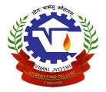    

**REPORT**

**GOLAZO**

* Venue: Communication engineering lab
* Date: 05/12/2022
* Total Number of participants: 33
* Student coordinators: Nevin Saji & Sebastian George

**Brief:**

IEEE Circuits and Systems society and Photonics society on behalf of TANTRA- Tech fest 2022, an online football gaming competition was conducted for under graduate students. There were around 33 students participated in the event. A good response was put forwarded by the students as it helped them build their confidence in circuits and getting more knowledge.

**EVENT POSTER**

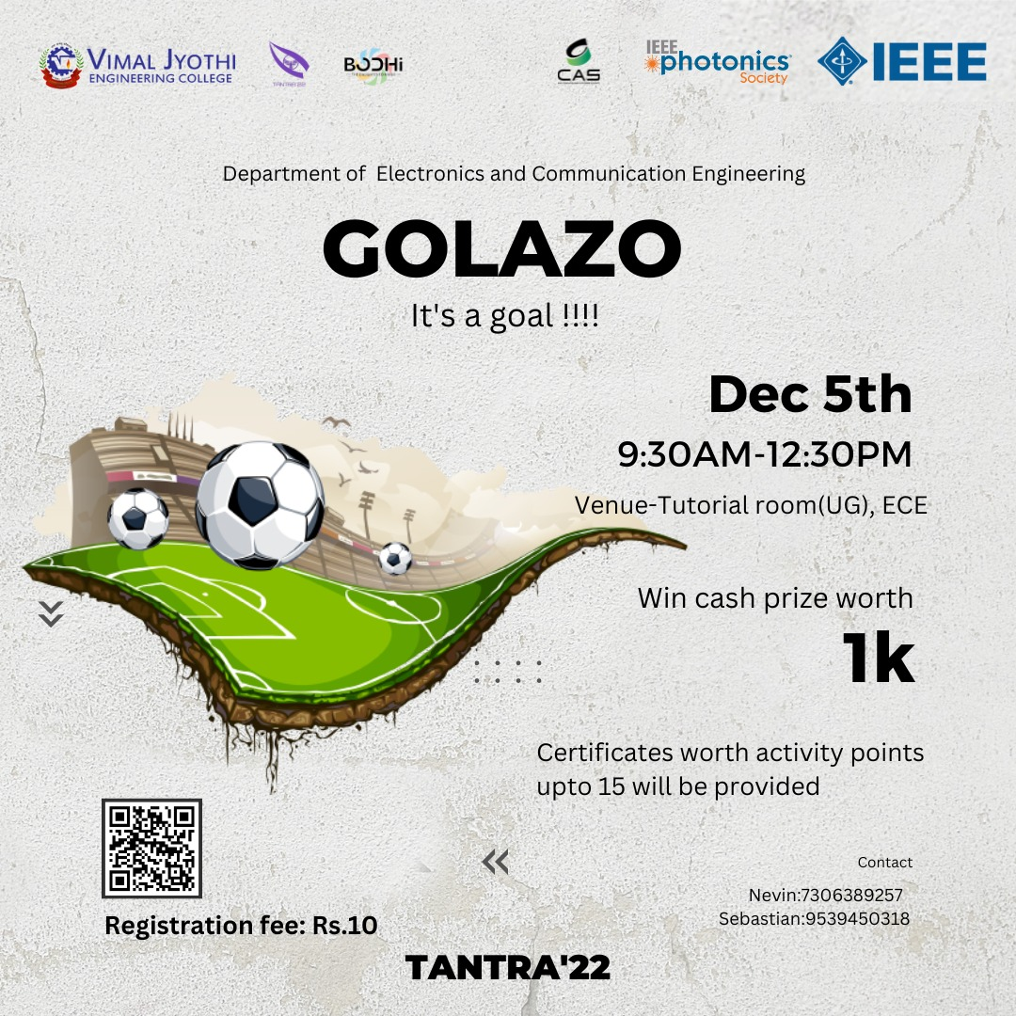

**EVENT FEEDBACK**

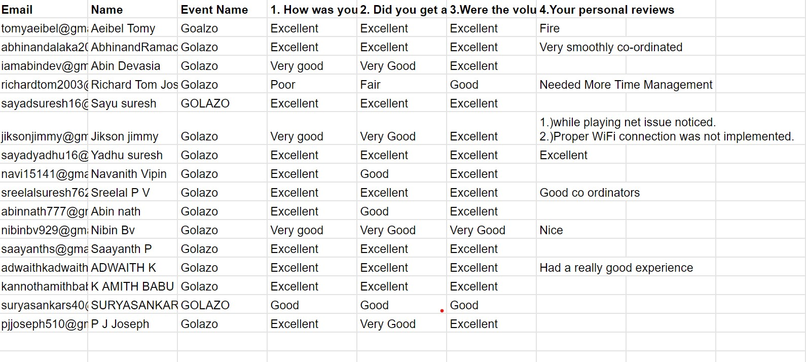

**WINNERS**

1st

Sreelal P V

2nd

Akash Jolly