**PROJECT**

**Project Title :**

HematoVision: Advanced Blood Cell Classification Using

Transfer Learning

**Team ID :**

LTVIP2025TMID37571

**Team Members :**

* Bulusu Geethika
* Baditha Harika
* Dasari Kavya

# Phase-1 : Brainstorming & Ideation

**Objective:**

To develop an AI-powered blood cell classification system using transfer learning that enhances diagnostic accuracy, reduces manual analysis time, and supports healthcare applications such as automated diagnostics, remote consultations, and medical education.

**Key Points:**

1. **Problem Statement:**

* + Microscopic analysis of blood cells plays a critical role in diagnosing conditions such as leukemia, anemia, and infections. However, manual analysis is time-consuming and subject to human error.
  + HematoVision utilizes transfer learning to classify blood cell types from microscopic images accurately. By integrating Al into hematovision system enhances diagnostic speed, precision, and reliability, supporting early disease detection and improves patient outcomes.

1. **Proposed Solution:**

* + An AI-powered application that uses transfer learning to accurately classify blood cells from microscope images in real-time.
  + It helps doctors by providing quick, reliable results, reducing manual effort and improving the speed and accuracy of diagnosis.

1. **Target Users:**

* + Pathologists and lab technicians who need quick and accurate blood cell analysis.
  + Hospitals and diagnostic centers aiming to automate blood smear classification.
  + Doctors offering remote consultations who require fast diagnostic support.
  + Medical students and trainees learning about blood cell identification.

1. **Expected Outcome:**

* + A functional AI-powered application that accurately classifies blood cells from images using transfer learning.
  + Provides fast, reliable diagnostic support to improve efficiency in medical analysis and education.

# Phase-2: Requirement Analysis

Define the technical and functional requirements for the HematoVision application.

**Key Points:**

1. **Technical Requirements:**

* + **Programming Language: Python**
  + **Python Packages:** NumPy, Pandas, Scikit-learn, Matplotlib, SciPy, Seaborn, TensorFlow, Flask
  + **Frameworks:** Flask for web integration, TensorFlow for deep learning
  + **Pre-trained Model:** VGG16 (used for transfer learning)
  + **Development Tools:** Command Line (pip install)

1. **Functional Requirements:**

* + Ability to **upload microscopic blood cell images** through the web interface.
  + Classify blood cells into types like **eosinophils, lymphocytes, monocytes, and neutrophils** using a trained model.
  + Display **classification results** along with prediction confidence.
  + Provide an easy-to-use interface for doctors, students, and lab technicians.

1. **Constraints & Challenges:**

* + Handling imbalanced data across different blood cell classes.
  + Managing low-quality or blurry microscope images that affect prediction accuracy.
  + Optimizing model size and performance for faster processing and easy deployment.
  + Ensuring the web interface is responsive and user-friendly on all devices.

# Phase-3: Project Design

Develop the architecture and user flow of the application.

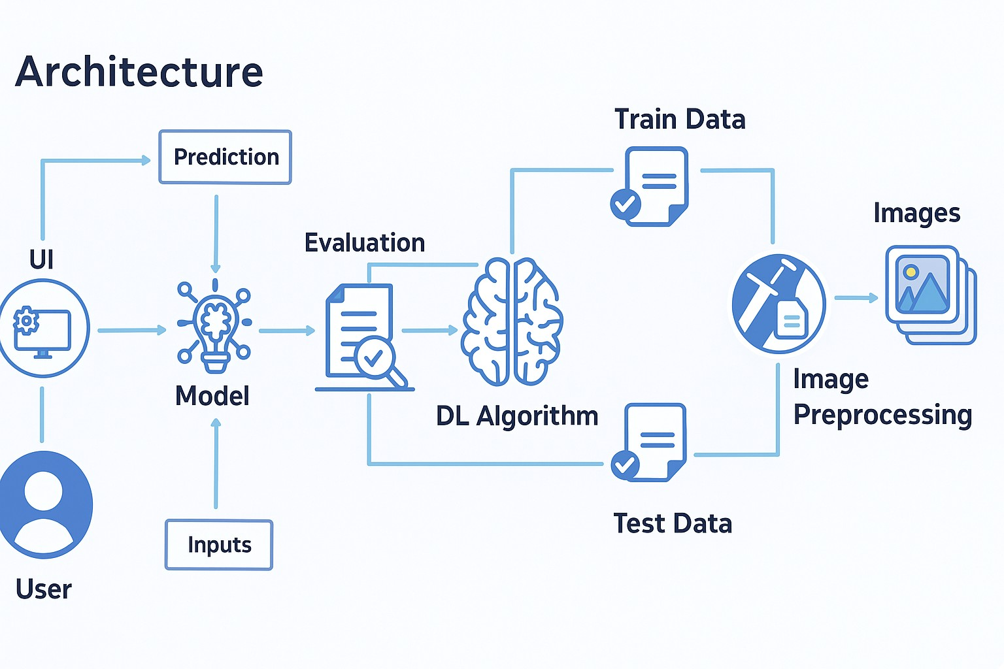

**Key Points:**

1. **System Architecture:**

* + The user uploads a blood cell image through the web interface (UI).
  + The image is sent as input to the trained deep learning model.
  + The model uses a pre-trained CNN (like VGG16) to process the image and predict the blood cell type.
  + The prediction is evaluated and displayed back on the UI with confidence levels.
  + Initially, the model is built using preprocessed images from the dataset, split into training and testing sets.
  + The training data is used to fine-tune the DL algorithm using transfer learning, while test data is used for evaluation.

1. **User Flow:**

* + Step 1: User opens the web application.
  + Step 2: Uploads a microscope image of a blood smear.
  + Step 3: The model processes the image and classifies the cell type.
  + Step 4: The predicted cell type and confidence score are displayed.
  + Step 5:User can repeat with other images or use the results for diagnostic insight.

# Phase-4: Project Planning

Breakdown development tasks for efficient completion.

|  |  |  |  |  |  |  |  |
| --- | --- | --- | --- | --- | --- | --- | --- |
| **Sprint** | **Task** | **Priority** | **Duration** | **Deadline** | **Assigned to** | **Dependencies** | **Expected outcome** |
| Sprint 1 | Environment  Setup &  Package  Installation | 🔴High | 3 hours | Day 1 | Member 1 | Anaconda , Python | Project environment ready |
| Sprint 1 | Dataset  Collection &  Preprocessing | 🔴High | 4 hours | Day 1 | Member 2 | Dataset access | Clean,prepar ed image dataset |
| Sprint 2 | Model  Building using  Transfer  Learning | 🔴High | 5 hours | Day 2 | Member 3 | Preprocessed data,  TensorFlow | Trained classification model |
| Sprint 2 | Flask Web App  Integration | 🟡Medium | 3 hours | Day 2 | Member  1 & 2 | Trained Model,Flask installed | Working web interface |
| Sprint 3 | Testing & Debugging | 🟡Medium | 2 hours | Day 2 | Member  1, 2 & 3 | Complete System | Bug-free and responsive system |
| Sprint 3 | Final  Presentation  & Deployment | 🟢Low | 1 hour | End of Day 2 | Entire Team | Working application | Project deployed and demo-ready |

**Sprint Planning with Priorities**

**Sprint 1 - Setup & Preparation (Day 1)**

🔴 **High Priority**

* Set up the environment using Anaconda Navigator.
* Install all required Python packages (TensorFlow, Flask, etc.).
* Collect and preprocess the blood cell image dataset.

**Sprint 2 – Model Development & Integration (Day 2)**

🔴 **High Priority**

* Build and train the blood cell classification model using transfer learning (e.g., VGG16).
* Integrate the trained model with the Flask web application.

**Sprint 3 – Testing, Deployment & Submission (Day 2)**

🟡 **Medium Priority**

* Test the app functionality, fix bugs, and improve UI responsiveness.

🟢 **Low Priority**

* Finalize deployment and prepare presentation/demo materials.

# Phase-5: Project Development

**Objective:**

Implement the core features of the HematoVision application using transfer learning for blood cell classification.

**Key Points:**

1. **Technology Stack Used:**

* + **Frontend:** HTML (via Flask templates)
  + **Backend:** Flask Framework
  + **Deep Learning:** TensorFlow with pre-trained VGG16 model
  + **Programming Language:** Python

1. **Development Process:**

* + Built and trained a blood **cell classification model using transfer learning** (VGG16).
  + Preprocessed a dataset of **12,000 labeled blood cell** images.
  + Integrated the trained model into a **Flask web application**.
  + Developed a user interface to upload images and display classification **results with prediction confidence**.

1. **Challenges & Fixes:**

* + **Challenge:** Model overfitting on certain blood cell types.

**Fix:** Used data **augmentation and dropout** regularization.

* + **Challenge:** Large model size caused slow predictions.

**Fix:** Applied model optimization and saved in**.h5** format for faster loading.

* + **Challenge:** Image quality variation.

**Fix:** Added preprocessing steps like resizing and normalization before prediction.

# Phase-6: Functional & Performance

**Objective:**

Ensure that the HematoVision application performs accurately, reliably, and consistently across various test cases and environments.

|  |  |  |  |  |  |
| --- | --- | --- | --- | --- | --- |
| **Test**  **Case ID** | **Category** | **Test**  **Scenario** | **Expected Outcome** | **Status** | **Tester** |
| TC-001 | Functional Testing | Upload image of eosinophils | Correct cell type identified with confidence score | ✅ Passed | Tester 1 |
| TC-002 | Functional Testing | Upload mixed  WBC/RBC image | Multi-class classification displayed correctly | ✅ Passed | Tester 2 |
| TC-003 | Performance  Testing | Check model response time | Results displayed under 2 secods | ⚠Needs Optimization | Tester 3 |
| TC-004 | Bug Fix Validation | Image with poor lighting | System still makes reasonable prediction | ✅ Fixed | Developer |
| TC-005 | UI  Responsiveness | Test on mobile browser | Layout adjusts properly on mobile | ❌ Failed | Tester 2 |
| TC-006 | Deployment  Testing | Hosted on  local server and accessed remotely | App loads and predicts successfully online | 🚀 Deployed | DevOps |