PROJECT DOCUMENTATION
AgriFlow
An Interactive Algorithm Lab on Farm Data
Advanced Algorithms, Modules 1 to 6, implemented by hand in Java
Submitted by (ID numbers)
2500030117
2500030142
2500032128
2500032215

Department: Computer Science and Engineering (CSE)
Year: Second year
Guide / Faculty: Dr. Maganti Syamala
Date: 16 October 2026

Contents
1. Abstract
2. Introduction
3. System design
4. Module-wise implementation
5. Testing and verification
6. Results from the running application
7. How to run the project
8. API reference
9. Limitations
10. Future work
11. Conclusion
References
Appendix A: list of all labs

1. Abstract
AgriFlow is a farm-data search and optimisation platform built in Java. It holds a knowledge base of 15 farm records (crop, disease, soil, fertiliser, water need, season and practice) and uses it as a live test-bed for the algorithms in the Advanced Algorithms syllabus: string matching and suffix structures (Module 2), advanced dynamic programming (Module 3), network flow (Module 4), NP-completeness and approximation (Module 5), and randomised and parallel algorithms (Module 6), on top of a hand-built engine (Module 1).
Every algorithm is written by hand using only arrays and java.lang; the engine package contains no java.util collection. A small HTTP server exposes each algorithm as a JSON endpoint, and a single web page with 31 interactive labs sends queries, receives the answers and draws them as heat-map tables, flow networks, route maps and bar charts. Correctness is checked by a self-check program that runs 54,614 randomised comparisons against brute-force or reference answers, with 0 failures.

2. Introduction

2.1 Background
Farm decisions involve many crops, resources, schedules and field activities. The information is largely text (crop names, diseases, practices, reports) together with routes, networks and choices under a budget. These are exactly the kinds of problems the syllabus algorithms were designed for, which makes farm data a natural setting for learning them.

2.2 Problem statement
Algorithms taught from a textbook are shown as a single frozen example, which makes them hard to picture. The aim of this project is to implement every topic of the syllabus in one application, on a realistic data set, so that each algorithm can be run, inspected and compared interactively.

2.3 Objectives
- Implement all syllabus algorithms in Java, using only arrays and java.lang in the engine.
- Apply them to a farm knowledge base: searching records, matching near-identical terms, planning routes, moving water and crops, selecting crops under a budget, and sampling data.
- Expose each algorithm through a simple HTTP API and a visual web page, with a plain-language explanation and the Big-O cost beside every lab.
- Verify correctness with randomised testing against brute force.

2.4 Scope
The project covers Modules 1 to 6 of the question bank. It is a learning and demonstration platform. The built-in data set is small by design, and the platform is not intended as a production farm-management system.

3. System design

3.1 Architecture
AgriFlow is split into four layers. The browser page only asks questions and draws answers; all computation happens in Java.
Layer | Component | Responsibility
Presentation | web/index.html | Sidebar navigation, 31 labs, SVG drawings, an 'explain it like I'm 10' box, Big-O line and the exact request URL for every lab.
Server | AgriFlowServer, Q, Json | Serves the page, routes /api/ paths, reads and range-checks query parameters, and writes JSON.
API | ApiStrings, ApiGraph | Turns each request into algorithm calls and packages the result, including traces and counters.
Algorithm engine | agriflow.algorithms (27 files) | Hand-built algorithms. Uses arrays and java.lang only.

3.2 Request flow
A click on Run builds a GET request such as /api/flow?algo=dinic&s=Reservoir&t=Field Tank&edges=... The server matches the path, the API class calls the algorithm, and the answer returns as JSON. The page then draws it. Each lab prints the exact URL and the round-trip time under its result.

3.3 Project structure
Part | Files | Lines | Contents
src/agriflow/algorithms | 27 | 2,035 | All algorithms, IntList and Rng helpers.
src/agriflow/server | 6 | 1,331 | HTTP server, routing, JSON writer, query parser, data and API classes.
src/agriflow/model | 1 | 28 | FarmRecord data class.
src/agriflow/AgriFlowApp.java | 1 | about 20 | Starts the server and picks a free port.
test/Selfcheck.java | 1 | 661 | Randomised brute-force verification.
web/index.html | 1 | 522 | The interactive front end.

In total the Java source is 35 files and about 3,400 lines, plus the test program and the front-end page.

3.4 Engine rule
The syllabus rule for the engine is that nothing is borrowed from java.util. A search of the algorithms package confirms this: the only match for "java.util" is a comment in IntList.java. Two helper classes replace what the library would normally provide: IntList (a growable int array) and Rng (a seeded random number generator). The server and the tests are allowed to use the JDK.

3.5 Data set
The knowledge base holds 15 records: Rice, Wheat, Tomato, Cotton, Maize, Groundnut, Chilli, Paddy, Potato, Soybean, Sugarcane, Mustard, Banana, Turmeric and Pigeon Pea. Each has a crop, disease, soil, fertiliser, water need, season, practice and a short description. At start-up the server joins the records into one lowercase text corpus of 2,451 characters and builds a suffix array and LCP array over it. Twelve farm sites with coordinates are used for the routing labs.

4. Module-wise implementation

Module 1: Foundations and the hand-built engine
Module 1 sets the ground rules: algorithm analysis and an engine built only from arrays. The engine endpoints list which algorithm answers which kind of question, and the similarity lab finds records that share long chunks of text using a suffix array over a combined string.
Algorithm | Source file | Time cost | Used in AgriFlow for
IntList, Rng | IntList, Rng | O(1) amortised append | Replace java.util collections and Random.
Suffix array of a#b | SuffixTools | O(n log² n) per pair | Find the most similar records.

Module 2: String algorithms
Farm records are mostly words, so string search is the first capability. The naive method re-reads text after every mismatch. KMP builds a prefix table (lps) so it never re-reads matched characters, the Z-function measures prefix agreement at each position, and Rabin-Karp compares rolling hashes (double hash with a random prime found by Miller-Rabin). Aho-Corasick searches many patterns in one pass, and the suffix array with the Kasai LCP array supports fast search, longest repeated text and counting distinct substrings.
Algorithm | Source file | Time cost | Used in AgriFlow for
Naive search | NaiveSearch | O(n·m) | Baseline for comparison counts.
KMP | KMP | lps O(m), scan O(n) | Search a word in the knowledge base.
Z-function | ZAlgorithm | O(n+m) | Prefix-agreement search.
Rabin-Karp | RabinKarp | average O(n+m) | Hash-based search, double hash.
Aho-Corasick | AhoCorasick | build O(Σ|pattern|), scan O(n+matches) | Find many disease names in one pass.
Suffix array | SuffixArray | build O(n log² n), query O(m log n) | Indexed search over the corpus.
LCP (Kasai) | LCPArray, SuffixTools | O(n) | Longest repeated and common substring.

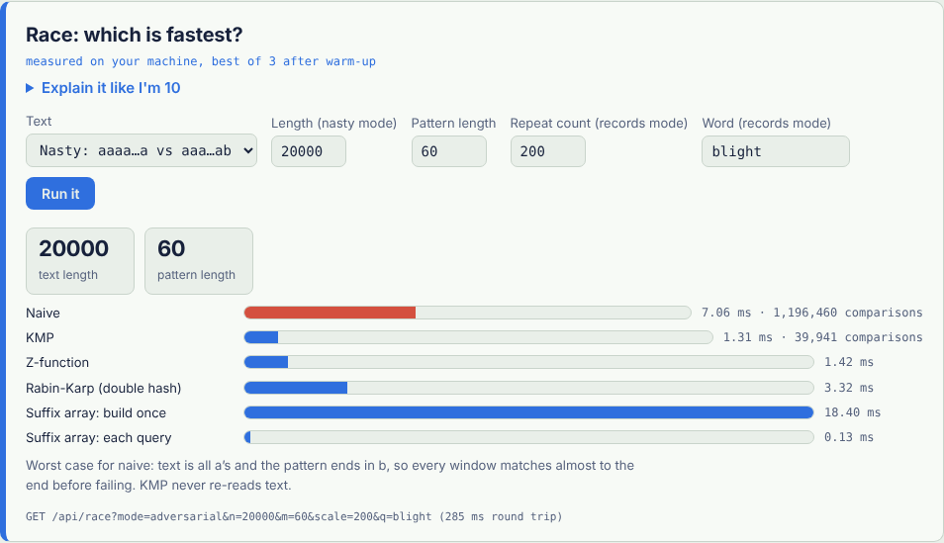
Figure 1: The race lab. On an adversarial text, naive search makes 1,196,460 comparisons and KMP makes 39,941.

Module 3: Advanced dynamic programming
Dynamic programming stores answers to small sub-problems so they are never solved twice. AgriFlow uses it to compare words (edit distance and alignment), to order operations (matrix-chain and optimal search tree), and to plan routes and treatments (Held-Karp, set cover, tree DP, subset DP). A greedy-versus-DP coin demo shows a case where the greedy choice is wrong.
Algorithm | Source file | Time cost | Used in AgriFlow for
Levenshtein, Damerau, weighted edit distance | EditDistance | O(m·n) | Match misspelled crop or disease terms.
Needleman-Wunsch, Smith-Waterman, Gotoh | Alignment | O(m·n) | Global, local and affine-gap alignment.
Matrix-chain order | IntervalDP | O(n³) | Best order of multiplication.
Optimal binary search tree | IntervalDP | O(n³), O(n²) with Knuth | Fast lookup tree for crops.
Held-Karp TSP | Tsp | O(2ⁿ·n²) | Shortest exact route over chosen farms.
Hamiltonian path | Tsp | O(2ⁿ·n) | Can one trip pass every farm once?
Set cover (exact and greedy) | SetCover | exact O(2ᵘ·sets), greedy ln(n)-approx | Cheapest set of treatments.
Tree DP | TreeDP | O(n) | Diameter, rerooting, centroid, independent set on a canal tree.
Sum-over-subsets DP | SubsetDP | O(k·2ᵏ) | Treatment packages versus farm problems.
Coin DP vs greedy | SubsetDP | O(target·bags) | Shows when greedy fails.

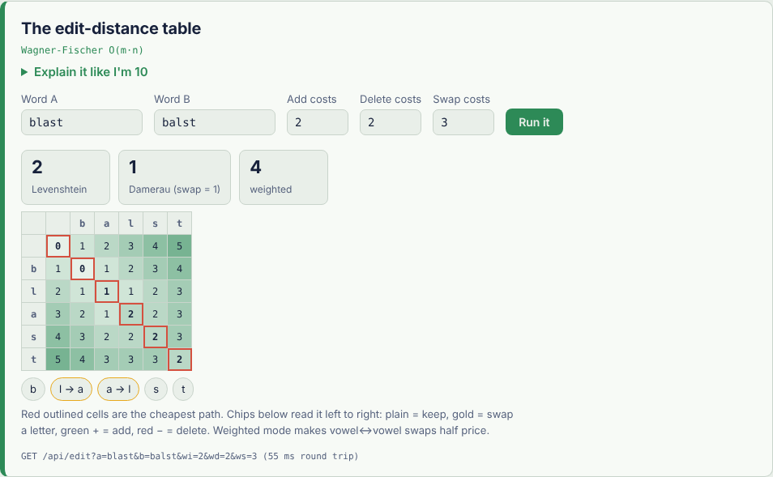
Figure 2: The edit-distance table for "blast" and "balst": Levenshtein 2, Damerau 1 (one swap).
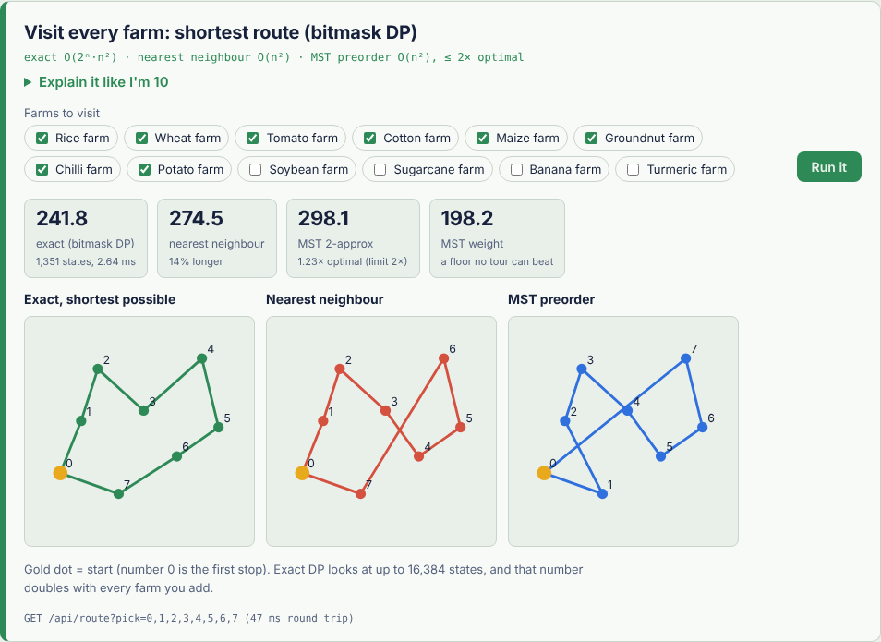
Figure 3: Shortest route over 8 farms: exact DP, nearest neighbour and MST 2-approximation side by side.

Module 4: Network flow
Flow models pipes with capacities. Max-flow is the most that can be pushed from source to sink, and the minimum cut is the cheapest set of pipes whose removal separates them; the two values are always equal. Edmonds-Karp and Dinic are both implemented, so their phases can be compared. Min-cost flow fills markets at the lowest total cost, bipartite matching pairs machines with jobs, and project selection is solved as a min-cut.
Algorithm | Source file | Time cost | Used in AgriFlow for
Edmonds-Karp | FlowNetwork | O(V·E²) | Max-flow on the water network.
Dinic | FlowNetwork | O(V²·E) | Max-flow with level graphs.
Min-cut | FlowNetwork | after max-flow, residual reachability | Bottleneck pipes.
Min-cost flow (SPFA) | FlowNetwork | O(flow·V·E) | Cheapest crop shipping to markets.
Bipartite matching, König cover | FlowApps | O(E·√V) on unit capacities | Who gets which machine.
Project selection | FlowApps | one max-flow | Which farm plan is worth doing.

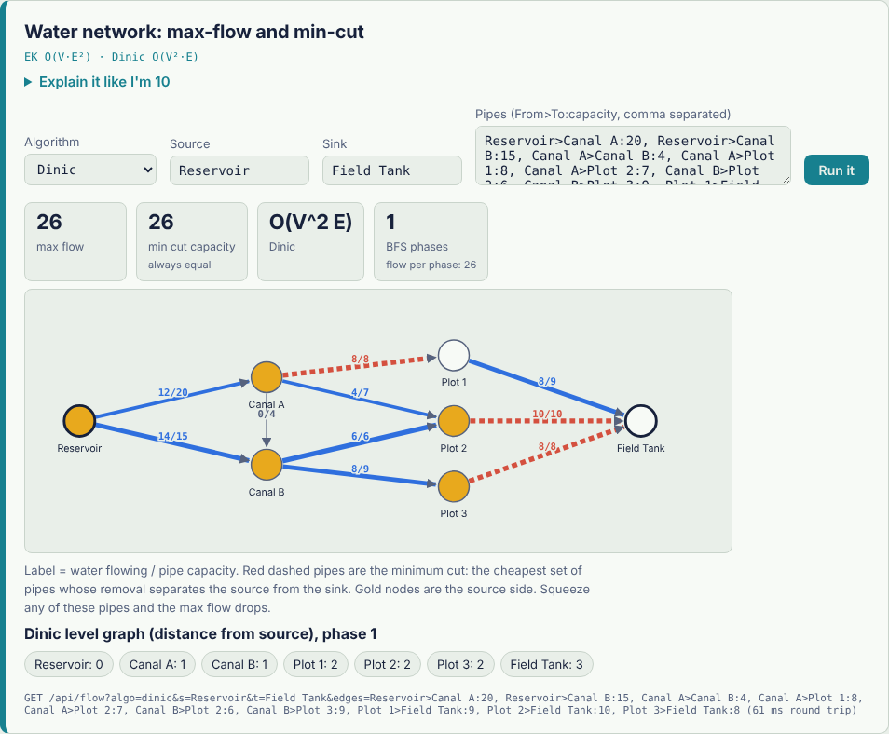
Figure 4: Water network. Max flow 26 equals min-cut capacity 26; the red dashed pipes form the cut.

Module 5: NP-completeness and approximation
Some problems become impractical to solve exactly as they grow. For each one the project provides an exact solver (to show where it slows down) and a method with a guarantee: a 2-approximation for vertex cover and for metric TSP, an FPTAS for knapsack, and a fixed-parameter algorithm for vertex cover that shrinks the graph with Buss kernelisation before searching.
Algorithm | Source file | Time cost | Used in AgriFlow for
Vertex cover: exact | VertexCover | O(2ⁿ·m) | Pest-trap placement, optimal.
Vertex cover: maximal matching | VertexCover | O(m), 2-approximation | Fast, near-optimal traps.
Vertex cover: FPT with Buss kernel | VertexCover | O(2ᵏ·m) | Fast when k is small.
Knapsack: exact, greedy, greedy+best item, FPTAS | Knapsack | exact O(n·W), FPTAS O(n³/ε) | Choose crops within a budget.
Subset sum | Knapsack | O(n·target) | Hit an exact amount.
TSP nearest neighbour, MST 2-approximation | Tsp | O(n²), at most 2× optimal | Route planning on many farms.

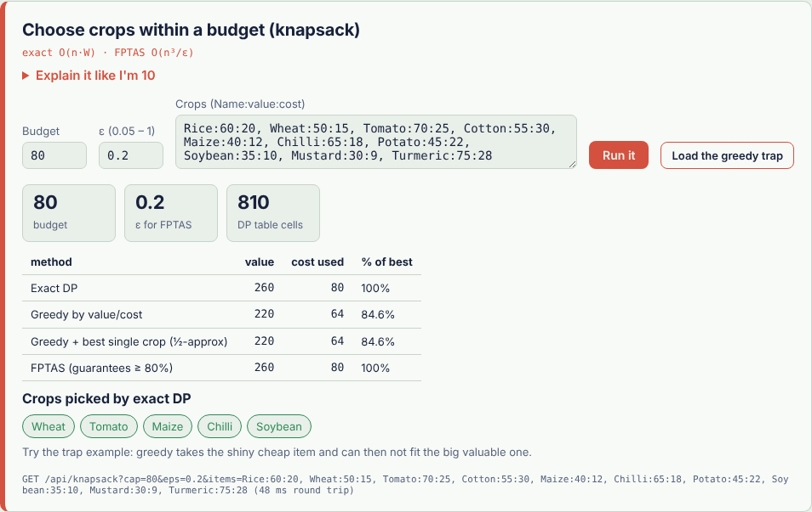
Figure 5: The knapsack lab, comparing exact, greedy and FPTAS answers.

Module 6: Randomised and parallel algorithms
Randomness can make an algorithm safer. Randomised quicksort avoids the worst case on any input, and Miller-Rabin tests large numbers for primality with a controllable error. Universal and perfect (FKS) hashing give collision control, and reservoir sampling picks a fair sample from a stream. The parallel primitives (reduce, Blelloch scan, fork-join merge sort) report work, span and the Brent bound, and the page shows the number of cores it ran on.
Algorithm | Source file | Time cost | Used in AgriFlow for
Miller-Rabin | MillerRabin | k rounds, each O(log n) modular multiplications | Primality test, Carmichael demo.
Randomised quicksort (Las Vegas) | RandomizedSort | expected O(n log n) | Sorting with no bad input.
Universal and FKS perfect hashing | PerfectHash | expected O(n) build, O(1) lookup | Collision-free lookup of crop names.
Reservoir sampling | Reservoir | O(n) time, O(k) memory | Fair sample from a stream of readings.
Parallel reduce, scan, merge sort | ParallelOps | work and span reported by the lab | Using several cores.

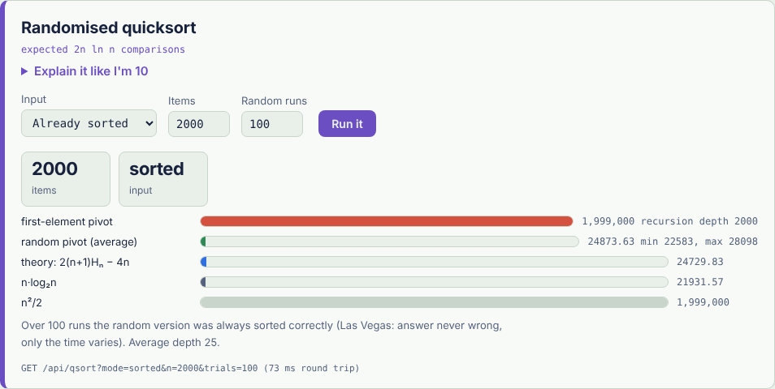
Figure 6: The randomised quicksort lab.

5. Testing and verification
The test program test/Selfcheck.java checks the engine without any outside library. For each module it generates random inputs and compares the optimised algorithm with a simpler or brute-force reference answer, or checks a known invariant (for example, that max-flow equals min-cut). The program reports the number of checks and the number of failures.
Group of checks | Method
Module 2: strings | Naive, KMP, Z, Rabin-Karp (including a deliberately weak hash) and suffix-array search compared with a plain String.indexOf count on thousands of random texts; Aho-Corasick checked against position sets; naive shown to do far more comparisons than KMP on an adversarial text.
Module 3: dynamic programming | DP answers compared with brute force: permutation search for routes, recursion for alignment scores, and reference answers for the other DP topics.
Module 4: network flow | Edmonds-Karp and Dinic must agree; max-flow must equal a brute-force minimum cut over all vertex subsets; the residual-reachable set must be a minimum cut; flow on every pipe stays within capacity and balances at each node; assignment checked by brute force.
Module 5: approximation | Exact and 2-approximate vertex covers must both be covers with approx at most twice optimal; FPT must find a cover of size OPT and say no for OPT minus 1; knapsack, subset sum and TSP approximations checked against exact answers.
Module 6: randomised and parallel | Miller-Rabin compared with trial division for every number below 200,000, plus known large primes and composites, all six listed Carmichael numbers, and 2,000 random numbers; sorting and sampling checked against references; parallel sum, scan and merge sort compared with sequential results using 1, 2, 3, 4 and 8 threads on 300,001 values.

Result: 54,614 checks, 0 failures.
Two further checks were done on the running application: every endpoint was called and its JSON inspected, and the page was opened in a headless browser at desktop and phone width to confirm that every lab draws correctly with no horizontal overflow.

6. Results from the running application
The table lists values read from the live labs with their default inputs.
Lab | Result | What it shows
Race (adversarial text, n=20,000, m=60) | Naive 1,196,460 comparisons; KMP 39,941 | KMP does about 30 times fewer comparisons on the worst case for naive search.
Edit distance, blast and balst | Levenshtein 2; Damerau 1 | A swap counts as one edit when it is allowed.
Route over 8 farms | Exact 241.8; nearest neighbour 274.5 (14% longer); MST 2-approx 298.1 (1.23 times optimal) | Heuristics are fast but not optimal, and stay within the 2 times guarantee.
Water network flow | Max flow 26; min-cut capacity 26 | The two values are equal, as the theorem requires.

Timings in the race lab are measured on the machine that runs the page, so they vary from computer to computer; the comparison counts do not.

7. How to run the project
The project needs JDK 11 or newer and no other library.

7.1 Eclipse
- Import the project: File, Import, General, Existing Projects into Workspace, and choose the agriflow folder.
- Check that the project uses JDK 11 or newer.
- Right-click src/agriflow/AgriFlowApp.java and choose Run As, Java Application.
- Read the Console line "AgriFlow is live -> http://localhost:PORT" and open that address in a browser.
- Stop the server with the red Terminate button in the Console.

7.2 Command line
mkdir bin
dir /s /b src\*.java > sources.txt
javac -d bin @sources.txt
java -cp bin agriflow.AgriFlowApp
An optional port number can follow the class name. If the port is busy, the program tries the next ones and prints which port it used.

7.3 Visual Studio Code
Install the Extension Pack for Java, open the agriflow folder, open AgriFlowApp.java and press Run above the main method.

8. API reference
Every lab is a GET endpoint under /api/. All answers are JSON.
Module | Endpoints
Original | /api/health, /api/search, /api/edit-distance, /api/suffix
1 | /api/engine, /api/similar
2 | /api/strlab, /api/race, /api/multi, /api/repeats
3 | /api/edit, /api/align, /api/matrix, /api/obst, /api/route, /api/hamilton, /api/setcover, /api/tree, /api/sos, /api/greedy
4 | /api/flow, /api/matching, /api/mcmf, /api/projects
5 | /api/vcover, /api/knapsack, /api/subsetsum
6 | /api/prime, /api/qsort, /api/hash, /api/reservoir, /api/parallel

Invalid input (for example a text where a number is expected) returns a 400 response with a short error message, and numeric limits are clamped so a large input cannot freeze the server.

9. Limitations
- The built-in data set has only 15 records. It is meant for learning, not for production use.
- The suffix array is built by prefix doubling in O(n log² n); a linear-time method such as SA-IS would be faster on very large texts.
- Parallel speed-up depends on the number of cores of the computer. On small inputs, threads can be slower than a single thread, and the lab shows this.
- The original project archive contained only compiled class files, so the Java source in this project is a rewrite that keeps the same classes, endpoints and sample records, and the web page was written new.
- The brute-force tests cover the algorithms; they do not replace a user-interface test on every browser.

10. Future work
- Load real datasets from a CSV file instead of the built-in 15 records.
- A step-by-step player that pauses, rewinds and replays each algorithm.
- Live farm feeds such as weather and soil-sensor readings to drive the flow and routing labs.
- A security use-case: scan log files with Aho-Corasick to find attack signatures.
- Saving runs, comparing algorithms side by side and exporting results.
- Packaging with Docker and hosting online.

11. Conclusion
AgriFlow covers every module of the Advanced Algorithms syllabus in one Java application. Each algorithm is hand-built under the engine rule, runs on farm data, and can be inspected through an interactive page that shows its cost and explains it in plain words. Randomised testing against brute force (54,614 checks, 0 failures) supports the correctness of the implementations.

References
- T. H. Cormen, C. E. Leiserson, R. L. Rivest and C. Stein, Introduction to Algorithms, MIT Press.
- D. E. Knuth, J. H. Morris and V. R. Pratt, "Fast pattern matching in strings", SIAM Journal on Computing 6(2), 1977.
- A. V. Aho and M. J. Corasick, "Efficient string matching: an aid to bibliographic search", Communications of the ACM 18(6), 1975.
- T. Kasai et al., "Linear-time longest-common-prefix computation in suffix arrays and its applications", CPM 2001.
- M. Held and R. M. Karp, "A dynamic programming approach to sequencing problems", Journal of the SIAM 10(1), 1962.
- J. Edmonds and R. M. Karp, "Theoretical improvements in algorithmic efficiency for network flow problems", Journal of the ACM 19(2), 1972.
- M. L. Fredman, J. Komlos and E. Szemeredi, "Storing a sparse table with O(1) worst case access time", Journal of the ACM 31(3), 1984.

Appendix A: list of all labs
Module | Lab id | Title
M1 | engine | What can AgriFlow answer?
M1 | similar | Find similar records
M2 | search | Pattern search on the knowledge base
M2 | strlab | KMP, Z and Rabin-Karp up close
M2 | race | Race: which is fastest?
M2 | multi | Many words, one pass (Aho-Corasick)
M2 | suffix | Suffix array search
M2 | repeats | Longest repeated text (LCP array)
M3 | edit | The edit-distance table
M3 | align | Sequence alignment (like DNA matching)
M3 | matrix | Matrix chain order (interval DP)
M3 | obst | Optimal search tree for crops
M3 | route | Visit every farm: shortest route (bitmask DP)
M3 | hamilton | Can one trip pass every farm exactly once?
M3 | setcover | Cheapest set of treatments (set cover)
M3 | tree | Canal network on a tree
M3 | sos | Treatment packages vs farm problems (SOS DP)
M3 | greedy | When DP is the wrong tool... or greedy is
M4 | flow | Water network: max-flow and min-cut
M4 | matching | Who gets which machine? (bipartite matching)
M4 | mcmf | Cheapest way to move crops to markets
M4 | projects | Which farm plan is worth it? (project selection)
M5 | vcover | Pest traps: vertex cover
M5 | knapsack | Choose crops within a budget (knapsack)
M5 | subsetsum | Exact amount (subset sum)
M5 | npcheck | Is my problem NP-hard? (checklist)
M6 | prime | Is this number prime? (Miller-Rabin)
M6 | qsort | Randomised quicksort
M6 | hash | Universal and perfect hashing
M6 | reservoir | Reservoir sampling
M6 | parallel | Work, span and threads

31 labs in total.

