**Automatic Transmission Controller**

A transmission control unit generally uses sensors from the vehicle as well as data provided by the engine control unit(ECU) to calculate how and when to change gears in the vehicle for optimum performance, fuel economy and shift quality. Gear shifting in automatic transmissions is a dynamic process that involves synchronized torque transfer from one clutch to another ,smooth engine speed change ,engine torque management and minimization of output disturbance.

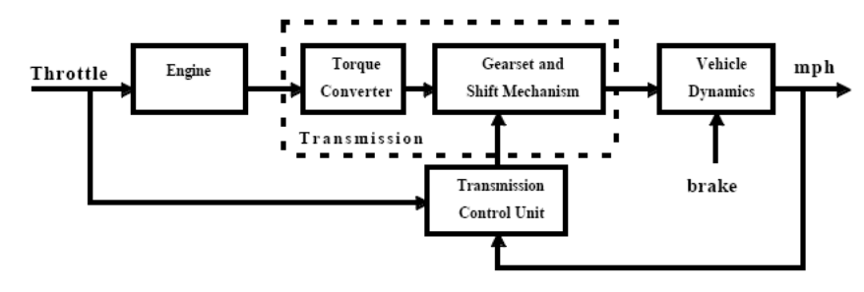

Figure:- Drivetrain system

Modeling Equations

The throttle opening is one of the inputs to the engine. The engine is connected to the impeller of the torque converter which couples it to the transmission.

Iei Ne=Te-Ti

Iei - Moment of Inertia of engine and impeller

Ne – Engine Speed

Te,Ti -Engine and Impeller torque

The input-output characteristics of the torque converter can be expressed as functions of the engine speed and the turbine speed.

Ti=(Ne/K)^2

K is the K -factor(capacity)

K=f2Nin/Ne

Nin-Turbine speed

The transmission model is implemented via static gear ratios, assuming small shift times.

R=Tout/Tin=Nin/Nout

The final drive, inertia, and a dynamically varying load constitute the vehicle dynamics .

IvNw=Rfd(Tout-Tload)

Rfd-Final Drive Ratio

The load torque includes both the road load and brake torque. The road load is the sum of frictional and aerodynamic losses .

Tload=sgn(Rload0+Rload2^2+Tbrake)

Rload0,Rload2 – Friction and Aerodynamic drag coefficients

Modeling

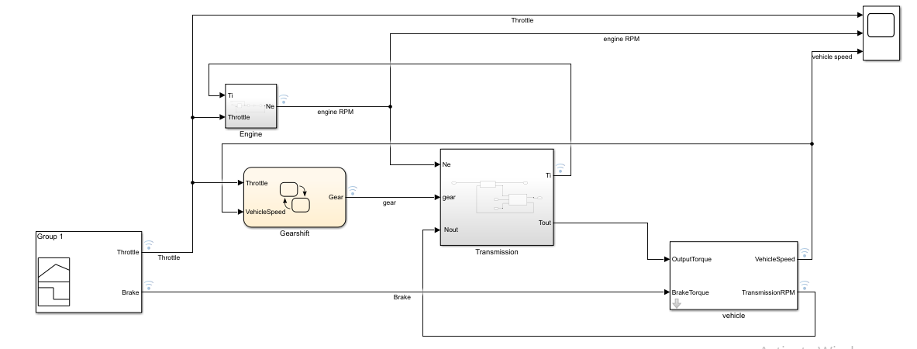

The Simulink model shown in figure is composed of modules which represent the engine, transmission, and the vehicle, with an additional shift logic block to control the transmission ratio. User inputs to the model are in the form of throttle and brake torque.

Signal Builder

The Throttle and brake torque are generated using the signal builder.

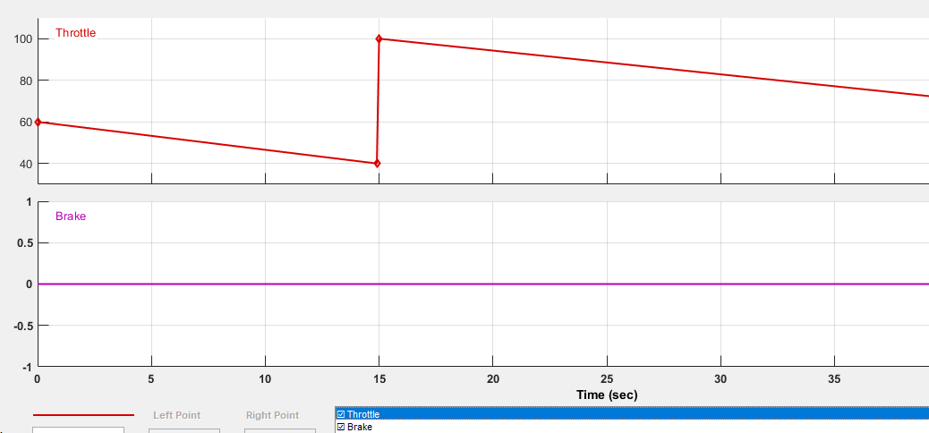

Solver Strategy

The model uses the fixed step Fifth-order Dormand-Prince formula to compute the model state at the next time step as an explicit function of the current value of the state and the state derivatives approximated at intermediate points. Since this a higher order ordinary differential equation ,the degree of computational complexity and the accuracy of the results increases.

Model Callbacks

Model callbacks execute at specified action points.The Engine subsystem consists of a two-dimensional table that interpolates engine torque versus throttle and engine speed. The throttle and engine speed parameters are given in callback post load fcn and callback initfcn.Various other parameters are given inside the data dictionary.

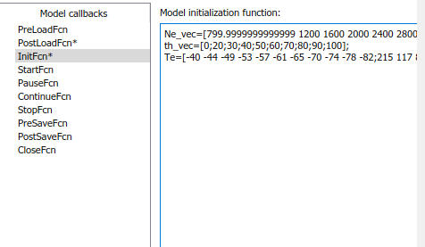

Lookup Table

The up threshold and down threshold values of vehicle speed with gear and throttle is given inside a 2-D lookup table in the gearshift chart. The transmission subsystem contains 1-D lookup table for appropriate gear ratios.

gear Rtr = Nin/Ne

1 2.393

2 1.450

3 1.000

4 0.677

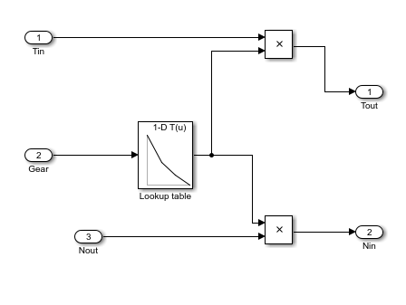

Data Inspector

The results are logged inside the data inspector by enabling data logging.

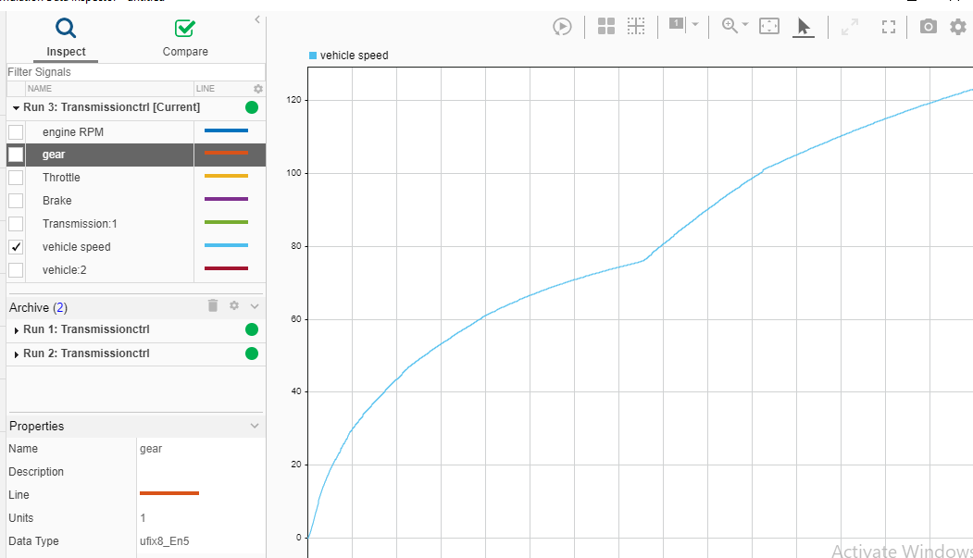

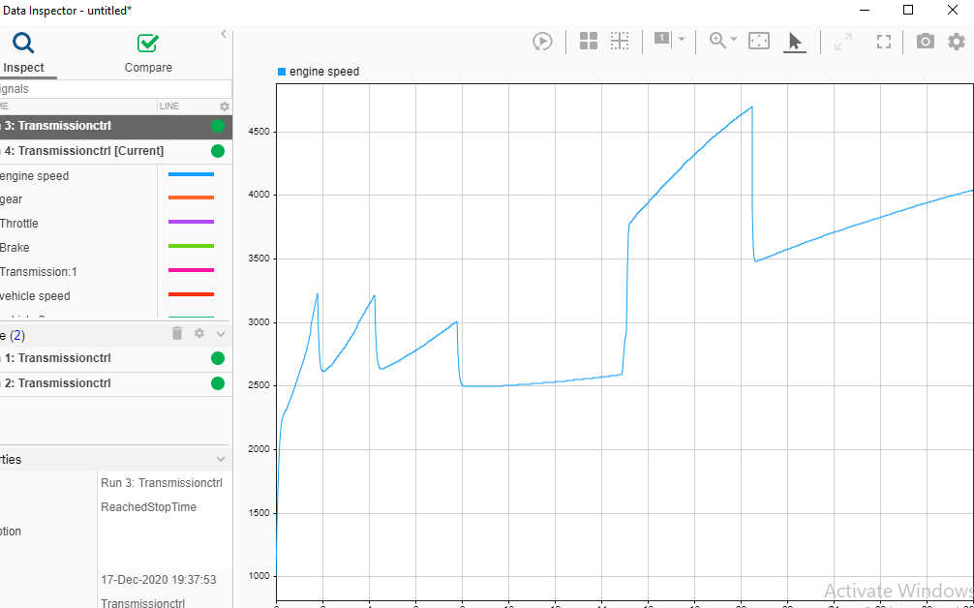

Results

At t=15sec, the driver steps the throttle to 100% . The transmission downshifts to third gear and the engine jumps from about 2600 RPM to about 3700 RPM. The engine torque thus increases somewhat, as well as the mechanical advantage of the transmission . With continued heavy throttle, the vehicle accelerates to about 100 mph and then shifts into overdrive at about t = 21 sec. The vehicle cruises along in fourth gear for the remainder of the simulation. The results are given in the following images.

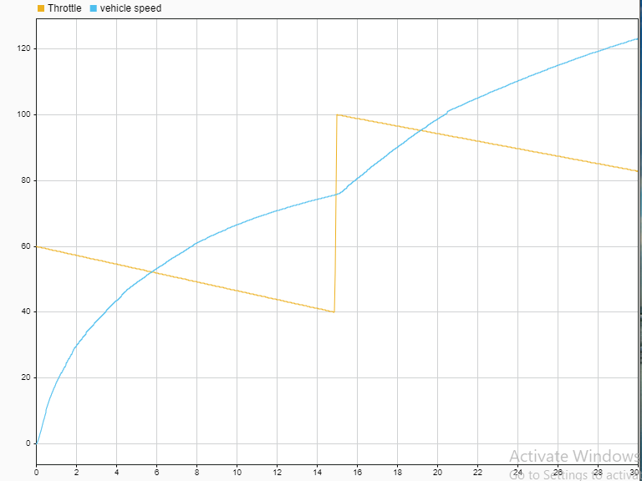

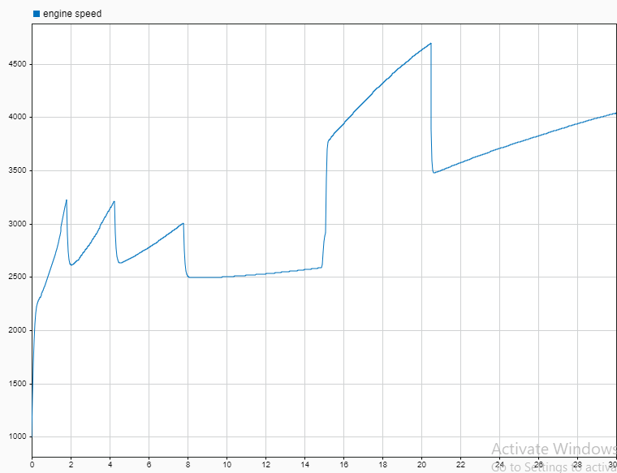

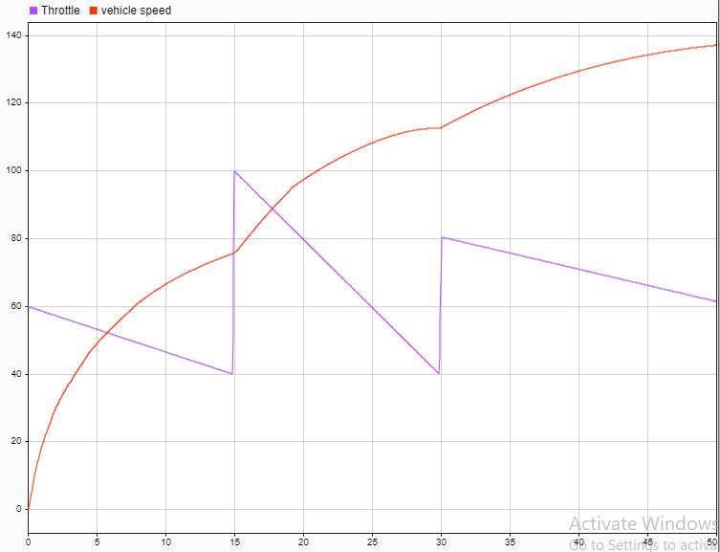

Figure: Vehicle speed result for different throttle signal

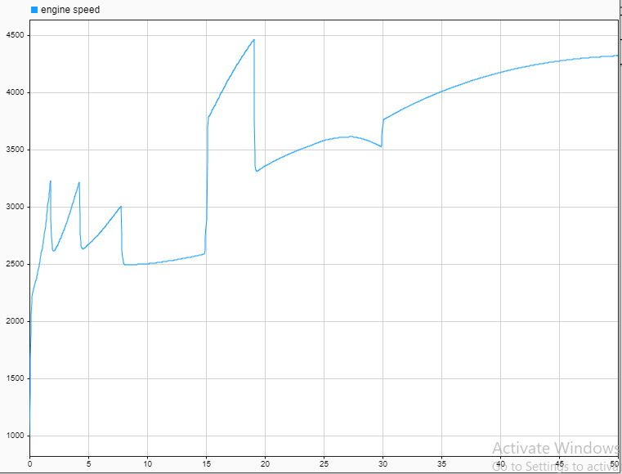

Figure:Engine speed result for different throttle signal