44443/44643 Mobile Computing – iOS
Assignment
Points
Bill Calculator is a simple application where you will get tip amount based on tip percentage and amount per person based on how many members paying the total amount
Please follow the following instructions to complete this assignment.
- Open Xcode from the launchpad of your mac.
- Click on create a new Xcode project. Select the iOS template and click on the App application.
- Click on next which will prompt you to choose options for the project.
- Provide product name as Lastname_BillCalculatorApp, “nwmsu” for organization identifier, “storyboard” as interface and swift as language.
- Click on next and select an appropriate location to save your app and click on create. A project directory will be loaded.
- When you are done with selecting the location of the project on your local storage, moving further you can see project settings screen. Set your Project Format to “Xcode 16.0-compatible” in your Project Document settings.
- Now look into Deployment Info settings on the same project settings and set it with default parameters.

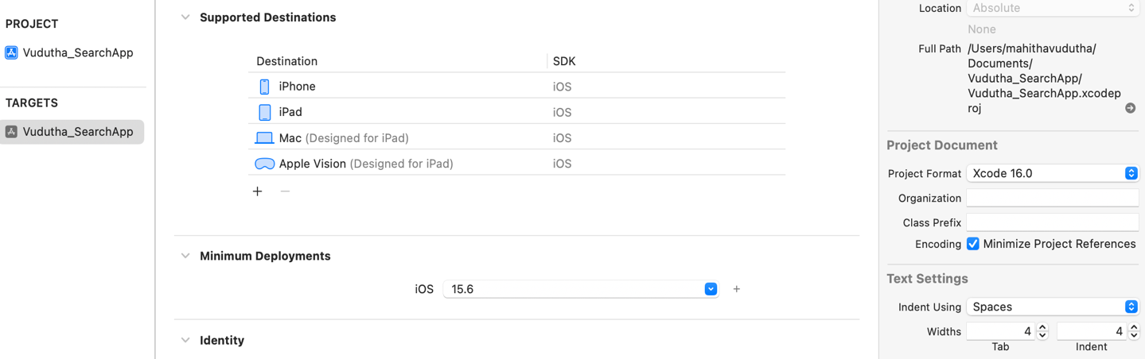
- Note: Follow the exact instructions given and don’t modify any other settings as it causes application not to run in different machines.
- From the project navigator click on “Main.storyboard” file, a blank mobile screen will be loaded.
- Click on the View Controller at the top of the screen and then click on the editor at the top of your screen, now click on the option saying embed in and then click on the Navigation Controller.
- Now you will see a new blank mobile screen where the app should be designed.
- Add a label at the top of the Screen and Enter “Bill Calculator” in the Attribute Inspector.
- Now add three labels for “Bill Amount”, “Tip (%)” and “No. of Persons Paying”.
- Now add three text fields beside of the above three labels and style them as you like. name them amountOL, tipOL and personsOL while creating outlets for them.
- All the text fields should be right justified.
- Now add two buttons below them for “Calculate Bill” and “Reset” and name them calculateBtnClicked and resetBtnClicked while creating actions.
- Now search for view controller from the library and drag and drop the view Controller beside the screen you designed.
- Now create a segue with calculate Bill button and name it as ResultSegue in the identifier tab under the attribute Inspector window.
- Now right click on the project file folder in the files window and select new file from template and then select cocoa touch class file and name it as ResultViewController.
- Now select the view Controller at the top of the 2nd screen and under the Identity Inspector window click R in class tab then you should see the new file name. if so click enter or else redo the last two steps
- Now add 6 labels for “Total Bill Amount”, “Tip Percentage (%)”, “Tip Amount”, “No. of Persons Paying”, “Total Amount to be Paid” and “Share Per Person” and name them enteredAmountOL, enteredTipOL, tipAmountOL, enteredPersonsOL, totalAmountOL, amountPerPersonOL
- Add a image view to display the image and make respective connection.
- After applying all the constraints, the final view should be similar to the below image:

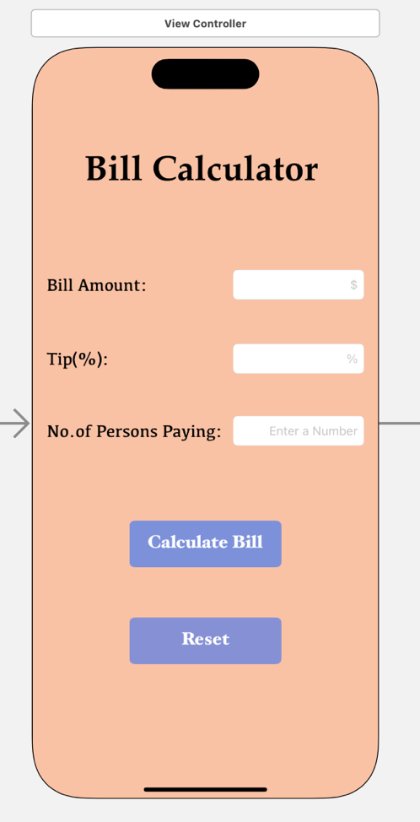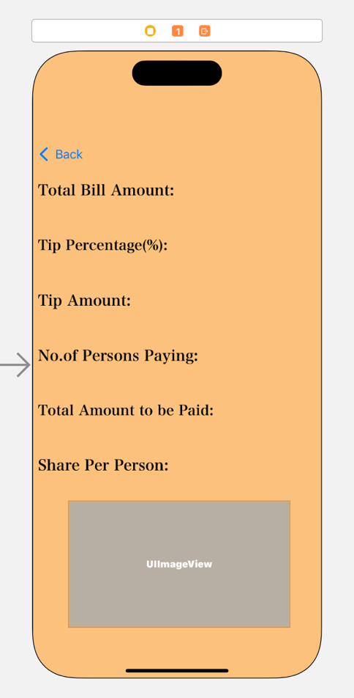

- Now we are done with the UI part. Make sure all the connections for the controls are
made correctly.
- This app is about displaying the tip amount, total amount to be paid and share per person based on tip percentage, bill amount and no. of persons paying. It should also display an image according to tip amount which was provided in the zip file.
- Declare the global variables: totAmount, tipAmount, and amountPerPerson and initialize them with 0.0.
- First Calculate the tip Amount basing in the tip percentage given:
tipAmount = billAmount*(tipPercentage/100)
- Then calculate the Total Bill Amount to be paid using the formula:
totAmount = billAmount + tipAmount
- Then Calculate the Amount each person should pay according to number of persons paying:
amountPerPerson = totAmount/persons
- Now add the image according to the tip amount. If the tip amount is greater than 20 add the image best else if tip amount is between 11 and 20 then it should display image better and if the tip amount is between 6 and 10 then it should display the image good else, it should display thankYou image.
- If the bill amount is 0 or less than or tip amount less than 0 or else no. of persons 0 or less than then all the values in the result view should be zero and invalid image should be displayed.

- Add a animation to the image while displaying. You can use the following code:
ImageViewOutlet.alpha = 0.0
UIView.animate(withDuration: 1.5) {
self.ImageViewOutlet.alpha = 1.0
- When the user navigates back to View 1, all input fields should reset to default.
override func viewWillAppear(_ animated: Bool) {
super.viewWillAppear(animated)
// Reset all input fields
amountOL.text = ""
tipOL.text = ""
personsOL.text = "”
}
- Once all the values are entered, when clicked calculate Bill Button, the app should calculate tip Amount, total Bill Amount and amount each person should pay and display it in the second screen along with the user – entered details and a relevant image.

Test Cases: -
3. Bill Amount: 95
Tip (%): -2
No. of persons paying: 2

2. Bill Amount: 120
Tip (%): 20
No. of persons paying: 2

1. Bill Amount: 100
Tip (%): 10
No. of persons paying: 2

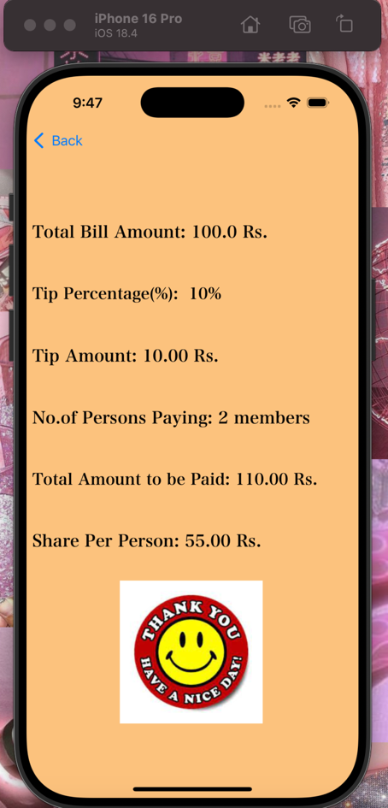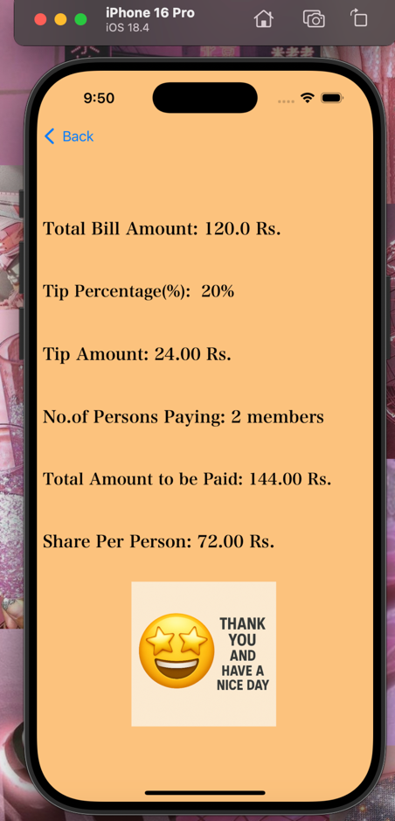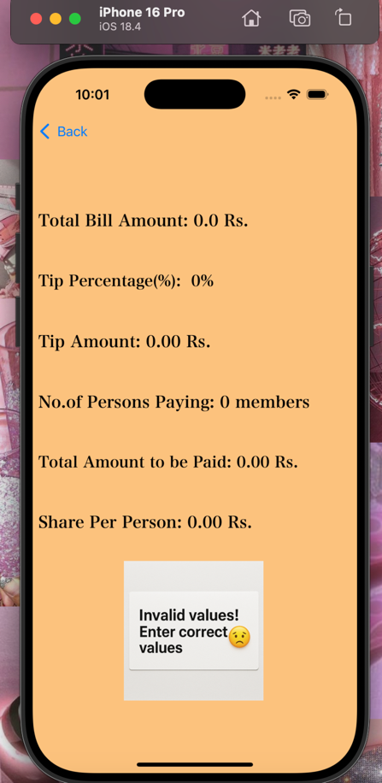

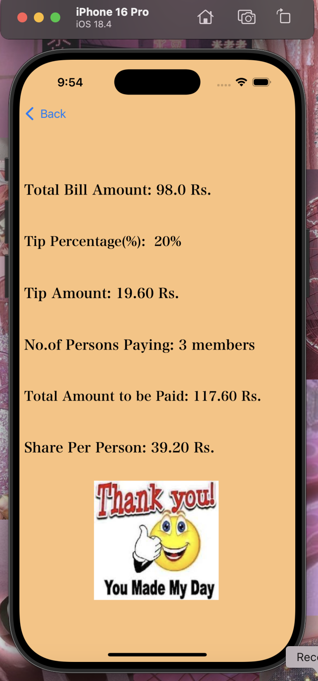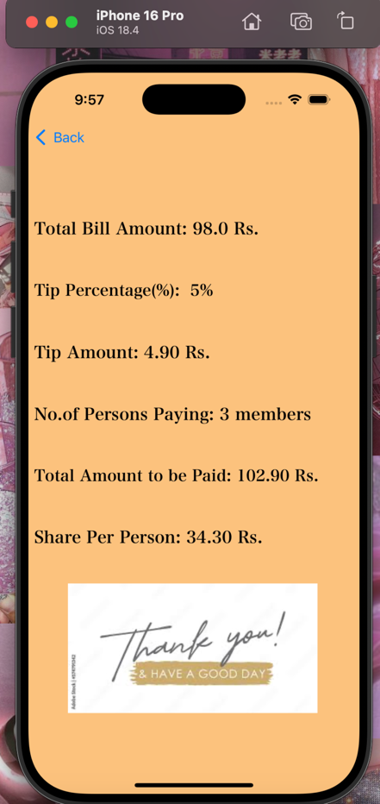
6. Bill Amount: -10
Tip (%): 2
No. of persons paying: 4

5. Bill Amount: 98
Tip (%): 5
No. of persons paying: 3

4. Bill Amount: 98
Tip (%): 20
No. of persons paying: 3

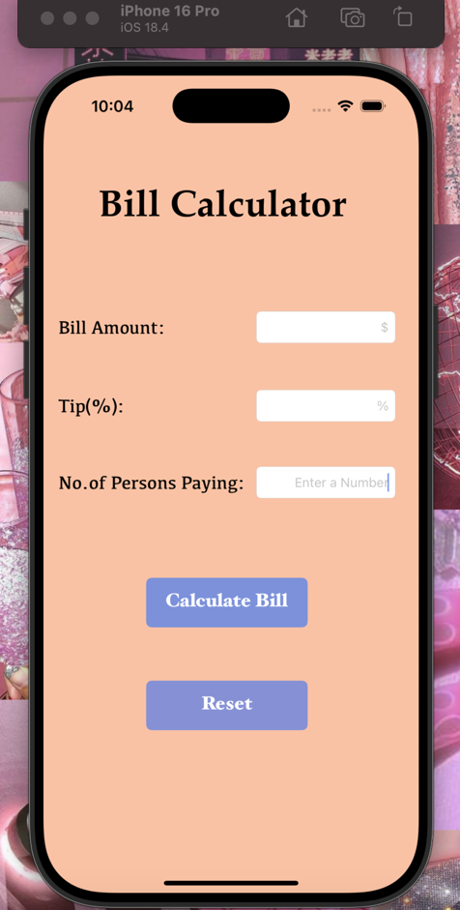
View if press back or reset Button

