Exam
points

For this exam, you will be creating an app called Ticket Entry App to help users register for events and generate a unique ticket ID. Users will enter their name, date of birth, event type, event name, and event date. The app will calculate the user’s age and create a 6-character alphanumeric registration ID. Based on the event type; a related image will be shown. It focuses on input validation, age calculation, and displaying ticket details on a separate screen.

- Instructions to create the project.
- Create a project in Xcode with the name LastName_Exam02.
- Ensure the project meets minimum deployment and formatting requirements as specified below.
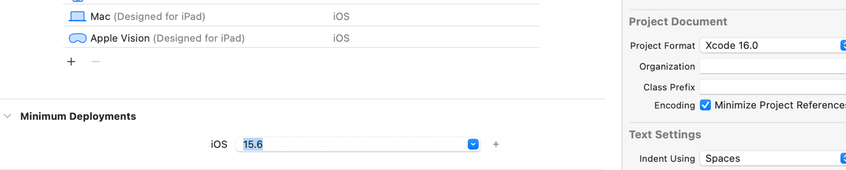

- Instructions to Create the Savings Goal Planner App
  - Design and implement the Ticket Entry App. Relevant images for goal types are provided in the zip file. You may use custom name for view controllers and segues.
  - Your app should consist of the following UI Components, and you may use your own colors of your choice.
  - Components for view -1 (Figure 1)
    - A title at the top displaying the text Enter Your details For Ticket. You can create the text as shown in the Figure Below.
    - Five Labels For:
      - Name
      - Date of Birth
      - Event Type
      - Event Name
      - Event Date
    - Two date pickers for Date of Birth and Event date.
    - Three Text fields for user input next to the remaining labels.

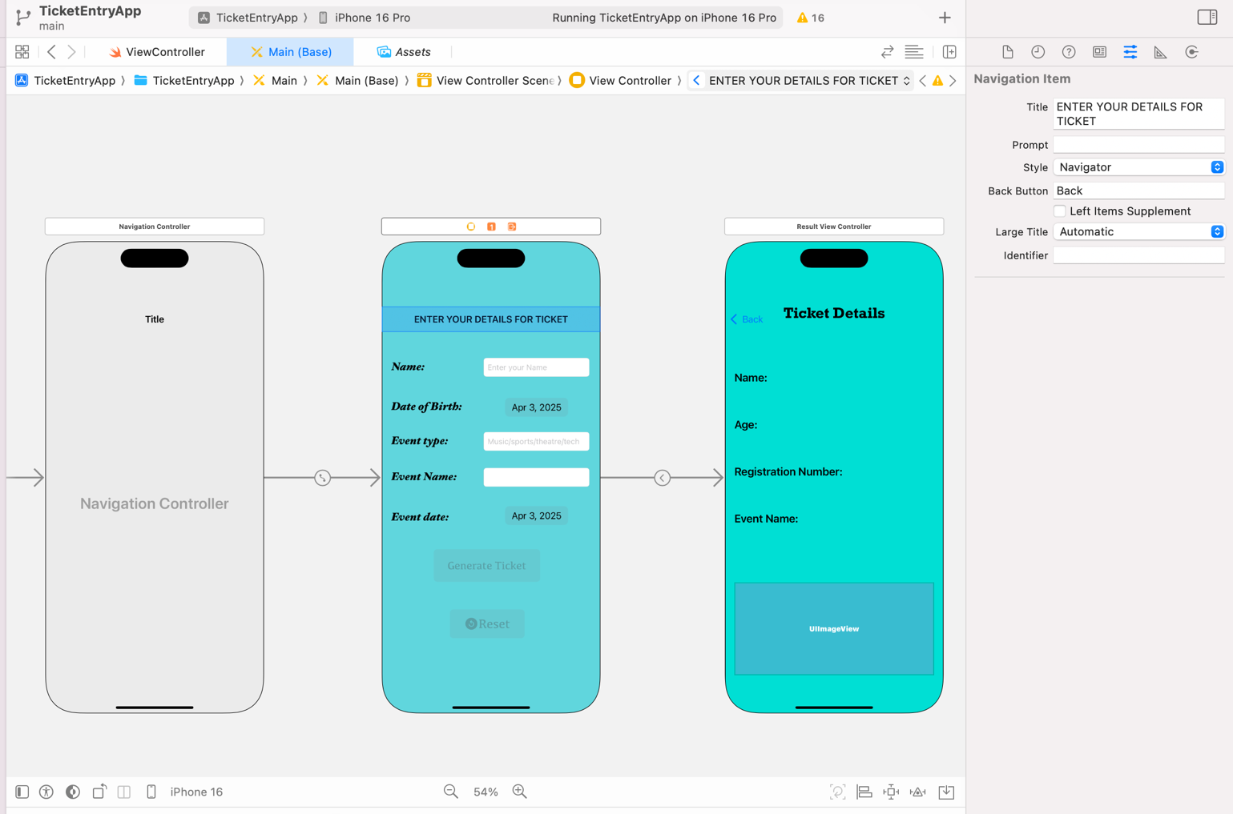
    - Two Buttons:
      - Generate Ticket
      - Reset
  - Once all the values are entered, when clicked Generate Ticket button, The app should calculate the age of the person and create a unique reference Id and display them in second view along with name and event name and relevant image.

Hint To Calculate age and generate a unique ID:
- Define a global Variable dateOfBirth Initializing it with date() and then calculate the age using the following
age =Calendar.current.dateComponents([.year], from: dateOfBirth, to: Date()).year ?? 0

- If age is 0 or less than then generate the alert.
let alertController = UIAlertController(title: "Invalid Age", message: "Please enter a valid age", preferredStyle: .alert)
let defaultAction = UIAlertAction(title: "OK", style: .default, handler: nil)
alertController.addAction(defaultAction)
present (alertController, animated: true, completion: nil)
return

- Generate a uniqueID for each ticket :
func generateAlphanumericID(length: Int) -> String {
let characters = "ABCDEFGHIJKLMNOPQRSTUVWXYZ0123456789"
return String((0..<length).compactMap { _ in characters.randomElement() })
}
- Write a prepare function for segue to pass data to the second view

  - Components for View – 2 (Figure – 2)

    - Labels displaying:
      - Ticket Details
      - Name
      - Age
      - Registration Number
      - Event Name
    - An ImageView displaying an image relevant to the selected goal type, with an animation effect. You can use the below function code for animation in the code or can use any animation effect
ImageViewOutlet.alpha = 0.0
UIView.animate(withDuration: 1.5) {
self.ImageViewOutlet.alpha = 1.0

    - When the user navigates back to View 1, all input fields should reset to default but the button should be enabled
    - Once user tries to navigate back to View 1, all the input text fields should not display any data previously entered. You can use the function below or the function of your own choice in your code to not display any data in the text fields when you click on the back button:

override func viewWillAppear(_ animated: Bool) {
super.viewWillAppear(animated)

// Reset all input fields
GoalTypeOutlet.text = ""
TargetAmountOutlet.text = ""
InterestRateOutlet.text = ""
TimePeriodOutlet.text = ""

}

Test Cases:
Test Case | Input Values | Expected Output
Test Case 1 | Name: Christopher  Date of Birth: March 19, 1999  Event Type: Music  Event Name: The Eras Tour  Event Date: May 5, 2025 | Name: Christopher  Age: 26 Years  Registration Number: any unique Id  Event Name: The Eras Tour  Image: Music
Test Case 2 | Name: Juliet  Date of Birth: May 25, 2005  Event Type: sports  Event Name: Basketball  Event Date: June 10, 2025 | Name: Juliet  Age: 19 Years  Registration Number: any unique Id  Event Name: Basketball  Image: sports
Test Case 3 | Name: Raghava  Date of Birth: January 18, 2004  Event Type: theatre  Event Name: Movie  Event Date: Nov 5, 2025 | Name: Raghava  Age: 21 Years  Registration Number: any unique Id  Event Name: Movie  Image: theatre
Test Case 4 | Name: Gayatri  Date of Birth: Feb 19, 2000  Event Type: tech  Event Name: InnoTech Expo  Event Date: Dec 10, 2025 | Name: Christopher  Age: 25 Years  Registration Number: any unique Id  Event Name: InnoTech Expo  Image: tech
Test Case 5 | Name: Farhan  Date of Birth: April 24, 2006  Event Type: community  Event Name: Laugh Festival Carnival  Event Date: Mar 14, 2026 | Name: Christopher  Age: 26 Years  Registration Number: any unique Id  Event Name: Laugh Festival Carnival  Image: event
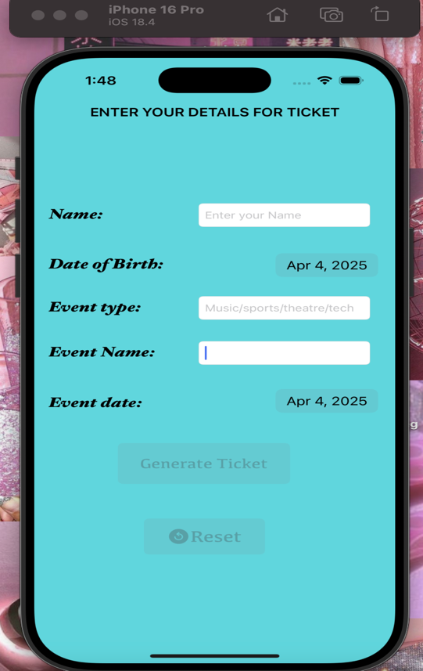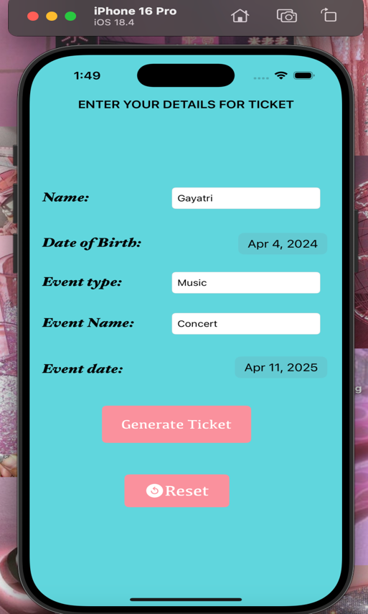
Initial View Of the First Screen When all the values in text fields are entered

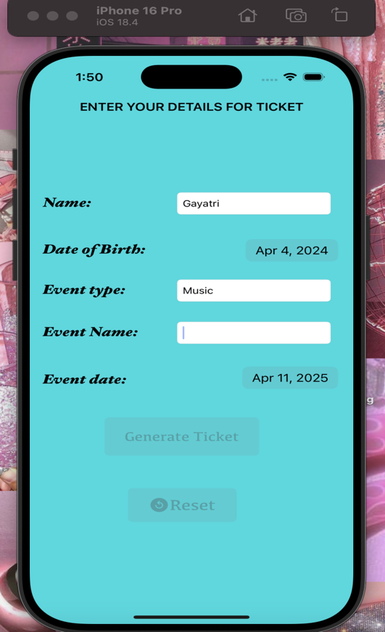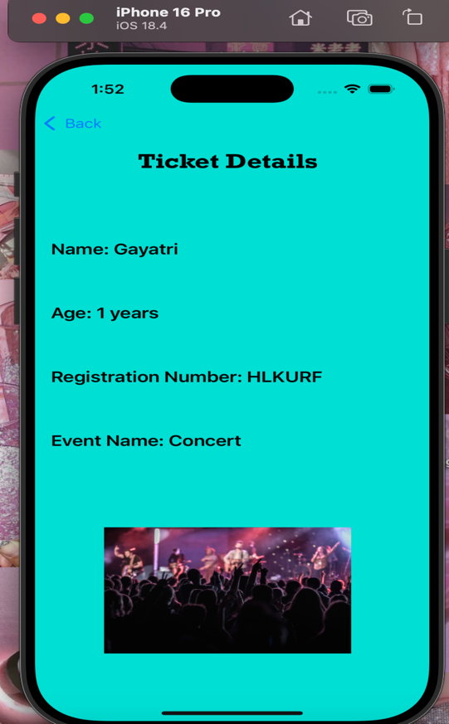
When all the values are not entered. When Generate Ticket Button is clicked.
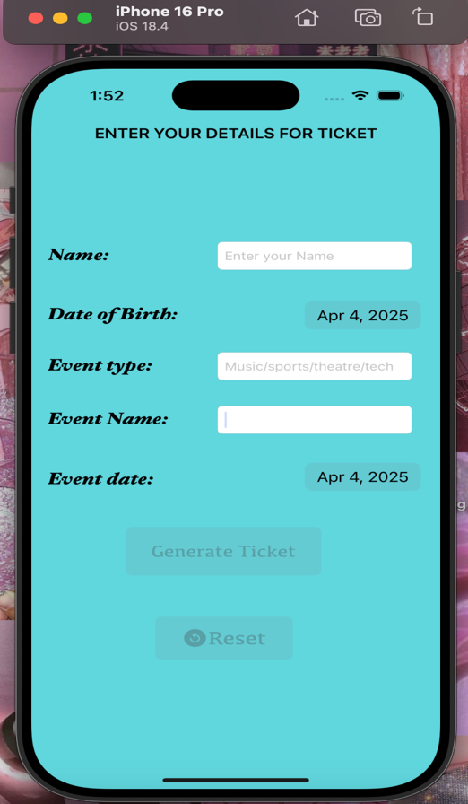
When back navigator on top is clicked. When Reset Button is clicked.

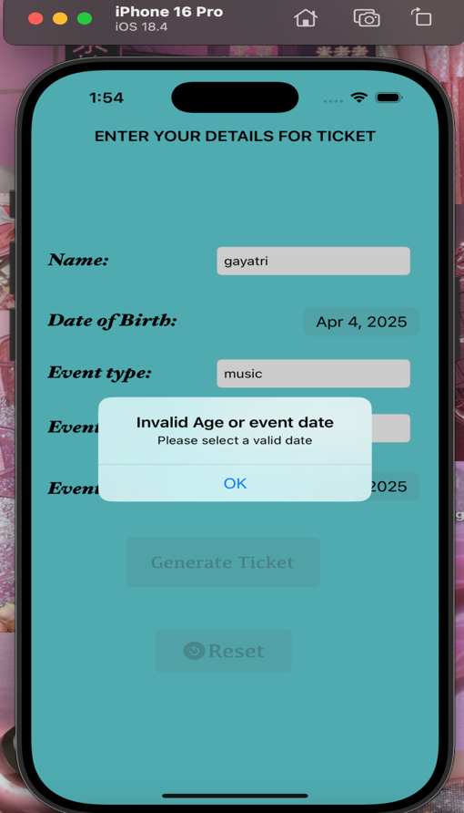
When age is less than a year. When event date entered is previous date.

