**DT BACKEND CHALLENGE TASK 2**

Nudge creation page wireframe.

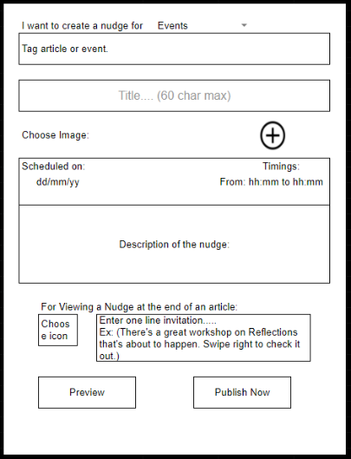

|  |  |  |  |
| --- | --- | --- | --- |
| **Nudge Object Data Model** | **FIELD** | **DATA TYPE** | **DESCRIPTION** |
| tagged_event_type | String | The event which is tagged |
| title | String | Title of the nudge |
| image | Image file( file upload) | Image shown as cover for nudge |
| schedule | Date+ timestamp | Time at which user wants to send nudge |
| desc | String | Description of the nudge |
| icon | Image file (file upload) | Icon shown when minimized |
| invitation | String | 1 line invite describing in short what the nudge is about |

**Common CRUD functions:**

* **CREATE** operation: The Create operation is the first step in adding new data to a database. It involves inserting new records or documents into a database, creating new entries that represent entities or objects in the system. The Create operation is crucial for applications that need to add new data dynamically, such as user registrations, product listings, or social media posts.
* **READ** operation: The Read operation is used to retrieve data from a database. It involves querying the database to fetch existing records or documents that match certain criteria, such as retrieving all records, retrieving records based on specific values or conditions, or retrieving records sorted in a particular order. The Read operation is essential for applications that need to retrieve and display data to users, such as displaying user profiles, retrieving product information, or showing news articles.
* **UPDATE** operation: The Update operation is used to modify existing data in a database. It involves making changes to the values or properties of existing records or documents to reflect updated information. The Update operation is commonly used in applications that require updating user profiles, editing product information, or making changes to any other type of data that needs to be updated over time.
* **DELETE** operation: The Delete operation is used to remove data from a database. It involves deleting records or documents that are no longer needed or relevant. The Delete operation is commonly used in applications that require deleting user accounts, removing products from a catalogue, or deleting any other type of data that needs to be removed from the database.

**API DETAILS FOR PERFORMING CRUD OPERATIONS ON NUDGE COLLECTION**

|  |  |  |  |  |
| --- | --- | --- | --- | --- |
| **NUDGE** | **Request type** | **Base URL** | **API Endpoint** | **Payload** |
| POST | /app | /nudges | tagged_event_type, title, image, schedule, desc, icon, invitation |
| UPDATE | /app | /nudges/:id | tagged_event_type, title, image, schedule, desc, icon, invitation |