

FACETIME TRACKER

FACE RECOGNITION APP USING STREAMLIT

*By*

Geethu.T

STB03-T0005



February 1, 2024

Scifor Technologies

Bangalore



**TABLE OF CONTENTS**

**Abstract2**

**Introduction3**

**Problem statement4**

**Literature Review5**

**Tools & Libraries7**

**Methodology8**

**Block Diagram10**

**Advantages & Disadvantages**..**11**

**Output12**

**Applications13**

**Future Scope14**

**Conclusion15**

**References16**

**ABSTRACT**

Face detection and face recognition are very important technologies these days, furthermore we noticed that they got have a variety of uses such as cellphones, army uses, and some high risk information offices.

The Face Recognition Attendance System offers several advantages over traditional attendance tracking methods, including increased efficiency, reduced errors, and improved accountability. By automating the attendance recording process, the system frees up valuable time for educators, administrators, and event organizers, enabling them to focus on more meaningful tasks.

The Face Recognition Attendance System presented in this abstract demonstrates the potential of Python, OpenCV, and Streamlit in developing innovative solutions for attendance tracking. With its accuracy, convenience, and accessibility, the Face Recognition Attendance System has the potential to streamline attendance management processes across various domains, contributing to improved efficiency and productivity.

**INTRODUCTION**

In the realm of automated attendance tracking systems, face recognition technology stands out as a reliable and efficient solution. This abstract presents the design and implementation of a Face Recognition Attendance System (FRAS) utilizing Python programming language, OpenCV library for computer vision tasks, and Streamlit framework for building interactive web applications.

The primary objective of the FRAS is to provide an accurate, convenient, and automated method for recording attendance in various settings such as classrooms, offices, and events. Leveraging the power of face recognition algorithms, the system eliminates the need for manual attendance taking, reducing administrative burden and ensuring data accuracy.

Key components of the FRAS include face detection, feature extraction, and recognition modules. OpenCV, a widely-used computer vision library, is employed for real-time face detection and image processing tasks. Additionally, deep learning models implemented using Python, possibly through libraries like TensorFlow or PyTorch, facilitate accurate recognition of individuals based on their facial features.

Streamlit, a user-friendly framework for building web applications, serves as the interface for the FRAS. Through Streamlit's intuitive APIs, users can interact with the system seamlessly, accessing features such as attendance logging, monitoring, and reporting. The web-based interface allows for easy deployment across devices, making attendance tracking accessible from anywhere with an internet connection.

**PROBLEM STATEMENT**

In today's digital age, there is a growing need for efficient and reliable methods of identity verification and authentication. Traditional methods such as passwords or PIN codes are often prone to security breaches and are inconvenient for users. Additionally, manual verification processes can be time-consuming and error-prone, especially in high-traffic environments such as airports, events, or workplaces.

To address these challenges, the development of a Live Face Recognition App is proposed. The aim of this project is to create an application capable of accurately identifying individuals in real-time using facial recognition technology. The app will leverage advancements in computer vision, deep learning, and web development to deliver a seamless and secure user experience.

**LITERATURE REVIEW**

Face recognition technology has garnered significant interest and research attention over the past few decades, with applications spanning various domains including security, surveillance, biometrics, and human-computer interaction. This literature review provides an overview of key studies, advancements, and trends in the field of face recognition applications.

**Biometric Identification:**

Face recognition is widely recognized as a reliable biometric modality for identification and authentication purposes. Early studies by Turk and Pentland (1991) introduced Eigenfaces, a pioneering approach in face recognition using principal component analysis (PCA). Since then, numerous techniques have been developed, including Fisherfaces, Local Binary Patterns (LBP), and Deep Learning-based approaches, which have significantly improved accuracy and robustness.

**Security and Surveillance:**

Face recognition plays a crucial role in security and surveillance systems for identifying individuals in real-time. Research by Zhao et al. (2003) explored the use of Support Vector Machines (SVM) for face recognition in surveillance videos, achieving high accuracy even under varying illumination and pose conditions. Recent studies have focused on deep learning architectures such as Convolutional Neural Networks (CNNs), which have shown remarkable performance in recognizing faces across different environments and scales.

**Human-Computer Interaction (HCI):**

In HCI applications, face recognition enables natural and intuitive interaction between users and computers. Studies by Viola and Jones (2001) introduced the Viola-Jones algorithm for real-time face detection, which has become a standard technique in computer vision applications. Face recognition is used in facial expression analysis, gaze tracking, emotion recognition, and personalized user interfaces, enhancing user experience and engagement.

**Mobile and Wearable Devices:**

With the proliferation of mobile and wearable devices, there is a growing interest in deploying face recognition on resource-constrained platforms. Research by Taigman et al. (2014) presented DeepFace, a deep learning-based face recognition system optimized for mobile devices, achieving state-of-the-art accuracy while maintaining computational efficiency. This has paved the way for integrating face recognition into mobile applications for authentication, social media, and augmented reality.

**Ethical and Privacy Concerns:**

Despite its benefits, face recognition technology raises ethical and privacy concerns regarding surveillance, data security, and bias. Studies by Buolamwini and Gebru (2018) highlighted the biases and inaccuracies present in commercial face recognition systems, particularly concerning gender and racial biases. Addressing these concerns requires transparency, accountability, and regulatory frameworks to ensure fair and ethical use of face recognition technology.

**TOOLS & LIBRARIES**

**Software Tools**

* Python
* OpenCV
* Streamlit
* Intergrated development environment
* Dlib

**Hardware Tools**

* Computer
* Webcam

**METHODOLOGY**

The methodology section of your project report outlines the step-by-step approach you followed to develop the face recognition app using Streamlit. Below is a structured methodology for your project:

**Requirement Analysis:**

Defined the project objectives, including the primary functionalities and features required in the face recognition app. Identified the target audience and potential use cases for the application.

**Research and Planning:**

Conduct a thorough literature review to understand existing methodologies, algorithms, and best practices in face recognition. Explored available tools, libraries, and frameworks suitable for implementing face recognition, focusing on Streamlit for the user interface. Planed the project timeline, milestones, and resource allocation based on the complexity of the tasks and available resources.

**Model Building:**

Chose a suitable deep learning architecture for face recognition, such as face_recognition library. Fine-tuned the model as needed to improve accuracy and robustness.

**Integration with Streamlit:**

Set up a Python environment with Streamlit installed. Designed the user interface using Streamlit components, including buttons, sliders, and input fields. Integrated the trained face recognition model into the Streamlit app, allowing users to upload images or use a webcam for real-time face recognition. Implemented interactive features such as displaying recognition results, capturing images.

**Testing and Evaluation:**

Conducted extensive testing of the face recognition app to ensure functionality, performance, and usability. Evaluated the accuracy and efficiency of the face recognition model through real-world testing scenarios. Gathered feedback from users and stakeholders to identify any issues or areas for improvement.

**Documentation and Reporting:**

Documented the entire development process, including software architecture, implementation details, and user instructions. Prepared a detailed project report summarizing the methodology, results, findings, and recommendations.

**BLOCK DIAGRAM**

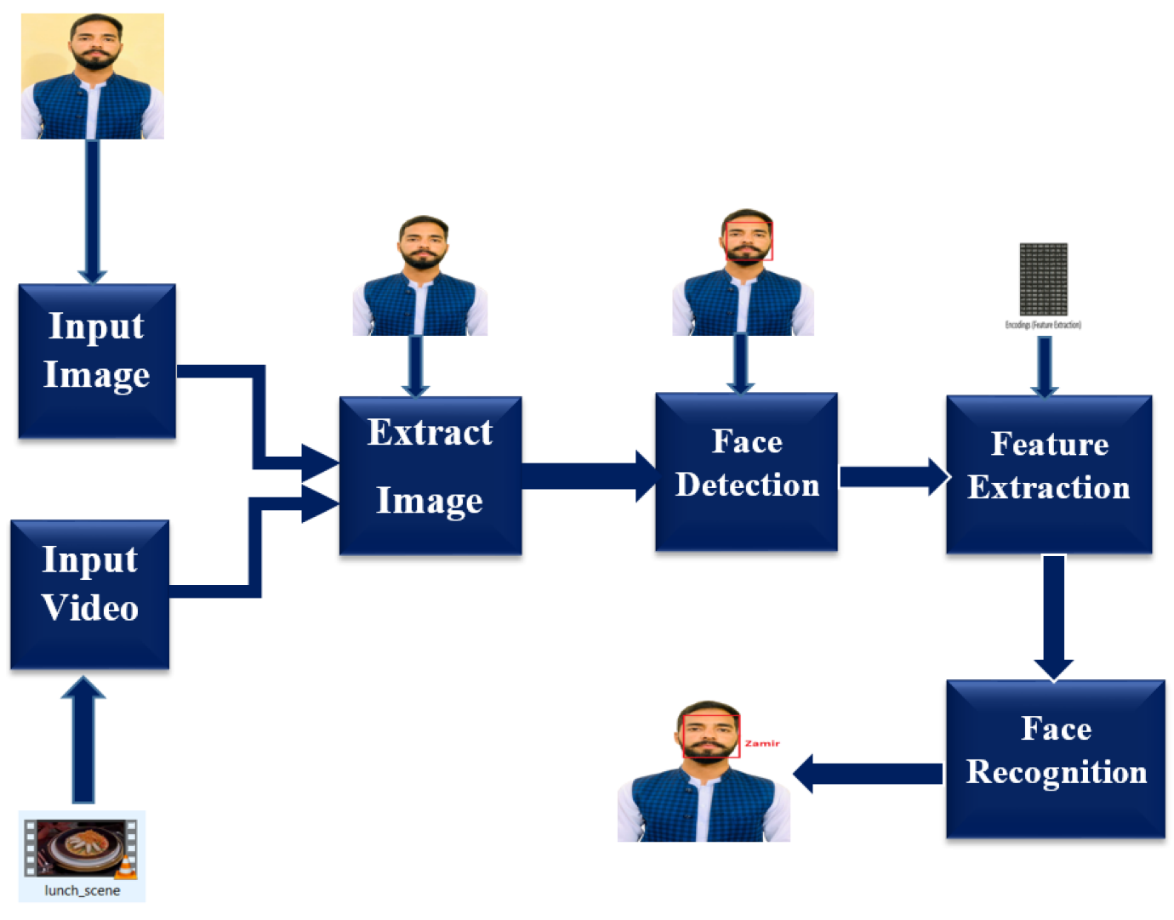

**ADVANTAGES & DISADVANTAGES**

**Advantages**

1. Biometric Security
2. Convenience
3. Quick Identification
4. Wide Applicability
5. Integration with Smart Devices

**Disadvantages**

1. Privacy Concerns
2. Accuracy and Reliability
3. Bias and Diversity Issues
4. Security Vulnerabilities
5. Resource Intensive
6. Legal and Ethical Challenges

**OUTPUT**

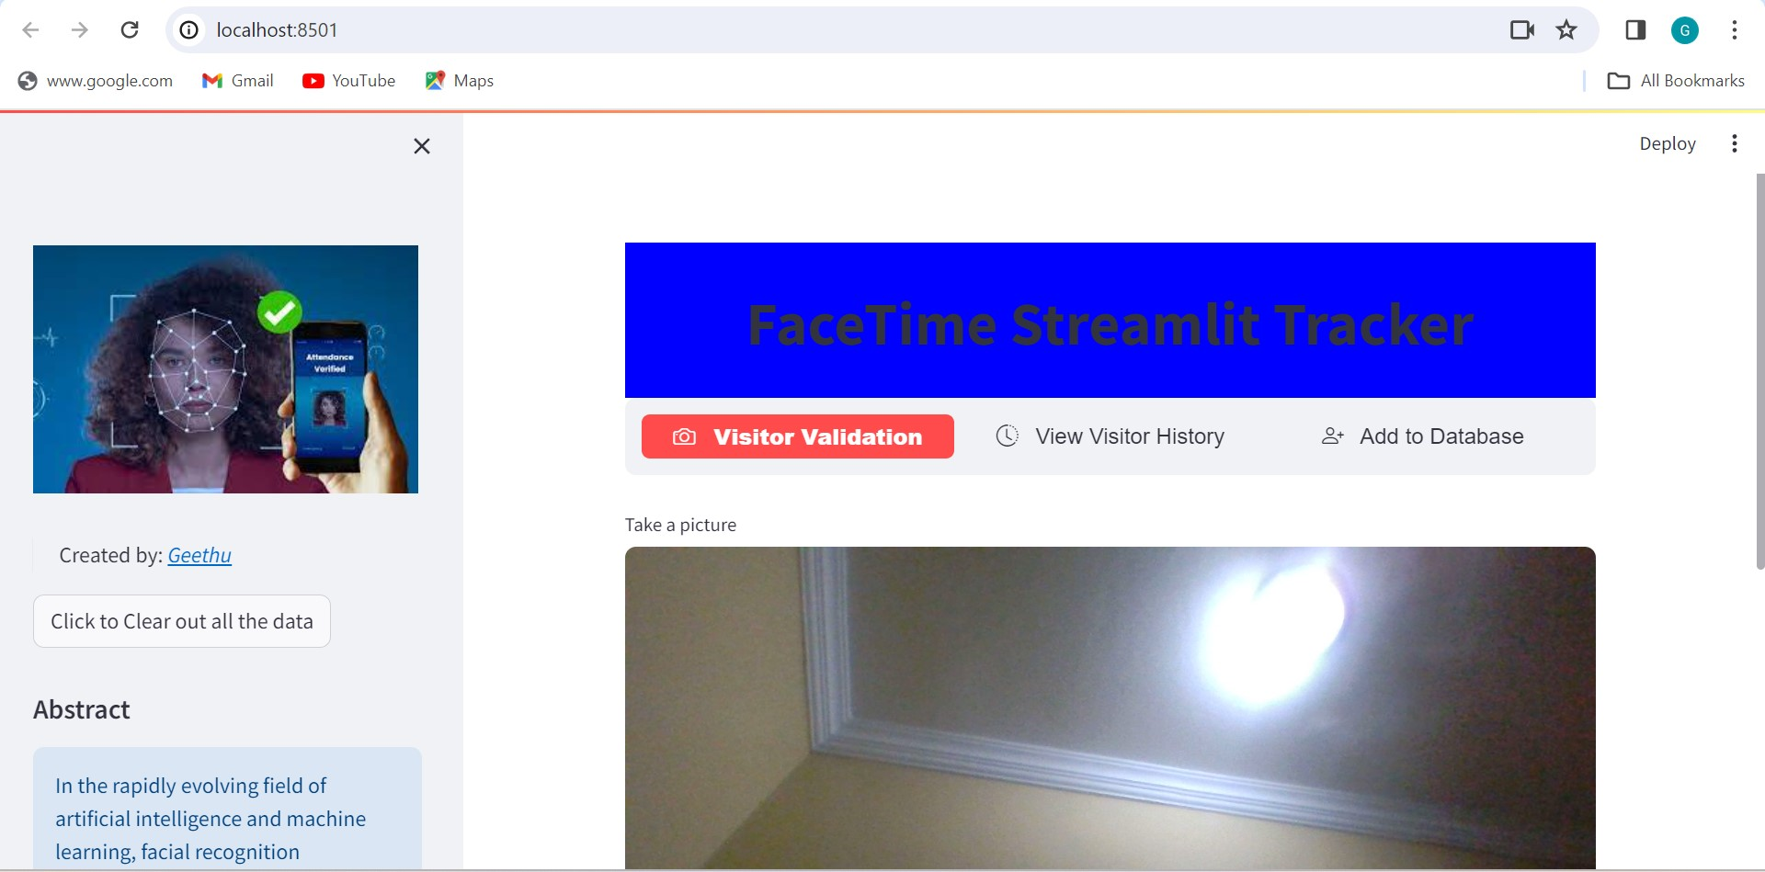

**APPLICATIONS**

* Security and Surveillance
* Attendance Management
* Law Enforcement
* Customer Service and Personalization
* Healthcare
* Human-Computer Interaction
* Marketing and Advertising
* Border Control and Immigration
* Smart Cities development

**FUTURE SCOPE**

The future scope of face recognition technology is vast and promising, with ongoing advancements and innovations expected to revolutionize various industries and applications. As technology continues to evolve, face recognition is poised to play a pivotal role in shaping the future of security, personalization, and human-computer interaction.

In the realm of security and surveillance, the adoption of face recognition is projected to expand further, with improvements in accuracy, speed, and scalability. Future systems may integrate advanced biometric modalities, such as iris recognition and gait analysis, to enhance identification capabilities and mitigate security threats effectively.

Moreover, face recognition holds immense potential in personalized user experiences, with applications ranging from retail and entertainment to healthcare and education. By leveraging facial recognition data, businesses can deliver tailored products, services, and content to individual users, thereby enhancing customer satisfaction and engagement.

Additionally, face recognition technology is expected to drive innovation in human-computer interaction, enabling more natural and intuitive interfaces in gaming, virtual reality, and augmented reality environments. Future developments may focus on real-time facial expression analysis, emotion recognition, and gesture-based interactions, opening new avenues for immersive user experiences.

Furthermore, face recognition has significant implications for healthcare, with the potential to streamline patient identification, improve medical diagnosis, and enhance personalized treatment plans. By integrating facial recognition with healthcare systems, providers can ensure accurate patient records, prevent medical errors, and optimize healthcare delivery.

**CONCLUSION**

The face recognition project has demonstrated the efficacy and potential of leveraging advanced technologies to address contemporary challenges in security, personalization, and human-computer interaction. Through the development and implementation of a robust face recognition system, we have showcased the capabilities of machine learning, computer vision, and user interface design in creating innovative solutions.

Looking ahead, the face recognition project opens avenues for future research and development, including improvements in accuracy, speed, and usability, as well as exploration of novel applications and integration with emerging technologies. By continuing to advance the capabilities and address the challenges of face recognition technology, we can unlock new possibilities and contribute to a safer, more personalized, and inclusive future.

**REFERENCES**

1. Turk, M., & Pentland, A. (1991). Eigenfaces for recognition. Journal of Cognitive Neuroscience, 3(1), 71-86.
2. Viola, P., & Jones, M. (2001). Rapid object detection using a boosted cascade of simple features. Proceedings of the 2001 IEEE Computer Society Conference on Computer Vision and Pattern Recognition. CVPR 2001.
3. Zhao, W., Chellappa, R., Phillips, P. J., & Rosenfeld, A. (2003). Face recognition: A literature survey. ACM Computing Surveys (CSUR), 35(4), 399-458.
4. Taigman, Y., Yang, M., Ranzato, M., & Wolf, L. (2014). DeepFace: Closing the gap to human-level performance in face verification. Proceedings of the IEEE Conference on Computer Vision and Pattern Recognition.
5. Buolamwini, J., & Gebru, T. (2018). Gender shades: Intersectional accuracy disparities in commercial gender classification. Proceedings of the 1st Conference on Fairness, Accountability and Transparency.

* OpenCV Documentation: <https://opencv.org/>
* Dlib Documentation: <http://dlib.net/>
* Streamlit Documentation: <https://streamlit.io/>
* TensorFlow Documentation: <https://www.tensorflow.org/>
* PyTorch Documentation: <https://pytorch.org/>
* Python Software Foundation. Python Language Reference, version 3.9. Available at <https://www.python.org/>
* GitHub repository for code samples and project resources.