**Q1)What is Streamlit, and how does it differ from other web frameworks?**

Streamlit is an open-source Python library used to create web applications for machine learning and data science projects. It simplifies the process of building interactive web applications by allowing developers to create them directly from Python scripts, without the need for knowledge of web development languages such as HTML, CSS, or JavaScript.

**Q2) Explain the basic structure of a Streamlit app.**

A Streamlit app typically follows a straightforward structure that consists of importing necessary libraries, defining the user interface elements, and writing the logic to handle user inputs and display outputs.

* Import Libraries
* Define User Interface Elements
* Handle User Inputs
* Display Outputs

**Q3)How can you add a title to your Streamlit app?**

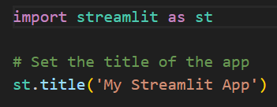

**Q4)What is the purpose of the st.write() function in Streamlit?**

The **st.write()** function in Streamlit serves multiple purposes and is a versatile tool for displaying various types of content in your application.

* Display Text
* Display Dataframes
* Display Visualizations

**Q5)How do you create interactive widgets in Streamlit? Provide examples.**

We cancreate interactive widgets using the various functions provided by the Streamlit API. These widgets allow users to interact with your application by providing input, such as selecting options, entering text, or adjusting sliders.

