**Crime rate analysis report for RCMP**

**_____________________________________**

Prepared By: Geethu Kannan

Student ID:100801786

Date:13th June 2021

**Introduction**

The purpose of this presentation is to effectively capture and visualize insights regarding crime rates in Ontario, Quebec, and Manitoba. This data is shared to the federal police to help them better understand the youth and adult crime rates and predict the crime rate for the next year based on the existing trend. For this exercise, we have used Microsoft Power BI to create the required visualisation.

**Visualization tool used**

Power BI is a business analytics service by Microsoft that provides a wide variety of features to represent data in a visual form. Power BI helps the user create interactive visualizations with a simple interface to transform enterprise data into rich visuals, thus extracting business intelligence for enhanced decision making. Power BI integrates easily with your existing business environment allowing you to adopt analytics and reporting capabilities. The automatic data refresh and publish reports allows users to seamlessly view the latest information. This tool helps transform enterprise data into rich visuals, thus extracting business intelligence for enhanced decision making.

When compared to Tableau, Power BI provides a personalized data visualization and is simpler for new users. Power BI offers data shaping and modelling features like a versatile query editor, set-documentation and PowerPivot dots that are more user-accessible while Tableau offers none of them. Power BI is also cheaper when compared to Tableau.

**Data analysis / Visualization approach**

Since we find power BI a better tool, we used this for our analysis. Initially, we took all provinces into consideration for data analysis, to find out which province has the highest crime rate. Post this step, we move on to a detailed analysis using a breakdown approach by focusing on the top 3 cities in each province based on crime rates. Using Power BI, we intend to visualise and understand the cities which contribute to higher crime rates using a stacked column chart.

**Report findings**

Crime rates are categorised and represented using 2 different rates - adult crime rate and youth crime rate. The adult and youth crime rates in Manitoba, Ontario and Quebec in the last 10 years (2010 - 2019) are represented as two separate pie charts. The adult and youth crime rates are similar in Manitoba and Ontario provinces and lesser in Quebec (with 22.59 and 16.5% respectively).

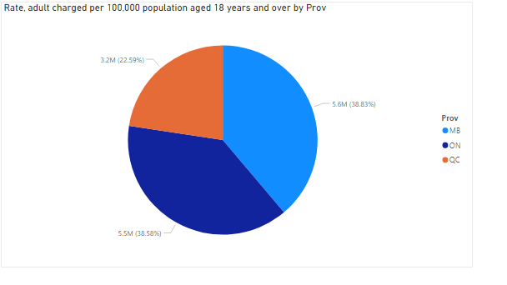

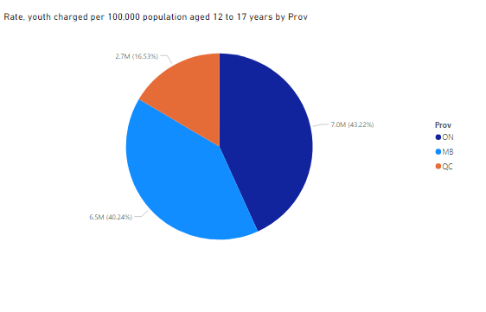

The crime rates for the top 3 cities for Manitoba, Ontario, and Quebec with the highest crime in the last 10 years are visualized using a stacked column chart, with the cities in the X axis and the actual incidents in the Y axis. For Manitoba, the top 3 crime cities are **Winnipeg**, Manitoba, Municipal [35304], **Thompson**, Manitoba, Royal Canadian Mounted Police, municipal [46774] and Brandon, Manitoba, municipal [46005]. The total crimes committed in Winnipeg is staggeringly high (0.6 million) compared to the other two cities which are both below 0.1 million. For Quebec, the top 3 crime cities are **Montreal**, Quebec, municipal [24175], **Quebec**, Quebec, municipal [24215] and **Longueuil**, Quebec, municipal [24231]. The total crimes committed in **Montreal** is higher (close to 1.2 million) compared to the other two cities which are both around 0.2 million. For Ontario, the top 3 cities are **Toronto**, Ontario, municipal [35304], **Peel Region**, Ontario, municipal [35041] and **Ottawa**, Ontario, municipal [35010]. The difference in crimes committed among the top 3 cities are lesser compared to other two provinces. The total crimes committed in Toronto is 1.3 million which is the highest in all cities. compared to the other two cities which are both around 0.4 million.

**Crime rate for top three cities in Quebec**

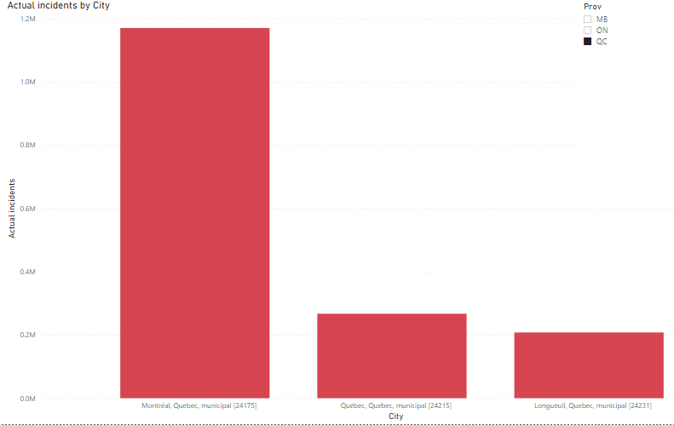**Crime rate for top three cities in Ontario**

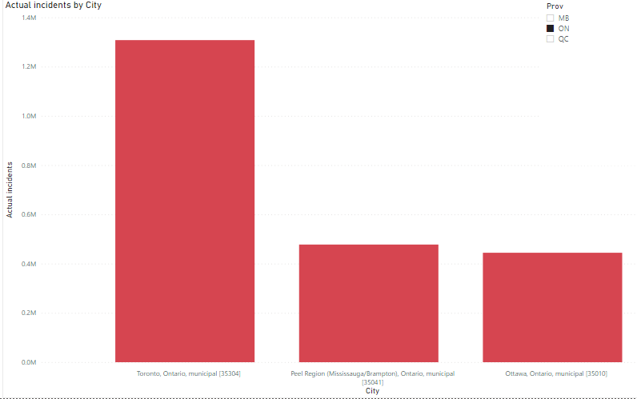

**Crime rate for top three cities in Manitoba**

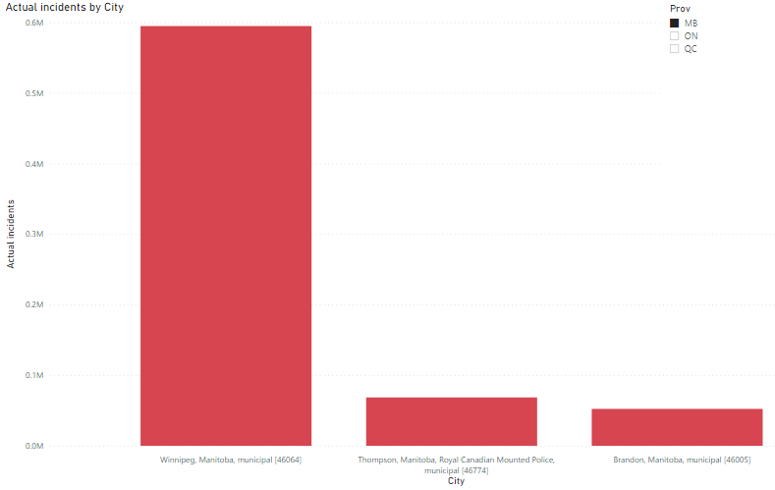

The youth crime and adult crime rates for each high crime rate city is plotted using a scatter plot to understand the correlation between the adult crime rate and the youth crime rate. On the whole, there seems to be a linear relation between the youth crime rate and adult crime rate across all these cities. As adult crime rate increases, the youth crime rate increases as well. For Winnipeg, the rates show a strong relationship with each other with a lesser linear relation for the other two cities.

**Crime rate of youth vs adult in Montreal, Quebec , Municipal [24175]**

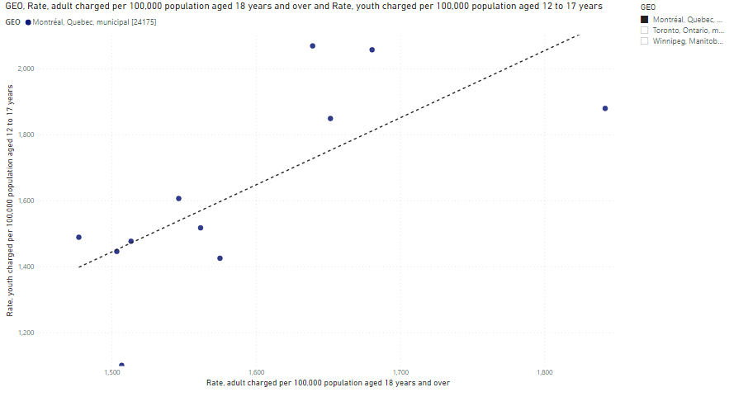

**Crime rate of youth vs adult in Toronto, Ontario, Municipal [35304]**

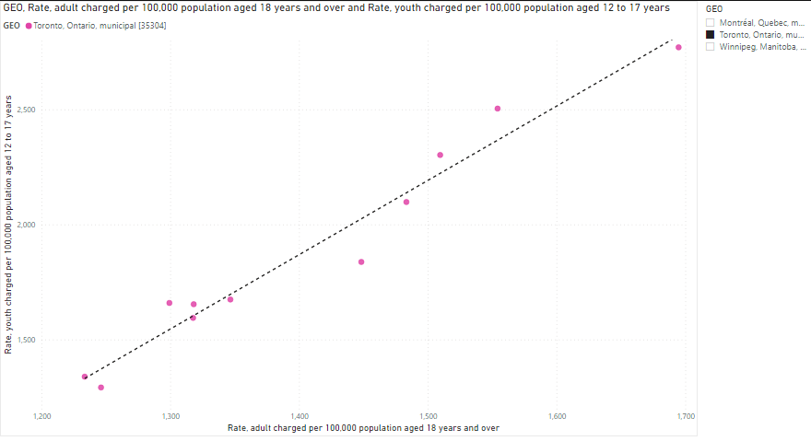

**Crime rate of youth vs adult in Winnipeg, Manitoba, Municipal [35304].**

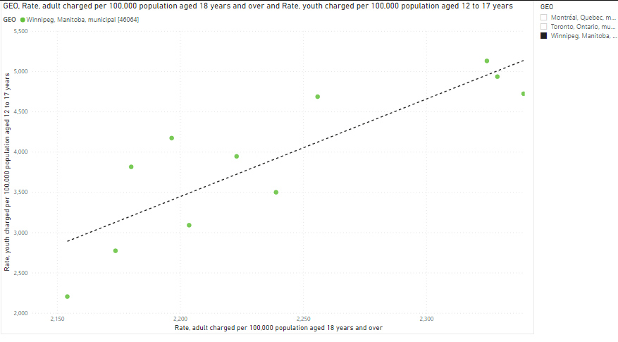

**Forecasting number of crimes in each province**

As per the analysis using power BI forecast tool and the visualizations generated.

**Forecast for the number of crimes in Quebec province**

The next crime rate in Quebec is forecasted to be in between the range 79102 to 99092, probably the number of crimes in 2020 will be 89097.

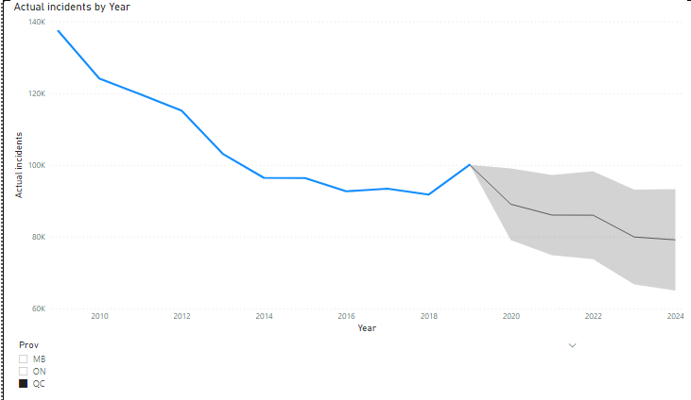

**Forecast for the number of crimes in Manitoba province**

The next crime rate in Manitoba is forecasted to be in between the range 61757 to 83073, probably the number of crimes in 2020 will be 72415.

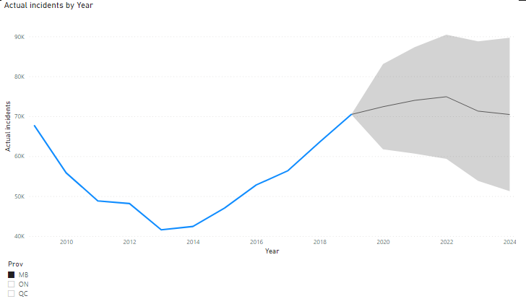

**Forecast for the number of crimes in Ontario :**The next crime rate in Ontario is forecasted to be in between the range 1,26410 to 1,48,877, probably the number of crimes in 2020 will be 137644.

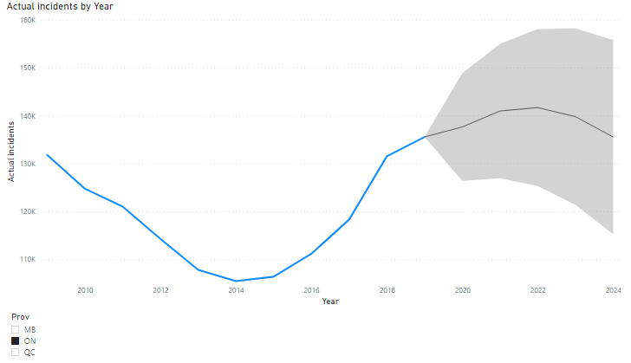

**Conclusion**

Using the reports generated, officer Richard from the police department would be able to get a clear picture on the crime rates across different provinces and their relationship and predict future crime rates at a given city or province using this data.