**Group Members:** Geetish Nayak

Purvi Bafna

Jyoti Yadav

Sherry Shi

**Assignment No:** 1

**Objective:**

* **Global Warming –** To check if there is an abnormal rise/fall in monthly average temperature over a year(By comparing them with average temperatures calculated over the 5 years)

**Programs and their Purposes :**

2 Hadoop Programs are written to serve the purpose

**1st Hadoop Program** – The purpose of the first Hadoop program is to calculate monthly temperature, Standard Deviation and 95% Confidence Interval over a period of 5 years.

**AverageMonthlyMapper.java** – Mapper class which provides entries to the reducer in the <Month,Temperature> format. Eg. <01,21.2>

**AverageMonthlyReducer.java** – The reducer class aggregates the data it receives from the mapper where it calculates the mean, standard deviation and 95% confidence interval. The output from the reducer consists of <Month, Mean_StandartDeviation> format.

Eg. : Apr [Mean:0.30 Std Dev : 4.39 Confidence Interval : 0.40 0.56]

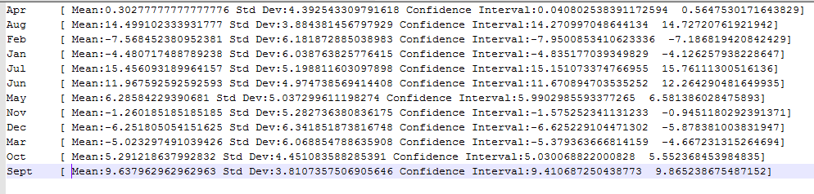

Fig. 1 Output of 1st Map Reduce Program

**2nd Hadoop Program** – The data from the 1st Hadoop program is hardcoded in the 2nd Hadoop program. For the testing data, for every year in the monthly averages are calculated and if the average for a specific year and a month goes beyond or below a threshold then an alert message is shown indicating that the temperature for a specific month is abnormal and an “Alert” message is outputted.

**CheckGlobalWarmingMapper.java** – It is the mapper class which outputs data in the following <Year_Month,Temperature> format.

**CheckGlobalWarmingReducer.java** – This class calculated the average temperature for a specific month and specific year and if it falls above/below a specific threshold value (calculated from the mean and standard deviation of monthly temperatures calculated in Hadoop program 1), then an alert message is shown corresponding to that month.

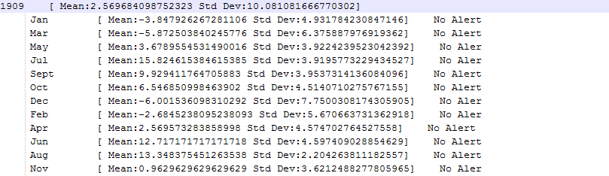

Output of 2nd Map – Reduce Program