**Online Food Delivery Application**

Problem Statement:

* The Aim of this application is to form a bridge between restaurant and customers.
* The Restaurant owners must be able to sign in to the application to create and list out their food items along with the price
* So, that the customers could sign up , view the nearby restaurants and place the order.
* The customer selects the method of payment and makes a payment for his order.
* The restaurant owner can accept his order and delivery the order to customer

Modules:

Class Diagram:

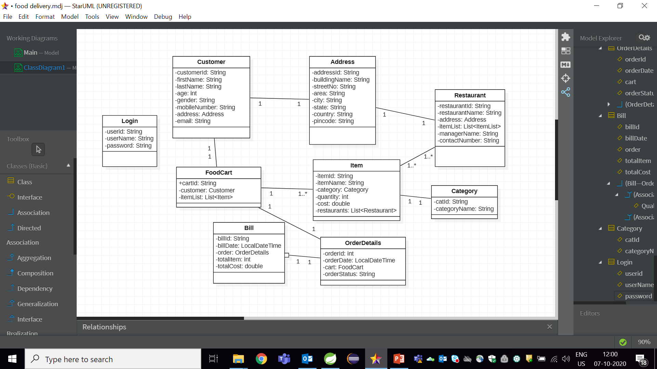

Services :

