Clean Slate Website Setup & Publishing Guide
How the site is connected, edited locally through Codex, previewed, and published through GitHub, Vercel, and Cloudflare
Quick summary Codex edits the local Next.js project. GitHub stores the source code. Vercel builds and hosts the website. Cloudflare manages the domain DNS and points the domain to Vercel. A push to the production branch triggers a Vercel deployment.

1. The complete architecture
The Clean Slate website uses a standard Git-connected deployment pipeline:
You request or make an edit in Codex
↓
Local project files on this Mac
↓
GitHub repository: Geffen53/CleanSlateFilm-AlexGeffen
↓
Vercel builds and deploys the Next.js application
↓
Cloudflare DNS directs cleanslatefilm.com to Vercel
Codex does not directly edit the live production website. It edits the local repository. The live website changes after the updated files are committed to Git and pushed to GitHub, which Vercel watches.

2. What each service does

Codex
Codex is the editing workspace. It can inspect the repository, change components and content, run verification commands, and help preview the site. It is working with files on your computer, not with a separate hidden copy of the live website.

Whisper flow
Use Whisper for voice-driven requests in Codex. The Ctrl+1 shortcut is enabled: activate it, dictate the request, review the transcription, and submit it for editing or verification.

GitHub
GitHub is the source-code repository and history. Every commit records what changed and when. The connected repository is:
https://github.com/Geffen53/CleanSlateFilm-AlexGeffen.git

Vercel
Vercel builds and hosts the Next.js application. It can create preview deployments for branches and production deployments from the production branch. This repository specifies the Vercel build command in vercel.json:
{
"buildCommand": "npm run verify"
}

Cloudflare
Cloudflare manages the domain and DNS. In this setup, Cloudflare is not the application host; it directs the domain to Vercel. Cloudflare account settings and DNS records live in the Cloudflare dashboard, not in this repository.

3. Local project location and important files
The local project folder is:
/Users/geffen/Documents/GitHub/CleanSlateFilm-AlexGeffen
Location | Purpose
app/page.tsx | Homepage layout and hero content.
app/film/page.tsx | Film page and production details display.
data/film.ts | Film facts, synopsis, media URLs, gallery data, and production details.
data/cast.ts | Cast information.
data/crew.ts | Crew information.
data/producers.ts | Producer information.
components/ | Reusable interface components such as navigation, footer, title, gallery, and video player.
public/media/ | Images, poster artwork, fonts, and other public media.
index.css | Site-wide CSS and design tokens.
next.config.mjs | Next.js settings, security headers, redirects, and media behavior.
vercel.json | Vercel build configuration.
package.json | Scripts, dependencies, and project metadata.
AGENTS.md | Project-specific design and implementation instructions used by Codex.

4. Programs to have open for local preview
- Codex: request and review edits.
- Terminal: run the development server and verification commands.
- A web browser: view the local site at http://localhost:3000.
- GitHub: review commits and deployment history when needed.
- Vercel and Cloudflare dashboards: only when checking deployment settings, domains, DNS, or logs.

5. First-time local setup
- Open Terminal.
- Move into the project directory:
cd /Users/geffen/Documents/GitHub/CleanSlateFilm-AlexGeffen
- Install dependencies if this is the first setup on the computer:
npm install
- Start the local development server:
npm run dev
- Open http://localhost:3000 in your browser.
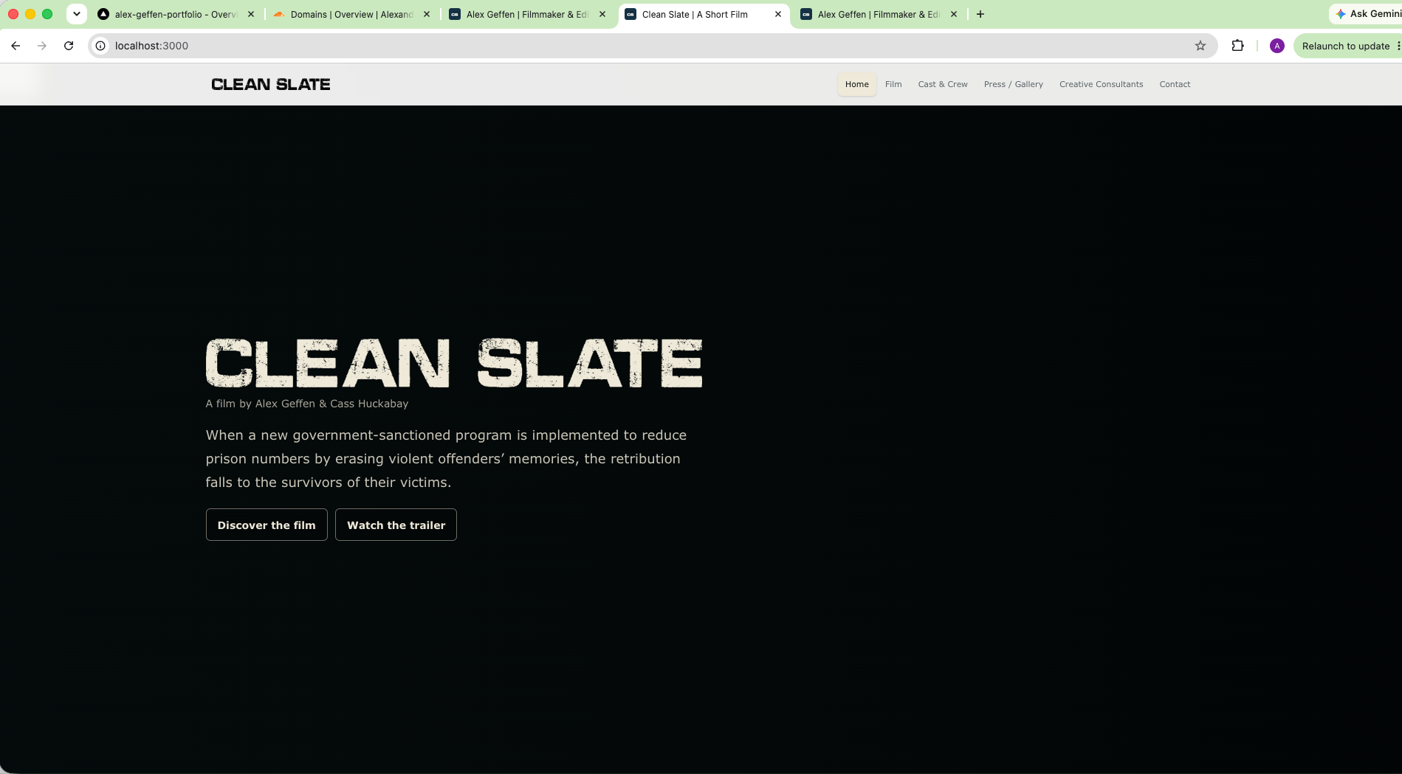
Figure 1. Local Clean Slate preview at http://localhost:3000.
The development server watches the source files and refreshes the browser when saved changes are detected. Stop it with Control+C in Terminal.
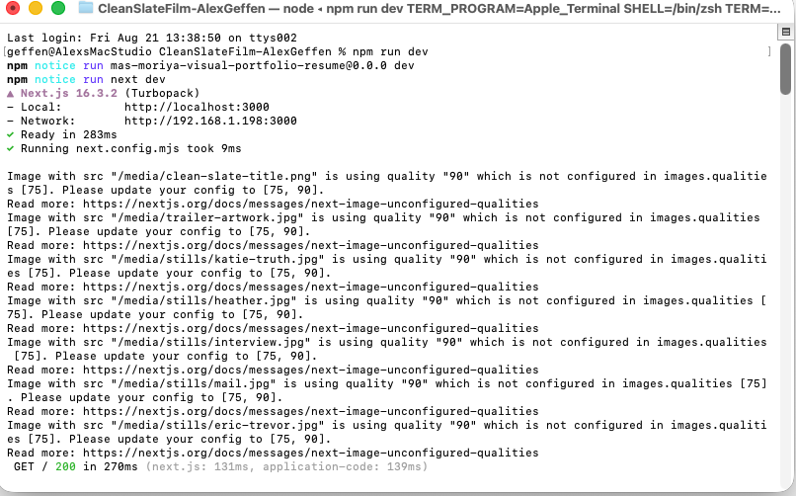
Figure 2. Terminal showing the local Next.js development server running.

6. Normal editing and preview workflow
- Ask Codex to make the requested change, or edit the relevant file directly.
- Keep npm run dev running in Terminal.
- Preview the result at http://localhost:3000.
- Check the page at desktop and mobile widths.
- Inspect the change before saving it to Git.
For a production-style local check, run:
npm run build
npm run start
The project’s full verification command is:
npm run verify
That runs the security boundary check, an npm audit, and the production build.

7. Save and publish changes through GitHub
After previewing a change, use Terminal from the project directory:
git status
git diff
Stage the files you want to include:
git add app/page.tsx
Or stage all changed files when you have reviewed the complete diff:
git add .
Create a descriptive commit:
git commit -m "Describe the change"
Push the commit to GitHub:
git push origin main
Once the push completes, Vercel detects the GitHub update, runs npm run verify, builds the Next.js site, and publishes the production deployment for the main branch.

8. Safer branch workflow for larger changes
For substantial design or feature work, use a separate branch so the production branch remains unchanged while you test:
git switch -c codex/my-site-change
# preview and verify the work
npm run verify
# save it
git add .
git commit -m "Update homepage hero layout"
git push -u origin codex/my-site-change
Vercel can create a preview deployment for the branch. After reviewing it, merge the branch into main through GitHub. Small, low-risk content changes can be committed directly to main if that is your preferred workflow.

9. How the domain connection works
- The domain is managed in Cloudflare.
- The website project is hosted in Vercel.
- The domain is added to the Vercel project under Settings → Domains.
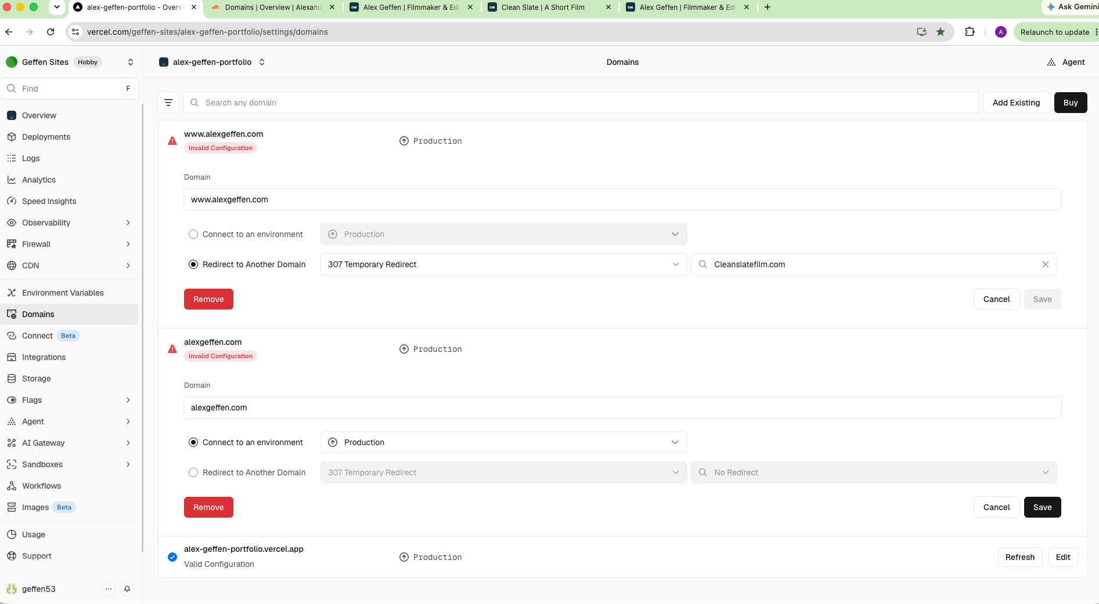
Figure 3. Vercel Domains settings showing the project connection and domain status.
- Vercel provides the DNS records required for the domain.
- Those records are added or updated in Cloudflare DNS.
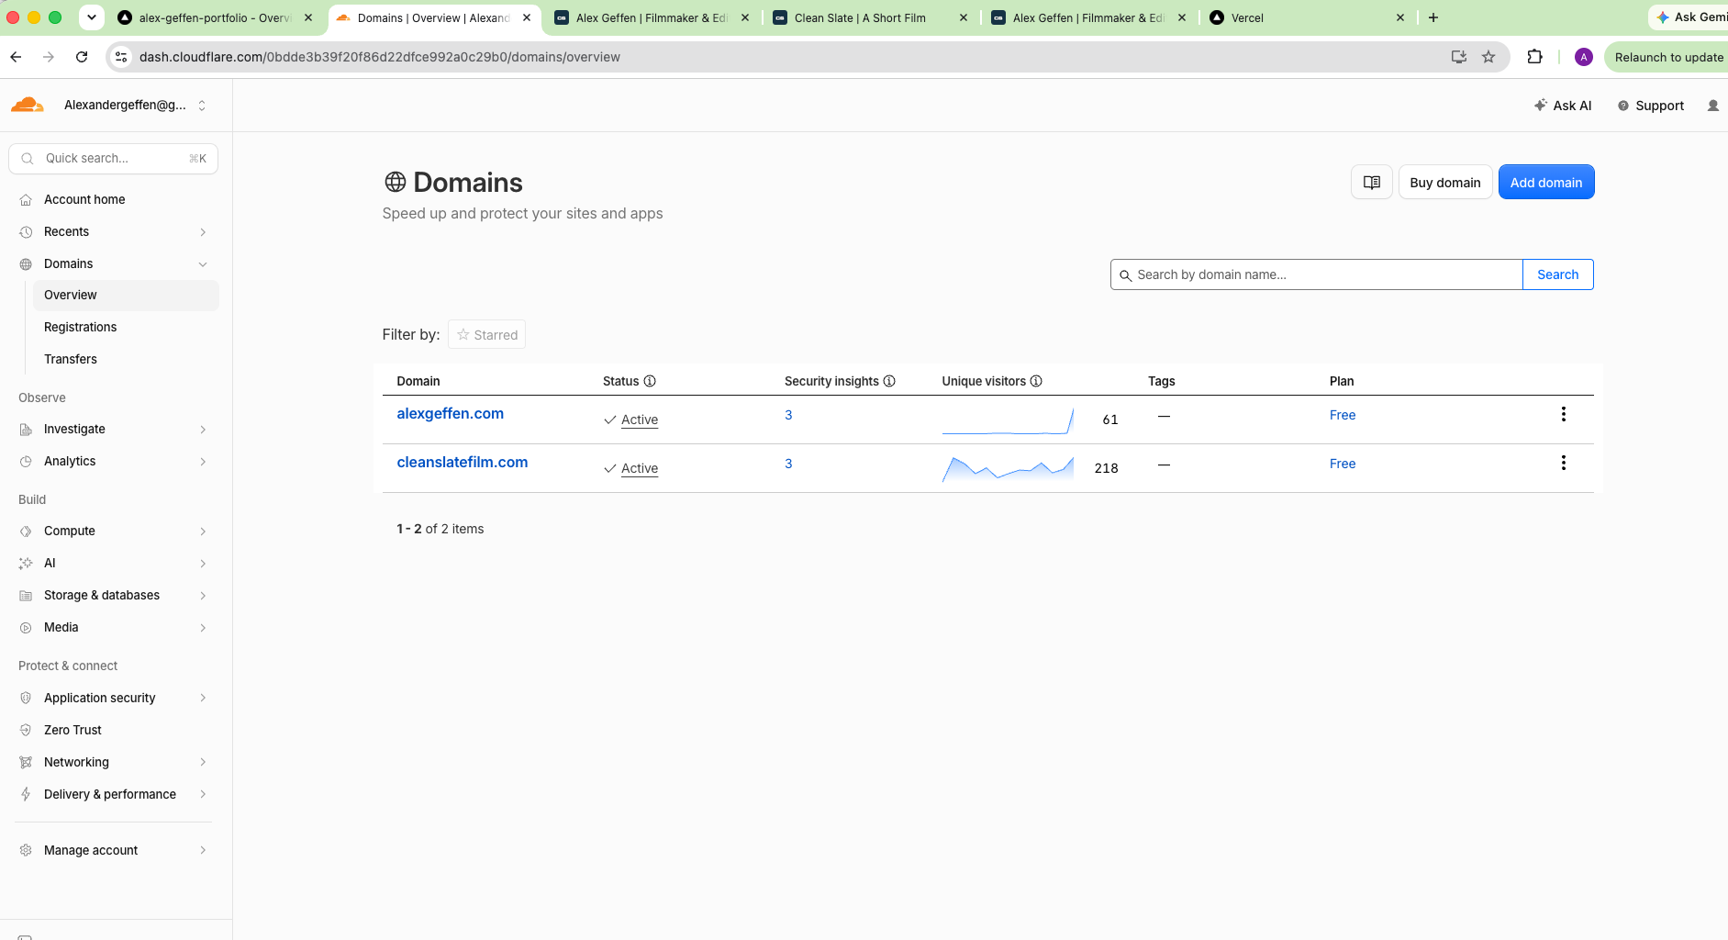
Figure 4. Cloudflare Domains overview showing the active domains.
- Vercel verifies the records and serves the site on the custom domain.
DNS caution Always copy the current record values from the Vercel Domains screen. Do not guess DNS values or delete existing Cloudflare records without first confirming what they support.

10. Manual Vercel deployment, if ever needed
The GitHub-connected workflow is recommended because it preserves the source history. If manual deployment is necessary, the Vercel CLI workflow is:
npm install -g vercel
vercel login
vercel link
vercel
For a direct production deployment:
vercel --prod
Use manual production deployment carefully when GitHub integration is active, since it can publish a state that has not yet been committed to GitHub.

11. Creating a new site in the future
- Create the local Next.js project.
- Run it locally and confirm http://localhost:3000 works.
- Initialize Git and create the first commit.
- Create an empty GitHub repository.
- Connect the local project to GitHub and push main.
- Import the GitHub repository into Vercel.
- Confirm the framework, build command, and environment variables in Vercel.
- Add the custom domain in Vercel.
- Copy Vercel’s DNS instructions into Cloudflare.
- Verify a preview deployment before publishing production changes.
npx create-next-app@latest my-new-site
cd my-new-site
npm install
npm run dev
git init
git add .
git commit -m "Initial site"
git branch -M main
git remote add origin https://github.com/YOUR-USERNAME/my-new-site.git
git push -u origin main

12. Safety rules and troubleshooting
- Do not edit .next/; it is generated build output.
- Do not commit .env, .env.local, passwords, API keys, or deployment tokens.
- Do not delete Cloudflare DNS records without identifying their purpose.
- Do not manually edit the live Vercel deployment; edit the repository instead.
- Keep public media in public/media/ so it can be referenced with paths such as /media/trailer-artwork.jpg.
- If localhost:3000 is unavailable, confirm npm run dev is still running and check the Terminal error.
- If Vercel fails, inspect the deployment build log and run npm run verify locally.
- If the domain fails, check the Vercel domain verification status and Cloudflare DNS records.

13. Quick reference checklist
cd /Users/geffen/Documents/GitHub/CleanSlateFilm-AlexGeffen
npm run dev
# preview at http://localhost:3000
npm run verify
git status
git diff
git add .
git commit -m "Describe the change"
git push origin main
In short: edit locally, preview locally, verify locally, commit to Git, push to GitHub, and let Vercel publish the verified repository state while Cloudflare continues directing the domain to Vercel.

