**Clone and run Project**

**Step 1.**

Clone project on your preferred directory, for example`

*<<your directory>>/git clone**https://github.com/Gegham94/rest_api_task.git*

**Step 2.**

Open the project rest_api_task in Visual Studio Code and in terminal enter command   
*<<npm install>>* for downloading needed modules from package.json

**Step 3.**

Enter command *<<npm start>>* or *<<nodemon>>* for running project

**Step 4.**

Open new tab in the terminal and enter following command for running server  
*<<mongod>>*

**How to do User requests …**

**Step 5. *Create user***

Open Postman, set request type *<<POST>>* , in Headers tick Content Type checkbox, write request url *<<http://localhost:3000/users/create>>*

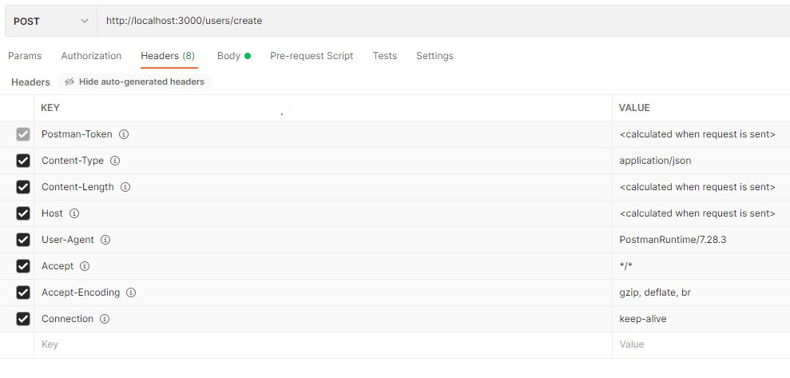

In *<<Body>>* choose *<<raw>>* and set *<<JSON>>*, then in the content write User fields, for example`

{

    "email":"newuser@gmail.com",

    "firstName":"User name",

    "lastName":"User surname",

    "possition":"Manager",

    "gender":"female",

    "dateOfBirth":"01.01.1991"

}

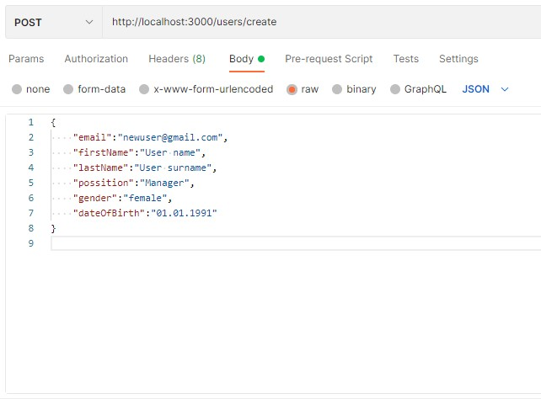

After sending request user will saved and you will see result with user image Buffer like this`

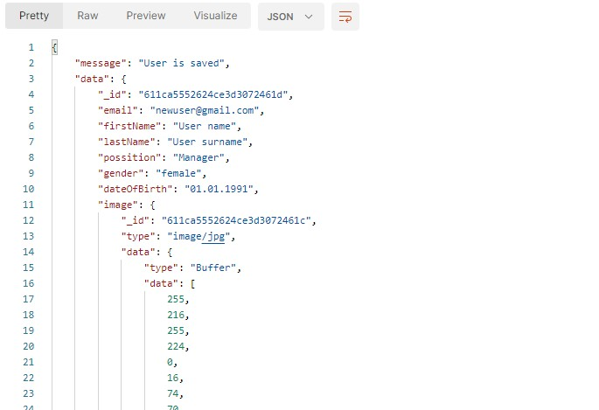

**Step 6. *Get User by ID***

Change request type to *<<GET>>*, request url with your user ID *<<http://localhost:3000/users/611cad1e77b8f91574a40649>>* and after sending request you will see that user like this`

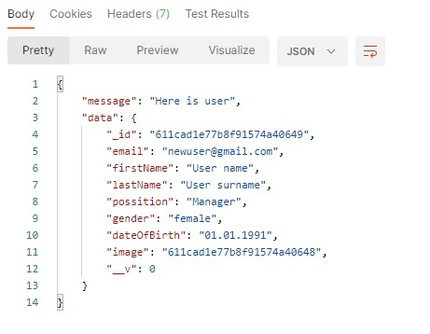

**Step 7. *Get all Users***

Keep request type to *<<GET>>*, delete ID from request url *<<http://localhost:3000/users>>* and after sending request you will see all user that are saved like this`

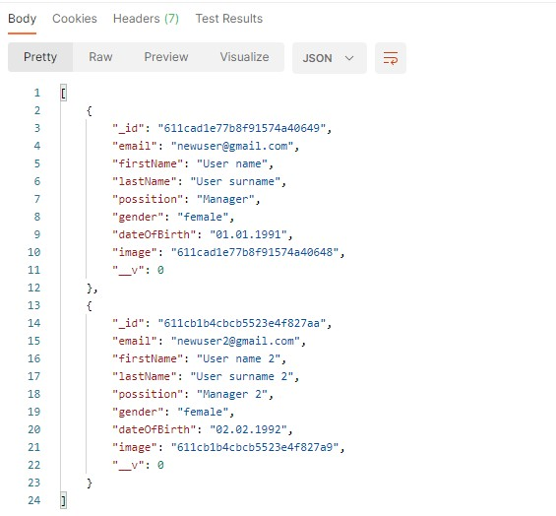

**Step 8. *Update User data by User ID***

Change request type to *<<PUT>>*, request url with that user ID you want to edit *<<http://localhost:3000/users/update/611cad1e77b8f91574a40649>>*, write in the Body content new fields that you want to update like this`

{

    "email":"editeduser@gmail.com",

    "firstName":"User new name",

    "lastName":"User new surname",

    "possition":"Developer",

    "gender":"male",

    "dateOfBirth":"05.05.1995"

}

And after sending request you will see result like this`

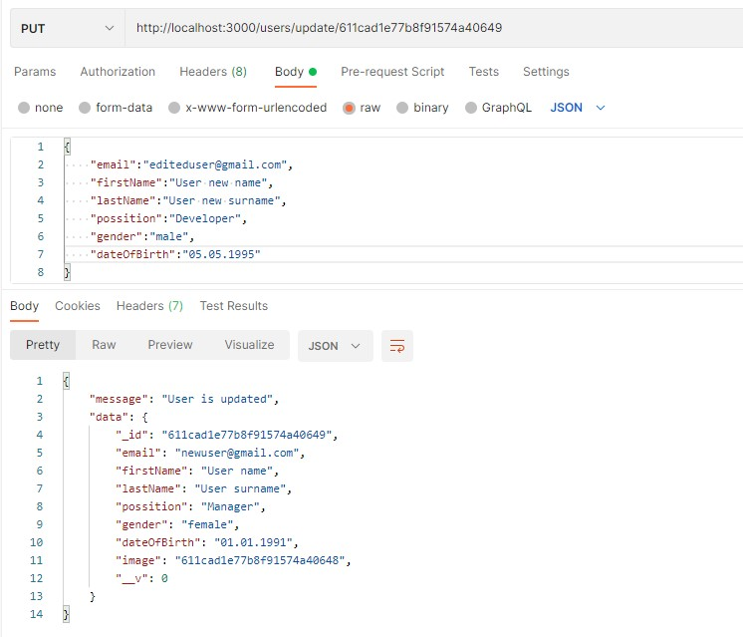

**Step 9. *Delete User by ID***

Change request type to *<<DELETE>>*, request url with that user ID you want to delete *<<http://localhost:3000/users/delete/611cad1e77b8f91574a40649>>* and after sending request in result you will see`

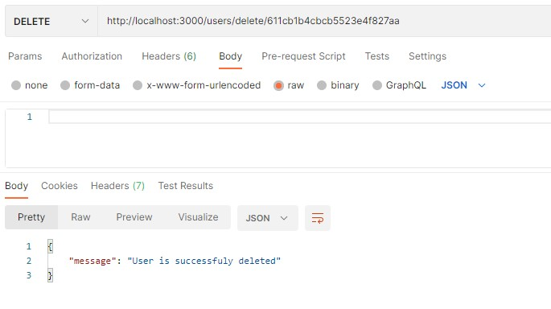

**How to do Project requests …**

**Step 10. *Create Project***

Set request type *<<POST>>* , in Headers tick Content Type checkbox, write request url *<<http://localhost:3000/projects/create>>,* in *<<Body>>* choose again *<<raw>>* and set *<<JSON>>,* then in the content write Project fields, in *"manager"* or *"developer"* keys you can set the *User ObjectId* that you want to assign to project like Manager or Developer , for example`

{

    "title": "gegham@gmail.com",

    "manager": "611cad1e77b8f91574a40649",

    "developer": "611cad1e77b8f91574a40649"

}

In result you will see`

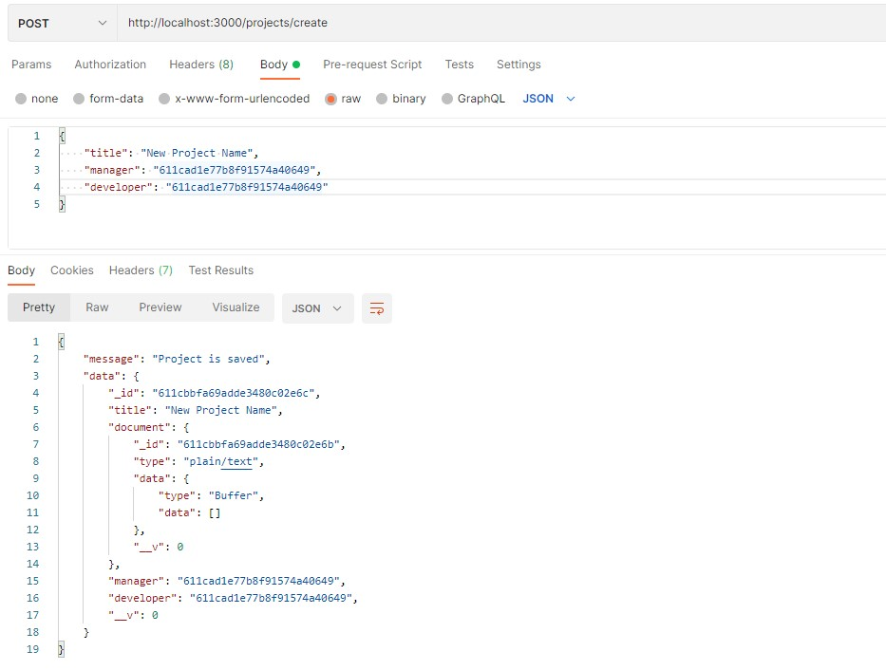

**Step 11. *Get Project by ID***

Change request type to *<<GET>>*, request url with your project ID *<<http://localhost:3000/projects/611cad1e77b8f91574a40649>>* and after sending request you will see that project like this`

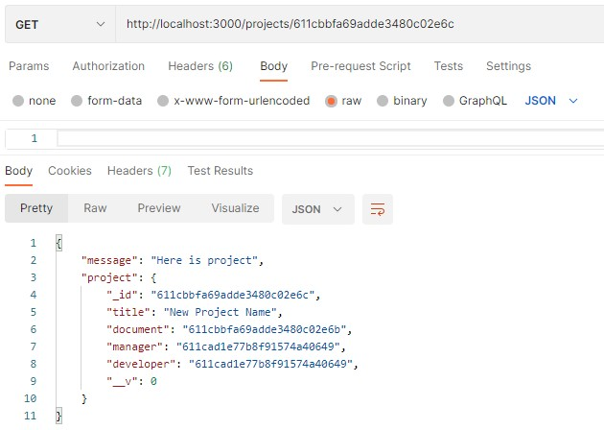

**Step 12. *Get all Projects***

Keep request type to *<<GET>>*, delete ID from request url *<<http://localhost:3000/projects>>* and after sending request you will see all projects that are saved like this`

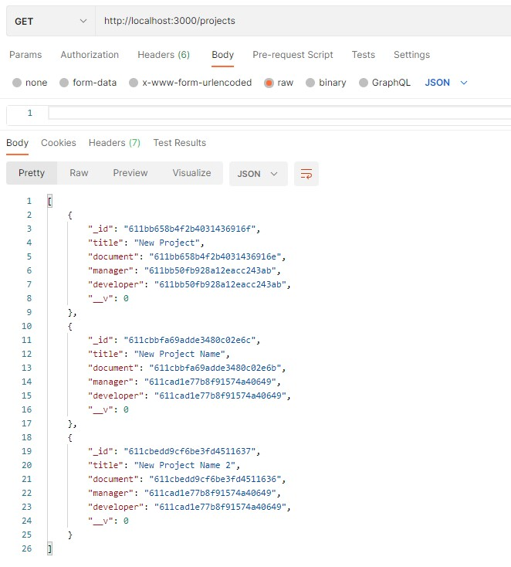

**Step 13. *Update Project Manager by Project ID and User email***

Change request type to *<<PUT>>* , request url with that project ID you want to edit *<<http://localhost:3000/projects/assign_manager/ 611bb658b4f2b4031436916f>>,* write in the Body content User email that you want to assign to project like this`

{

    "email": "editeduser@gmail.com"

}

In result you will see`

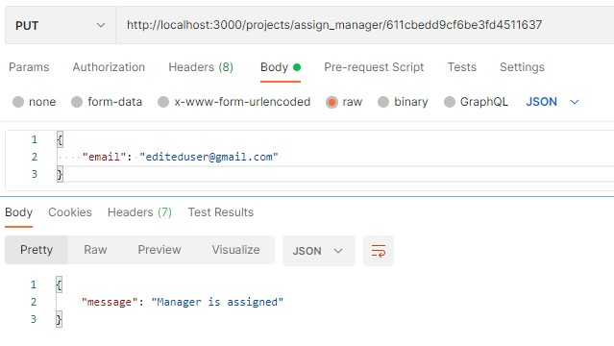

**Step 13. *Update Project Developer by Project ID and User email***

Keep request type to *<<PUT>>* , request url with that project ID you want to edit *<<http://localhost:3000/projects/assign_developer/ 611bb658b4f2b4031436916f>>,* write in the Body content User email that you want to assign to project like this`

{

    "email": "editeduser@gmail.com"

}

In result you will see`

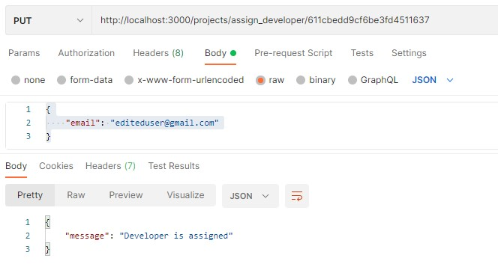

**Step 15. *Delete Project by ID***

Change request type to *<<DELETE>>*, request url with that project ID you want to delete *<<http://localhost:3000/projects/delete/611cbedd9cf6be3fd4511637>>* and after sending request in result you will see`

