SubwayStation
Gegi Chachibaia

Contents
1 Business Description 3
1.1 Business background 3
1.2 Problems. Current Situation 3
1.3 The benefits of implementing a database. Project Vision 3
2 Model description 3
2.1 Definitions & Acronyms 3
2.2 Logical Scheme 3
2.3 Objects 3

Business Description

Business background
The metro system is a critical component of transportation, providing speedy, reliable, and safe commutes for passengers. Metro stations, trains, and tunnels make a complex network that requires precise coordination and tracking.
Employees manage operations including scheduling, maintenance, ticketing, and passenger assistance. Passengers rely on train arrivals, accurate schedules, and secure ticketing systems.

Problems. Current Situation
Currently, metro operations face several challenges due to fragmented data management:
Difficulty tracking train schedules – Delays or changes in train assignments are hard to communicate, leading to passenger dissatisfaction.
Manual ticketing and payment records – Payments, ticket validation, and passenger records are sometimes handled offline or in multiple systems, causing reconciliation issues.
Maintenance tracking issues – Maintenance schedules for trains and tunnels are recorded manually, increasing the risk of missing critical safety checks.
Employee assignment confusion – Assigning employees to stations or shifts is done through spreadsheets, which can cause errors in coverage.
Passenger information management – Passengers with travel passes, discounts, or subscription plans are not centrally tracked, leading to inefficient service.
Limited operational reporting – Management lacks integrated insights into train usage, revenue collection, and route efficiency.
High risk of errors during peak hours – Manual data handling makes it difficult to quickly resolve issues related to overcrowding, train delays, or passenger complaints.

the Benefits of implementing a database. Project Vision
Implementing a centralized database will bring multiple benefits:
- Centralized scheduling and route management – Track all trains, routes, and schedules in one system, reducing errors and delays.
- Efficient ticketing and payment management – Store all ticket sales and payments digitally, making reconciliation faster and more accurate.
- Maintenance monitoring – Automatically track train and tunnel maintenance, ensuring safety compliance and timely interventions.
- Employee management – Assign employees to stations and shifts efficiently, with clear tracking of responsibilities.
- Passenger tracking and analytics – Manage passenger travel passes, subscriptions, and trip history to improve service and planning.
- Operational reporting and analytics – Generate reports on train performance, route efficiency, and revenue, supporting better decision-making.
- Error reduction and improved passenger experience – Automated data management reduces human error and improves reliability and transparency for passengers.

Model description

Definitions & Acronyms
 | Definition
Schedule | Represents the planned timetable for trains, including arrival and departure times at stations along a route.
Train | A vehicle unit that operates on the metro lines and follows assigned schedules.
Route | A predefined path that a train follows, consisting of an ordered list of stations.
Station | A location where passengers can board or alight from trains. Includes station name, code, and facilities.
StationLine | Junction table linking stations to metro lines, indicating which lines pass through which stations.
MetroLine | A specific line within the metro network, e.g., Saburtalo Line, 1st Line.
Employee | Staff working in the metro system, including station staff, train operators, and maintenance personnel.
Passenger | Individuals using the metro system for travel. Can have tickets, passes, or subscriptions.
StationEmployee | Bridge table linking employees to stations, showing which staff work at which station and during which shift.
Ticket | A record of a passenger’s purchase allowing travel on the metro system. Includes type (single, return, monthly pass).
Payment | Records of payments made by passengers for tickets.
MaintenanceRecord | Logs maintenance activities performed on trains, tunnels, or other metro infrastructure.

Logical Scheme
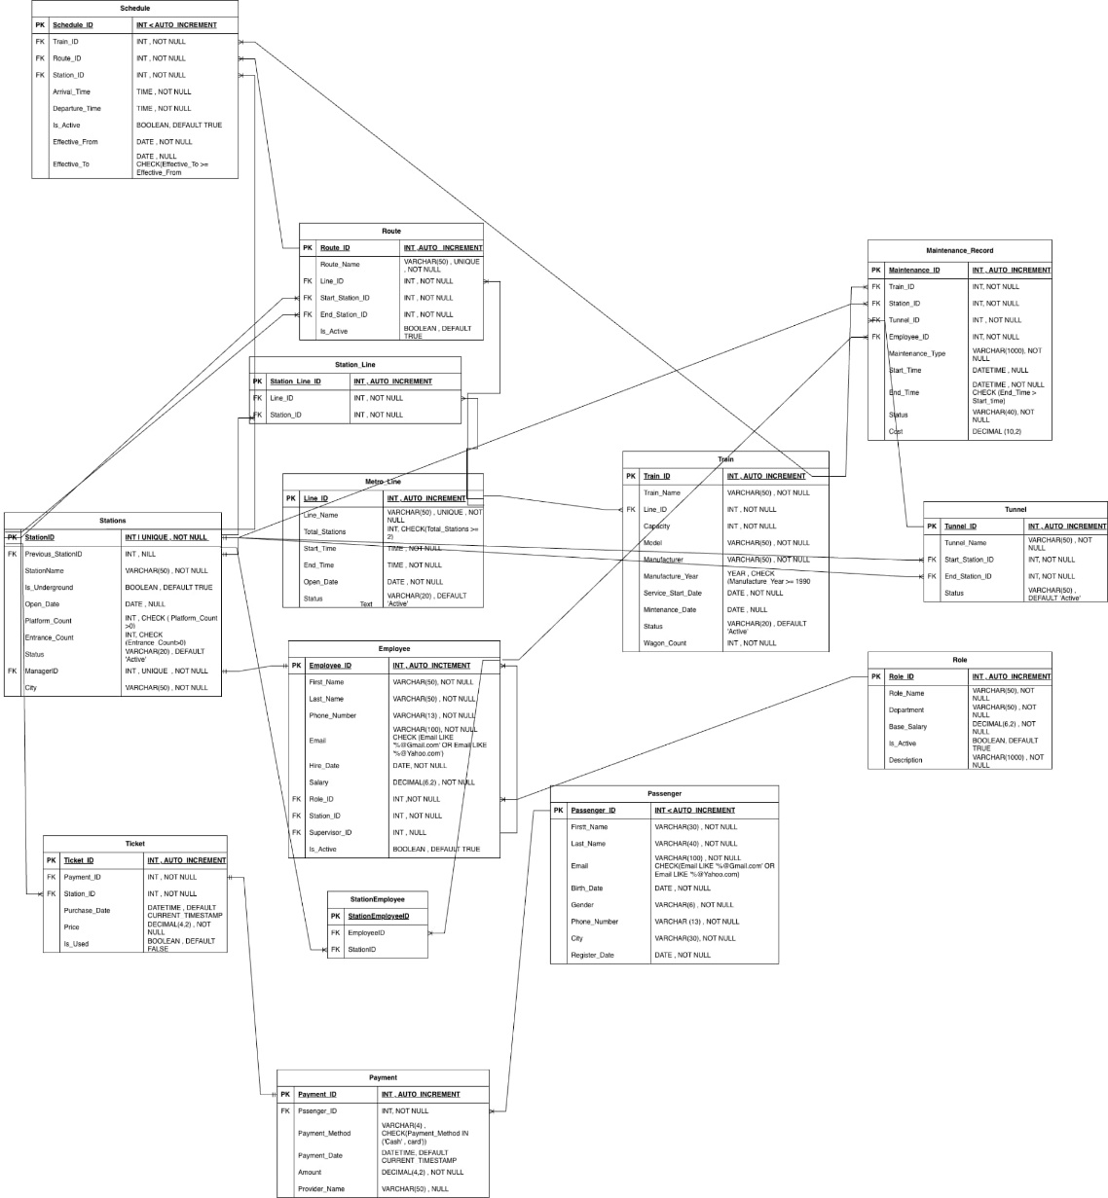

Objects
SCHEDULE
Stores the planned timetable for trains, including arrival and departure times at stations along a route..
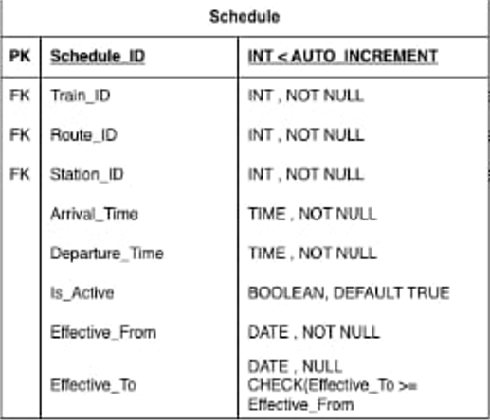
TrainID → Train(TrainID) (assigns the schedule to a specific train).
RouteID → Route(RouteID) (associates the schedule with a specific route).
StationID → Station(StationID) (indicates which station the train is scheduled for at a specific time)..
Example with data

scheduleid | trainID | routeid | stationID | arrivaltime | Dep_time | Is_active | effectivefrom | effectiveto
3 | 167 | 2 | 4 | 14:07 | 11:13 | true | 2025-10-10 | 2025-11-12
ROUTE
Represents a predefined path that trains follow, consisting of an ordered sequence of stations..
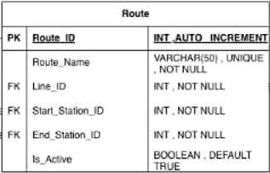
LineID → MetroLine(LineID) (assigns the route to a metro line)
StartStationID → Station(StationID) (indicates the first station of the route).
EndStationID → Station(StationID) (indicates the last station of the route).
Referenced by Schedule(RouteID) to assign schedules to trains along this route.
STATIONS
Stores information about metro stations, including name, location, manager, and connectivity to other stations.
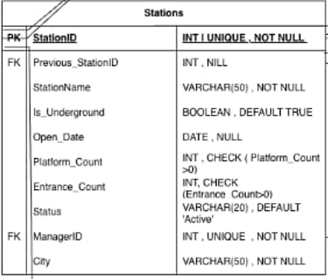
PreviousStationID → Station(StationID) (self-referential; indicates the station preceding this one on a line).
ManagerID → Employee(EmployeeID) (assigns an employee as the station manager).
Referenced by Schedule(StationID) to indicate train stops.
Connected to StationLine(LineID) to indicate which lines pass through the station.

STATIONLINE
Represents the association between metro lines and stations, indicating which stations belong to which metro lines.
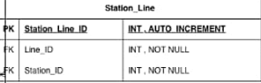
LineID → MetroLine(LineID) (links the station to a specific metro line).
StationID → Station(StationID) (links the line to a specific station).
METROLINE

Stores information about metro lines in the system, such as line name, color, and operational details.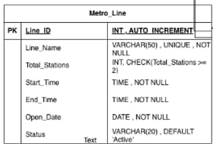
LineID → referenced by Route(LineID) to assign routes to the line.
LineID → referenced by StationLine(LineID) to link stations to the line.
TRAIN

Stores information about metro trains, including their identification, capacity, and assigned line.
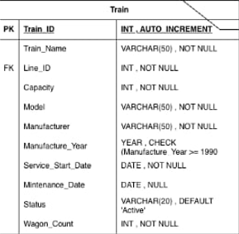
LineID → MetroLine(LineID) (assigns the train to operate on a specific metro line).
Referenced by Schedule(TrainID) to assign schedules for departures and arrivals.

EMPLOYEE

Stores information about metro staff, including operators, station personnel, maintenance workers, and administrative employees.
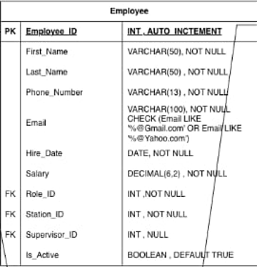
StationID → Station(StationID) (assigns the employee to a specific station).
SupervisorID → Employee(EmployeeID) (self-referential; links an employee to their supervisor).
RoleID → Role(RoleID) (defines the employee’s role or position within the metro system).

ROLE

stores information about employee roles or positions within the metro system, such as Train Operator, Station Manager, Maintenance Staff, or Ticket Inspector..
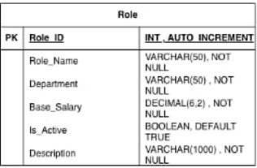
RoleID → referenced by Employee(RoleID) to assign a role to each employee.
PASSANGER

Stores information about metro passengers, including personal details and travel pass or subscription status.
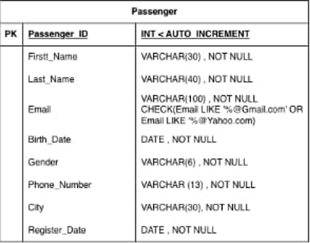
PassengerID → referenced by Payment(PassengerID) to track payments made by the passenger.

STATIONEMPLOYEE

Represents the assignment of employees to stations for specific stations.
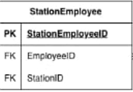
EmployeeID → Employee(EmployeeID) (links the assignment to a specific employee).
StationID → Station(StationID) (links the assignment to a specific station).
TICKET

Stores records of tickets purchased by passengers, including ticket type, validity, and associated travel details.
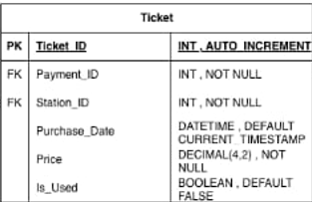
PaymentID → Payment(PaymentID) (links the ticket to its payment record).
StationID → Station(StationID) (indicates the station where the ticket was issued or validated).

PAYMENT

Records payments made by passengers for tickets or travel passes.
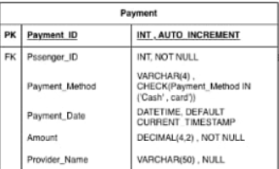
PassengerID → Passenger(PassengerID) (identifies the passenger making the payment).
Referenced by Ticket(PaymentID) to link one or more tickets to the payment

MAINTENANCERECORD

Stores information about maintenance activities performed on metro assets such as trains, tunnels, or stations
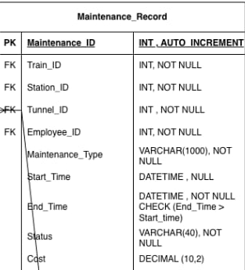
EmployeeID → Employee(EmployeeID) (identifies the employee responsible for the maintenance).
TrainID → Train(TrainID) (indicates the train being serviced, if applicable).
StationID → Station(StationID) (identifies the station where maintenance occurred, if applicable).
TunnelID → Tunnel(TunnelID) (indicates the tunnel involved in the maintenance task, if applicable).
TUNNEL
Represents the physical tunnels connecting metro stations along lines.
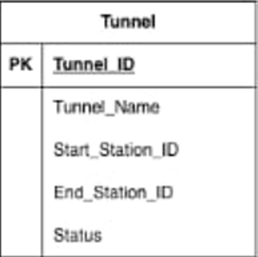
StartStationID → Station(StationID) (identifies where the tunnel begins).
EndStationID → Station(StationID) (identifies where the tunnel ends).
Referenced by MaintenanceRecord(TunnelID) to log maintenance on the tunnel.

