Security Precautions in the 'dvd_rental' Database

1. Existing Users / Roles and Their Permissions
SQL Query:
SELECT rolname, rolsuper, rolcreaterole, rolcreatedb, rolcanlogin, rolreplication, rolconnlimit
FROM pg_roles;
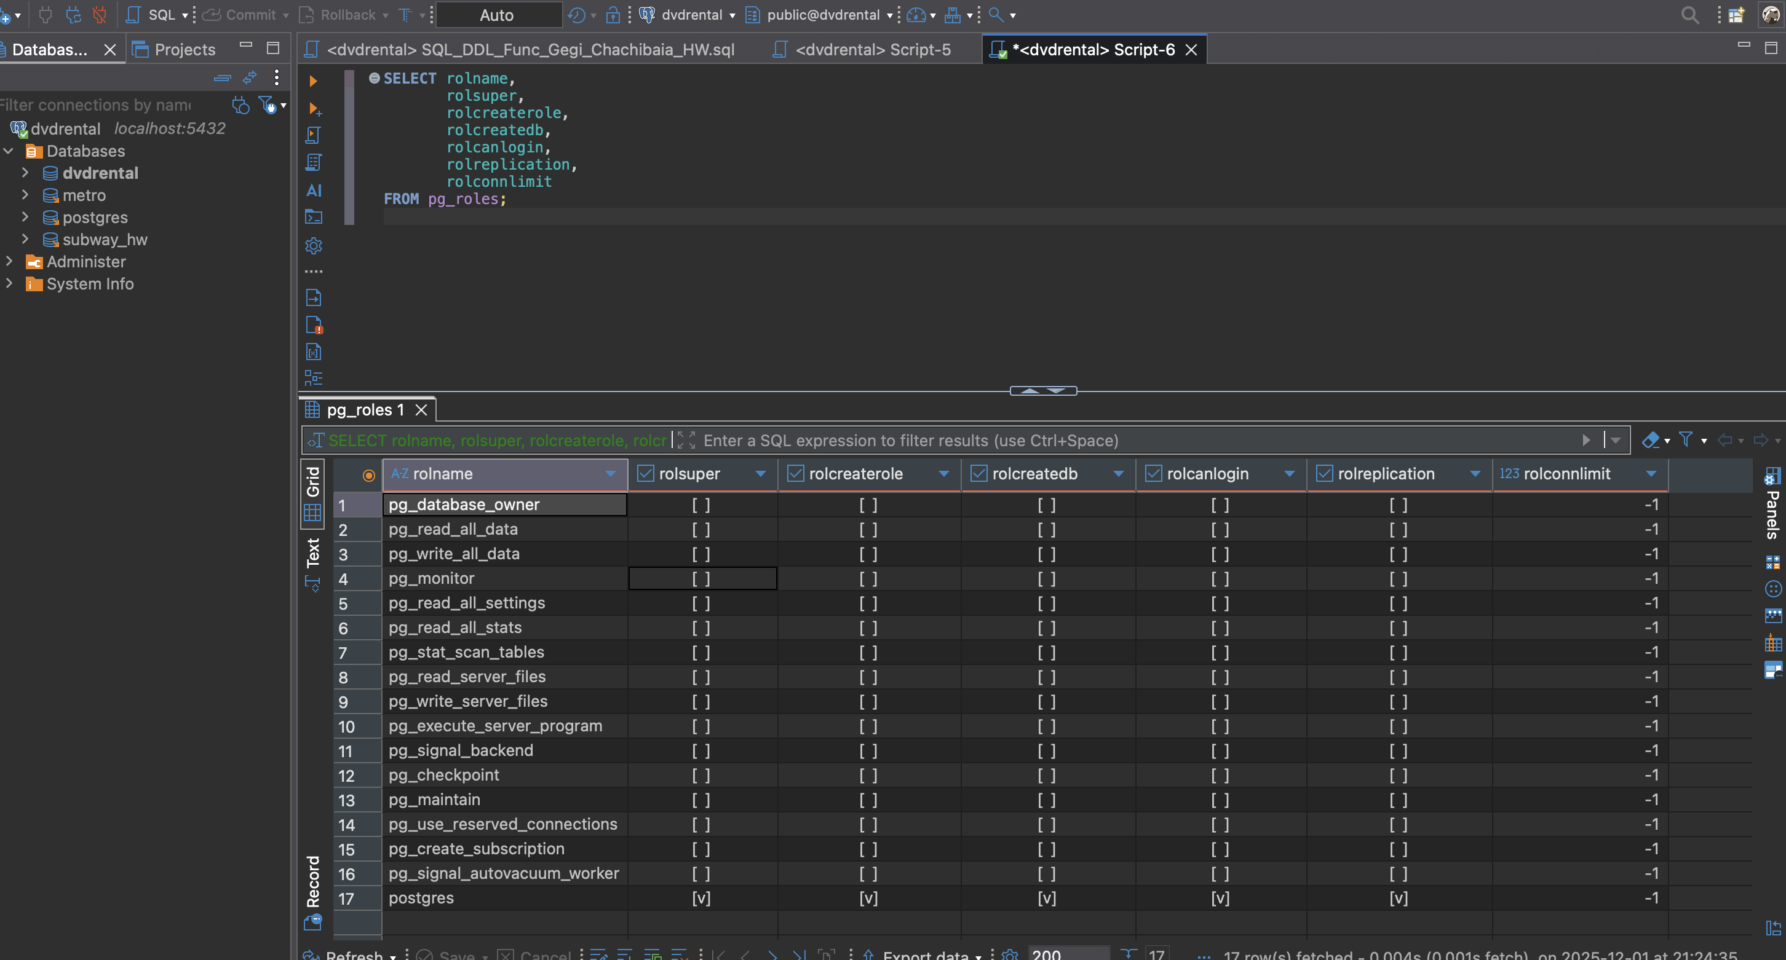

Findings:
Default roles like postgres, public, pg_read_all_data, etc. exist. postgres is the only superuser.

2. Table-Level Privileges
SQL Query:
SELECT table_schema, table_name, grantee, privilege_type
FROM information_schema.table_privileges
WHERE table_schema = 'public';
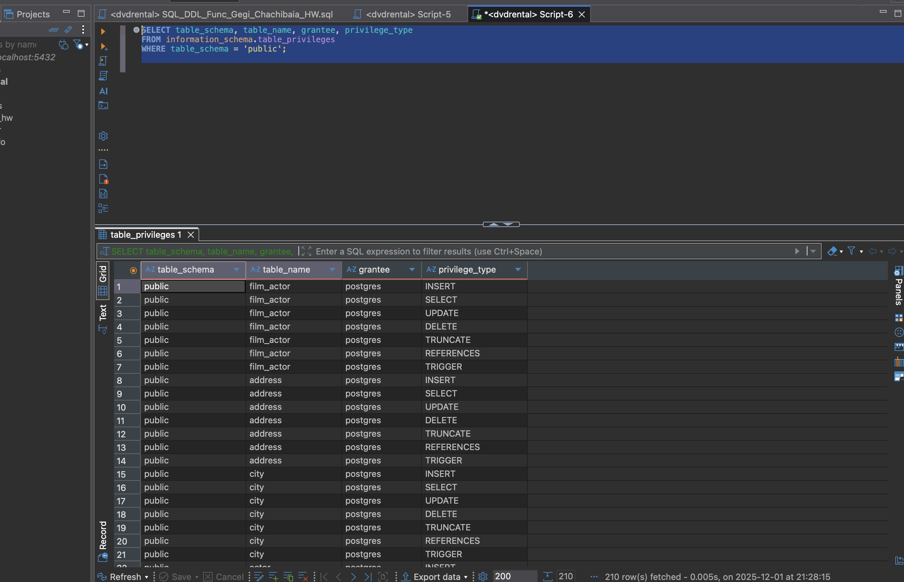
Findings:
Most tables grant SELECT to public and ALL PRIVILEGES to postgres.

3. Row-Level Security Policies
SQL Query:
SELECT relname, relrowsecurity FROM pg_class WHERE relkind = 'r';
SELECT * FROM pg_policies;
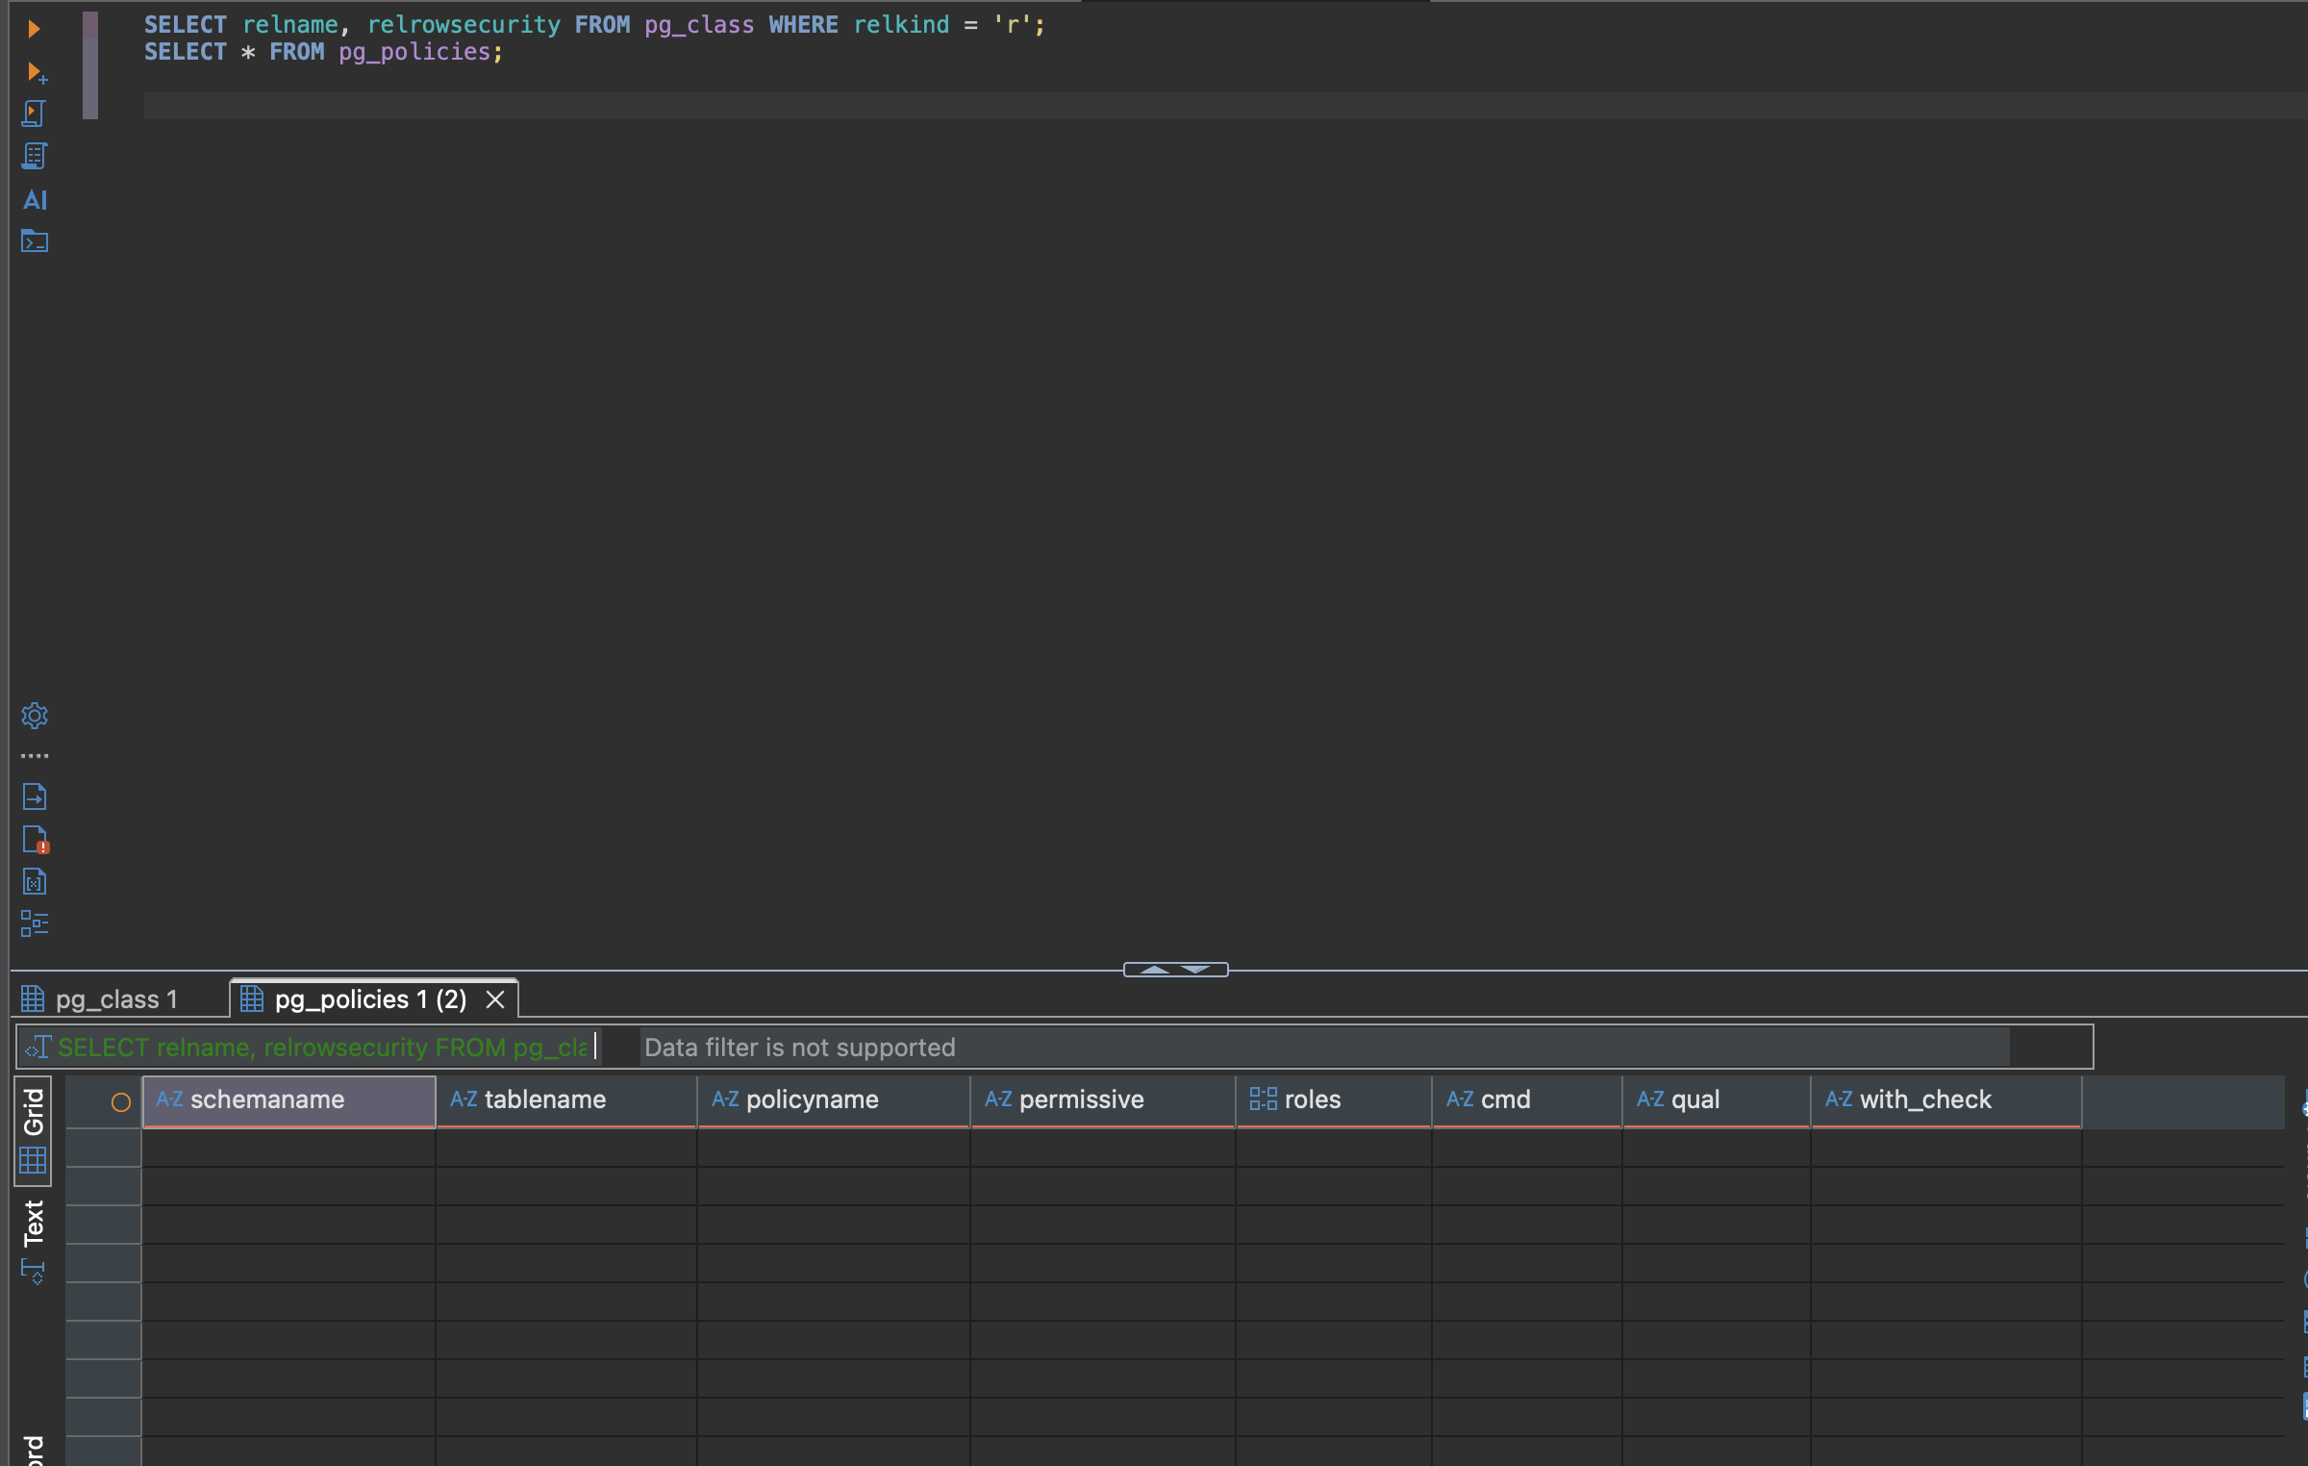
Findings:
No RLS enabled and no RLS policies exist in dvd_rental.

4. Database-Level Settings
SQL Query:
SELECT datname, datdba::regrole AS owner, datconnlimit, datacl FROM pg_database WHERE datname = 'dvd_rental';
SHOW password_encryption;

Findings:
Owner is postgres, unlimited connections, SCRAM-SHA-256 encryption.

