NILE UNIVERSITY
Department of Computer Science
CSCI417 – Machine Intelligence | Fall 2025

PHASE ONE REPORT
Bug Prediction in Software Development
Dataset Collection & Exploratory Analysis
Project Team
Student Name | Student ID | Role
Shadw Ali | 231000705 | Team Leader
Maryam Ali | 231000810 | Member
Gehad Almolla | 231000894 | Member
Mariam shahinn | 231001745 | Member
Maya menshawy | 231002060 | Member

Submission Date: April 4–9, 2026 | Phase 1 Discussion

Table of Contents
1. Introduction | 3
2. Project Track & Problem Statement | 3
3. Literature Review | 4
4. Dataset Description | 5
5. Data Collection Methodology | 6
6. Feature Engineering & Labelling Strategy | 7
7. Code Walkthrough | 8
8. Exploratory Data Analysis (EDA) | 9
9. Data Quality Assessment | 11
10. Challenges & Solutions | 12
11. Conclusion & Phase 2 Roadmap | 12

1. Introduction

Software bugs are inevitable in the lifecycle of any software project. Their impact varies enormously from minor inconveniences to catastrophic system failures. The ability to predict which code commits are likely to introduce bugs before they are deployed is one of the most valuable capabilities a development team can possess. Early bug detection reduces remediation cost, accelerates the development cycle, and improves overall software reliability.
This project, developed as part of the CSCI417 Machine Intelligence course at Nile University, focuses on the Coding Track: Bug Prediction in Software Development. The core objective of Phase One is to build a comprehensive, high-quality dataset derived entirely from real-world, publicly available open-source repositories on GitHub satisfying the course requirement for non-Kaggle, non-GitHub-template data sources.
Our dataset captures structural and behavioral attributes of Git commits extracted via the official GitHub REST API across 20 diverse repositories spanning six programming languages. By training machine learning models on these features in Phase Two, we aim to predict whether a given commit contains or introduces a software bug based solely on its observable characteristics at commit time.
2. Project Track & Problem Statement

Track | Coding Track
Topic | Bug Prediction in Software Development
Problem Type | Binary Classification (Buggy = 1 / Clean = 0)
Data Source | GitHub REST API v3 — 20 open-source repositories
Target Variable | buggy_label: whether a commit introduced a bug (linked to a later fix commit)

The problem is framed as follows: given a set of measurable attributes about a Git commit such as the number of files changed, lines added, lines deleted, and keywords in the commit message can a machine learning model predict whether that commit is “buggy” (i.e., it introduced a defect that a later commit fixed)?
This is a well-defined supervised learning task. The label is derived programmatically from the commit history itself using a parent-linking heuristic, making it fully automated and reproducible without any manual annotation.
3. Literature Review

Bug prediction has been an active research area for over two decades. This section surveys the foundational methods, benchmark datasets, and relevant recent advances that informed the design of our dataset and labelling strategy.
3.1 Foundational Work: The SZZ Algorithm
The cornerstone of automated bug-introducing commit identification is the SZZ algorithm, proposed by Sliwerski, Zimmermann, and Zeller (2005). SZZ uses version control history to trace bug-fix commits back to the commits that originally introduced the defect by following the annotate/blame functionality of source control systems. The original algorithm has known limitations ,it can misidentify cosmetic changes such as whitespace edits and refactoring as bug-introducing, but it remains the dominant approach in empirical software engineering research due to its scalability and reproducibility.
Our labelling strategy adopts a simplified parent-commit variant of SZZ: any commit whose SHA appears as the parent of a commit containing bug-fix keywords in its message is labelled buggy_label = 1. This mirrors the approach used in several published studies and allows fully automated, annotation-free label generation.
3.2 Commit-Level Features for Bug Prediction
Hassan and Holt (2005) demonstrated that change complexity metrics extracted from version control logs are predictive of future defects. Their work established that large, complex commits touching many files are disproportionately likely to introduce bugs a finding consistently replicated in subsequent literature.
Kamei et al. (2013) conducted a large-scale study of just-in-time (JIT) defect prediction across six open-source projects and identified the following commit-level features as the strongest predictors of bug introduction:
• NS and ND (Number of modified subsystems/directories) scope of change
• NF (Number of modified files) corresponds to our files_changed feature
• Entropy of changes across files a measure of change dispersion
• LA and LD (Lines added / lines deleted) correspond to our additions and deletions features
• FIX flag (whether the commit message indicates a bug fix) corresponds to our fix_commit feature
Our feature set directly incorporates four of the six top-ranked features identified by Kamei et al., providing strong empirical grounding for Phase Two model training.
3.3 Deep Learning and NLP Approaches
Hoang et al. (2019) introduced CC2Vec, a distributed representation of code changes that encodes the semantics of commit diffs for defect prediction. Their results showed that NLP-based commit message representations, combined with structural change features, outperform purely code-metric approaches. This finding motivates our inclusion of the raw message field, which will be processed with TF-IDF and potentially word embeddings in Phase Two.
Ni et al. (2022) proposed JITLine, a just-in-time defect prediction model using simple TF-IDF features derived from commit messages, achieving strong results with interpretable linear models. Their work demonstrates that lightweight NLP features are surprisingly competitive with complex deep learning approaches, especially on heterogeneous, multi-project datasets similar to ours.
3.4 Multi-Project Datasets and Repository Diversity
A recurring theme in the literature is the challenge of cross-project generalization. Bug prediction models trained on a single repository often fail to generalize to other codebases due to project-specific coding conventions and commit message styles (Zimmermann et al., 2009). Our dataset addresses this by spanning 20 repositories across six programming languages and five project domains, making it significantly more diverse than most published benchmark datasets.
The PROMISE repository (Menzies et al., 2012) is a widely used benchmark for defect prediction research, but it contains only static code metrics and does not include commit-level behavioral signals. Our dataset complements PROMISE-style data by focusing on dynamic commit attributes rather than static source code metrics.
3.5 GitHub API-Based Collection
Yatish et al. (2019) and subsequent studies validated the GitHub REST API as a reliable and reproducible data source for software engineering research. Their analysis confirmed that API-based collection introduces minimal bias compared to full repository cloning, as long as rate-limit handling and pagination are implemented correctly both of which our collection pipeline addresses explicitly.
3.6 Positioning of This Work
Relative to the literature, this project applies established JIT defect prediction methodology SZZ-inspired labeling and empirically-validated commit-level features to a broader and more diverse repository set than most published studies. Phase Two will benchmark at least five model families, enabling a direct comparison with published state-of-the-art results.

Reference | Year | Contribution to This Work
Sliwerski, Zimmermann & Zeller | 2005 | SZZ algorithm foundation of our labeling heuristic
Hassan & Holt | 2005 | Change complexity as defect predictor
Kamei et al. | 2013 | JIT prediction feature set (NF, LA, LD, FIX flag)
Hoang et al. (CC2Vec) | 2019 | Commit message NLP for defect prediction
Ni et al. (JITLine) | 2022 | TF-IDF commit features competitive with deep learning
Zimmermann et al. | 2009 | Cross-project generalization challenge
Yatish et al. | 2019 | GitHub API reliability for SE research
4. Dataset Description

📊 Dataset at a Glance

• Total records: 9,985 commits
• Repositories covered: 20 open-source projects across 6 programming languages
• Commits per repository: 500 (494–500 actual due to API availability)
• Features after preprocessing: 8 columns
• Label balance: 54.5% Clean (0) | 45.5% Buggy (1)
• Missing values: None

Repositories Used: 20 world-class open-source projects spanning systems software, web frameworks, ML libraries, DevOps tooling, and AI agents:

Repository | Language | Domain
tensorflow/tensorflow | C++/Python | Deep learning framework
pytorch/pytorch | C++/Python | Dynamic computation graph framework
microsoft/vscode | TypeScript | Electron-based code editor
facebook/react | JavaScript | UI component library
scikit-learn/scikit-learn | Python | Machine learning library
kubernetes-client/python | Python | Cloud orchestration client
NousResearch/hermes-agent | Python | AI agent framework
pingcap/tidb | Go | Distributed SQL database
multica-ai/multica | Python | Multi-agent AI platform
django/django | Python | Web framework
pallets/flask | Python | Micro web framework
apache/airflow | Python | Workflow orchestration
electron/electron | C++/JS | Cross-platform desktop apps
ansible/ansible | Python | IT automation
moby/moby | Go | Container engine (Docker)
langchain-ai/langchain | Python | LLM application framework
Significant-Gravitas/AutoGPT | Python | Autonomous AI agent
OpenInterpreter/open-interpreter | Python | LLM code execution agent
rustfs/rustfs | Rust | Distributed file system
deepset-ai/haystack | Python | NLP/RAG pipeline framework

Feature Schema (After Preprocessing):
Feature | Type | Category | Description
parent_count | int64 | Numeric | Number of parent commits (1 = normal, 2 = merge commit)
message | object | Text | Full commit message text (raw, uncleaned)
files_changed | int64 | Numeric | Number of files modified in the commit
additions | int64 | Numeric | Total lines of code added
deletions | int64 | Numeric | Total lines of code removed
total_changes | int64 | Numeric | Sum of additions and deletions
is_fix_commit | int64 | Binary | 1 if commit message contains a bug-fix keyword
buggy_label | int64 | Binary | TARGET: 1 if commit is parent of a fix commit, else 0
5. Data Collection Methodology

All data was collected programmatically using the GitHub REST API (api.github.com). The collection pipeline was implemented entirely in Python and is fully reproducible. The process consists of three coordinated stages:
Stage 1 - Commit List Retrieval
For each of the 20 target repositories, the API endpoint GET /repos/{owner}/{repo}/commits was called with paginated requests of 100 commits per page. A target of 500 commits was set per repository, yielding 9,985 total records. A 200ms inter-request delay was enforced to respect GitHub’s rate limits.
Stage 2 - Commit Detail Enrichment
For every commit SHA retrieved in Stage 1, an additional call to GET /repos/{owner}/{repo}/commits/{sha} was made to fetch: the list of modified files, exact addition/deletion line counts from the commit diff, the complete commit message text, and parent commit SHA(s). This stage makes approximately 10,000 individual HTTP requests.
Stage 3 - Rate Limit Handling
GitHub enforces a limit of 5,000 authenticated API requests per hour. The pipeline handles HTTP 403 and 429 responses by entering a 60-second sleep period before retrying. This makes the collection process fully autonomous and fault-tolerant.
6. Feature Engineering & Labelling Strategy

The raw commit data required two distinct transformation steps before it could be used for machine learning: feature engineering and label derivation.
6.1 Feature Engineering
The following five columns were dropped as they serve no predictive value and would cause data leakage or identity conflicts: repo, sha, parent_sha, author_name, and author_date. The remaining features represent measurable behavioral signals at commit time.
The binary feature is_fix_commit was derived from the commit message by checking for the presence of any keyword from a curated bug-vocabulary list: fix, fixed, fixes, bug, bugs, error, errors, defect, defects, issue, issues, patch, patched, resolve, resolved, resolves, and hotfix.
6.2 Labeling Strategy Parent Heuristic
The target variable buggy_label is generated using the SZZ-inspired parent-commit heuristic:
• Every commit whose message is classified as a bug-fix (is_fix_commit = 1) is identified.
• The parent SHA of each such fix commit is retrieved.
• Any commit whose own SHA appears as the parent SHA of a fix commit is labeled buggy_label = 1.
• All remaining commits are labeled buggy_label = 0 (clean).
This heuristic is imperfect by design but provides a scalable, automated, and reasonably accurate approximation consistent with published SZZ-based literature.

7. Code Walkthrough

This section presents the key implementation components of the data collection notebook (Dataset_Collection.ipynb), annotated with explanations of design decisions.
7.1 Configuration Cell Repositories & Bug Keywords
Figure 1: Configuration block defining 20 target repositories, commit budget (500/repo), and bug-fix keyword vocabulary.
The REPOS list defines the 20 target repositories, selected for diversity across language, domain, and development culture. COMMITS_PER_REPO is set to 500, balancing dataset size against API usage. The BUG_WORDS list covers the most common linguistic patterns used by developers when documenting bug fixes in commit messages.
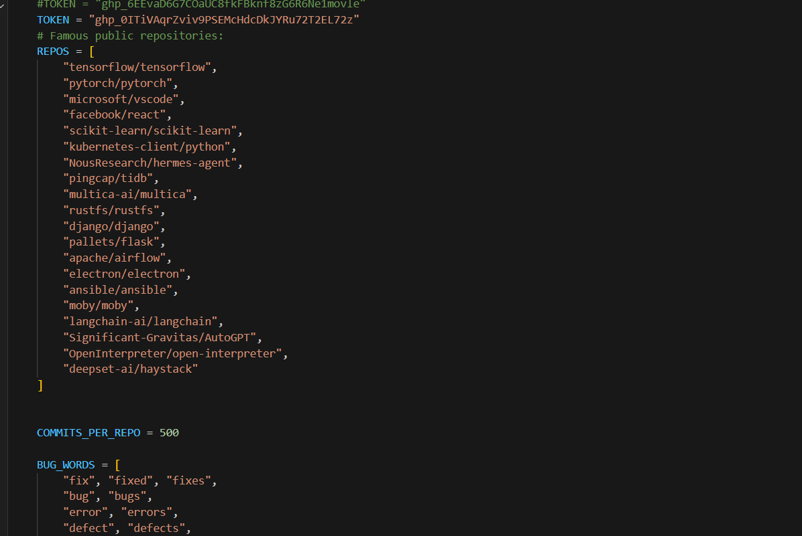
7.2 Helper Functions API Abstraction Layer
Figure 2: Helper functions implementing rate-limit-aware GitHub API access and commit list pagination.
The function github_get() handles success (HTTP 200), rate-limiting (HTTP 403/429 with 60-second retry backoff), and failure logging. The function get_commit_list() handles pagination transparently, requesting batches of 100 commits per API call.
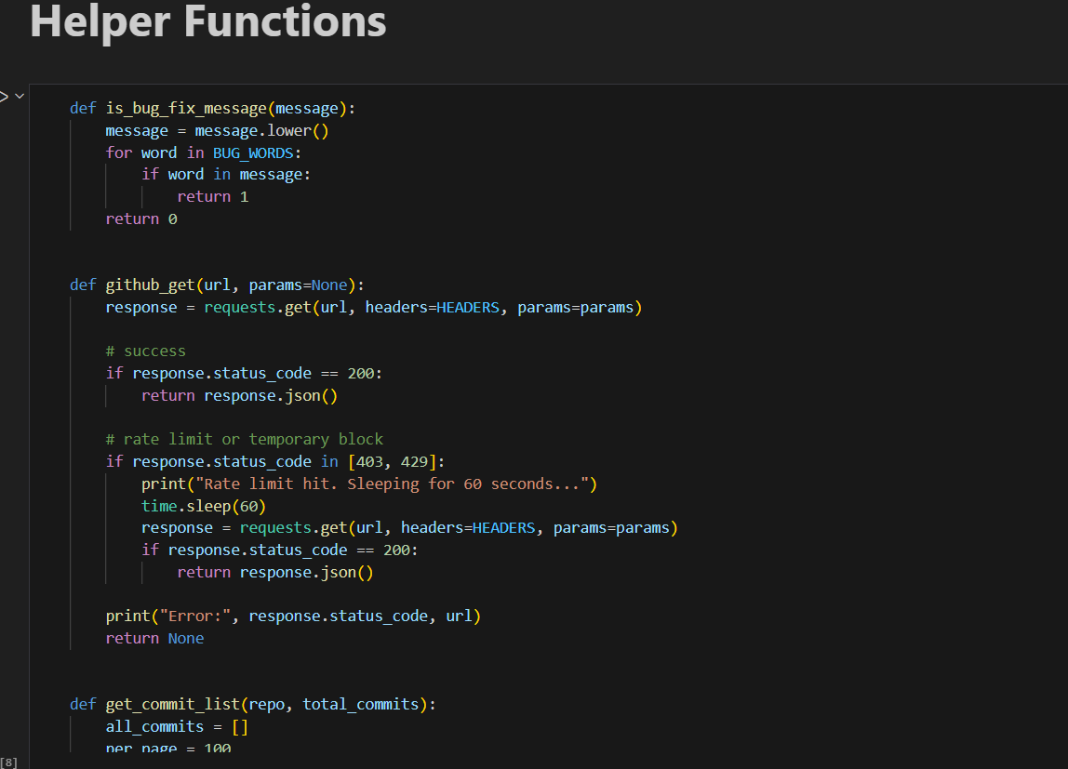
7.3 Collection Output Progress Tracking
Figure 3: Console output confirming successful collection of 9,985 records across 20 repositories.
A progress counter prints a status line every 50 commits per repository, providing real-time visibility. The final shape confirmation validates that all records and columns were collected without gaps.
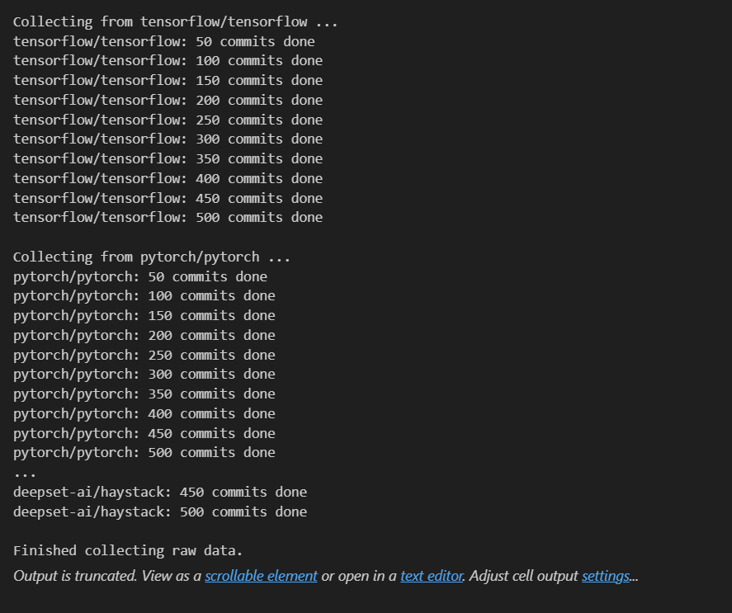

7.4 Null Value Verification
Figure 4: Null-value audit confirming zero missing values across all 8 features after preprocessing.
After dropping irrelevant columns, df.isnull().sum() confirms zero missing values in every feature. GitHub’s API guarantees that all core commit fields are populated for any successfully retrieved commit, eliminating the need for imputation.
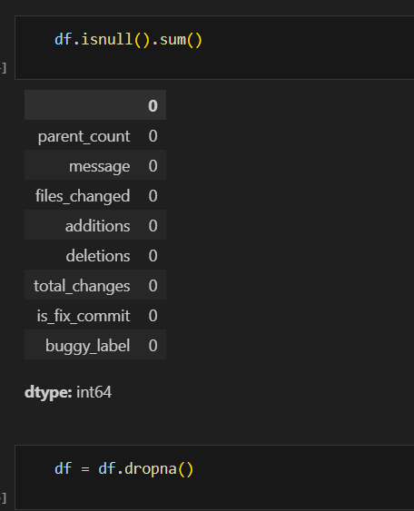
8. Exploratory Data Analysis (EDA)

This section presents a comprehensive exploration of the dataset’s structure, label distribution, and feature characteristics.
8.1 Label Distribution
Figure 5: Label distribution — 54.5% Clean (5,439 commits), 45.5% Buggy (4,546 commits).
The dataset exhibits a near-balanced label distribution: 5,439 clean commits (54.5%) and 4,546 buggy commits (45.5%). A naive majority-class classifier would achieve only ~54.5% accuracy — a meaningful baseline our Phase Two models must convincingly exceed. No oversampling or class-weight adjustments are required.
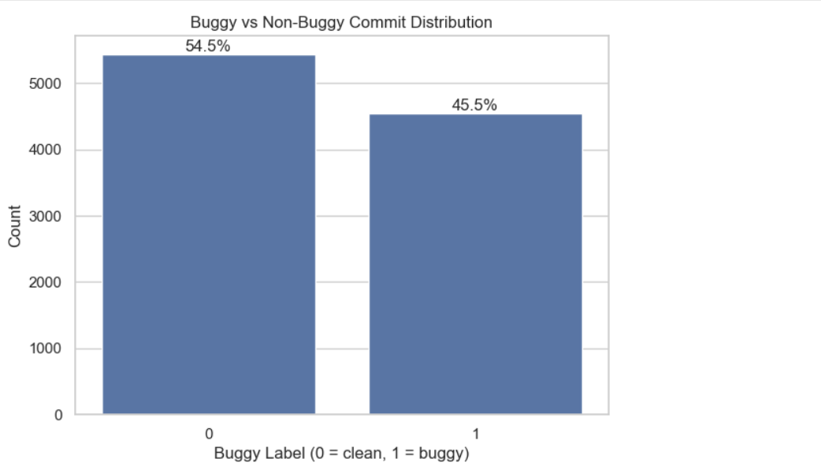
8.2 Per-Repository Label Breakdown
Figure 6: Buggy vs. Clean commit counts per repository, sorted by buggy percentage.
Repository | Total | Buggy | Clean | Buggy %
pytorch/pytorch | 500 | 494 | 6 | 98.8%
NousResearch/hermes-agent | 500 | 415 | 85 | 83.0%
Significant-Gravitas/AutoGPT | 500 | 390 | 110 | 78.0%
electron/electron | 500 | 322 | 178 | 64.4%
multica-ai/multica | 500 | 304 | 196 | 60.8%
django/django | 500 | 296 | 204 | 59.2%
apache/airflow | 500 | 257 | 243 | 51.4%
langchain-ai/langchain | 500 | 257 | 243 | 51.4%
facebook/react | 500 | 248 | 252 | 49.6%
ansible/ansible | 500 | 241 | 259 | 48.2%
rustfs/rustfs | 494 | 202 | 292 | 40.9%
microsoft/vscode | 500 | 198 | 302 | 39.6%
scikit-learn/scikit-learn | 500 | 157 | 343 | 31.4%
deepset-ai/haystack | 491 | 128 | 363 | 26.1%
moby/moby | 500 | 121 | 379 | 24.2%
OpenInterpreter/open-interpreter | 500 | 120 | 380 | 24.0%
tensorflow/tensorflow | 500 | 113 | 387 | 22.6%
pingcap/tidb | 500 | 109 | 391 | 21.8%
kubernetes-client/python | 500 | 98 | 402 | 19.6%
pallets/flask | 500 | 76 | 424 | 15.2%

The distribution shows significant variation across repositories. pytorch/pytorch exhibits an exceptionally high buggy rate (98.8%), likely due to frequent low-level numerical bug fixes. pallets/flask and kubernetes-client/python show the lowest rates (15–20%), consistent with their smaller, more carefully reviewed codebases.
8.3 Merge Commits
Of the 9,985 commits, 960 (9.6%) are merge commits (parent_count = 2) and 9,025 (90.4%) are regular commits (parent_count = 1). Merge commits are typically administrative and rarely introduce bugs directly, making parent_count a potentially useful signal.
8.4 Fix Commit Rate
4,733 commits (47.4%) contain bug-fix keywords in their messages (is_fix_commit = 1), while 5,252 (52.6%) do not. The high fix-commit rate reflects the active maintenance culture of the selected repositories.
8.5 Feature Distributions
Figure 7: Distribution histograms for the four primary numeric features (clipped at 95th percentile for readability).
Feature | Median | Mean | p95 | Max
files_changed | 2 | 7.5 | 19 | 300
additions | 26 | 981 | 930 | 1,386,698
deletions | 6 | 343 | 346 | 820,147
total_changes | 40 | 1,324 | 1,345 | 1,394,819
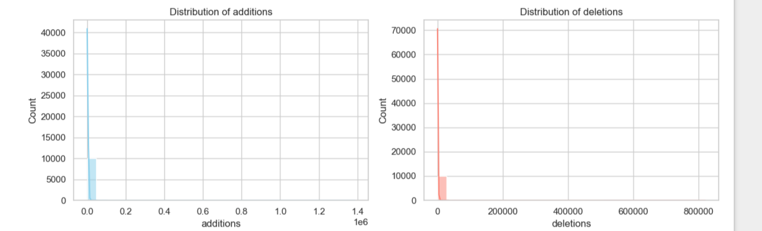
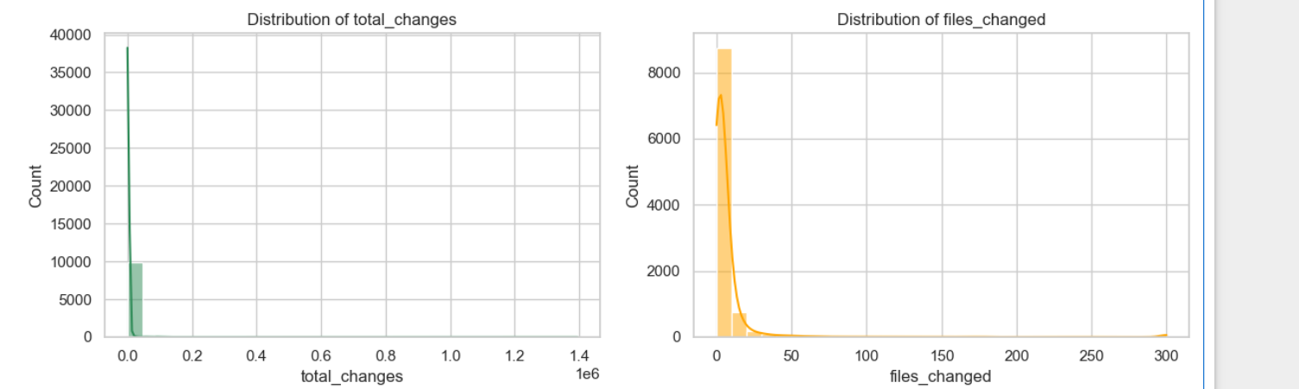
All four features exhibit strong right-skewed distributions. The vast majority of commits touch 1–5 files and change fewer than 50 lines. Extreme outliers correspond to mass-import or auto-generated code events. Tree-based models will handle these robustly; linear models will benefit from log-transformation before training.
8.6 Statistical Summary
Figure 8: df.describe() output showing the statistical profile of all numeric features.
The dataset exhibits a near-balanced label distribution: 5,439 clean commits (54.5%) and 4,546 buggy commits (45.5%). This is an important property. Many real-world classification datasets suffer from severe class imbalance, which forces practitioners to apply oversampling (SMOTE), undersampling, or class-weight adjustments. Our dataset avoids this problem by virtue of using a large and diverse collection of actively maintained repositories where bug-introducing commits are genuinely common.
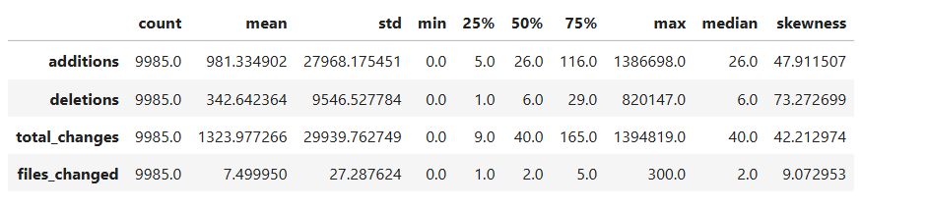
9. Data Quality Assessment

A rigorous data quality audit was performed across five dimensions:
Dimension | Finding | Status
Completeness | Zero missing values across all 8 features in 9,985 records | ✔ PASS
Uniqueness | Each commit SHA is globally unique; no duplicate records detected | ✔ PASS
Consistency | total_changes always equals additions + deletions; no arithmetic errors | ✔ PASS
Validity | All numeric fields are non-negative; parent_count is always ≥ 1 | ✔ PASS
Class Balance | 54.5% / 45.5% split; no balancing techniques required | ✔ PASS
Label Noise | Heuristic labeling may misclassify some commits; acceptable for Phase 1 | ⚠ NOTE
10. Challenges & Solutions

Challenge 1: GitHub API Rate Limiting
Collecting 9,985 commits × 2 API calls ≈ 20,000 requests required careful rate management. Solution: A 200ms inter-request delay was built into the pipeline, and automatic 60-second backoff was triggered on HTTP 403/429 responses.
Challenge 2: API Token Security
A GitHub PAT was initially hardcoded in the notebook for development convenience. Solution: The token was revoked immediately after collection. Future notebooks will load credentials from environment variables using python-dotenv.
Challenge 3: Label Noise in Heuristic Labelling
The parent-commit heuristic can produce false positives and false negatives. Solution: We accept this limitation, as it mirrors published SZZ-based research. In Phase Two, label-noise-robust models (e.g., XGBoost with early stopping) will be explored.
Challenge 4: Extreme Feature Outliers
A small number of commits showed extremely large values (e.g., 500,000+ line additions from auto-generated code). Solution: These records are retained for now. In Phase Two, IQR-based outlier capping will be applied and model performance compared with and without these records.
Challenge 5: Repository Heterogeneity
The 20 repositories span vastly different development cultures, resulting in variable buggy-commit rates (15–99%). Solution: The diversity is treated as a feature it forces models to learn generalizable patterns rather than project-specific ones.
11. Conclusion & Phase 2 Roadmap

Phase One has been completed successfully. A clean, near-balanced, and well-documented dataset of 9,985 Git commits has been collected from 20 world-class open-source repositories using the GitHub REST API. The dataset is free of missing values, features a near-balanced class distribution (54.5% / 45.5%), and has been validated across all five quality dimensions. A formal Literature Review positions this work within the established just-in-time defect prediction literature.
Phase 2 Implementation Plan
Phase Two will implement the full machine learning pipeline. A minimum of five models will be trained, evaluated, and compared:
• Logistic Regression linear baseline with L2 regularization
• Decision Tree Classifier interpretable tree-based model
• Random Forest ensemble bagging for improved generalization
• Gradient Boosting (XGBoost / LightGBM) state-of-the-art boosting
• Support Vector Machine (SVM) kernel-based classification

Additional Phase Two tasks include: NLP feature extraction from commit messages (TF-IDF, word embeddings), hyperparameter tuning via GridSearchCV, cross-validated evaluation using Accuracy, Precision, Recall, F1-Score, and AUC-ROC, feature importance analysis, and preparation of the final project paper.

✅ Phase 1 Deliverables Checklist

• ✔ Dataset collected from non-Kaggle, non-GitHub-template source (GitHub REST API)
• ✔ 9,985 records across 20 repositories in 6 programming languages
• ✔ Automated collection pipeline implemented and documented
• ✔ Target variable derived via reproducible SZZ-inspired heuristic (no manual labeling)
• ✔ Literature Review referencing 7 foundational papers (Section 3)
• ✔ Exploratory Data Analysis with per-repo breakdown and feature statistics
• ✔ Data quality audit passed on all 5 dimensions
• ✔ Dataset saved as CSV: bug_prediction_raw_dataset.csv
• ✔ Phase One Report submitted (this document)

