CMP 464 Data Science

Professor: Liang Zhao

Geidy Dorviny Molina

Final Project

<https://github.com/Geidy/Data-911>

911 End to End Data

The 911 End to End Data offers a range of statistic information in regards with the Agency and incident types called, received. Specifically, Agency meaning the FDNY fire_department, NYPD police_department and EMS emergencies. Furthermore, Final Incident Type column represent the different cases, or definition of the incident that has been report over the phone to the 911 line.

The 911 End-To-End dataset has 30 columns and 2500 rows. The main idea is to analyze and explore the data using Numpy, Data Frame, Time Series and plotting my findings in a Scatter plot or Histogram. I have divided the data in groups to get a better perspective. I mainly focused in separating the 911 calls by departments. On my research, I amount of Incidents. As well as, how to correlate the Incident Type by different departments. For example, for the Police Department what’s the average of incidents. If the date is giving, I will look for periods of more frequency in incidents that involve the different departments quick response. I will get to conclusions depending on the results of my research.

Phase I of the Jupyter Notebook represents the Loading and extraction of the general Data. It represents general statistic of the whole data. For example, the volumes of called and info in regard to all the main Agency together.

Phase II The main idea is to divide and identify some differences between the volume of incidents for each Agency. In this diagram are shown a simple colorful line defining the frequency of incidents type for each Agency. However, it doesn’t show a clear understanding. For a better idea a correlation of the data needs to be done.

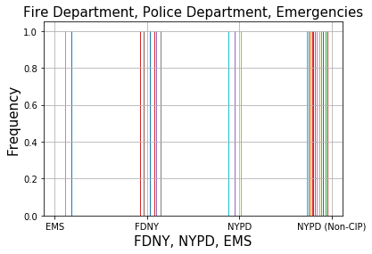

Phase III Correlation. It starts with a correlation of the data incidents generated for each department.

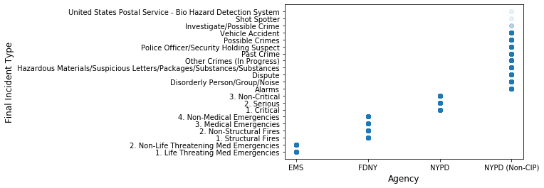

In the previous Histogram the Categorization of incidents for each department is shown. Emergency has two main incidents: Life Threating Medical Emergencies and Non-Life Life Threating Medical Emergencies. FDNY has four: Structural fires, Non-Structural Fires, Medical Emergencies and Non-Medical Emergencies. NYPD has Three: Critical, Serious and Non-Critical. Last one, NYPD (Non-CIP) which I have analyzed separate. It means Non-Crime In Process but has a high volume of called, as well.

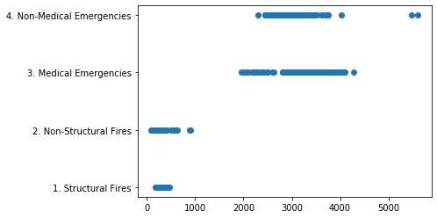

The scatter plot shows the amount of calls related by its specific incident Type. These is a correlation between the calculated number of incident Types and Incident for FDNY, Fire Department. As we can see in NYC the Fire Department has many more requests for Medical and Non - Medical Emergencies issues than for Structural Fires. The Numbers shown 0 to 1000 for Structural and Non - Structural Fire. And from 2000 to 4500 for Medical and Non - Medical Emergencies.

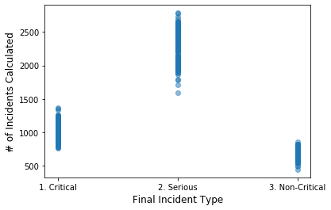

Scatter for The Police Department

* The bigger # of Incidents calculated are for Serios Incidents between 1500 and 3000
* Critical Incidents goes from 700 to 1200
* Non - Critical has the smaller # of incidents less than 1000

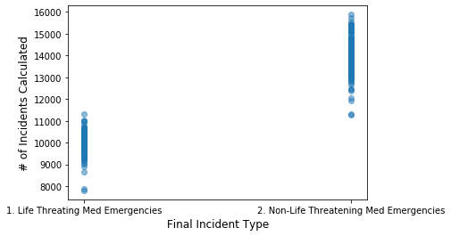

Scatter for Emergencies

* The bigger # of incidents go to Non-Life-Threatening Medical Emergencies between 11000 and 16000
* Life Threatening Med Emergencies has a smaller # of incidents between 8000 and 11000

The NYPD (Non-CIP) has a wider range of incident with higher calls and request than the rest of the data. It is composed for 13 types of Incidents. Out of all the incidents the ones with higher calls are Dispute, Past crime, possible Crimes and Vehicle Accidents.