# Geierwally's Control – Line – Application

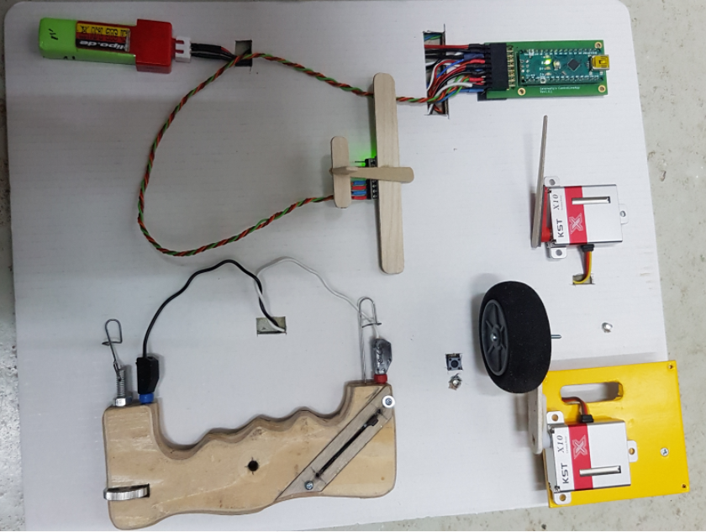

**G**eierwally's **C**ontrol – **L**ine – **A**pplication (GCLA) realizes a throttle control in combination with position control and additional functions for control line models with stroke engines.

This allows the model to be started without helpers, a flight that can be interrupted at any time and an optional automatic control of the throttle carburettor depending on the flight position.

The linear potentiometer for the throttle control is located in the control handle. The encoder signal is transmitted through the two control lines, evaluated by a microcontroller (Arduino Nano) and mechanically transmitted via a servo to the throttle carburettor of the stroke engine. An LED in the edge arc of the model indicates the operating status of the controller, as well as the remaining flight time during the flight. Optionally, the position-dependent throttle control can be activated or deactivated during the flight. The position control automatically makes the engine leaner during ascending - and fatter during descending flight. The control areas can be taught. Optionally, expo from 10 – 100% can be mapped to the control. The minimum throttle position as well as the position for engine shut-off can be also taught. Flight times can be set from 1 – 10 minutes. After each minute, the remaining flight time is flashed by the status LED. If the flight time has elapsed, this is signalled by continuous flashing of the LED and by briefly throttling the engine for one second.

In addition, the microcontroller monitors both cell voltages of the supply battery (2S LiPo 330 mAh). If this drops below 3.5 V for one or both cells, this is also signalled by continuous flashing of the status LED. Short throttle pulses can be used to switch the flight attitude control on or off and to control additional functions such as retractable landing gear or landing lights.

## **Description of Hardware Components**

The core of the control system is an Arduino Nano microcontroller. The position control sensor is an MPU 6050 gyroscope accelerometer unit. The sensor signals are read in via I²C interface. Further connection assignments can be seen in the circuit diagram and layout in the KiCad project. The encoder for the throttle control is a linear potentiometer, which is installed in the control handle of the control line model.

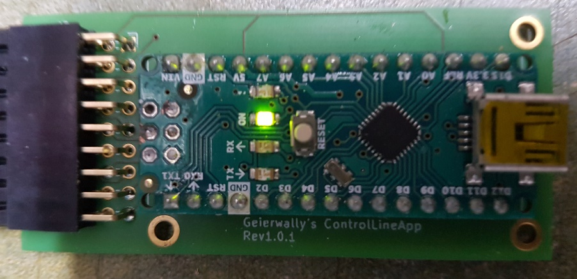

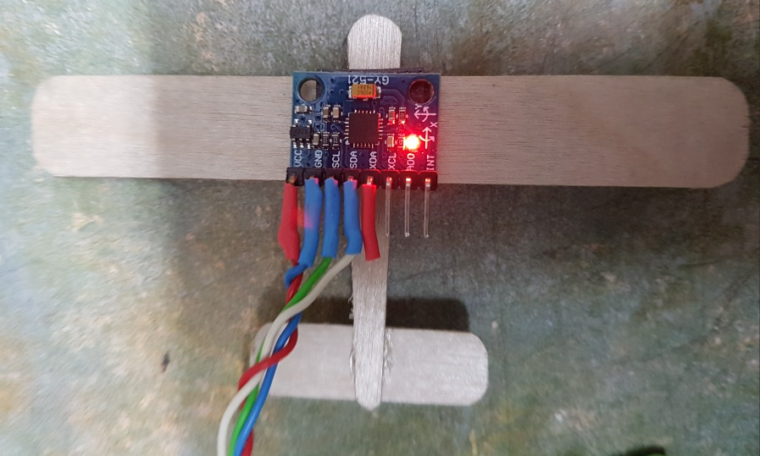

## **Installation of the control components in the model**

The controller board, power supply battery and servo can be installed in the wing or fuselage, depending on the space. The battery bay should be easily accessible. The MPU 6050 gyroscope unit should be installed at the pivot point of the transverse and longitudinal axis. The MPU 6050 sensor unit can optionally be mounted normally or inverted and suspended downwards. Be sure to mount the sensor unit vibration-damped, preferably using adhesive pads for helicopter gyroscopes!

The encoder signal from the control handle is connected to the inner edge arch of the wing via micro banana bushings. To avoid a short circuit of the encoder cable, the control triangle of control line model must be made of non-conductive material such as Pertinax.

## **Teach-in servo positions, time-of-flight timer and voltage monitoring**

To avoid mechanical blockages, the control linkages from the servo to the throttle carburetor and, if used, to the retractable landing gear must be disconnected before the servo positions are taught for the first time. The front end position of the servo (full throttle) can be adjusted mechanically without blockage. The same applies to retractable landing gear retracted. To access the teach menu, press and hold the user button until the status LED signals the corresponding menu by flashing. The following main teach menu items are implemented:

teach servo throttle position 2 * flashing

teach servo end position (motor shut-off) 3 * flashing

teach servo direction 4 * flashing

encoder potentiometer end positions 5 * flashing

retractable landing gear 6 * flashing

voltage monitoring 7 * flashing

gyroscope – teach menu 8 * flashing

flight time – timer 9 * flashing

Position teaching is described in the following steps and should be done exactly in this order.

### Teach-in of the encoder end positions (main menu 5 * flashing)

To do this, hold down the menu button until the status LED has flashed five times in a row.

In the submenu, the LED flashes once or twice for each end position. First, place the potentiometer in an end position and press the teach button briefly. LED now flashes twice to bring the potentiometer to the second end position and confirm with a short button click. The positions are now permanently stored in the E²Prom of the microcontroller.

### Servo direction reversal, only when required (main menu 4 * flashing)

To do this, press and hold the menu button until the status LED has flashed four times in a row. This menu item can only be selected if the servo needs to be reversed depending on the mounting position in the model. In this menu item, no confirmation via the teach button is required. The servo activates or deactivates the reversal of the direction of travel. This position is also permanently stored in the E²Prom of the microcontroller.

### Servo end position motor shut-off (main menu 3 * flashing)

Move the sensor to the middle position and hold down the menu button until the status LED has flashed three times in succession. Position the encoder potentiometer so that the throttle carburettor is in the end position for the engine shut-off without blocking. Confirm the position by briefly pressing the menu button. The position remains stored in the E²Prom of the microcontroller.

### Servo Minimum throttle position (main menu 2 * flashing)

Move the encoder potentiometer to the middle position and hold down the menu button until the status LED has flashed twice in succession. Position the potentiometer so that the throttle carburettor is in the minimum throttle position. This position should be tested beforehand with the engine running and marked on the transducer stick. The same applies to all other throttle carburettor positions. Confirm the position by briefly pressing the menu button. The position remains stored in the E²Prom of the microcontroller.

### Behaviour in case of short circuit of control wires (main menu 5 * flashing)

This function is only active when position control is inactive. It is set here whether the throttle carburettor goes into full throttle or engine shutdown in the event of a short circuit. A short circuit occurs, for example, when you fly a loop. With position control activated, it remains active until you fly a loop in the opposite direction and the control wires are free again. For aerobatic models, of course, engine shutdown in the event of a short circuit would not be an option!! To teach, press and hold the menu button until the status LED flashes five times in a row. You are now in the submenu.

If the LED flashes once and you confirm, the motor shut-off is active in the event of a short circuit. If the LED flashes twice and you confirm with the menu button, full throttle is activated in the event of a short circuit of the encoder cable. The option is permanently stored in the microcontroller's E²Prom.

### Supply Voltage Single Cell Monitoring (Main Menu 7 * Flashing)

This function is used to calibrate the two analogue to digital converters inputs of the voltage monitor. To do this, fully charge the supply battery until a single-cell voltage of 4.2 volts is reached. Plug in the battery, press and hold the menu button until the status LED flashes seven times in a row. Further confirmation is not necessary in this teaching function. The calibration value is permanently stored in the E²Prom of the microcontroller. If one or both LiPo cells fall below 3.5 volts, the status LED signals the fault with continuous flashing.

### Setting flight time timer (main menu 9 * flashing)

This function is used to set the flight time timer. Times of 1 minute – 10 minutes are possible depending on the tank volume and the resulting engine runtime. If the timer is active, the remaining flight time in minutes is signalled every minute during the flight by flashing the status LED. When the end of the flight time is reached, the status LED switches to continuous flashing and the engine throttles briefly for a second. End of flight time should of course signal before the tank is empty, so that you can still land safely with the throttle function.

To teach, press and hold the menu button until the status LED flashes nine times in a row.

You are now in the submenu and the LED flashes one to ten times depending on the number of flight minutes. You have to confirm the desired number of minutes with the menu button. This data is also stored permanently. The time-of-flight timer is started and stopped again by briefly pressing the menu button. The end of the flight time can also be confirmed by briefly pressing the menu button. When the timer is started, it immediately signals the set flight time with LED flashing.

## **Position-dependent throttle control via gyroscope accelerometer (main menu 8 * flashing)**

The GCLA has an optionally activated position-dependent throttle control. The flight position is recorded by an MPU 6050 gyroscope – accelerometer sensor unit. For position control, the throttle positions for neutral and inverted flight (70 – 80% rpm) as well as the throttle position for dive (between 5 – 20% rpm) are taught. The speed positions should be set with a tachometer before teaching while the engine is running and marked on the encoder. This makes it easier to teach it later.

The position control can be switched on or off at any time during the flight by briefly throttling the engine. This is indicated by the status LED. Blink briefly twice = position control active. The optional deactivation allows the model to be started without position control and at full throttle. Otherwise, only the learned 70 – 80% speed would be active in neutral position. It should be full throttle for the start. Below is the description of the position control teach submenu

To access the Position Control Teach submenu, press and hold the menu button until the status LED flashes eight times in a row. You are now in the submenu of the position control.

The following submenu items are implemented:

sensor unit normal mounting position 1 * flashing

sensor unit hanging mounting position 2 * flashing

calibrate sensor unit 3 * flashing

throttle position normal flight 4 * flashing

throttle position dive 5 * flashing

expo 6 * flashing

position control on 7 * flashing

position control off 8 * flashing

position control leave teach menu 9 * Flashing

### Normal mounting position gyroscope accelerometer unit (submenu 1 * flashing)

Select this option if the gyroscope accelerometer sensor unit is normally mounted from above. Depending on the space in the model, it can be mounted normally from above or suspended from below. The sensor unit should be mounted at the pivot point of the transverse and longitudinal axis in a vibration-damped manner. For this purpose, adhesive pads of helicopter gyroscopes can be used. For this function, after a single LED flash, briefly confirm with the menu button. The option will be saved and you will immediately be back in the Gyro - Teach - submenu.

### Hanging mounting position gyroscope accelerometer unit (submenu 2 * flashing)

Select this option if the gyroscope accelerometer sensor unit is suspended mounted. Function is otherwise analogous to menu item 4.1. Confirm the teach after blinking the status LED with the menu button.

### Calibration of the gyroscope accelerometer unit (submenu 3 * flashing)

This menu item is used to calibrate the gyroscope accelerometer unit. To do this, confirm after flashing the LED three times by clicking on the menu button. Calibration takes one minute. During this time, the model should be rotated in all axes so that the sensor comes into all possible flight positions. After one minute, the calibration data is permanently stored and you are automatically back in the Gyro – Teach – submenu.

### Position control normal flight - throttle position (submenu 4 * flashing)

This is used to teach the throttle position for normal flight / inverted flight. This should be between 70 and 80% speed. It is best to determine beforehand with a tachometer and mark it on the encoder. To teach the position in the submenu, after flashing four LEDs, confirm with the menu button, move the encoder to the desired position and save it by pressing the teach button again. After that, you are back in the Gyro – Teach – submenu.

### Position control dive - throttle position (submenu 5 * flashing)

This is used to teach the throttle position for diving. This should be between 5 and 15% speed. It is best to determine beforehand with a tachometer and mark it on the encoder. To teach the position in the submenu, after flashing the LED five times, confirm with the menu button, move the encoder to the desired position and save it by pressing the teach button again. After that, you are back in the Gyro – Teach – submenu.

### Expo position control (submenu 6 * flashing)

With this function, you can overlay the position-dependent throttle control with expo. This works in a similar way to how you use expo on the RC models.

Confirm with the menu button after status LED has flashed six times. You can now choose between 0% = linear control curve and 100% = maximum exponential superposition in steps of ten. The following control curves were recorded directly with the controller and illustrate the application of expo to throttle control:

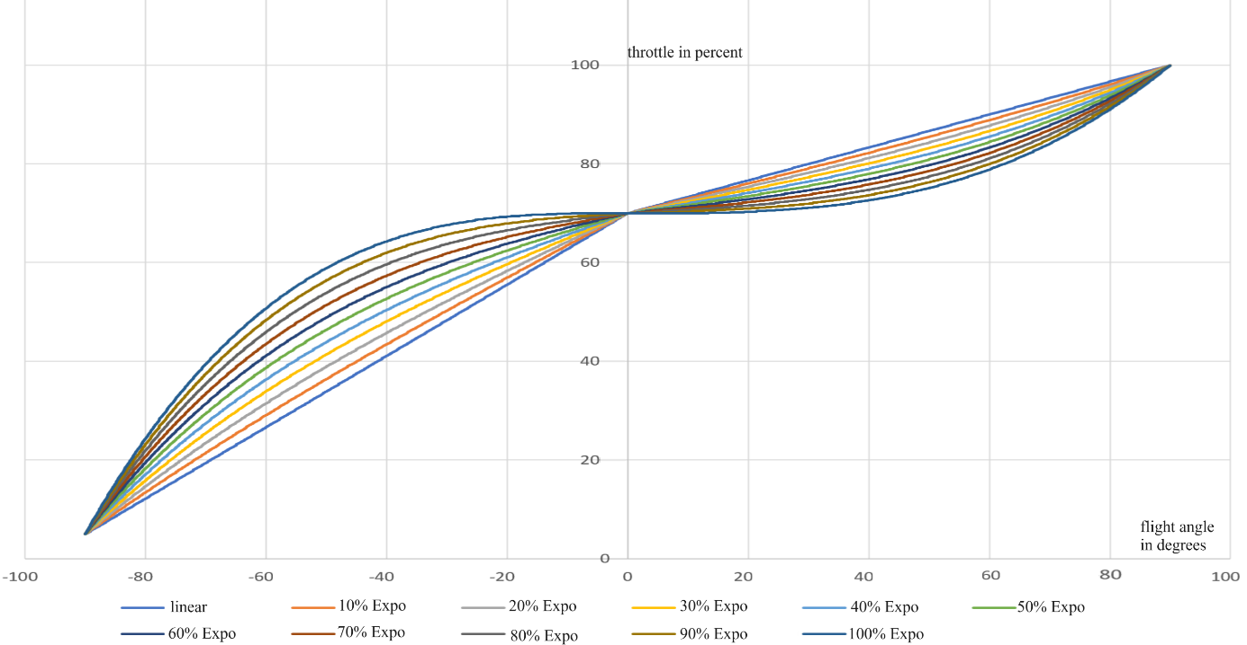

X-axis shows flight angle of -90° = vertical descent flight, 0° = normal/invert flight, 90° = vertical ascend flight

Y-axis shows throttle position (0 - 100 percent of maximum speed)

In the Expo – Teach menu, the status LED flashes from one to ten times briefly for the selection of the expo in percentage. One flash = 10% Expo, two flashes = 20% Expo.....ten flashes = 100% Expo. After flashing the desired percentage expo, confirm briefly with the menu button. For linear curve, i.e. no expo, the status LED flashes once long after the maximum expo position.

Whether and how much expo is needed has to be flown. This data is also stored permanently.

### 4.7 Flight control active (submenu 7 * flashing)

This option activates position control. The position control can then be switched on or off by briefly throttling the engine during the flight. It only regulates when the throttle encoder potentiometer is at the set value for neutral flight or above in the direction of full throttle. This means that you can throttle the engine and end the flight at any time, even with active position control. The effect of the position control is shown in the following short video clip with a maximum expo, i.e. 100% superimposed. [Video GCLA Position Control](https://www.youtube.com/shorts/paRSoQgenMU)

To select function in the submenu, confirm with menu button if LED has flashed seven times. This will save the option permanently and you are back in the Gyro – Teach – submenu.

### 4.8 Flight control disabled (submenu 8 * flashing)

This option permanently disables position control. This means that the control system cannot be switched on or off even in flight with the throttle position. Only pure manual throttle control with the encoder is possible. This option can then also be used to activate the motor shut-off function described in menu item 3.5 in the event of a short circuit of the control lines.

To select function in the submenu, confirm with menu button if LED has flashed eight times. This will save the option permanently and you are back in the Gyro – Teach – submenu.

### 4.9 Flight Lag Control Disabled (Submenu 9 * Flashing)

With this option you leave the Gyro – Teach – submenu and are back in the normal control menu. To select function in the submenu, confirm with menu button if LED has flashed nine times