**Modified Preflight Check with audio output of checks and configurable full check and partial check slices**

**Configuration:**

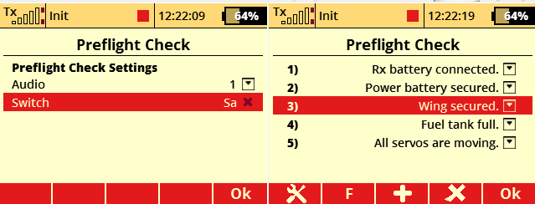

Audio: Sets audio output of preflight test slices active.

Switch: Starts the check manually.

Set and delete test slices from pool is similar to previous version. New is Option F for full check or P for partial check, configurable over key_2. The button label changes depending on configured slice.

**Application:**

The full preflight check is executed in 12 hour cycle for each model on startup transmitter or model change. All full configured slices are executed.

If the full check was already executed for model or check was manually switched, it starts with following question:

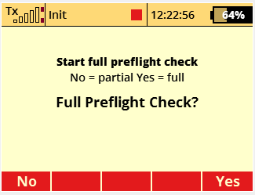

Here user has possibility to start full check or continue with partial check.

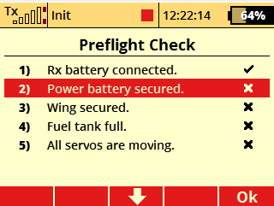

Over key_3 (down arrow) the check slice is acknowledged and the focus is set to next slice. Depending on configuration audio - output of next slice starts.

If all slices are executed the following control is active for further user switches:

