**Please save your test with your group “1A/B/2AB/3AB/4AB-LAST NAME-FRIST NAME”**

**Writing Test**

NAME: Morgado-Samagaio Jonathan Group: 3A

**A. Writing an email. ( /10)**

During a business convention in Boston, **Jerry Burgh**, sales manager at Step Soft (an American computer software firm) meets **Tom Duparc**, CEO of Pharmaplus, a French pharmaceutical company. Tom Duparc is very interested in Step Soft's latest software dedicated to stock management.

**You are Jerry** and **you send Tom** a message including *where you met *what you discussed *suggest meeting or calling him *suggest some dates/times *offer to give him a trial of the product in an attached document etc. Include the different parts that are necessary in an email and the appropriate expressions to be used in a professional context.

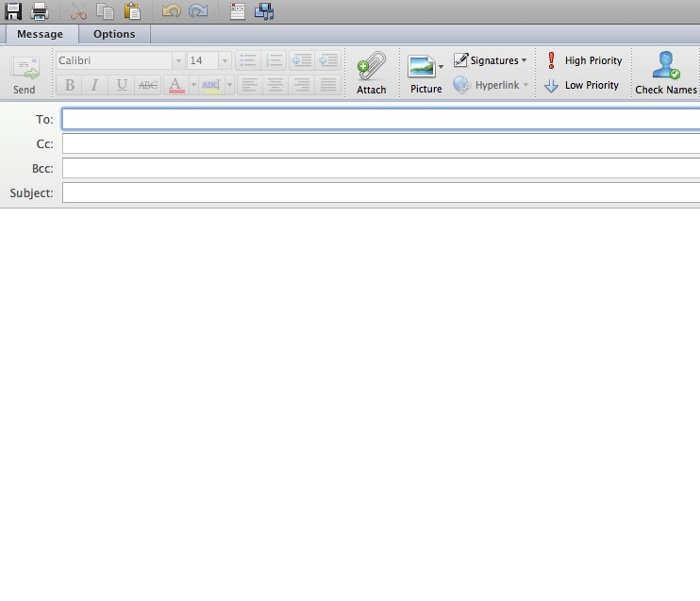

Tom.Duparc@gmail.com

Dear Mr Duparc

I am contacting you following our discussion about Step Soft’s products at the business convention in Boston. To help you make a choice, I attached a trial version of our most popular product.

I would be grateful if we could meet, or call if it is not possible, in the near future. How about on February 3rd or sometime near?

I look forward to hearing from you.

Yours sincerely

Jerry Burgh

**A. Commenting on trends. ( /10)**

Choose one of the following graphs and comment it. (50-60 words minimum)

|  |  |
| --- | --- |
| **A** | **B** |
| https://www.emailtray.com/blog/category/email-trends-and-stats/ | https://www.statista.com/chart/2283/electronic-waste/ |

The bar chart A represent the email spam trends in the period between October 2011 and 2012. We can see that the trend was high at the beginning with 74% in October. It then started to decrease slightly in November and December with respectively 70 and 67%. It went up a little bit in January with 69% but then fell to the lowest value with 64% and stayed there for 2 months. I started to increase steadily in the next 3 months by staying around 67%. It the grew to reach the state it was at in the beginning in August with 72% and went even further in September with 75% only to fall drastically by 10% to reach 64%.

|  |  |  |  |  |
| --- | --- | --- | --- | --- |
| **Assessment criteria** | **Basic**  **knowledge** | **Satisfactory**  **knowledge** | **Excellent**  **knowledge** | **Total** |
| **Content: the topic**  . Does the student do what is asked in the subject? Ideas related to the topic.  . Are the necessary parts present? (numbers  long enough) | 0,5 | 1-1,5 | 2-3 |  |
| **Language : grammar and sentence structure** | 0,5 | 1-2 | 2,5-3,5 |  |
| **Language : vocabulary**  Is the vocabulary rich, varied and accurate?  Is the spelling correct? | 0,5 | 1-2 | 2,5-3,5 |  |

**Please save your test with your group “1A/B/2AB/3AB/4AB-LAST NAME-FRIST NAME”**