The **seven rules** of rhetoric

The speakers in 2 used a number of rhetorical techniques. The main ones are listed below. Complete them using

the words in the box.

questions language words threes points sounds opposites

1. Repeat words

I still have a dream. It is a dream deeply rooted in the American dream.

1. Repeat sounds

We are the people... who persuaded others to buy British, not by begging them to do so, but because it was best.

1. Use contrasts and opposites

Ask not what your country can do for you - ask what you can do for your country.

1. Group key points in threes

We must therefore act together as a united people, for national reconciliation, for nation building, for the birth of a new world.

1. Ask rhetorical questions

What are our chances of success ? It depends on what kind of people we are.

1. Accumulate supporting points

We are the people who, amongst other things, invented the computer, the refrigerator, the electric motor, the stethoscope, rayon, the steam turbine, stainless steel, the tank ...

1. Use metaphorical language

To lead our country out of the valley of darkness.

## Conclusion

The last few minutes of a presentation are your final chance to make a lasting impression. Listen to the closing re- marks of your presentations and number the techniques in the order you hear them. Which is the most effective ?

the sum up □

the call to action □ the famous quotation □ the emergency stop □

1. Which one will you choose ?
2. Ladies and gentlemen, we are on the brink/threshold of… I’m reminded of the words of…, who said …And I’d like this company/this department/us to be able to say…
3. Well, that just about brings me to the end of my presentation, except to say… And if there’s one central message I’d like to get across to you this morning/afternoon/evening. It’s this…
4. So, how do you sum up… I could tell you that…, that…and that… I could also mention…
5. My conclusion :

**charisma**

kəˈrɪzmə

Noun

compelling attractiveness or charm that can inspire

devotion in others.

synonyms : charm, presence, aura, personality, strength of character, individuality.

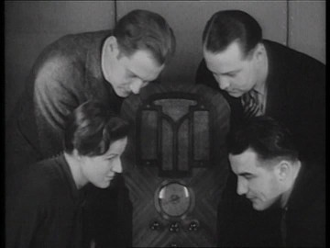

**LaLaLLab 12**

**Presence and performance**

1. For many people the magic ingredient great presenters have is charisma. What's the equivalent word in your language?
2. Can you remember the following extracts from the speeches?

**Extract 1**

**a.**I do not shrink from this responsibility – I welcome it.

**b**.I do not believe that any of us would exchange places with any other people or any other generation.

**c**.The energy. the faith, the devotion, which we bring to the endeavor will light our country and all who serve it.

**d.** And so, my fellow Americans, ask not what your country can do for you – ask what you can do for your country .

**Extract 2**

**a.** I still have a dream It is a dream deeply rooted in the American dream

**b.** I have a dream that one day on the red hills of Georgia the sons of former slaves and the sons of former slave owner will be able to sit down together at the table of brotherhood.

**c.** I have a dream that my four little children will one day live in a nation where they will not be judged by color of their skin but by content of their character. I have a dream today.

**Extract 3**

1. What are our chances of success? it depends on what kind of people we are.
2. What kind of people are we? We are the people that in the past made Great Britain the workshop of the world

**c**… . the people who persuaded others to buy British not by begging them to do so, but because it was best.

**Extract 4**

a. We understand it still that there is no easy road to freedom. We know it well that none of us acting together can achieve success.

b. Let each know that for each the body, the mind and the soul have been freed to fulfil themselves.

c. Never, never and never again shall it be that this beautiful land will again experience the oppression of one by another.

22

**HelpX - Couchsurfing - WWoofing**

1. Visit the other 2 groups. Ask them as many questions as you want. Take notes, then decide which concept you like best.
   1. How did it all start?
   2. What is the concept? How does it work?
   3. Give 4 examples of the places you can go:
   4. Is it easy to get a listing of hosts? What do you have to do?
   5. What do you think about it? Advantages? Disadvantages?
   6. Any other info you think is important:

**HelpX - Couchsurfing - WWoofing**

1. Visit the other 2 groups. Ask them as many questions as you want. Take notes, then decide which concept you like best.
   1. How did it all start?
   2. What is the concept? How does it work?
   3. Give 4 examples of the places you can go:
   4. Is it easy to get a listing of hosts? What do you have to do?
   5. What do you think about it? Advantages? Disadvantages?
   6. Any other info you think is important:

21

II. Studying Abroad— A gap year—DUETI

## Lab 10

##### HelpX - Couchsurfing - WWoofing

###### Do your research to be able to answer the others' questions. Circle the one you present. Try to sound convincing!

* 1. How did it all start?
  2. What is the concept? How does it work?
  3. Give 4 examples of the places you can go:
  4. Is it easy to get a listing of hosts? What do you have to do?
  5. What do you think about it? Advantages? Disadvantages?
  6. Any other info you think is important:

20

Prepare for speaking test

Situation 1

Situation 2

Situation 3

19

Student A

Sample Conversation:

Would You Like to Leave a Message?

A= Secretary B=Business Client A : Good Afternoon . Stellar Corporation.

B: Hello. Can you put me through to Mary Jenkins please?

A : I’m sorry. She's at a meeting with a client . B: Do you know when she'll be back?

A: She should be back by 2 :00.

Would you like to leave a message for her?

B: Yes. Could you tell her the new ads are finished? A : Certainly.. Can I have your name please?

B: My name is Jack Fel spar. That's F-E-L-S-P-A-R. I’m with Spectrum Printers. And could you have her call me when she has a spare moment. I need to discuss the billing details.

A : Does she have your number?

B: I think so,but I better give it to you just to be sure.

It's 314-274-5464.

A : Alright, Mr. Felspar .I’ll have her call you when she gets a minute/she's back in the office.

B: Thanks . I appreciate it. Have a nice day.

A : You too.

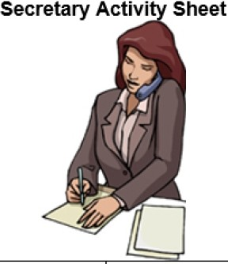**Would You liketo leave a Messa.ge?**

You are a secretary for the Stellar Corporation. Your boss Mary Jenkins is out so when business clients call, take their message.

*'*

18

|  |  |  |  |
| --- | --- | --- | --- |
| Client Name Company | Tel# | Message | Wants to Discuss |
| 1 | | | |
| *Jack Felspar* : *Spectrum* : *314-* : *New ads are* : *Billing details* | | | |
| : *Printers* : *274-5464* : *finished* , | | | |
| - -------- - - ---1L-- ----- - - - - - --•1 - ----- - - - - - J ------- - - - - - ------- - - - - - -------- - - - - - - | | | |
| - -------- - - - - -L1 ---------- - - --'1- -------- - - | | | |
| 1 1 | | | |
| 1 | | | |
| - -------- - - - - -L ---------- - - --'- -------- - - | | | |
| - -------- - - - - -1L-- ----- - - - - - --'1 --------- - - - - - - - - - - - - - - - - - - - - -··- - - - - - - - - - - - - - - - - - - | | | |
| ' | | | |
| - ----------- - -1 ---------- - - --1.- -------- --11 -- -------- - - -------11 --- - - -------------- | | | |
|  | | | |
| 1 1 | | | |
| 1 1 1 1 | | | |
| - -------- - - - - -• ---------- - - --1.- -------- --11 -- -------- - - -------11 - - - - - - - - ----------- | | | |

[www.bogglesworldesl.com/businessESL.htm](http://www.bogglesworldesl.com/businessESL.htm)

Pair Activity: The hotline

Student B

|  |
| --- |
| **B1**  You help the person with his/her problem.  Ask for their name, phone number. Ask if there is paper in the printer. Put them through the engineer dpt. |
| **B2**  Since the last time the technician came, no- thing works. Imagine several problems with your computer and/or its peripherals. |
| **B3**  You help the person with his/her problem. |
| **B4**  You can’t connect to the internet. Each time you try, you get an error message. |
| **B5**  You help the person with his/her problem. |

17

Apologizing

**Lab 8**

**Language study. Going further...**

It is sometimes necessary to apologize because someone has not done something that they should have done. Study this example:

The consignment was delayed at the customs. (send/more documentation)

*I’m sorry. We should have sent more documentation.*

Now apologize in a similar way in these situations.

1. The hotel rooms weren’t clean when the guests arrived. (check/ready)
2. Nobody told us there was a problem. (we/warn you/about delay)
3. You sent our parcel to the wrong address. (check/your order)
4. Two of the three boxes arrived damaged. (pack/properly)
5. There was no instruction manual. (put/in the box)

Getting things done

You will often need to say that you will get another person to perform a service for the person you are talking to. Study this example:

The room you put me in isn't clean. I'll **have it cleaned** for you.

Now change these sentences in a similar way.

1. Are you sure this invoice is correct? (check)
2. The photocopier isn't working properly. (fix)
3. There may be some letters for me. (forward)
4. I'd like some information about the latest model. (send)
5. We need the parts as soon as possible. (dispatch at once)
6. I've left my luggage in the conference room on the 10th floor. (bring down)

16

**Pair Activity : The Hotline**

Student A

|  |
| --- |
| **A1**  You can’t print your document. The printer is on (the light is green) but nothing happens  when you want to print. |
| **A2**  You help the person with his/her problem. |
| **A3**  You can’t find the file you saved. You looked everywhere but can’t find it. |
| **A4**  You help the person with his/her problems. |
| **A5**  You mistakenly deleted a very important file (you spent months working on it) so you would like to get it back. |

15

## Language

Task 3

Complete the sentences with words from the list below. Use each word once only.

1. I’m phoning you about a _ _ _ _ _ _ _ _ _ _ _ matter.
2. You can’t have packed it properly; the package was already _ _ _ _ _ _ _ _ _ _ _ when it was _ _ _ _ _ _ _ _ _ _ _

to us.

1. We expected a much higher standard of _ _ _ _ _ _ _ _ _ _ _ _ _ .
2. I’m ringing to say how _ _ _ _ _ _ _ _ _ _ _ I was by the final result.
3. I can only _ _ _ _ _ _ _ _ _ _ _ on behalf of the company.
4. I’m afraid there’s been a _ _ _ _ _ _ _ _ _ _ _ ; your order was dispatched to the wrong address.
5. We haven’t received the parts from our supplier, so there’s inevitably a

_ _ _ _ _ _ _ _ _ _ _ in _ _ _ _ _ _ _ _ _ _

your order.

1. We’re very sorry for the _ _ _ _ _ _ _ _ _ _ _.

processing | mix-up | inconvenience | delay

| service

apologize | delivered | disappointed | serious | damaged



14

## Lab 7

##### Dealing with problems on the phone

###### What sort of problems does this person have?

* 1. Complete the sentences with words for dealing with problems on the phone.

A. I’m sorry, ___________________________ ?Can you repeat ________________________________, please?

B.I’m __________________________. I still didn’t ____

_______________ your name. Could you _____ it again,

please?

C.___________________________________ me a ________________________________. I’ve got another _________________ .

D. Sorry _____________________ that. What can I __________________ for you?

E.I’m _______________ I can’t hear you.

F. I think we got ____________________________ .

G. Thanks. I’ll ____________ you straight ________ .

* 1. Look at the phone conversations. Correct the receptionist’s rude response.
     1. **Caller:** I’d like to speak to Matti, please.

**Receptionist**: There’s no Matti here.

* + 1. **Caller:** Ich möchte bitte mit Claudia sprechen.

**Receptionist:** What?

* + 1. **Caller:** Oh, hello. It’s Mehmet here.

**Receptionist:** Who?

* + 1. **Caller:** It’s about the project.

**Receptionist:** Wait. I have to answer the other phone.

* + 1. **Caller:** Hello it’s Mehmet again. We were speaking a minute ago.

**Receptionist:** What happened to you?

* + 1. **Caller:** I wanted to talk to Stuart about the JW111.

**Receptionist:** I don’t know what you’re saying.2

13

Role-play 2: Phone conversations

**Student A:**

*Situation 1*. You are the caller. Call Student B and ask to speak to Fernando Gomez in Marketing.

*Situation 2.* You receive a call from B. You are the receptionist. Try to help B with his or her call.

The HR department is having an all-day meeting.

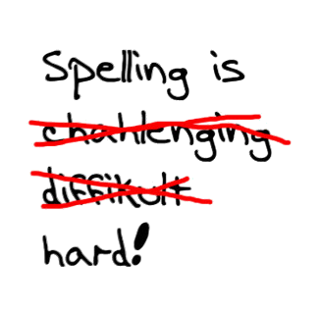

Student B

*Situation 1*. You receive a call from A. you work in accounts. Try to help A with his/her call.

*Situation 2.* You are the caller. you want to speak to the Human Resources manager.

**ROLE-PLAY 1 : Pair-work. Speaking activity. Student B**

#### Client Activity Sheet

Sample Conversation :

Would You Like to Leave a Message?

A= Secretary B=Business Client

A: Good Afternoon.Stellar Corporation.

B: Hello. Can you put me through to Mary Jenkins please?

A: I’m sorry. She's at a meeting with a client.

B: Do you know when she'll be back?

A:She should be back by 2:00. Would you like to leave a message for her?

B: Yes. Could you tell her the new ads are finished? A:Certainly.Can I have your name please?

B: My name is Jack Felspar. That's F-E-L-S-P-A-R. I’m with Spectrum Printers. And could you have her call me when she has a spare moment. I. need to discuss the billing details.

A: Does she have your number?

B: I think so ,but I better give it to you just to be sure.

It’s 314-274-5464.

A: Alright, Mr. Felspar .I’ll have her call you when she gets a minute/she's back in the office.

B: Thanks. I appreciate it. Have a nice day.

A: You too.

**Would You like to leave a Message?**

### You are a business client of the Stellar Corporation. You want to call a manager there, Mary Jenkins, to let her know some important information and to discuss some details. If she is not there, leave a message with her secretary.

|  |  |  |
| --- | --- | --- |
| Secretary's Name (Classmate 's Name) | Mary Jenkins Location | Expected Return lime/Date |
| *J iyoung At a meet ing 2:00* | | |
| *(C/ass!Tlllte's name)* | | |
|  | | |
| - - - - - - - - - - - - - - - - - - - - - - - - - ---------------------------·- ----------------------- | | |
| ' 1  1 | | |
| - ----------------------- -------------------- ------- - - - - - ------------------- | | |
|  | | |
|  | | |
| 1 | | |
| ------------------------ --------------------------- ------------------------ | | |
|  | | |
| ------------------------ --------------------------- ------------------------ | | |
| ------------------------ - --------------------------------------------------- | | |
| ' | | |
|  | | |
| - - ----------------------1--------------------------- - ----------------------- | | |
| I | | |

11

www.boggles worldesl.com/businessESL.htm

|  |  |
| --- | --- |
| **Tips** | **Important phrases** |
| GENERAL:  .  .  .  .  .  . | INTRODUCTION  .  .  .  .  .  . |
| 'in a meeting' is code for  DO NOT USE: 'he is too busy': it suggests  ' '  Keep messages and | RECEPTIONIST  .  .  IF HE CAN'T OR DOESN'T WANT TO TALK:  .  .  .  .  ADD: ? |
| Pronounce | SIMPLE PHRASES WHEN LEAVING A MESSAGE:  .  .  . |
|  | TO MAKE SURE YOU HAVE ALL THE DETAILS CORRECT:  .  .  .  .  . |
| .  . | WHEN SOMEONE CALLS BACK:  .  .  . |
| .  . | POLITE WAY OF ENDING A CONVERSATION:  .  .  . |

10

II. Telephoning

## Lab 6

Australia Network - Episode 11

<http://legacy.australianetwork.com/businessenglish/stories/ep11.htm>

**PART 1:**

1. Who is speaking? (Name/company)
2. What does the client want?
3. Is it possible? Why?
4. What is the message?

**PART 2:**

1. What did Lin Chan call Mr. Wilson for?
2. When is the meeting going to take place?

9

|  |  |
| --- | --- |
| **MEETING PREPARATION SHEET** | |
| MY ROLE/VIEWPOINT  (Who do you agree with? Who do you disagree with?) | |
|  |  |
| ARGUMENTS FOR MY POINT OF VIEW | POSSIBLE ARGUMENTS AGAINST MY POINT OF VIEW |
| LANGUAGE I WOULD LIKE TO USE | |
|  |  |

8

## MEETING VOCAB ULARY

Interrupting Requesting Information

May I have a word? I'd like you to...

If I may, I think... Would you mind... I wonder if you could... Excuse me for interrupting.

May I come in here?

Giving Opinions Asking for Repetition

I (really) feel that... I didn't catch that. Could you repeat that, please?

In my opinion... I missed that. Could you say it again, please?

The way I see things... Could you run that by me one more time? If you ask me,... I tend to think that...

Asking for Opinions Asking for Clarification

Do you (really) think that... I'm afraid I don't quite understand what you are getting at

How do you feel about...? Could you explain to me how that is going to work?

(name of participant) can we get your input? I don't see what you mean. Could we have some more details,

please?

Commenting on Other Opinions Asking for Verification

I never thought about it that way before. Do you mean that...? Good point! Is it true that...?

I get your point.

I see what you mean.

Agreeing with Other Opinions Asking for Spelling

Exactly! Would you mind spelling that for me, please? That's (exactly) the way I feel.

I have to agree with (name of participant).

Disagreeing with Other Opinions Asking for Contributions for Other Participants

Up to a point I agree with you, but... What do you think about this proposal?

(I'm afraid) I can't agree Would you like to add anything, (name of participant)?

Has anyone else got anything to contribute? Are there any more comments?

Advising and Suggesting Correcting Information

We should... Sorry, that's not quite right.

Why don't you.... I'm afraid you don't understand what I'm saying.

How/What about... That's not quite what I had in mind.

I suggest/recommend that... That's not what I meant.

Clarifying Keeping the Meeting on Time

Have I made that clear? Well, that seems to be all the time we have today.

Do you see what I'm getting at? Please be brief.

Let me put this another way... I'm afraid we've run out of time.

I'd just like to repeat that... I'm afraid that's outside the scope of this meeting.

Let's get back on track, why don't we? That's not really why we're here today.

Why don't we return to the main focus of today's meeting.

We'll have to leave that to another time.

We're beginning to lose sight of the main point. Keep to the point, please.

I think we'd better leave that for another meeting. Are we ready to make a decision?

7

## LAB 3

**Pronunciation**

1. **Underline the stressed syllables.**

here decide option important

advantage agree alternative repeat

proposal investors interrupting Japan

Japanese company suggest disagree

1. **Underline the stressed syllables.**

A.I see what you mean.

B. May I have a word?

C.I agree with you.

D.I didn’t catch that.

E. I’m afraid I don’t understand.

**Useful expressions for your meeting**

Some managers are facing a cashflow crisis. Match the halves of the statements in the conversation below.

1. I just don’t see how we can go on a. I suggest we break off here.
2. No, I think we’ll be ok, b. they might stay on. Or how about profit share?
3. Maybe, but unless we do, c. our people will simply go and work for the competition.
4. In my opinion, we’d save a lot of money, d. if we keep overspending like this.
5. Look, we’re in a hi-tech industry. If we cut wages, e. if we aren’t making any profit?
6. No, wait. If we gave them a stake in the company, f. we’re going to be in serious financial trouble.
7. No, no, no. How is that going to work, g. if we just reduced wages. Our wages bills are enormous!
8. OK. Look, if we can’t reach an agreement on this, h. providing we get this Russian contract.

6

## James Bond Movies

1. You need to crack the code to find the encrypted message.

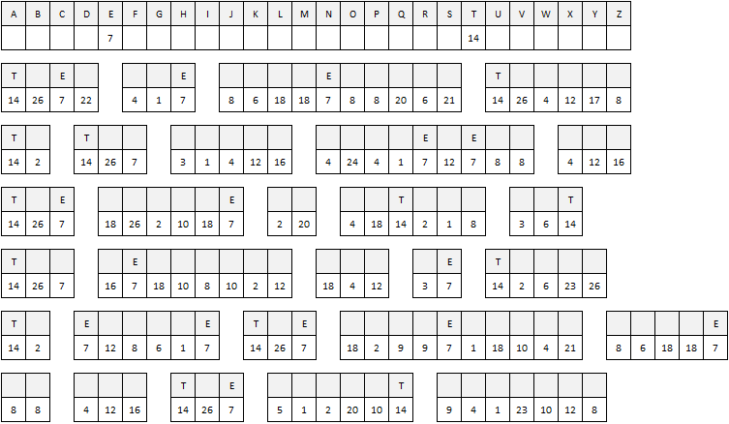

**How to express opinion, agreement and disagreement.**

Fill out the following expressions with the words from the word bank :

|  |  |  |  |
| --- | --- | --- | --- |
| WORD BANK  *point - always - opinion – idea - couldn’t – about - totally – anything – According – agree - agree – think - don't – do – disagree – necessarily – honest – concerned – absolutely – sure – for – true – see – feel – how – way – with – accept – guess - was* | | | |
| **Stating an opinion** | **Asking for an opinion** | **Expressing agreement** | **Expressing disagreement** |
| . In my __________ …  . The way I _______ it…  . If you want my ____ opinion  . ____________ to Lisa…  . As far as I’m __________ …  . If you ask me… | . What’s your _________?  . How do you ___ about that?  . Do you have ____________ to say about this?  . What ________ you think?  . Do you __________? | . I ________ with you 100 %.  . I ____ agree with you more.  . That’s so _________.  . That’s ______ sure.  . Tell me about it! **(slang)**  . You’re ___________ right.  . That’s exactly _____ I feel.  . I have to side ______ John on this one.  . No doubt __________ it.  . I suppose so./I _______ so.  . You have a _______ there.  . I ____ just going to say that. | . I _________ agree with you.  . I don’t _________ so.  . No ______! **(strong)**  . I’m afraid I ____________.  **.** I ______ disagree. **(strong)**  . Not _____________.  . That’s not __________ true.  . No, I’m not so _____ about that.  . I can’t ________ it. |

5

## Lab 2

**The decision-making meeting**

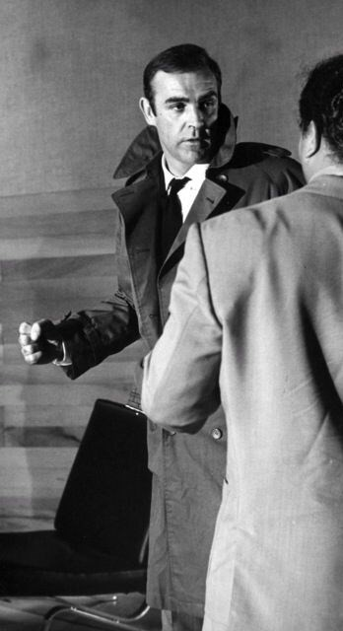**NOBODY does it better**

**THE JAMES BOND** movies are the longest-running, highest grossing film se- ries in history. Current turnover stands at over $6 billion. In fact, the combi- ned earnings of the Star Wars and Star Trek series and the most successful single film ever, Gone with the Wind, still fall $750 million short of Bond at the box office.

Bond is also the most profitable film series ever. The special effects may cost much more these days, but the films still enjoy 30% profit margins, not inclu- ding merchandising. Even Steven Spielberg's blockbusters ET, Jurassic Park and the Indiana Jones trilogy can't compete.

Bond appeals to men and women, adults and children alike. From Russia with Love was one of President Kennedy's top ten favourite books. But James Bond is no longer just a Hollywood hero; he's a bestselling brand. Although the actor playing Bond has changed several times over the last forty years, and although there are no more Ian Fleming novels on which to base the films, the series goes on and on.

The film business is risky - seven out of ten movies lose money. But brand awareness of Bond is so strong that even people who don't like the films ins- tantly recognise the Bond music, fast cars and glamorous women. They know that James takes his vodka Martini 'shaken not stirred'.

And then there is Bond himself - certainly the key factor in 007's commercial success. With so much money at stake, the choice of a new Bond always makes front-page news. Not everyone agreed in 1962 with the decision to choose a virtually unknown Sean Connery was only paid £7,000 for Dr No, but it was perhaps one of the best recruitment decisions ever made.

And the rest, as they say, is history.

1. According to the article, what are the main reasons for the success of the Bond films ? Tick the correct answers.
   * the special effects
   * the sex and violence
   * the 007 brand name
   * the actors playing Bond
   * the novels the films are based on
   * the Bond character
2. Now try and match up the collocations.

|  |  |  |  |  |  |
| --- | --- | --- | --- | --- | --- |
| a current | brand | d combined | earnings | g. commercial | news |
| b profit | turnover | e key | awareness | h front-page | series |
| c bestselling | margins | f brand | factor | l film | success |

|  |  |
| --- | --- |
| 3. To deal with an interruption. | 1.  2. |
| 4. To make a suggestion | 1.  2.  3. |
| 5. To express disagreement. |  |
| 6. To express agreement. | 1.  2. |

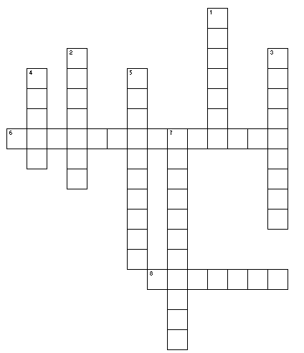3/ A meeting 1

**Across**

6. Someone who represents a company

8. adjective to describe someone from another country

Dow n

1. a formal banking relationship
2. synonym of numbers
3. synonym of workmate
4. what has been sold
5. meeting a person not on the phone
6. to help understand, to explain step by step and carefully

I- Organizing a Meeting

## Lab 1

### The decision-making process

AGENDA

* 1. Objectives ◻ ◻
  2. Priorities ◻ ◻
  3. Data analysis ◻ ◻
  4. Alternatives ◻ ◻
  5. Pros & cons ◻ ◻
  6. Final decision ◻ ◻

1/ Look at the agenda for a decision-making meeting on the left.

**Decide which two statements below were made at each stage in the meeting.**

* + 1. **We're here to decide** whether to go ahead with the project
    2. **One option would be to do** detailed market research.

1. **The most important thing is:** can we make this profitable?
2. **The advantage of** doing market research is we reduce risk.
3. **Have a look at** these figures.
4. **Above all we must** be sure there's a market for our service.
5. **What we've agreed, then, is to** start marketing this service now.
6. **Another alternative is to** offer the service on a trial basis.
7. **On the other hand**, market research takes time.
8. **Our aim is to** find out if there's a good chance of success.
9. **As you can see**, client feedback is very positive.
10. **So, that's it - we're going ahead with** the project.

Watch the video.

Why are they having the meeting?

2/ Participating in a meeting.

What are their jobs?

|  |  |
| --- | --- |
| Maya |  |
| David |  |
| Anna |  |
| Marcus |  |

How does Marcus introduce Maya, David and Anna.

-

-

What language do you hear for the following?

|  |  |
| --- | --- |
| 1. To ask for clarification |  |
| 2. To express an opinion. |  |

|  |  |
| --- | --- |
| **Syllabus**  16 Labs | |
| **# week** | **I- Organizing a Meeting** |
| 1-4  2-5  3-6  4-7 | Meeting 1 -  Meeting 2 –  Meeting 3 -  Meeting 4 - |
| 8 | Holidays |
| **II. Telephoning** | |
| 5-9  6-10  7-11  8-12  9-13  10-14 | Meeting 5 - Mock exam  Meeting 6 - **Speaking test**  Telephoning 1  Telephoning 2  Telephoning 3  Telephoning 4- **Speaking Test** |
| 15-16 | Holidays |
| **III. Studying Abroad - A Gap Year Business English** | |
| 11-17  12-18  13-19  20-21 | DUETI 1 - Gap Year  DUETI 2 - Improving conclusion  DUETI 3 - Feedback on introduction and conclusion - **Listening Test**  NO CLASS |
| 14-22  15-22  16-23 | DUETI 4 - Getting ready - DUETI 5- **Speaking test** Closing |
| **Assessment -** M 2206 coef 2.5  **.** 3 speaking tasks: organizing a meeting + Telephoning + Presenting a project : studying abroad  . 1 Listening task | |

**Extra Work Opportunity**

You will have the opportunity to do **extra** reading, listening and/or writing to get **extra practice** and a **personal feedback** from your teacher.

You will get an **extra 0.5 point per document** (assuming you did the work seriously enough). You can

get **up to 2 pts**. The points will be added to the graded tests during the semester.

All the documents are on Moodle.

**I . U. T. Blagnac Semester 2 2021**

Professional Communication in English

# Name:

_ _ _ _ _ _ _ _ _ _ _ _ _ _ _ _ _ _ _ _ _ _



**ENGLISH COMMUNICATION SKILLS**

###### Isabelle Clavel Akane Ogata

[isabelle.clavel@univ*-*tlse2.fr](mailto:isabelle.clavel@univ-tlse2.fr) [akane.ogata@gmail.com](mailto:akane.ogata@gmail.com)