**The video aims at** people trying to get a job

**The video aims to** inform you on how to use social media and privacy.

* **Identify the 3 parts in the video, and the pieces of advice given in each of them.**

**Part one : How do you present yourself professionally**

|  |  |
| --- | --- |
| DO | DON’T |
|  | Don’t blog without approval |

**Part two Employees policy**

Only post things that you‘d say to someone face Not so easy to say to Frank's face, is it?

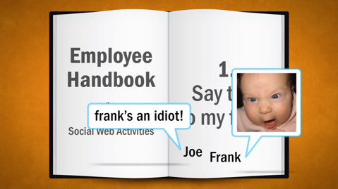Moving on… You represent your company. HR may also want to talk to you, or worse, if they feel that your comments are damaging the company reputation

Disclosure and transparency are critical : disclose if you're__________________________________ that reference your firm or business interests.

Confidentiality : Do not identify a customer or business partner by name without permission. Do not discuss topics that may compromise confidentiality details within your business or your client’s business.

And remember, future employers and recruters also have access to your information.

**Part three Online image**

1. You **needn’t** check all your profiles. 🞎 R 🞎W

Justify :…………………………………………………………………………………………………………………………………………………………….

1. You **should** check the clubs and affiliations featured in your profiles. 🞎R 🞎 W

Justify :…………………………………………………………………………………………………………………………………………………………….

1. Your LinkedIn profile **must** be consistent with your resume. 🞎 R 🞎W

Justify :…………………………………………………………………………………………………………………………………………………………….

1. Your personal status **ought to** reflect the stability you want to show in job interviews. 🞎 R 🞎W

Justify :…………………………………………………………………………………………………………………………………………………………….

1. You **had better** express strong political views or affiliations. 🞎 R 🞎 W

Justify :…………………………………………………………………………………………………………………………………………………………….

* **Explain in the context what** *“This is often less than the 6 degrees of Kevin Bacon”* **means.**

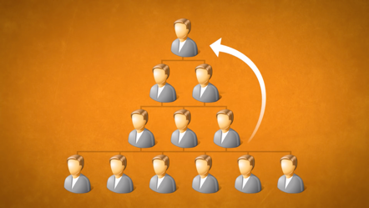…………………………………………………………………………………………………………………

…………………………………………………………………………………………………………………

…………………………………………………………………………………………………………………

…………………………………………………………………………………………………………………

…………………………………………………………………………………………………………………

* **How was Joe “busted”?**























