**SURNAME : First Name : Group :**

1. 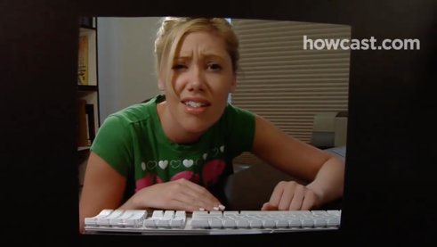**Quel est le sujet de la vidéo ? (1)**

How to follow proper etiquette online

1. **Pour chaque étape citée dans la vidéo, trouvez un titre et résumez-en le contenu en français. (18)**

**Step 1**: Title: Be clear in your email and text messages

Don’t include acronyms, don’t use sarcasm, and don’t write in all caps.

**Step 2:** Title: no large files in attachment

Compress file if larger than 5mb, share photos by posting them online

**Step 3**: Title: respect people privacy in BCC

Prevent people from seeing other email address that this mail was sent to.

**Step4**: Title: Fill in the subject line

Take a second, provide useful info,

**Step 5**: Title: Don’t tag pictures of other people

Don’t discuss private business

**Step 6:** Title: Think before you send instant message.

Brief, swift exchange. Don’t start instant message if the conversation will take a while.

**Step 7**: Title: Don’t contribute to boards until you read everything

Don’t annoy people with questions that are already been answered. Read FAQ before asking

**Step 8**: Title: Refrain from flaming

Don’t be a troll.

1. **Quelle est la morale, la conclusion de cette vidéo ? (1)**

Treat people online like they were offline people.