Documentation Interact with Objects

Requires Main_Interact.cs and another Script, like Example_Interact.cs

For the another Script, it is required to use
Name_Interact.cs for prober declaration and easy understanding.
The first part of the script defines the interaction performed, the second part
defines, that is an Interaction with an Object. Please use the “_” between the first and the second part to avoid confusion. Main_Interact.cs is the main Script, it can be modified/extended, but normally this is not required

First Part: Main_Interact.cs

1.1 Namespaces
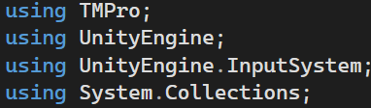

TMPro is required for UI, please use only TMPro instead of UnityEngine.UI to avoid confusion

UnityEngine is required for UnityCore features, for example Gameobjects

UnityEngine.InputSystem is required for the player Input, including actions and keybindings

System.Collections is required for corountines and IEnumerator for asynchronous
operations and delays.

1.2 Interface Implementation

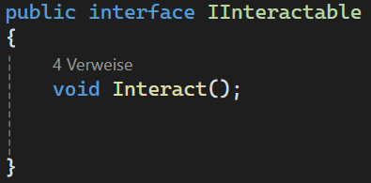

IInteractable defines a contract for the objects, which use the IInteractable interface for Interactions. Scripts that implement the Iinteractable interface need the method Interact to work.

