Hanjin Shipyard Technical Due Diligence

BALLPARK ESTIMATE OF INTERVENTIONS and CAPEX Program

Nam Le, Mark Ogot, Paul Magbanua, Liezel Convento

4/08/2020

Table of Contents

| Abbreviation | Names |
| --- | --- |
| JV | Joint Venture |
| LOS | Level of Services |
| MS | Microsoft |
| NSCP | National Structural Code of the Philippines |
| NY | Northyard |
| NY+SY | Northyard and Southyard |
| O&M | Operation & Maintenance |
| SY | Southyard |
| TDD | Technical Due Diligence |
| USD or $ | United States Dollar |

# Introduction

## The project

Hanjin Heavy Industries and Construction Philippines, also known as HHIC Phil, is strategically located at the tip of Redondo peninsula, Sitio Agusuhin, Subic, Zambales. It was established in February 2006 by Hanjin Heavy Industries and Construction of South Korea with an approximate area of 250 hectares. It is considered as one of the largest shipyard in the world.

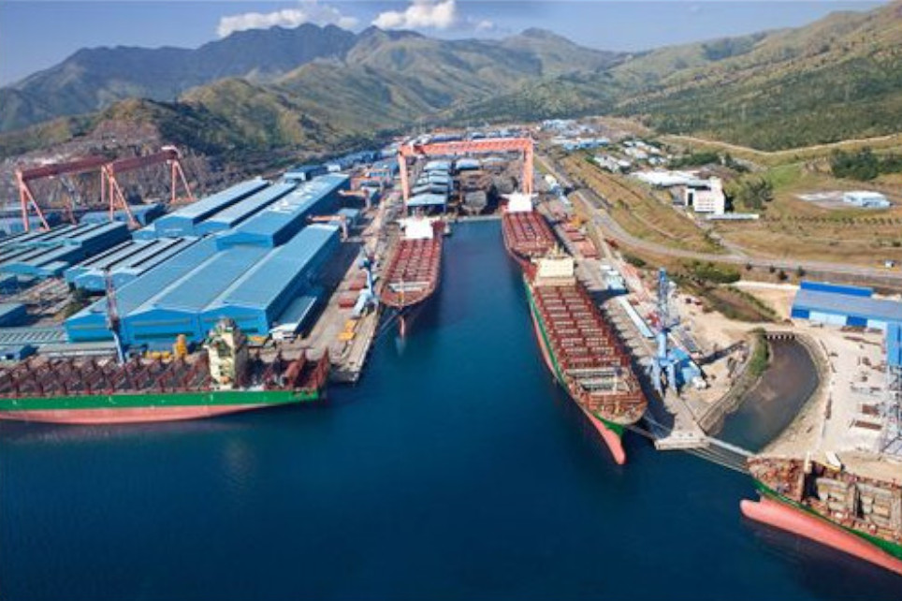

Figure 1: Hanjin Shipyard

Following the completion of Phase 1 of the Technical and Environmental Due Diligence by the end of 2019, Arcadis has been commissioned by Cerberus Capital Management in January 2020 to continue the Phase 2 of the Technical Due Diligence on the Shipyard. Site visits were conducted on 18th -21st of February and 4th-6th of March.

This report has been prepared exclusively for generation of CAPEX items, intervention strategies, and intervention program based on evaluation and validation on existing condition states, risks, compliance to current applied standards and codes, and specific requirements from Clients based on numerous discussions.

This report has also been prepared using the existing information such as documents and drawings provided by HHIC. Although Arcadis could not capture all the required information, follow-through site validation was conducted with interviews of Hanjin personnel and walkthrough along the utility corridor line and facilities.

This report addresses concerning issues of the existing facilities and possible concerns in setting up shared services among tenants. This report also discusses recommendations of potential options to deal with each identified existing and potential issues.

## Objectives and Scopes

The objectives of this work are to determinate optimal CAPEX program for 25 years, formulate a master schedule to show the feasibility and strategy on how to execute the CAPEX items under 2 years and to recommend Clients on Engineering and Procurement Strategies based on rigorous site visual inspection, interview, review of documents and drawings, as well as suitable engineering approach and benchmarking of cost.

The project’ scope includes desktop study, site evaluation and confirmatory measurements of naval buildings and infrastructure at the facility to assess the current state. This will provide a report that highlights estimated CAPEX expenditure needed over the next 12-24 months as well as any other considerations relevant to the development owner. This will include regulatory risk or any limitations or restrictions in future use. The assessment will also review and provide an independent view on proposed CAPEX plans from operators for the buildings.

Interested readers are suggested to refer to the submitted proposal of Arcadis for the detailed scope of works.

## Assumptions and Clarification

Findings and outcome presented in the report are subjected to have a certain level of uncertainty due to the followings:

* Visual inspection was conducted by eye-witness and not by precision monitoring devices, thus a precise conclusion on condition states of assets is not possible;
* No physical testing has been conducted to identify the soundness and operational state of assets;
* Quantity surveying method used has been fundamentally based on generic area of facilities and not on individual components unless otherwise applicable in some certain cases;
* The benchmark cost has been extracted from Arcadis’s cost database of similar projects and activities. This is a high level cost (ballpark estimate), thus subject to a certain level of deviation which should be further verified in Engineering and Procurement phase of the project. However, the ballpark is good enough for high level budgeting and programing.

# Methodology

## General

Following bullet points give a brief on the methodology

* Site visit and visual inspection;
* Interview and discussion with managers and staff of the Shipyard;
* Discussion with Cerberus team weekly;
* Conceptual layout preparation;
* Quantity Surveying and cost benchmarking;
* Data programing

## Hierarchy

The CAPEX items are classified into levels of hierarchy, referred herein as the Hierarchy (Table 1)

Table 1: The Hierarchy

| Area | Floor Level | Tenant | Zone | User | Owner | Operator | Work Type | Disciplines |
| --- | --- | --- | --- | --- | --- | --- | --- | --- |
| NY | Roof | Austal | Dock 5 | Navy | JV | DynCorp-NY | All | Architectural |
| SY | 5 | Navy | Dock 6 | Dock 6 |  | DynCorp-SY | Building Fabric | All Disciplines |
| NY+SY | 4 | Tenant 3 | Support | Austal |  | Navy | Contingencies | Building |
|  | 3 | Dock 6 | Dry Dock | Tenant 3 |  | Austal | Demolition | Civil |
|  | 2 | JV |  | Shared |  |  | Disposal | Contingencies |
|  | 1 |  |  |  |  |  | Electrical System | Electrical |
|  | B1 |  |  |  |  |  | Environmental | Engineering and Management |
|  | Lot |  |  |  |  |  | Fire Protection System | Environmental |
|  |  |  |  |  |  |  | HVAC | Fire Protection |
|  |  |  |  |  |  |  | Interior | Hydraulic |
|  |  |  |  |  |  |  | Mechanical System | Mechanical |
|  |  |  |  |  |  |  | Miscellaneous | Miscellaneous |
|  |  |  |  |  |  |  | Engineering and Management | Plumbing |
|  |  |  |  |  |  |  | Perimeter Fence | Soft Cost |
|  |  |  |  |  |  |  | Plumbing System | Roof |
|  |  |  |  |  |  |  | Preliminaries | Structural |
|  |  |  |  |  |  |  | Roof |  |
|  |  |  |  |  |  |  | Structural Elements |  |
|  |  |  |  |  |  |  | Structural Upgrade |  |
|  |  |  |  |  |  |  | Vertical Transportation |  |

The CAPEX items (e.g. a GENSET or a structural beam) should belong to these levels of hierarchy. By using this hierarchy, it is possible to analyze and summaries the Condition/Operational States, Risks, and Cost in an appropriate manner.

Inspection forms are then formulated in tabular formats that consider these levels of hierarchy and the states that are defined in subsequent sections.

## Tidy Data and Definitions

We formulate a tidy data set (refer to CAPEX tab in the submitted excel file) that allows Client to understand the approach of evaluation and estimation. The tidy data has been set up keeping in mind of following important points

* Column is attribute with the same type of unit for respective columns. Thus, no mixing of values are allowed. This keeps the consistency of the dataset for evaluation and summary purpose.
* Row is observation (CAPEX item)

### Condition States and Risks

In the context of TDD, Level of Services (LOS) for assets of a building are a qualitative adjustment and evaluation subjected to visual walk-through, interview, and observation on provided documents such as corrective and preventive maintenance records, standards of O&M and specifications.

Condition/Operation States, herein named as Condition State(CS) of the CAPEX items are defined using a discrete scale of 5 (refer to Table 2).

Table 2: Condition States

| CS | Description | Possible Intervention |
| --- | --- | --- |
| 0 |  | Non existent |
| 1 | Very Good | only planned maintenance is required |
| 2 | Good, likely new | Minor maintenance required plus planned maintenance |
| 3 | Fair/moderate | Significant maintenance required |
| 4 | Poor/bad | Significant rehabilitation/replacement required |
| 5 | Very Poor/very bad | Physically unsound and/or beyond rehabilitation, need replacement or alternative renewal |

It is important to note that only generic definition of CS is defined and the definition can be used globally for all type of assets of the targeted building. Engineers should use their own engineering adjustment and experience to define appropriately the CS. Findings and remarks are documented in order to provide validation on the decision on which CS is used for a particular asset.

Risk is defined in three (3) categories (RED, AMBER, and GREEN). Table 3 gives a generic definition on risks.

Table 3: Risks

| Risk | Name | Remarks |
| --- | --- | --- |
| 1 | Green | Repair is somehow needed; However, repairs can be done withing above 6 years |
| 2 | Amber | Repair is needed; However, repairs can be done withing 1yr to 6yr span |
| 3 | Red | needs to be repaired immediately; Immediately needs replacement, May impose Health and Safety Risk, Upgrade to Codes |

The GREEN code infers that in case of failure or in case of not providing adequate LOS, negative impact that could be generated by the asset is not significant. For example, if one part of the floor title located at the corner is damaged, it will not result in high consequence.

The AMBER code infers that in case of failure or in case of not providing adequate LOS, negative impact that could be generated by the asset is moderate.

The RED code infers that in case of failure or in case of not providing adequate LOS, negative impact that could be generated by the asset is massive. For example, if the FDAS is not working, it will certainly cause a threat to the safety of people staying/working inside the building.

### Compliance Assessment

Code Compliance is rated either 0 or 1 depending on the structure’s compliance to the National Structural Code of the Philippines 2015. It should be noted that some of the structures were built following the specifications of the Korean Structural Code. Structures that are code compliant are given a rating of 1 while those that are not compliant are given a rating of 0. Non code compliant structures are considered for immediate intervention to ensure these are built and operating appropriate to Philippine Standards.

### Standards Life Expectancy of Assets

Life expectancy of assets or components of assets is always uncertain variable. This is due to the fact that assets of the same types, same manufacturers and installed at the same time might have different end-of-life because they are under different ambient temperature, different loading and operational scheme. Therefore, a fixed end-of-life is never a persuasive number. However, for the purpose of this work, following indicative average end-of-life of assets have been assumed (Table 4).

Table 4: Expected average life expectancy of assets/components (years)

| Assets/Components | Life Expectancy |
| --- | --- |
| Painting | 10 |
| Ceiling Board | 15 |
| Air-condition (flor mounted, DX type, inverter) | 10 |
| Panel Board | 25 |
| Polycarbonate roof | 25 |
| Electrical Wirings (not exposed to weather) | 50 |
| Electrical Wirings (exposed) | 25 |
| Generator Set | 30 |
| Linoleum | 20 |
| Steel plate | 20 |
| Electrical & Auxillary equipment | 30 |
| Waterproofing | 25 |
| HVAC System | 30 |
| Lifts | 25 |
| Vinyl tiles | 20 |

With the project’s 25-year CAPEX consideration, the asset’s life expectancy is also noted for the purpose of providing another cost item once an asset’s life is exhausted. As an example, items listed with repainting will be listed recurringly since the paint’s life expectancy is just 10 years and repainting will have to be done after that.

### Intervention Types, Strategies, and Program

Intervention is a global term encompassing a number of activities on assets such as: Do Nothing, Repair, Maintenance, Renewal, Replacement, and Upgrade. Intervention type refers to a specific type of intervention on an asset such as crack sealing with epoxy glue. Intervention strategy is a set of intervention types that can be executed in time and space. Intervention strategy can be for one asset or a group of assets. In many cases, a set of intervention strategies will form an intervention program or or a workplan.

Table 5: Intervention Types

| Type | Definition |
| --- | --- |
| 1 | Do Nothing |
| 2 | Minor Repair |
| 3 | Major Repair |
| 4 | Rehabilitation |
| 5 | Replacement |
| 6 | Alternative Renewal |
| 7 | Audit and Testing |
| 8 | Replacement due to Life Expectancy |
| 9 | Soft Cost |

## CAPEX modeling and Cashflow Analysis

Per Client’s specific requirements, CAPEX modelling is of deterministic model with discount rate of 0%. The cashflow analysis will be done for 25 years taking into consideration of end of service life of assets recommended by either manufacturers (in the event of knowing the data) or Arcadis’s standard table.

# Highlights on Findings and Intervention Types

This section briefly describes the important findings that led to the determination of intervention types and strategies for some typical facilities. The findings include the value of condition states and risks. Based on the condition states and risks, an intervention type and strategy has been formulated with detailed scope given in columns named “Reasons for Interventions” and “Scope of Work”, respectively. Readers of the report is encouraged to refer to the provided excel file.

In addition to the condition state and risk, we have also focused on an important aspect that is the COMPLIANCE. The compliance is a matter of uncertain. For example, under the context of uncertainty analysis, it is, in some cases, to be believed that the structure of a specific facility might no longer provided adequate level of services if there is a strong earthquake generated nearby the Shipyard area. As the facilities were built more than 10 years ago, it is likely that structural code used for design might be no longer met the current requirement from Philippine Structure Codes. In such as circumstance, there is a need to provide retrofitting or strengthening of the existing structure. Similarly, aside from compliance to structure code, there might be issues with compliance to other codes such as environmental, electrical, water and wastewater.

It is important to note the compliance or incompliance to codes must be verified in Engineering Phase. Within the context of this phase, we have agreed with the Client to go with a conservative approach, e.g. to assume incompliance on particular parts of the facilities if found necessary.

## General

### Structure Code Incompliance

Most of the buildings and facilities within the shipyard were designed and constructed from 2006 to 2009 using the Korean Building Code and the NSCP 2001. With the release of memorandum from DPWH, all structures 15 yrs and above must remain contemporary with the latest local governing structural code – NSCP 2015.

Considering the latest code, we believe that there is a high probability that existing structures are subjected to have structural strengthening works. Thus, we indicate in our analysis a major CapEx components for most of the structures of the shipyard, that is to perform structural upgrade or retrofitting. Readers of the report can refer to columns “Code Compliance” in Table “CAPEX” of the provided tidy data set.

### HVAC

Montreal released a protocol that R-22 and R-123 refrigerants affects the ozone layers depletion. This protocol was observed and made these refrigerants be phase-out by year 2020-2030.

All the HVAC system installed in the shipyard still using these refrigerants. With this scenario, replacement of HVAC system needs replacements to all the buildings within 5-yrs or until refrigerant runs out as these refrigerants are already out in the market. Some of the HVAC can still be in use; however, efficiency cannot be maximized due to its condition.

### Environmental Code Incompliance

It was confirmed through the site inspection that most of the facilities does not have its own catch drain. All its downspouts are directing to the main road which might cause flooding in the area (refer to Figure 2). Provision of construction of storm ditches are provide in the CAPEX program.

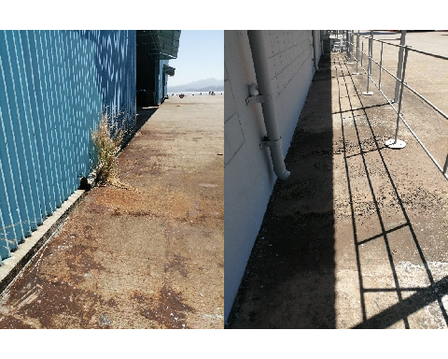

Figure 2: No storm ditches

### Shared Facilities

The previous operation of shipyard was operated as one component where all these utilities are interconnected. With the plan to divide the area into four tenants, operating the shipyard will be challenging. Hence, set of measures where laid to different utilities to make the operation less complicated. Details of this discussion are found in “Shared Utilities Report”.

#### Water Utilities

To measure the water consumption of all tenants, installation of water meters must be installed strategically in places where all the readings must be captured. Supply and installation cost of these water meters were included in the CapEx

#### Power Utilities

Software for the power monitoring is already outdated according to Hanjin’s operator. Provision of CapEx for the upgrading of this software is incorporated to check the power consumption of the four tenant’s.

#### Fencing

As per Client’s requirement, construction of fencing is necessary to provide privacy and security of the tenant most especially for the Philippine Navy. At least 9100 l.m. of fence is required to barricade the tenant’s division.

## Main Office Building

From our meeting with Philippine Navy together with Cerberus, they are planning to divide the main office building into different office sectors.

Per site visit, replacement of the carpets and ceiling boards due to stains are needed to restore its as-built condition. Aside from these, extension of wires and replacement of Korean brand outlets are necessary as the current set-up may not fit with the Philippine Navy’s purpose.

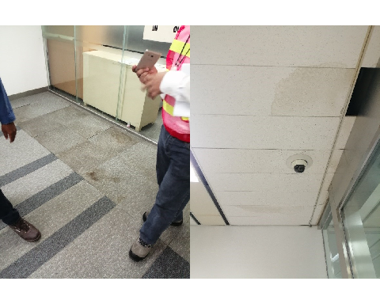

Figure 3: Poor condition of carpets and ceiling boards

One major intervention of the building is one of its HVAC has serious gushing of water. Current alternative repair is feasible, however, needs to be replaced in within 5yrs due to condition and efficiency.

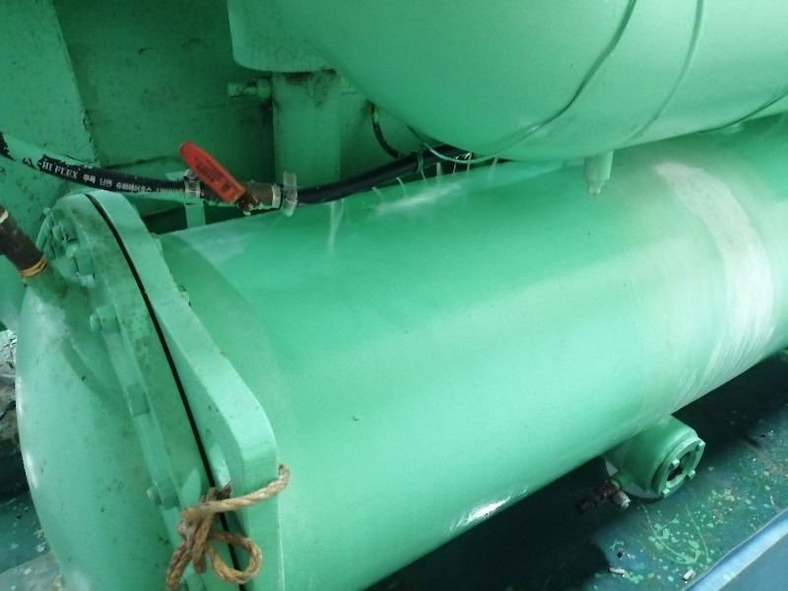

Figure 4: Gushing of water - HVAC

## Barracks

Most of the barracks intervention are fit-out to remain its as-built condition when Philippine Navy used this facility. The interventions are interior paints are vandalized and stains, linoleum floorings are dilapidated, comfort rooms are in poor condition and most of the window type AC’s are not working.

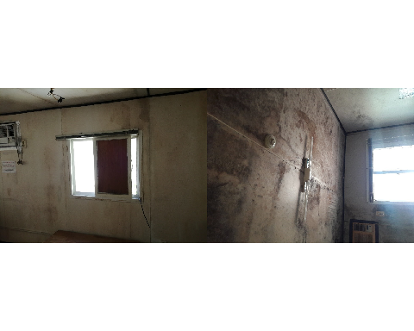

Figure 5: Poor conditions of assets in Barracks

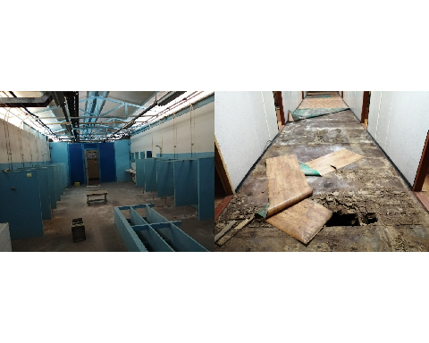

Figure 6: Poor conditions of assets in Barracks

One barrack has a serious issue its wooden flooring was infested by termites. Due to this, major repair is needed to restore its useful condition.

## Field Offices

Most of the offices has dilapidated rubberized flooring, vandalized walls, damage ceilings, and HVAC’s not working. To make the field office workable as per fit to purpose, interventions are needed such as repainting, installation/extensions of new electrical wires, IT support services and replacement of HVACs.

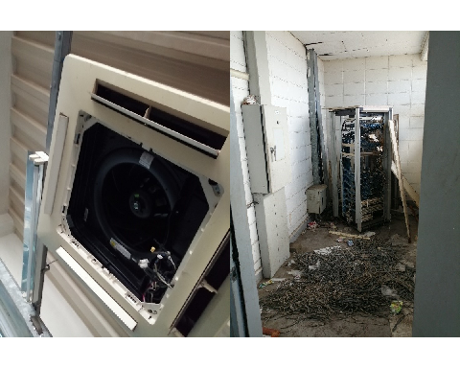

Figure 7: Poor conditions of assets in field offices

## Piping Pre-treatment building/Galva

Piping pre-treatment building is one of the worst building conditions in the shipyard due to its previous usage where all the shipyards pipes are treated in this building using chemicals; the GI roofs and walls including its insulation needs replacement due to it is rusted and dilapidated; its structural steel frames are corroded and needs careful attention to remove all this rust and provide paint protection.

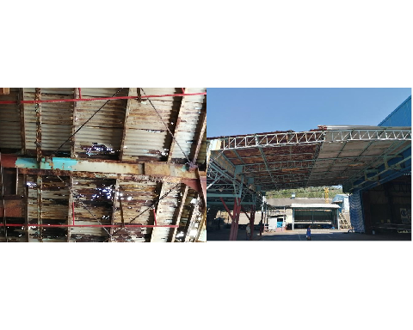

Figure 8: Poor conditions of assets in Piping treatment Buildings/Galva

## Possible Demolition

Aside from the pre-treatment building, there are other two (2) building that has a serious building condition – The CO2 plant and the Production Center/Hospital building. These buildings might be required for partial to entire demolition.

### CO2 Plant

The CO2 plant, same with pre-treatment-building is a chemical production building that was used for the treatment of the pipe. To date, Philippine Navy has no plans to take-over this facility but with its condition, it is better to demolish the facility since its structural members including the roofs are corroded and rusted.

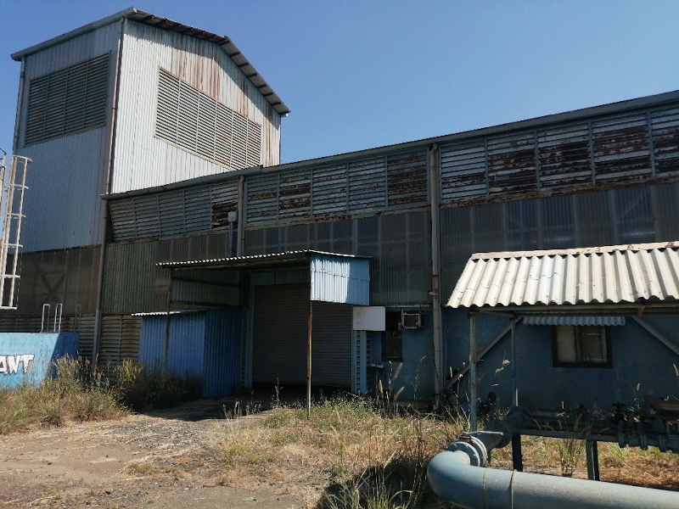

Figure 9: CO2 Plant

### Production Center/Hospital Building

It was reported by the staff of Hanjin shipyard that, due to the earthquake occurred on April 2019, there has been several damages to the building. In our view, there is a possible reason that there is a lack of lateral restraint (shear walls), under which, the internal masonry wall might have accepted most of laterial forces and this might be the source of cracking and other damages.

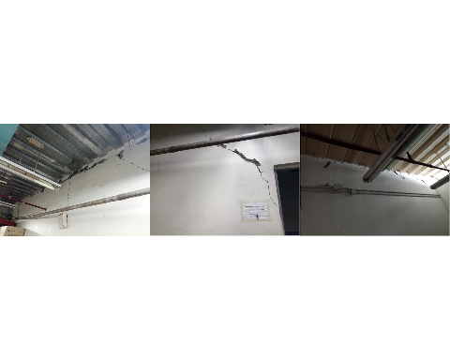

Figure 10: Poor conditions of assets in Piping treatment Buildings/Galva

# Intervention Strategies and Programs

As explained in early section, once intervention types are generated for each facilities, we can formulate Intervention Strategies and Programs.

Intervention Strategies need to be strategized based on Client’s requirements on when tenants are expected to occupy and take over the space for their business operation. Intervention Program is then linked to Procurement Strategies, that is how many Contractors the Client wishes to engage in order to execute construction works for CAPEX items.

Per discussion with the Client, Arcadis has formulated the Intervention Strategies and Program based on following assumptions

* There will be three phases of CAPEX program
  + Engineering Phase: The phase required to perform physical verification for code compliance and detailed design of facilities;
  + Procurement Phase: Preparation of specifications, bill of quantity, contract documentation to form a tender package. This phase includes bidding process, evaluation, and award of contract to winning Contractors;
  + Construction Phase: Winning Contractors to execute physical intervention works within a specific timeline.
* The total duration of CAPEX program will be concentrated in the first 2 years, with flexibility to defer a certain works if Tenants require. Within the 2 years CAPEX program, the first 4-6 months will be allocated for Engineering Phase and Procurement Phase. These two phases can be executed in parallel. The rest of the time will be allocated for the Construction Phase.
* Construction Works for many facilities will be done in parallel in order to meet the targeted timeline. This can be done by strategically formulate the program into 2 to 3 Procurement Packages that will be then awarded to more than one main Contractors. By doing so, risks on labor and resources might be minimized as currently and in the next 1-2 years, the construction market in the Philippines is still very active. This is due to the policy of the current government to construct many major infrastructure works. In addition, by having more than 1 main Contractors, the Client can minimize the risks of having insufficient cashflow of the Contractors.

## Major Intervention Strategies

### Austal

Offices is one of the Austal much needed facilities. In order to fast track its repair and rehabilitation, we might require 3 teams doing the nine (9) field offices in parallel. With this strategy, finishing the offices may be possible within six (6) months. Total fit-out cost of the field offices for Austal area is USD 1,482,060 and is to be spent up from 6-12 months.

Aside from field offices, a total of USD 6,456,120 is envisaged to be spent within 2 years program after the mobilization of the contractor. This is for the repair, rehabilitation and strengthening of the structural steel framed facilities. The assumption is to executed the works by 3 different teams – apart from the 3 contractors working on the field offices – will work on the strengthening and repair. The strategy is to commence the construction at the hull shop followed by the nearby facilities down to the less important once such as the tool shop, outfitting shop and Air-compressed room 2,3.

### Navy

Most of the facilities in the Philippine Navy area are needed immediately such as Main Office building, Catering center, Barracks, field offices and other facilities. In order to speed up the construction, we have allocated at least 10-12 contractors working at the same time for the 37 facilities.

The main office, catering center and the three (3) field offices can be done by one team per facility. This work shall be commerced immediately after the Procurement Phase completed so as the Client can handle over to tenant in case of need. The three major works can be done relatively around 200 calendar days.

Aside from the above-mentioned facilities, barracks are also one of the important facilities to work with as navy personnel will use this as their sleeping quarters. Unofficially, according to Philippine Navy presentation, the number of personnel that will be brought inside the facility is by batch. Our basic strategy is to allow three (3) teams to work simultaneously with the first 3 barracks and the rest of the barracks will follow after the completion of the other. Most probably, the Philippine Navy might be able to strategize on how many of the personnel can be deploy inside the facility.

Pre-treatment Building/Galva is anticipated to receive major rehabilitation and the construction work for this building might be able to be done not in priority (per discussion with the Client). In this respect, the commencement date might be of flexibility. From the constructability and feasibility of duration, around 270 calendar days would be possible to complete the rehabilitation program for the facility.

### Dock 6

Majority of intervention works on Dock 6 is with structural upgrade for most of the field offices. We anticipate on the schedule that majority of works could be achived around 200 days with three teams to perform the work in parallel.

### Tenant 3

Most of the facilities in the tenant 3 are recently built (2017). Only 3 facilities within the area were constructed in 2006 to 2009 which are the T-HBD shelter, H-Cover shelter and D-House shelter. As they are old buildings, they might need to receive structural upgrade due to possible code incompliance.

Other facilities in the area is relatively new, minor repairs are only expected except to those mentioned facilities that were constructed later.

### Shared Facilities

Per Client’s request, shared facilities and utilities must provide adequate level of services from the onset of operation as they are critical facilities. Thus, the intervention strategies are to execute them as soon as possible. Possibly immediately after the Procurement Phase or even earlier if some procurment packages specifically designed for shared facilities are completed earlier.

More or less, in term of duration, 150 days or less shall be sufficient to carry out construction works. Detailed schedule of the intervention program is given in the Appendix.

# Cashflow and CAPEX analysis

In this section, a brief cashflow analysis is presented, keeping in mind that the intervention works will be concentrated in the immediate and short-term, for medium and long-term, most of the works are recurrence of a certain type of activities due to end of life.

## General

Yearly budget distribution has been generated based on Arcadis’s assumptions on intervention year.

Intervention year is triggered by having to

* satisfy code compliance if deems violate
* Condition state and risk
* Tenant’s specific decision (if applicable)
* cycle of replacement based on expected life expectancy

CAPEX program will be distributed in each year, with summary on

* **Immediate term**: year 0
* **Short Term**: year 1 and 5
* **Medium Term**: year 6 to year 10
* **Long Term**: year 11 to year 25

Tables 6 presents the yearly distribution of CAPEX under each disciplines.

Table 6: Yearly CAPEX Distribution - Disciplines

| Disciplines | immediate | shortterm | mediumterm | longterm | CAPEX | freq |
| --- | --- | --- | --- | --- | --- | --- |
| Structural | 10,037,250 | 30,000 | 0 | 0 | 10,067,250 | 19.35 |
| Mechanical | 790,400 | 2,618,160 | 567,360 | 5,136,250 | 9,112,170 | 17.51 |
| Soft Cost | 7,649,430 | 28,480 | 227,690 | 0 | 7,905,600 | 15.20 |
| Civil | 5,652,030 | 0 | 0 | 0 | 5,652,030 | 10.86 |
| Roof | 1,057,030 | 0 | 410,070 | 3,902,460 | 5,369,560 | 10.32 |
| Electrical | 1,711,160 | 0 | 0 | 3,376,710 | 5,087,870 | 9.78 |
| Miscellaneous | 3,384,050 | 212,750 | 0 | 0 | 3,596,800 | 6.91 |
| Architectural | 1,341,300 | 250,610 | 377,330 | 1,055,710 | 3,024,950 | 5.81 |
| Building | 0 | 0 | 917,970 | 0 | 917,970 | 1.76 |
| Fire Protection | 858,290 | 0 | 0 | 0 | 858,290 | 1.65 |
| Plumbing | 251,530 | 30,330 | 0 | 0 | 281,860 | 0.54 |
| Environmental | 130,000 | 0 | 0 | 0 | 130,000 | 0.25 |
| All Disciplines | 23,190 | 0 | 0 | 0 | 23,190 | 0.04 |
| Total | 32,885,660 | 3,170,330 | 2,500,420 | 13,471,130 | 52,027,540 | 100.00 |

As can be seen from the summary table, the largest contribution to the CAPEX under immediate term is approximately $10 millions out of nearly $ 33 millions, followings are Soft Cost (Engineering Management) and cost allocated for civil works. Contribution to the cost of structural upgrade will be described in later section.

Soft Cost includes 5% of permitting, 10% of preliminary preparation and engineering management, 10% of contingency. These costs are redistributed per facilities.

Miscellaneous are items that cannot be quantified precisely such as minor repair, door replacement, annual inspection of fire protection assets, renewal of fire protection and safety devices, tightening materials like bolts and screws, and items that were not foreseen by only visual eye inspection. We have allocated costs for such items based on average percentage, ranging from 5% to 15% of the CAPEX, depending on types of facilities.

Graphical representation of the yearly distribution can be seen in Figure 11

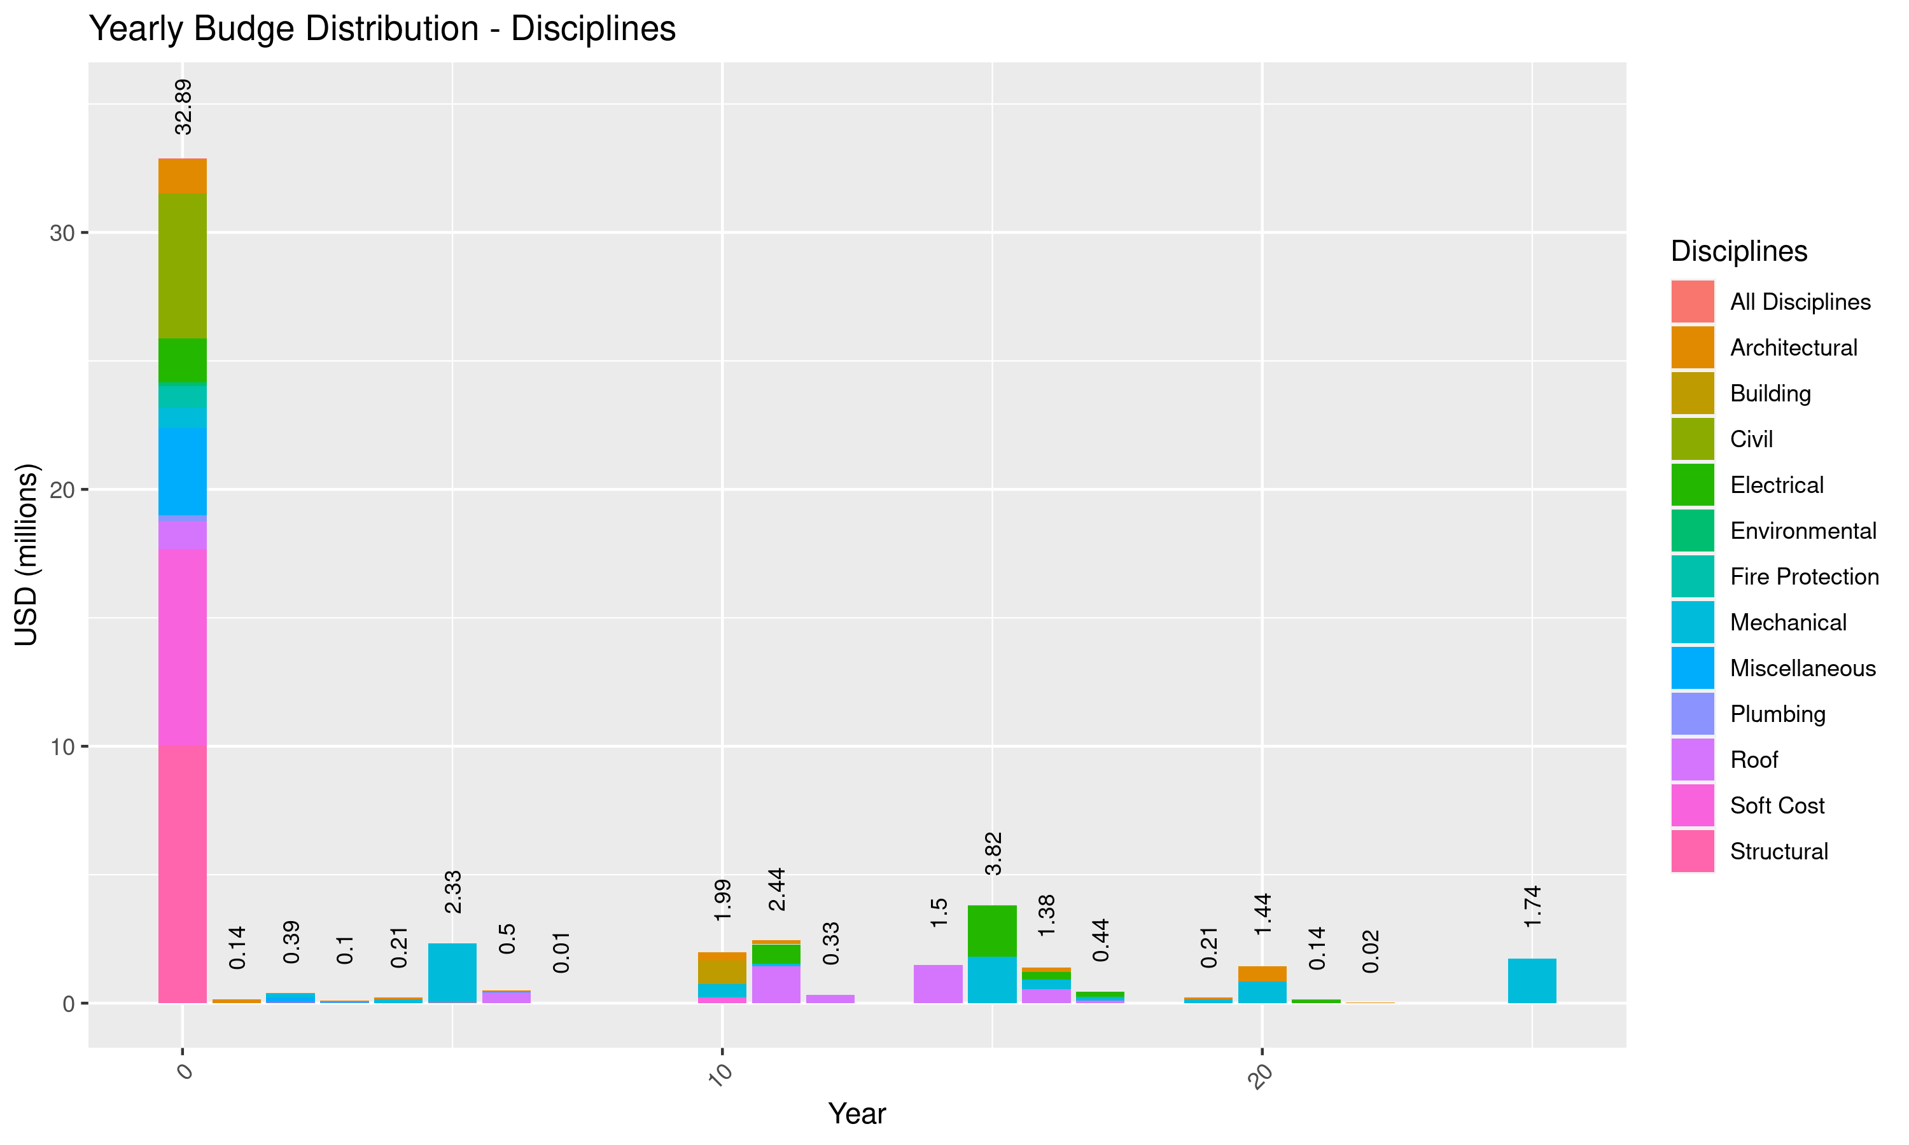

Figure 11: Yearly Distribution of CAPEX - Disciplines

Tables 7 presents the yearly distribution of CAPEX under each area.

Table 7: Yearly CAPEX Distribution - Area

| Area | immediate | shortterm | mediumterm | longterm | CAPEX | freq |
| --- | --- | --- | --- | --- | --- | --- |
| SY | 19,683,150 | 1,831,330 | 1,616,250 | 7,663,500 | 30,794,230 | 59.19 |
| NY | 6,233,190 | 1,339,000 | 884,170 | 5,807,630 | 14,263,990 | 27.42 |
| NY+SY | 6,969,320 | 0 | 0 | 0 | 6,969,320 | 13.40 |
| Total | 32,885,660 | 3,170,330 | 2,500,420 | 13,471,130 | 52,027,540 | 100.00 |

As can be seen from the table, about 60% of the cost is allocated for South Yard (approximate $20 millions). Under immediate term, total CAPEX for the South Yard is approximately $20 million. Further distribution of yearly CAPEX can be referred to Figure 12 and the provided CAPEX tidy dataset.

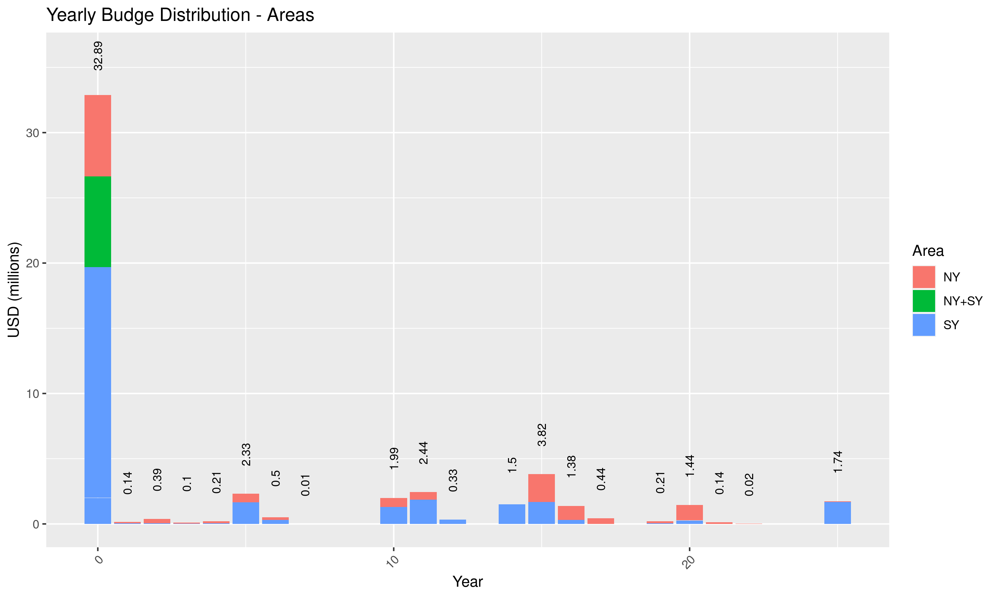

Figure 12: Yearly Distribution of CAPEX - Areas

Tables 8 presents the yearly distribution of CAPEX under each tenant.

Table 8: Yearly CAPEX Distribution - Tenant

| Tenant | immediate | shortterm | mediumterm | longterm | CAPEX | freq |
| --- | --- | --- | --- | --- | --- | --- |
| Austal | 8,436,320 | 945,930 | 1,399,020 | 3,979,950 | 14,761,220 | 28.37 |
| Navy | 6,294,240 | 1,241,260 | 868,330 | 5,683,620 | 14,087,450 | 27.08 |
| Dock 6 | 7,818,070 | 909,520 | 75,660 | 3,288,150 | 12,091,400 | 23.24 |
| JV | 7,472,850 | 43,620 | 5,400 | 7,010 | 7,528,880 | 14.47 |
| Tenant 3 | 2,864,180 | 30,000 | 152,010 | 512,400 | 3,558,590 | 6.84 |
| Total | 32,885,660 | 3,170,330 | 2,500,420 | 13,471,130 | 52,027,540 | 100.00 |

The three tenants Austal, Navy, and Dock 6 contributes to majority of CAPEX with 28.37%, 27.08%, and 23.24%, respectively. Details on distribution of cost per tenant will be detailed in later section of the report. Further distribution of yearly CAPEX can be referred to Figure 13 and the provided CAPEX tidy dataset.

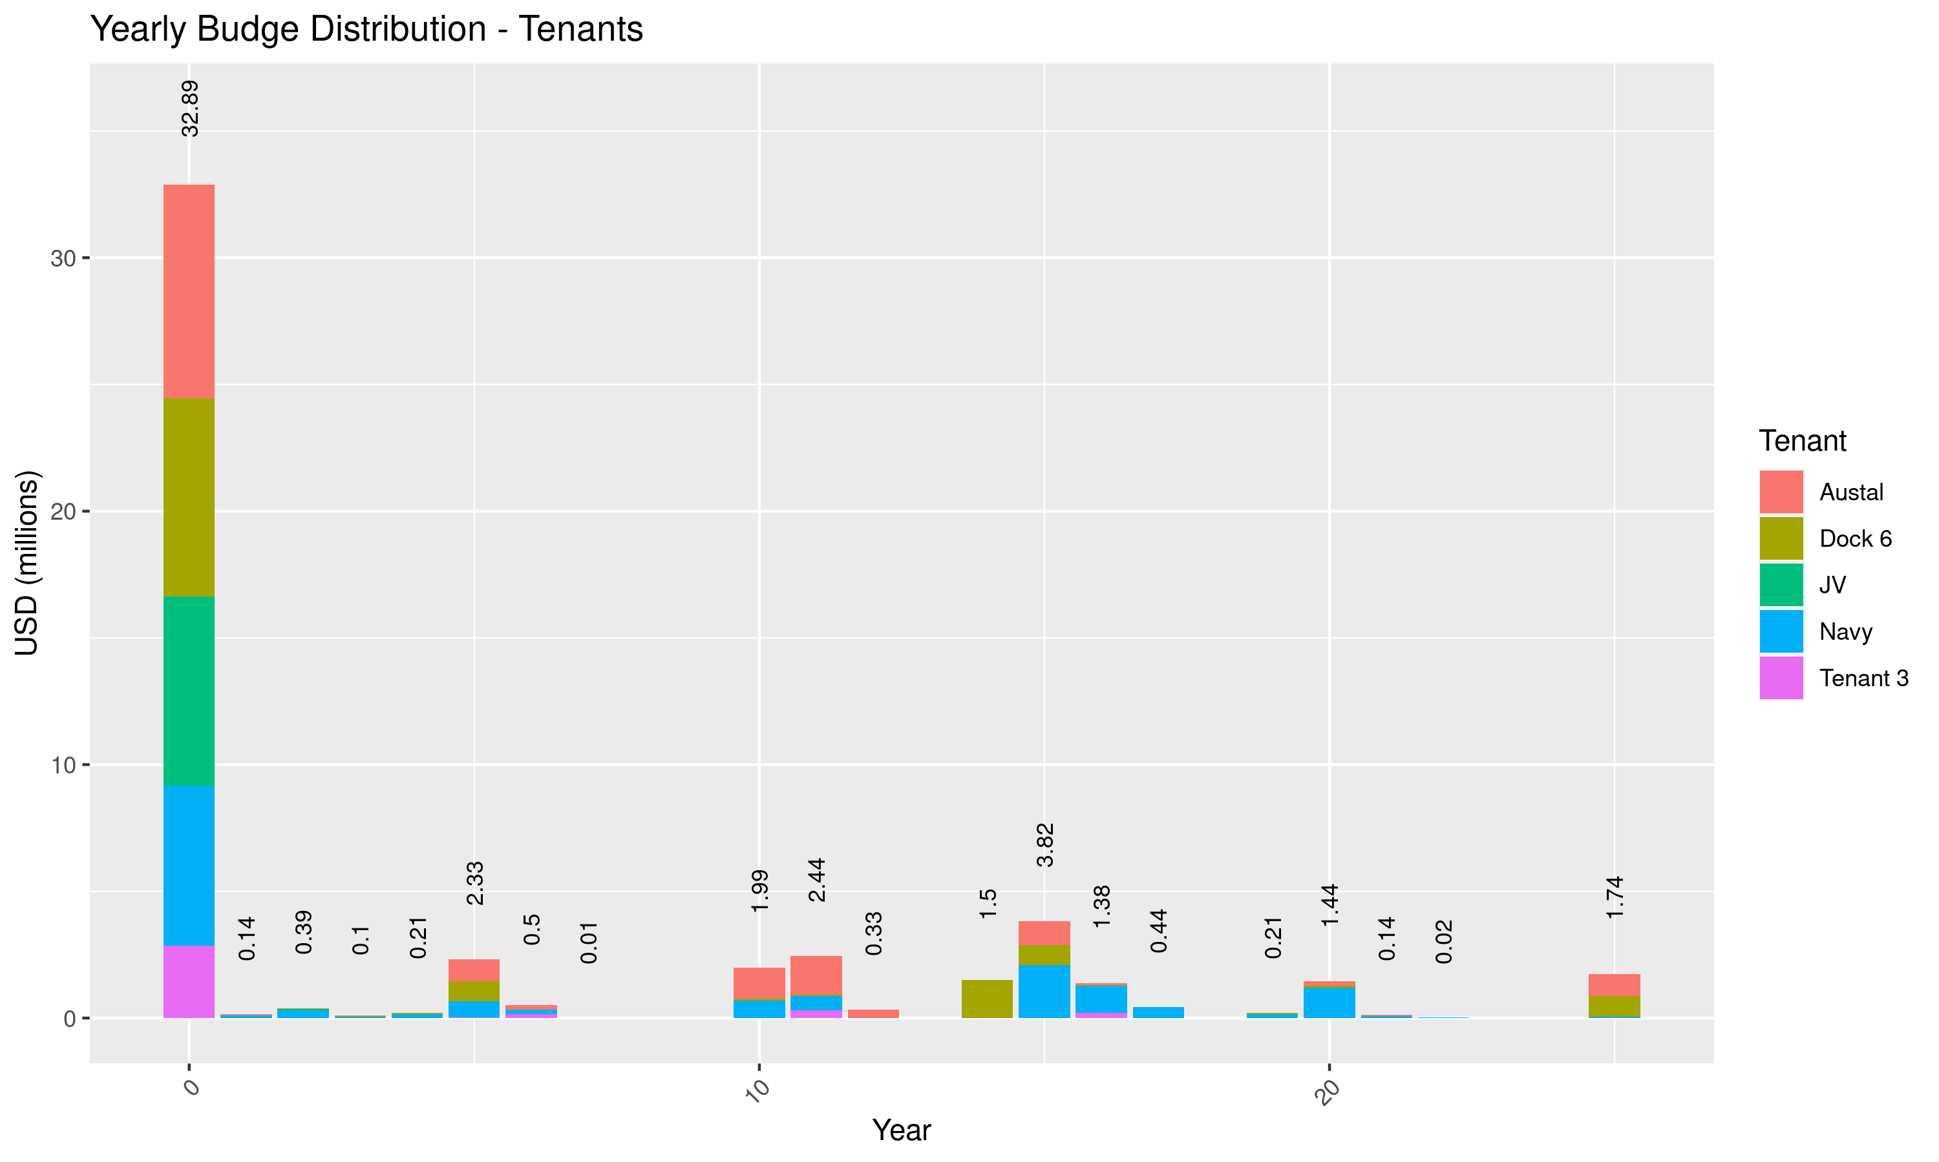

Figure 13: Yearly Distribution of CAPEX - Tenants

Tables 9 presents the yearly distribution of CAPEX under each work type.

Table 9: Yearly CAPEX Distribution - Work Types

| WorkType | immediate | shortterm | mediumterm | longterm | CAPEX | freq |
| --- | --- | --- | --- | --- | --- | --- |
| Structural Upgrade | 9,597,420 | 0 | 0 | 0 | 9,597,420 | 18.45 |
| HVAC | 781,570 | 2,610,310 | 567,360 | 5,048,010 | 9,007,250 | 17.31 |
| Roof | 1,057,030 | 0 | 410,070 | 3,902,460 | 5,369,560 | 10.32 |
| Perimeter Fence | 5,352,950 | 0 | 0 | 0 | 5,352,950 | 10.29 |
| Electrical System | 1,711,160 | 0 | 0 | 3,376,710 | 5,087,870 | 9.78 |
| Miscellaneous | 3,384,050 | 212,750 | 0 | 0 | 3,596,800 | 6.91 |
| Preliminaries | 3,109,910 | 11,580 | 92,960 | 0 | 3,214,450 | 6.18 |
| Contingencies | 2,809,390 | 10,530 | 84,500 | 0 | 2,904,420 | 5.58 |
| Interior | 1,202,470 | 250,610 | 377,330 | 1,055,710 | 2,886,120 | 5.55 |
| Engineering and Management | 1,730,130 | 6,370 | 50,230 | 0 | 1,786,730 | 3.43 |
| Demolition | 0 | 0 | 917,970 | 0 | 917,970 | 1.76 |
| Fire Protection System | 858,290 | 0 | 0 | 0 | 858,290 | 1.65 |
| Plumbing System | 550,610 | 30,330 | 0 | 0 | 580,940 | 1.12 |
| Structural Elements | 413,020 | 0 | 0 | 0 | 413,020 | 0.79 |
| Environmental | 180,000 | 30,000 | 0 | 0 | 210,000 | 0.40 |
| Building Fabric | 138,830 | 0 | 0 | 0 | 138,830 | 0.27 |
| Vertical Transportation | 8,830 | 0 | 0 | 88,240 | 97,070 | 0.19 |
| Mechanical System | 0 | 7,850 | 0 | 0 | 7,850 | 0.02 |
| Total | 32,885,660 | 3,170,330 | 2,500,420 | 13,471,130 | 52,027,540 | 100.00 |

Further distribution of yearly CAPEX can be referred to Figure 14 and the provided CAPEX tidy dataset.

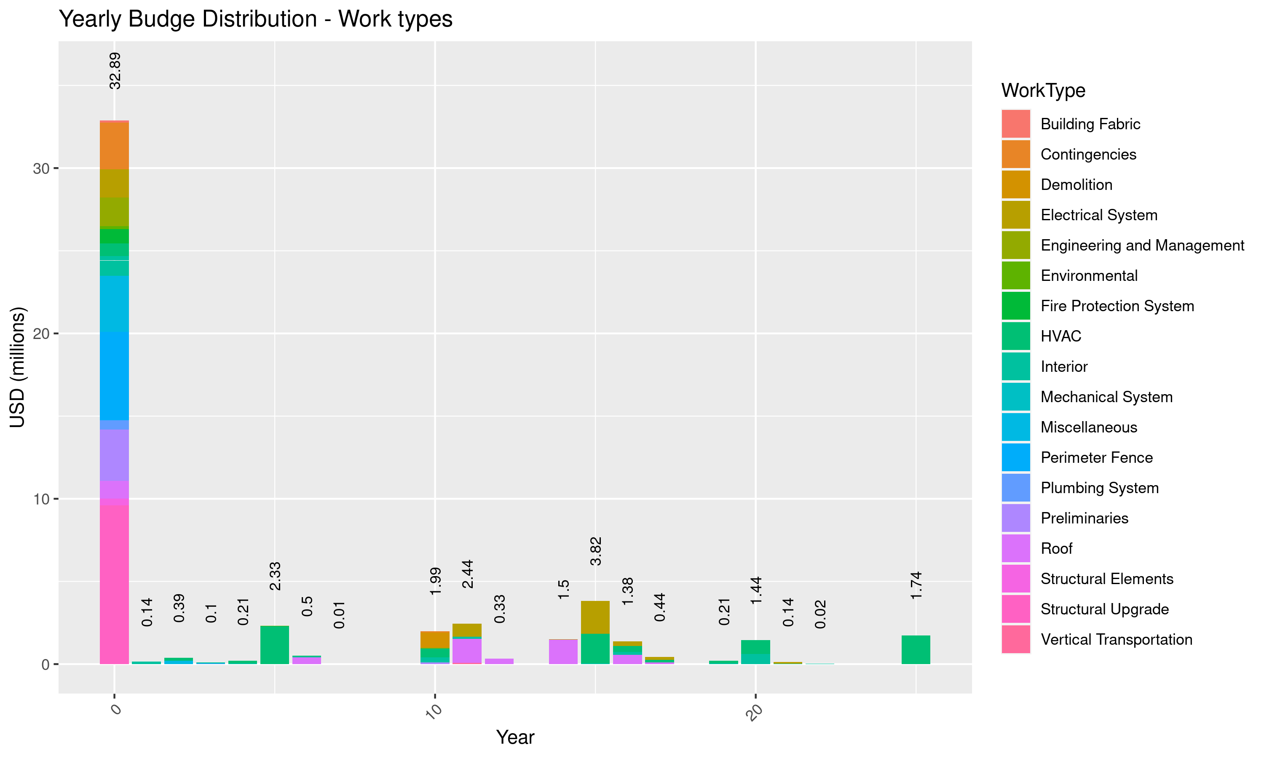

Figure 14: Yearly Distribution of CAPEX - Work Types

## Austal

The distribution of CAPEX under Austal is presented in the Table 10.

Table 10: Austals CAPEX Distribution

| Disciplines | immediate | shortterm | mediumterm | longterm | CAPEX | freq |
| --- | --- | --- | --- | --- | --- | --- |
| Structural | 3,906,300 | 0 | 0 | 0 | 3,906,300 | 26.46 |
| Mechanical | 247,620 | 871,340 | 110,950 | 1,929,390 | 3,159,300 | 21.40 |
| Soft Cost | 2,013,410 | 0 | 224,140 | 0 | 2,237,550 | 15.16 |
| Roof | 207,020 | 0 | 122,360 | 1,676,830 | 2,006,210 | 13.59 |
| Miscellaneous | 917,680 | 0 | 0 | 0 | 917,680 | 6.22 |
| Building | 0 | 0 | 828,550 | 0 | 828,550 | 5.61 |
| Electrical | 494,340 | 0 | 0 | 215,810 | 710,150 | 4.81 |
| Architectural | 130,440 | 74,590 | 113,020 | 157,920 | 475,970 | 3.22 |
| Fire Protection | 434,040 | 0 | 0 | 0 | 434,040 | 2.94 |
| Plumbing | 52,970 | 0 | 0 | 0 | 52,970 | 0.36 |
| Environmental | 32,500 | 0 | 0 | 0 | 32,500 | 0.22 |
| All Disciplines | 0 | 0 | 0 | 0 | 0 | 0.00 |
| Total | 8,436,320 | 945,930 | 1,399,020 | 3,979,950 | 14,761,220 | 100.00 |

Clearly shown in the table, cost allocated to structural upgrading and strengthening is significant, especially under immediate term. The cost associated with structural components alone is nearly $3.9 million out of $8.43 millions. Along with it is $2 millions of soft cost, which is basically the expenses used for engineering and construction management activities.

As discussed in previous section, structural strengthening is mainly due to possible code incompliance and this needs to be verified. If fortunately, major of structure components will satisfy the new code, the Client might save significant CAPEX expenditure for this tenant.

Other significant costs are with the mechanical and roofing, however, it falls into long-term CAPEX as intervention strategies for those items are mainly contributed by recurrence of replacement and major intervention due to end of services life of assets.

The soft cost cost includes 10% of preliminaries work, 5% for permitting, and 10% for contingencies. These percentages are of standard values in the local market.

Figure 15 presents the yearly CAPEX distribution for this tenant.

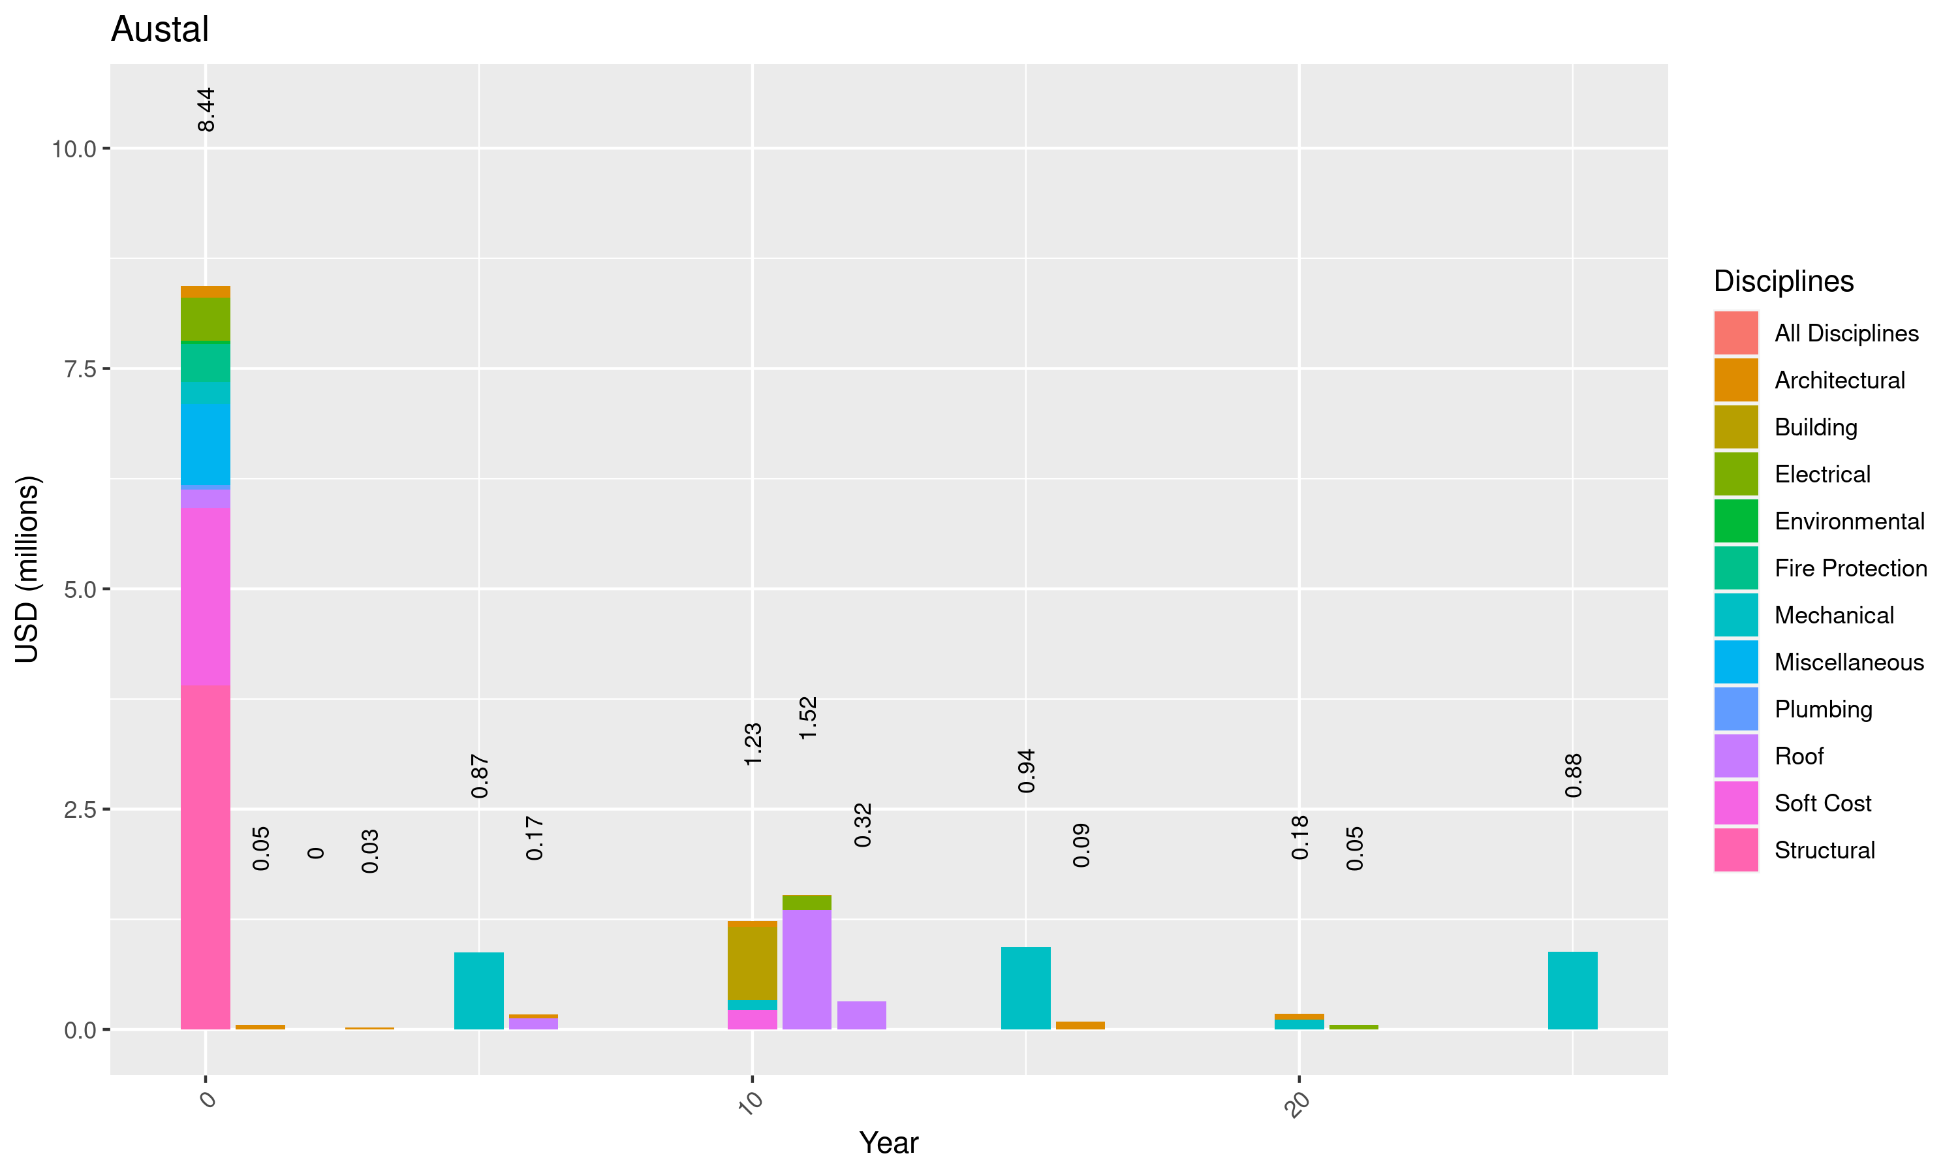

Figure 15: Yearly Distribution of CAPEX - Austal

Since the CAPEX is heavily distributed under structural components, per discussion with the Client, further breakdown into distribution for this item is necessary.

Table 11 presents a summary of CAPEX items subjected to structural upgrade

Table 11: Austals CAPEX Distribution - Structure

| CAPEXassets | Facilities | NPVCapexUSD | freq |
| --- | --- | --- | --- |
| Upgrade to comply current structural code | Assembly shop (B) | 795,340 | 20.360 |
| Upgrade to comply current structural code | Hull Shop (A) | 739,930 | 18.942 |
| Upgrade to comply current structural code | Assembly shop (A) | 537,060 | 13.749 |
| Upgrade to comply current structural code | Pre-erection area (6 nos) - No. 5 Dock Shelter | 337,650 | 8.644 |
| Upgrade to comply current structural code | Sub Assembly Shop | 305,100 | 7.810 |
| Upgrade to comply current structural code | Blasting & Painting Shop B | 272,460 | 6.975 |
| Upgrade to comply current structural code | Assembly shelter (6 nos) | 261,890 | 6.704 |
| Upgrade to comply current structural code | Pre-Outfitting Shop (A) | 172,650 | 4.420 |
| Upgrade to comply current structural code | Outfitting Shop | 131,770 | 3.373 |
| Upgrade to comply current structural code | Welding Inspection Shop | 98,040 | 2.510 |
| Upgrade to comply current structural code | No.5 Dock Shelter | 97,060 | 2.485 |
| Upgrade to comply current structural code | Pre Treatment Shop A | 91,420 | 2.340 |
| Upgrade to comply current structural code | Pre Treatment Shop B | 65,930 | 1.688 |
| Total | - | 3,906,300 | 100.000 |

Table 12 presents a summary of CAPEX items subjected to Miscellaneous.

Table 12: Austal CAPEX Distribution - Miscellaneous

| Facilities | immediate | shortterm | mediumterm | longterm | CAPEX | freq |
| --- | --- | --- | --- | --- | --- | --- |
| Pre-erection area (6 nos) - No. 5 Dock Shelter | 84,420 | 0 | 0 | 0 | 84,420 | 9.20 |
| Hull Shop (A) | 79,180 | 0 | 0 | 0 | 79,180 | 8.63 |
| Assembly shop (A) | 56,930 | 0 | 0 | 0 | 56,930 | 6.20 |
| No.5 Dock Shelter | 48,530 | 0 | 0 | 0 | 48,530 | 5.29 |
| Sub station #12 | 43,240 | 0 | 0 | 0 | 43,240 | 4.71 |
| Assembly shop (B) | 40,570 | 0 | 0 | 0 | 40,570 | 4.42 |
| Sub Station #14 | 36,000 | 0 | 0 | 0 | 36,000 | 3.92 |
| Sub Assembly Shop | 31,740 | 0 | 0 | 0 | 31,740 | 3.46 |
| Field Office 1 | 31,430 | 0 | 0 | 0 | 31,430 | 3.42 |
| Assembly shelter (6 nos) | 30,560 | 0 | 0 | 0 | 30,560 | 3.33 |
| Tool Shop | 28,980 | 0 | 0 | 0 | 28,980 | 3.16 |
| Outfitting Shop | 28,550 | 0 | 0 | 0 | 28,550 | 3.11 |
| Blasting & Painting Shop B | 27,250 | 0 | 0 | 0 | 27,250 | 2.97 |
| Sub station #17 | 27,060 | 0 | 0 | 0 | 27,060 | 2.95 |
| Field Office 8 | 25,600 | 0 | 0 | 0 | 25,600 | 2.79 |
| Field Office 2A | 22,600 | 0 | 0 | 0 | 22,600 | 2.46 |
| Field Office 2 | 22,470 | 0 | 0 | 0 | 22,470 | 2.45 |
| Sub Station #13 | 21,830 | 0 | 0 | 0 | 21,830 | 2.38 |
| Sub Station #9 | 21,180 | 0 | 0 | 0 | 21,180 | 2.31 |
| Sub Station #15 | 19,530 | 0 | 0 | 0 | 19,530 | 2.13 |
| Sub station #20 | 19,120 | 0 | 0 | 0 | 19,120 | 2.08 |
| Field Office 7 | 19,080 | 0 | 0 | 0 | 19,080 | 2.08 |
| Field Office 6 | 18,520 | 0 | 0 | 0 | 18,520 | 2.02 |
| Pre-Outfitting Shop (A) | 17,620 | 0 | 0 | 0 | 17,620 | 1.92 |
| Sub station #11 | 15,690 | 0 | 0 | 0 | 15,690 | 1.71 |
| Air Compressed Room - 2,3 | 14,990 | 0 | 0 | 0 | 14,990 | 1.63 |
| Welding Inspection Shop | 14,710 | 0 | 0 | 0 | 14,710 | 1.60 |
| Field Office 6a | 12,360 | 0 | 0 | 0 | 12,360 | 1.35 |
| Field Office 3 | 10,290 | 0 | 0 | 0 | 10,290 | 1.12 |
| Pre Treatment Shop A | 9,150 | 0 | 0 | 0 | 9,150 | 1.00 |
| Field Office 15 | 9,020 | 0 | 0 | 0 | 9,020 | 0.98 |
| Sub Station #3 | 7,650 | 0 | 0 | 0 | 7,650 | 0.83 |
| Sub Station #16 | 7,060 | 0 | 0 | 0 | 7,060 | 0.77 |
| Pre Treatment Shop B | 6,600 | 0 | 0 | 0 | 6,600 | 0.72 |
| Sub Station #37 | 4,910 | 0 | 0 | 0 | 4,910 | 0.54 |
| Spill Prevention Kits/Secondary Containment Austal | 3,260 | 0 | 0 | 0 | 3,260 | 0.36 |
| Total | 917,680 | 0 | 0 | 0 | 917,680 | 100.00 |

## Navy

The distribution of CAPEX under Navy is presented in the Table 13.

Table 13: Navy CAPEX Distribution

| Disciplines | immediate | shortterm | mediumterm | longterm | CAPEX | freq |
| --- | --- | --- | --- | --- | --- | --- |
| Electrical | 714,550 | 0 | 0 | 2,895,040 | 3,609,590 | 25.62 |
| Mechanical | 391,150 | 945,850 | 450,910 | 1,599,420 | 3,387,330 | 24.05 |
| Architectural | 1,058,420 | 106,950 | 188,750 | 753,160 | 2,107,280 | 14.96 |
| Soft Cost | 1,585,360 | 19,180 | 3,550 | 0 | 1,608,090 | 11.42 |
| Structural | 1,144,410 | 0 | 0 | 0 | 1,144,410 | 8.12 |
| Roof | 449,230 | 0 | 135,700 | 436,000 | 1,020,930 | 7.25 |
| Miscellaneous | 736,090 | 138,950 | 0 | 0 | 875,040 | 6.21 |
| Plumbing | 147,570 | 30,330 | 0 | 0 | 177,900 | 1.26 |
| Building | 0 | 0 | 89,420 | 0 | 89,420 | 0.63 |
| Environmental | 32,500 | 0 | 0 | 0 | 32,500 | 0.23 |
| All Disciplines | 23,190 | 0 | 0 | 0 | 23,190 | 0.16 |
| Fire Protection | 11,770 | 0 | 0 | 0 | 11,770 | 0.08 |
| Total | 6,294,240 | 1,241,260 | 868,330 | 5,683,620 | 14,087,450 | 100.00 |

As can be seen from the table, under immediate term, there are a number of significant CAPEX items distributed under each desciplines, they are Electrical, Architectural, Soft Cost, and Structural and Miscellaneous.

Figure 16 presents the yearly CAPEX distribution for this tenant.

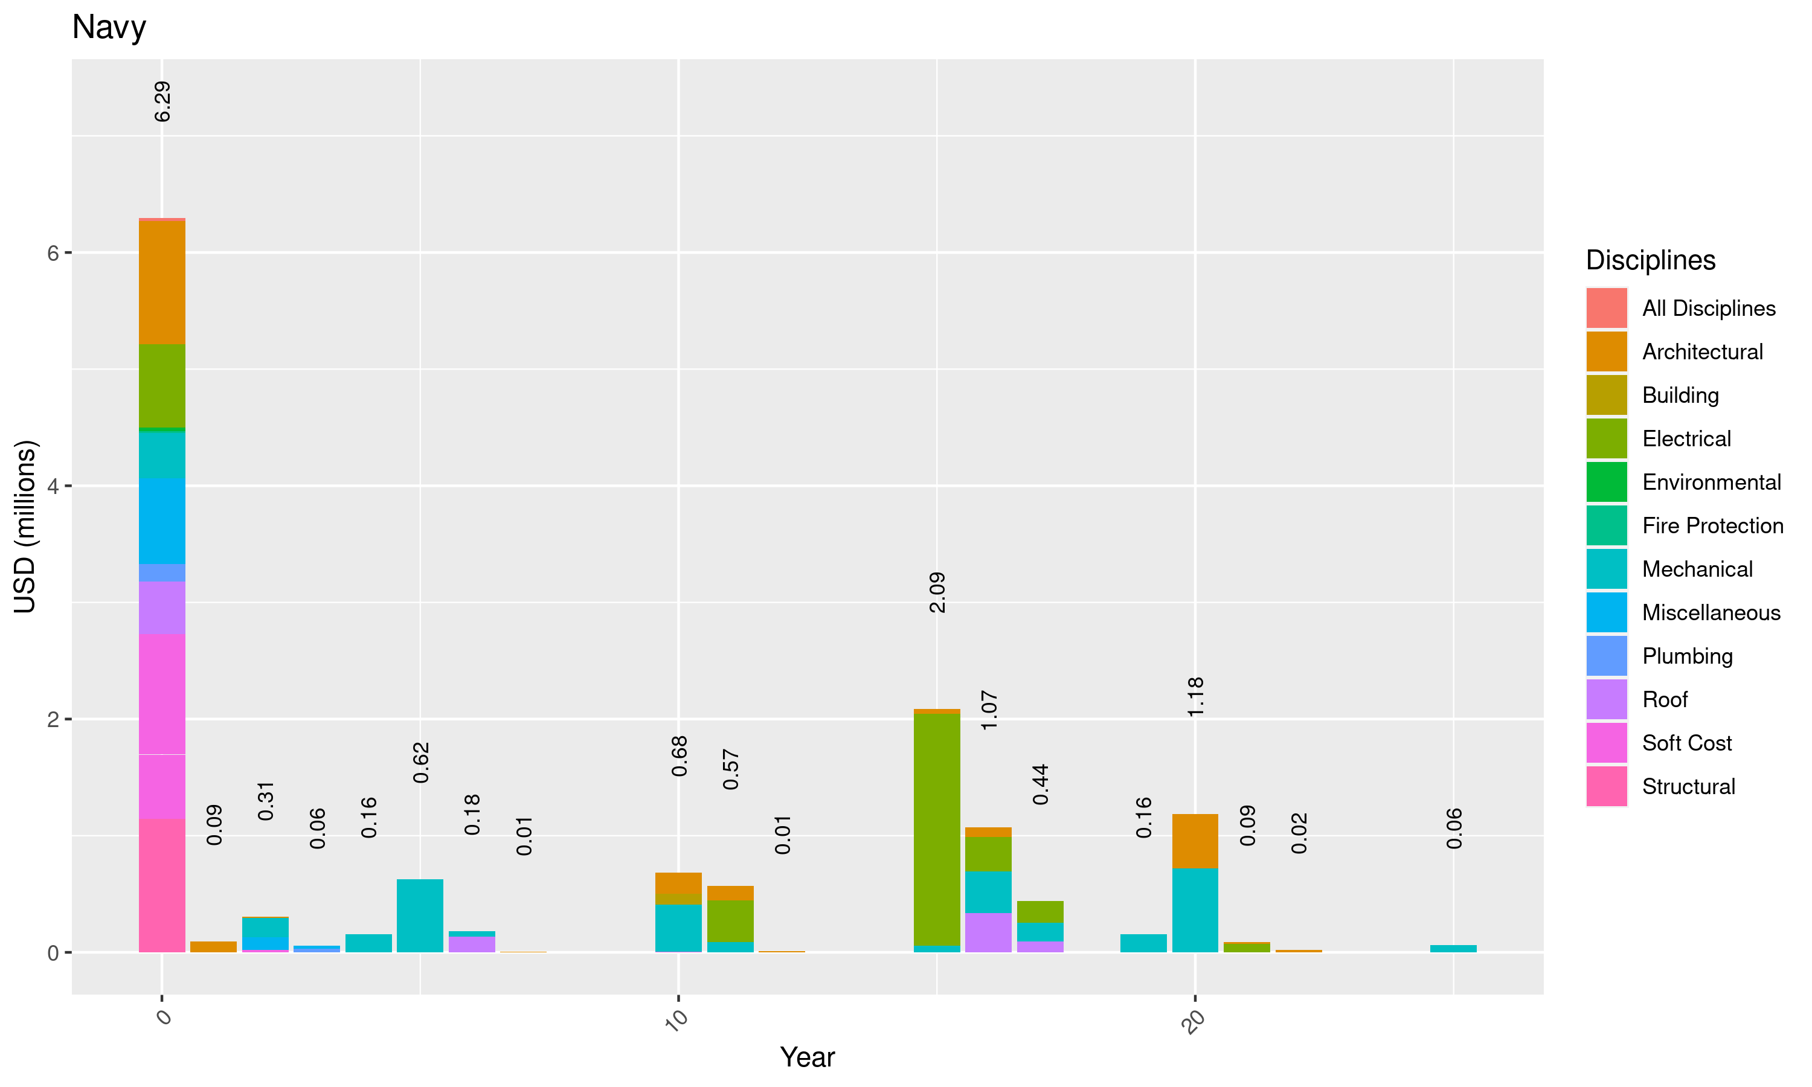

Figure 16: Yearly Distribution of CAPEX - Navy

Table 14 presents a summary of CAPEX items subjected to structural upgrade

Table 14: Navy CAPEX Distribution - Structure

| CAPEXassets | Facilities | NPVCapexUSD | freq |
| --- | --- | --- | --- |
| Upgrade to comply current structural code | Main Office | 274,510 | 23.99 |
| Overall structural retrofitting | Piping Pre-treatment building Galva | 199,020 | 17.39 |
| Upgrade to comply current structural code | Electric Steel Outfitting Shop | 181,180 | 15.83 |
| Upgrade to comply current structural code | Guest House | 112,550 | 9.83 |
| Upgrade to comply current structural code | Pipe Manufacture Shop A&B | 82,060 | 7.17 |
| Repair of Structural Steel frame members | Electric Steel Outfitting Shop | 77,650 | 6.79 |
| Repair of C-purlins for GI Sheet Wall | Cable Cutting | 53,340 | 4.66 |
| Upgrade to comply current structural code | Assembly Shop (D) | 46,590 | 4.07 |
| Installation of missing X- Brace | Pipe Manufacture Shop A&B | 36,930 | 3.23 |
| Upgrade to comply current structural code | Main Gate | 31,580 | 2.76 |
| Upgrade to comply current structural code | Cable Cutting | 24,510 | 2.14 |
| Upgrade to comply current structural code | Shelter for Piping | 16,400 | 1.43 |
| Upgrade to comply current structural code | Piping Shelter | 7,850 | 0.69 |
| Repair of Missing 12mm Dia Rod Brace including accessories | Painting Shop A -1 | 240 | 0.02 |
| Total | - | 1,144,410 | 100.00 |

Table 15 presents a summary of CAPEX items subjected to Architectural.

Table 15: Navy CAPEX Distribution - Architectural

| Facilities | immediate | shortterm | mediumterm | longterm | CAPEX | freq |
| --- | --- | --- | --- | --- | --- | --- |
| Main Office | 441,200 | 0 | 44,120 | 147,070 | 632,390 | 30.01 |
| Barracks - G1 | 20,400 | 0 | 17,160 | 276,530 | 314,090 | 14.90 |
| Catering Center | 80,650 | 89,500 | 0 | 106,220 | 276,370 | 13.12 |
| Guest House | 147,000 | 0 | 6,180 | 46,700 | 199,880 | 9.49 |
| Piping Pre-treatment building Galva | 198,850 | 0 | 0 | 0 | 198,850 | 9.44 |
| Barracks - C | 31,540 | 0 | 19,860 | 23,690 | 75,090 | 3.56 |
| Barracks - E | 31,540 | 0 | 19,860 | 23,690 | 75,090 | 3.56 |
| Field Office 13 | 7,720 | 12,360 | 10,890 | 35,610 | 66,580 | 3.16 |
| Barracks - Admin | 27,470 | 0 | 17,160 | 21,580 | 66,210 | 3.14 |
| Barracks - G2 | 21,580 | 0 | 17,160 | 21,580 | 60,320 | 2.86 |
| Barracks - D | 19,270 | 0 | 16,180 | 19,270 | 54,720 | 2.60 |
| Barracks - B | 19,610 | 0 | 12,210 | 14,510 | 46,330 | 2.20 |
| Field Office 5 | 8,940 | 5,090 | 3,840 | 8,930 | 26,800 | 1.27 |
| Field Office 14 | 1,830 | 0 | 3,310 | 6,960 | 12,100 | 0.57 |
| Barracks - Accommodation | 820 | 0 | 820 | 820 | 2,460 | 0.12 |
| Total | 1,058,420 | 106,950 | 188,750 | 753,160 | 2,107,280 | 100.00 |

Table 16 presents a summary of CAPEX items subjected to Electrical

Table 16: Navy CAPEX Distribution - Electrical

| Facilities | immediate | shortterm | mediumterm | longterm | CAPEX | freq |
| --- | --- | --- | --- | --- | --- | --- |
| Main Generator Room | 0 | 0 | 0 | 0 | 1,985,300 | 55.00 |
| Main Office | 220,590 | 0 | 0 | 12,600 | 527,310 | 14.61 |
| Piping Pre-treatment building Galva | 227,460 | 0 | 0 | 0 | 227,460 | 6.30 |
| Pipe Manufacture Shop A&B | 0 | 0 | 0 | 140,000 | 140,000 | 3.88 |
| Assembly Shop (D) | 0 | 0 | 0 | 0 | 70,000 | 1.94 |
| Cable Cutting | 0 | 0 | 0 | 0 | 70,000 | 1.94 |
| Electric Steel Outfitting Shop | 0 | 0 | 0 | 0 | 70,000 | 1.94 |
| Shelter 712 | 0 | 0 | 0 | 70,000 | 70,000 | 1.94 |
| Shelter for Piping | 0 | 0 | 0 | 70,000 | 70,000 | 1.94 |
| Piping Shelter | 0 | 0 | 0 | 0 | 49,020 | 1.36 |
| Painting Shop A -1 | 0 | 0 | 0 | 42,160 | 42,160 | 1.17 |
| Barracks - Admin | 29,420 | 0 | 0 | 0 | 29,420 | 0.82 |
| Barracks - G2 | 29,420 | 0 | 0 | 0 | 29,420 | 0.82 |
| Barracks - C | 25,500 | 0 | 0 | 0 | 25,500 | 0.71 |
| Barracks - E | 25,500 | 0 | 0 | 0 | 25,500 | 0.71 |
| Field Office 5 | 25,430 | 0 | 0 | 0 | 25,430 | 0.70 |
| Field Office 13 | 24,720 | 0 | 0 | 0 | 24,720 | 0.68 |
| Barracks - G1 | 21,570 | 0 | 0 | 0 | 21,570 | 0.60 |
| Barracks - D | 20,590 | 0 | 0 | 0 | 20,590 | 0.57 |
| Field Office 14 | 18,240 | 0 | 0 | 0 | 18,240 | 0.51 |
| Catering Center | 0 | 0 | 0 | 16,450 | 16,450 | 0.46 |
| Barracks - B | 15,300 | 0 | 0 | 0 | 15,300 | 0.42 |
| Sub Station #31 | 9,810 | 0 | 0 | 490 | 10,300 | 0.29 |
| Sub Station #33 | 9,810 | 0 | 0 | 490 | 10,300 | 0.29 |
| Sub Station #35 | 9,810 | 0 | 0 | 490 | 10,300 | 0.29 |
| Guest House | 0 | 0 | 0 | 3,920 | 3,920 | 0.11 |
| Barracks - Accommodation | 1,380 | 0 | 0 | 0 | 1,380 | 0.04 |
| Total | 714,550 | 0 | 0 | 356,600 | 3,609,590 | 100.00 |

Table 17 presents a summary of CAPEX items subjected to Miscellaneous.

Table 17: Navy CAPEX Distribution - Miscellaneous

| Facilities | immediate | shortterm | mediumterm | longterm | CAPEX | freq |
| --- | --- | --- | --- | --- | --- | --- |
| Electric Steel Outfitting Shop (Building at the back) | 121,480 | 0 | 0 | 0 | 121,480 | 13.88 |
| Main Office | 61,520 | 28,680 | 0 | 0 | 90,200 | 10.31 |
| Guest House | 57,400 | 0 | 0 | 0 | 57,400 | 6.56 |
| Electric Steel Outfitting Shop | 51,770 | 0 | 0 | 0 | 51,770 | 5.92 |
| Barracks - K | 50,990 | 0 | 0 | 0 | 50,990 | 5.83 |
| Convenience Store building | 0 | 49,220 | 0 | 0 | 49,220 | 5.62 |
| Helicopter Hangar | 44,120 | 0 | 0 | 0 | 44,120 | 5.04 |
| Main Gate | 0 | 39,480 | 0 | 0 | 39,480 | 4.51 |
| Piping Pre-treatment building Galva | 38,300 | 0 | 0 | 0 | 38,300 | 4.38 |
| Catering Center | 37,900 | 0 | 0 | 0 | 37,900 | 4.33 |
| Barracks - F | 34,320 | 0 | 0 | 0 | 34,320 | 3.92 |
| Shelter 712 | 32,360 | 0 | 0 | 0 | 32,360 | 3.70 |
| Gasoline Station | 29,420 | 0 | 0 | 0 | 29,420 | 3.36 |
| Canteen-Romanian | 0 | 21,570 | 0 | 0 | 21,570 | 2.47 |
| Cable Cutting | 20,370 | 0 | 0 | 0 | 20,370 | 2.33 |
| Sub Station #31 | 18,830 | 0 | 0 | 0 | 18,830 | 2.15 |
| Sub Station #33 | 13,440 | 0 | 0 | 0 | 13,440 | 1.54 |
| Barracks - C | 12,120 | 0 | 0 | 0 | 12,120 | 1.39 |
| Pipe Manufacture Shop A&B | 11,900 | 0 | 0 | 0 | 11,900 | 1.36 |
| Barracks - J | 10,300 | 0 | 0 | 0 | 10,300 | 1.18 |
| Barracks - Romanian | 10,300 | 0 | 0 | 0 | 10,300 | 1.18 |
| Barracks - D | 9,120 | 0 | 0 | 0 | 9,120 | 1.04 |
| Field Office 5 | 7,920 | 0 | 0 | 0 | 7,920 | 0.91 |
| Barracks - G1 | 7,790 | 0 | 0 | 0 | 7,790 | 0.89 |
| Barracks - Admin | 7,470 | 0 | 0 | 0 | 7,470 | 0.85 |
| Barracks - G2 | 7,000 | 0 | 0 | 0 | 7,000 | 0.80 |
| Assembly Shop (D) | 6,260 | 0 | 0 | 0 | 6,260 | 0.72 |
| Field Office 13 | 6,060 | 0 | 0 | 0 | 6,060 | 0.69 |
| Barracks - B | 5,710 | 0 | 0 | 0 | 5,710 | 0.65 |
| Sub Station #35 | 5,100 | 0 | 0 | 0 | 5,100 | 0.58 |
| Blasting & Painting Shop E | 4,780 | 0 | 0 | 0 | 4,780 | 0.55 |
| Spill Prevention Kits/Secondary Containment Navy | 3,260 | 0 | 0 | 0 | 3,260 | 0.37 |
| Painting Shop A -1 | 2,140 | 0 | 0 | 0 | 2,140 | 0.24 |
| Shelter for Piping | 1,640 | 0 | 0 | 0 | 1,640 | 0.19 |
| Field Office 14 | 1,610 | 0 | 0 | 0 | 1,610 | 0.18 |
| Piping Shelter | 1,570 | 0 | 0 | 0 | 1,570 | 0.18 |
| Main Generator Room | 1,480 | 0 | 0 | 0 | 1,480 | 0.17 |
| Barracks - Accommodation | 340 | 0 | 0 | 0 | 340 | 0.04 |
| Total | 736,090 | 138,950 | 0 | 0 | 875,040 | 100.00 |

## Dock 6

The distribution of CAPEX under Dock 6 is presented in the Table 18.

Table 18: Dock 6 CAPEX Distribution

| Disciplines | immediate | shortterm | mediumterm | longterm | CAPEX | freq |
| --- | --- | --- | --- | --- | --- | --- |
| Structural | 3,906,950 | 0 | 0 | 0 | 3,906,950 | 32.31 |
| Mechanical | 151,630 | 0 | 806,470 | 1,607,440 | 2,565,540 | 21.22 |
| Soft Cost | 1,860,990 | 0 | 0 | 0 | 1,860,990 | 15.39 |
| Roof | 84,620 | 0 | 0 | 1,488,210 | 1,572,830 | 13.01 |
| Miscellaneous | 963,990 | 39,480 | 0 | 0 | 1,003,470 | 8.30 |
| Electrical | 453,150 | 0 | 0 | 53,270 | 506,420 | 4.19 |
| Architectural | 147,040 | 69,070 | 70,160 | 139,230 | 425,500 | 3.52 |
| Fire Protection | 210,330 | 0 | 0 | 0 | 210,330 | 1.74 |
| Environmental | 32,500 | 0 | 0 | 0 | 32,500 | 0.27 |
| Plumbing | 6,870 | 0 | 0 | 0 | 6,870 | 0.06 |
| Total | 7,818,070 | 108,550 | 876,630 | 3,288,150 | 12,091,400 | 100.00 |

Figure 17 presents the yearly CAPEX distribution for this tenant per disciplines.

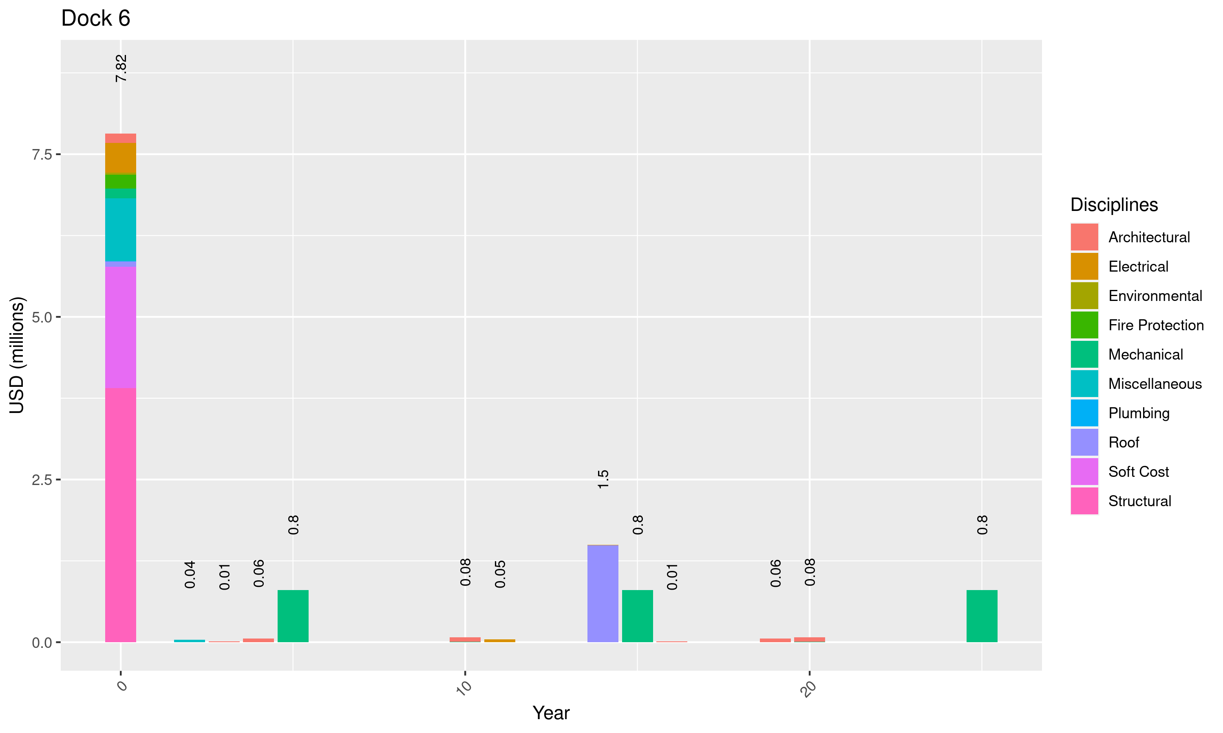

Figure 17: Yearly Distribution of CAPEX - Dock 6

Table 19 presents a summary of CAPEX items subjected to structural upgrade

Table 19: Dock 6 CAPEX Distribution - Structure

| CAPEXassets | Facilities | NPVCapexUSD | freq |
| --- | --- | --- | --- |
| Upgrade to comply current structural code | Panel Shop | 1,078,100 | 27.59 |
| Upgrade to comply current structural code | Hull Shop B | 763,140 | 19.53 |
| Upgrade to comply current structural code | Assembly Shop (C) | 423,930 | 10.85 |
| Upgrade to comply current structural code | Pre-Erection Area - Dock 6 (Pre-Erection Shelter A, B) | 372,220 | 9.53 |
| Upgrade to comply current structural code | Blasting & Painting Shop D | 294,280 | 7.53 |
| Upgrade to comply current structural code | Blasting & Painting Shop C | 294,140 | 7.53 |
| Upgrade to comply current structural code | Welding Shop (B) | 207,850 | 5.32 |
| Upgrade to comply current structural code | Painting Shop A Ext. | 205,890 | 5.27 |
| Upgrade to comply current structural code | Pre-Outfitting Shop (B) | 89,950 | 2.30 |
| Upgrade to comply current structural code | Blasting Shop A | 86,050 | 2.20 |
| Upgrade to comply current structural code | Air Compressed Room - 1 | 31,580 | 0.81 |
| Upgrade to comply current structural code | Paint Can Stock Area | 30,400 | 0.78 |
| Upgrade to comply current structural code | Maintenance Shop | 29,420 | 0.75 |
| Total | - | 3,906,950 | 99.99 |

Table 20 presents a summary of CAPEX items subjected to Miscellaneous.

Table 20: Dock6 CAPEX Distribution - Miscellaneous

| Facilities | immediate | shortterm | mediumterm | longterm | CAPEX | freq |
| --- | --- | --- | --- | --- | --- | --- |
| Panel Shop | 109,970 | 0 | 0 | 0 | 109,970 | 10.96 |
| Hull Shop B | 77,850 | 0 | 0 | 0 | 77,850 | 7.76 |
| Waste Matter/Scrap Iron Stock | 76,480 | 0 | 0 | 0 | 76,480 | 7.62 |
| Steel Stock Yard | 73,090 | 0 | 0 | 0 | 73,090 | 7.28 |
| Sub Station #32 | 47,060 | 0 | 0 | 0 | 47,060 | 4.69 |
| Sub station #22 | 44,710 | 0 | 0 | 0 | 44,710 | 4.46 |
| Sub station #26 | 44,710 | 0 | 0 | 0 | 44,710 | 4.46 |
| Assembly Shop (C) | 43,460 | 0 | 0 | 0 | 43,460 | 4.33 |
| Air Compressed Room - 1 | 0 | 39,480 | 0 | 0 | 39,480 | 3.93 |
| Pre-Erection Area - Dock 6 (Pre-Erection Shelter A, B) | 37,970 | 0 | 0 | 0 | 37,970 | 3.78 |
| Field Office 11B | 30,260 | 0 | 0 | 0 | 30,260 | 3.02 |
| Field Office 9 | 30,070 | 0 | 0 | 0 | 30,070 | 3.00 |
| Blasting & Painting Shop D | 29,430 | 0 | 0 | 0 | 29,430 | 2.93 |
| Blasting & Painting Shop C | 29,420 | 0 | 0 | 0 | 29,420 | 2.93 |
| Blasting Shop A | 27,470 | 0 | 0 | 0 | 27,470 | 2.74 |
| Field Office 10 | 25,540 | 0 | 0 | 0 | 25,540 | 2.55 |
| Sub station #21 | 25,500 | 0 | 0 | 0 | 25,500 | 2.54 |
| Fire Station | 22,060 | 0 | 0 | 0 | 22,060 | 2.20 |
| Welding Shop (B) | 22,040 | 0 | 0 | 0 | 22,040 | 2.20 |
| Painting Shop A Ext. | 20,590 | 0 | 0 | 0 | 20,590 | 2.05 |
| Field Office 11A | 19,880 | 0 | 0 | 0 | 19,880 | 1.98 |
| Sub station #25 | 19,120 | 0 | 0 | 0 | 19,120 | 1.91 |
| Field Office 12 | 19,080 | 0 | 0 | 0 | 19,080 | 1.90 |
| Sub Station #30 | 17,460 | 0 | 0 | 0 | 17,460 | 1.74 |
| Field Office 5A | 13,490 | 0 | 0 | 0 | 13,490 | 1.34 |
| Sub station #22-1 | 13,440 | 0 | 0 | 0 | 13,440 | 1.34 |
| Pre-Outfitting Shop (B) | 10,720 | 0 | 0 | 0 | 10,720 | 1.07 |
| Sub Station #23 | 8,040 | 0 | 0 | 0 | 8,040 | 0.80 |
| Sub Station #24 | 6,670 | 0 | 0 | 0 | 6,670 | 0.66 |
| Sub Station #34 | 5,100 | 0 | 0 | 0 | 5,100 | 0.51 |
| Sub Station #10 | 4,060 | 0 | 0 | 0 | 4,060 | 0.40 |
| Spill Prevention Kits/Secondary Containment Dock 6 | 3,260 | 0 | 0 | 0 | 3,260 | 0.32 |
| Paint Can Stock Area | 3,040 | 0 | 0 | 0 | 3,040 | 0.30 |
| Maintenance Shop | 2,950 | 0 | 0 | 0 | 2,950 | 0.29 |
| Total | 963,990 | 39,480 | 0 | 0 | 1,003,470 | 100.00 |

## Tenant 3

The distribution of CAPEX under Tenant 3 is presented in the Table 21.

Table 21: Tenant3 CAPEX Distribution

| Disciplines | immediate | shortterm | mediumterm | longterm | CAPEX | freq |
| --- | --- | --- | --- | --- | --- | --- |
| Structural | 3,906,950 | 0 | 0 | 0 | 3,906,950 | 32.31 |
| Mechanical | 151,630 | 0 | 0 | 2,413,910 | 2,565,540 | 21.22 |
| Soft Cost | 1,860,990 | 0 | 0 | 0 | 1,860,990 | 15.39 |
| Roof | 84,620 | 0 | 0 | 1,488,210 | 1,572,830 | 13.01 |
| Miscellaneous | 963,990 | 39,480 | 0 | 0 | 1,003,470 | 8.30 |
| Electrical | 453,150 | 0 | 0 | 53,270 | 506,420 | 4.19 |
| Architectural | 147,040 | 12,700 | 56,370 | 209,390 | 425,500 | 3.52 |
| Fire Protection | 210,330 | 0 | 0 | 0 | 210,330 | 1.74 |
| Environmental | 32,500 | 0 | 0 | 0 | 32,500 | 0.27 |
| Plumbing | 6,870 | 0 | 0 | 0 | 6,870 | 0.06 |
| Total | 7,818,070 | 52,180 | 56,370 | 4,164,780 | 12,091,400 | 100.00 |

Figure 18 presents the yearly CAPEX distribution for this tenant per disciplines.

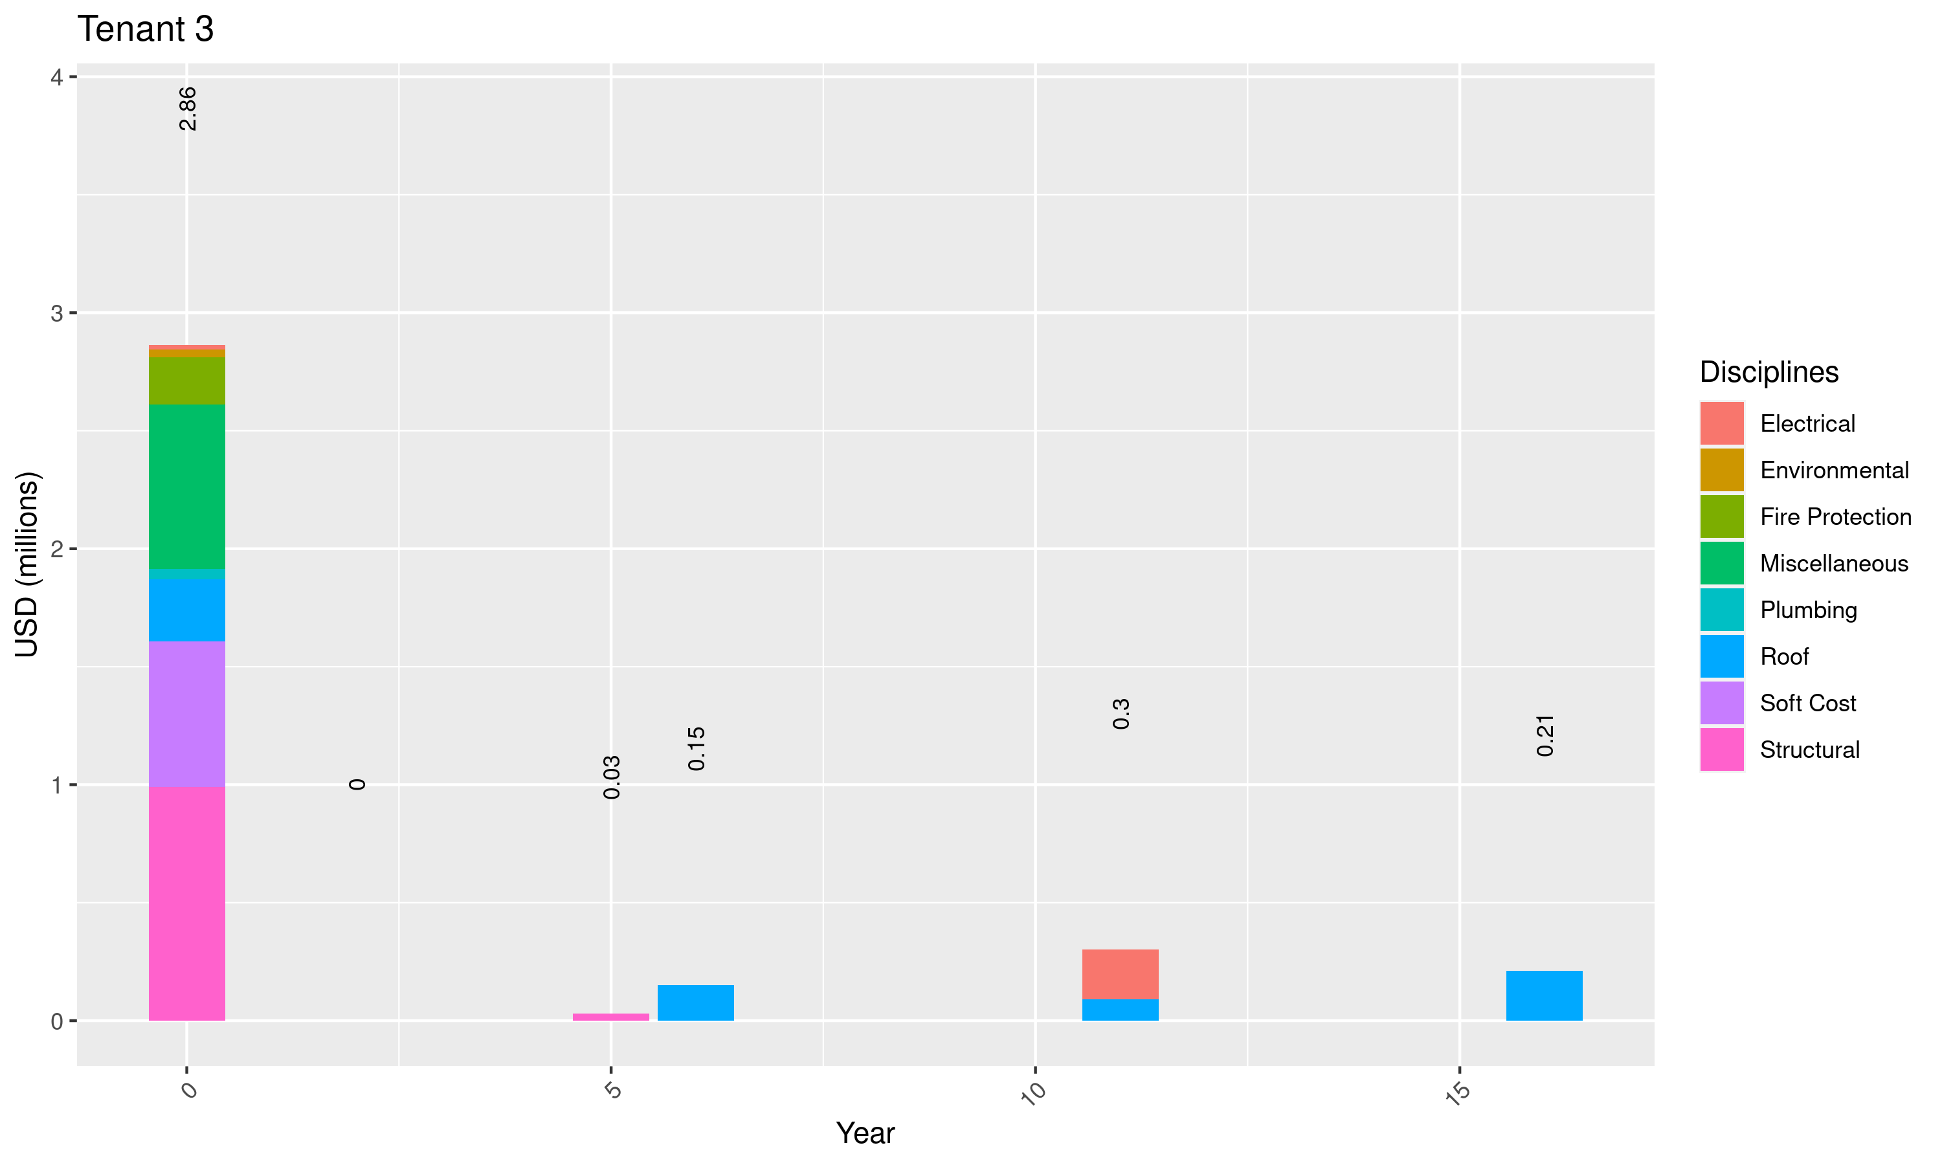

Figure 18: Yearly Distribution of CAPEX - Tenant 3

Table 22 presents a summary of CAPEX items subjected to structural upgrade

Table 22: Tenant 3 CAPEX Distribution - Structure

| CAPEXassets | Facilities | NPVCapexUSD | freq |
| --- | --- | --- | --- |
| Upgrade to comply current structural code | Hatch cover Shelter | 376,480 | 36.89 |
| Upgrade to comply current structural code | Dhouse Shelter | 297,650 | 29.16 |
| Upgrade to comply current structural code | T-BHD Shelter | 224,120 | 21.96 |
| Slope Protection | Slope protection | 50,000 | 4.90 |
| Upgrade to comply current structural code | Sub-Assembly Shop (94 bay) | 42,360 | 4.15 |
| Slope Protection | Slope protection | 30,000 | 2.94 |
| Total | - | 1,020,610 | 100.00 |

Table 23 presents a summary of CAPEX items subjected to Miscellaneous.

Table 23: Tenant 3 CAPEX Distribution - Miscellaneous

| Facilities | immediate | shortterm | mediumterm | longterm | CAPEX | freq |
| --- | --- | --- | --- | --- | --- | --- |
| Nagyantok Outfitting Shop A | 193,630 | 0 | 0 | 0 | 193,630 | 27.80 |
| Samandra - Maintenance Shop/Office | 151,180 | 0 | 0 | 0 | 151,180 | 21.70 |
| Dhouse Shelter | 43,870 | 0 | 0 | 0 | 43,870 | 6.30 |
| Nagyantok Stock Room 1 | 35,300 | 0 | 0 | 0 | 35,300 | 5.07 |
| Nagyantok Stock Room 2 | 29,420 | 0 | 0 | 0 | 29,420 | 4.22 |
| Hatch cover Shelter | 29,400 | 0 | 0 | 0 | 29,400 | 4.22 |
| Nagyantok Segragation Area | 24,510 | 0 | 0 | 0 | 24,510 | 3.52 |
| Sub Station #36 | 23,530 | 0 | 0 | 0 | 23,530 | 3.38 |
| T-BHD Shelter | 22,870 | 0 | 0 | 0 | 22,870 | 3.28 |
| Samandra - Container Shop | 22,550 | 0 | 0 | 0 | 22,550 | 3.24 |
| Nagyantok Warehouse | 22,310 | 0 | 0 | 0 | 22,310 | 3.20 |
| Sub-Assembly Shop (94 bay) | 21,350 | 0 | 0 | 0 | 21,350 | 3.07 |
| Nagyantok Procurement Storage shop | 20,590 | 0 | 0 | 0 | 20,590 | 2.96 |
| Samandra - Warehouse | 16,180 | 0 | 0 | 0 | 16,180 | 2.32 |
| Sub Station #38 | 15,890 | 0 | 0 | 0 | 15,890 | 2.28 |
| Nagyantok Stock office | 5,890 | 0 | 0 | 0 | 5,890 | 0.85 |
| Slope protection | 5,000 | 0 | 0 | 0 | 5,000 | 0.72 |
| Nagyantok Material Store and Bond shop | 4,910 | 0 | 0 | 0 | 4,910 | 0.70 |
| Samandra - Shop B | 4,910 | 0 | 0 | 0 | 4,910 | 0.70 |
| Spill Prevention Kits/Secondary Containment Tenant 3 | 3,260 | 0 | 0 | 0 | 3,260 | 0.47 |
| Total | 696,550 | 0 | 0 | 0 | 696,550 | 100.00 |

## Shared Facilities

The distribution of CAPEX under shared facilities is presented in the Table 24.

Table 24: Shared facilities CAPEX Distribution

| Disciplines | immediate | shortterm | mediumterm | longterm | CAPEX | freq |
| --- | --- | --- | --- | --- | --- | --- |
| Civil | 5,652,030 | 0 | 0 | 0 | 5,652,030 | 75.0713 |
| Soft Cost | 1,573,270 | 9,300 | 0 | 0 | 1,582,570 | 21.0200 |
| Miscellaneous | 69,740 | 34,320 | 0 | 0 | 104,060 | 1.3821 |
| Structural | 88,980 | 0 | 0 | 0 | 88,980 | 1.1818 |
| Roof | 53,930 | 0 | 0 | 0 | 53,930 | 0.7163 |
| Electrical | 29,500 | 0 | 0 | 1,610 | 31,110 | 0.4132 |
| Architectural | 5,400 | 0 | 5,400 | 5,400 | 16,200 | 0.2152 |
| Total | 7,472,850 | 43,620 | 5,400 | 7,010 | 7,528,880 | 100.0000 |

As can be seen from the table, the majority of the cost under shared facilities is allocated under Civil work, which mainly includes the fencing. Table 25 presents a summary of CAPEX items subjected to Civil Works.

Table 25: Shared Facilities CAPEX Distribution - Civil Works

| CAPEXassets | Disciplines | Facilities | NPVCapexUSD | freq |
| --- | --- | --- | --- | --- |
| Shared Utilities - Fence | Civil | Shared Utilities - Fence | 5,352,950 | 94.71 |
| Upgrade to comply DAO 2016 | Civil | Sewage Treatment Plant | 196,080 | 3.47 |
| Shared Utilities - Water | Civil | Shared Utilities - Water | 103,000 | 1.82 |
| Total | - | - | 5,652,030 | 100.00 |

# Discussion on OPEX

Per request of the Client, Arcadis has been working on high level OPEX estimation for several assets of the Shipyard, mainly on Water and Wastewater, Power consumptions.

Various online discussions have been initiated to provide Client better understanding of local requirements on labor and human resource requirements for operation and maintenance. Discussion with managers and staff of the Shipyard has also been carried out to understand the past requirements.

This section briefly provides a short narrative on a certain number of components associated with OPEX of some certain facilities, but not entirely the OPEX of the shipyard as a complete OPEX of the shipyard should be done as an separated execise that involves economic modelling and cash flow analysis based on assumed production and operation of specific tenants. This has been in agreement with the Client.

As a matter of practice, ballpark estimate for OPEX is often formulated based on the percentage (%) of CAPEX that spreads over the expected end of life of particular assets. Thus, in order to estimate the OPEX, it is necesaary to estimate the ballpark value of CAPEX.

For example, pavement sections in the shipyard might have been designed with different thickness for different purposes. This results in different OPEX annualy per square meter for different road sections. Similarly, annualy OPEX of pumps and GENSET should also be different, depending on how big or small the assets are and on the criticality of assets as well.

## OPEX on Water and Wastewater Plants

It is a fact that no official and historical records of OPEX of the Shipyard has been transmitted to Arcadis for this analysis. Data collected was mainly by telephone calls and benchmark data of major water supply companies in the Philippines. Thus, the data provided here on OPEX should be read as only for references.

Table @ref{tab:opex1} presents benchmark values of OPEX. The values are reference values from major water and waste water companies and projects in the Philippines.

Table 26: Water and Wastewater OPEX benchmark

| Items | (Php/m3/day) | (USD/m3/day) |
| --- | --- | --- |
| Water Treatment Plant (WTP) | 5~8 | 0.1~0.15 |
| Sewage Treatment Plant (STP) | 5~7.5 | 0.1~0.14 |

Reference values shown in the table includes

* Power consumption
* Routine maintenance (labour and materials)
* Chemical consumption
* Inspection and auditing

The annual OPEX of a WTP is believed to be around 40% of the CAPEX. Whislt, for STP, OPEX is often higher and could reach to event 200% of the CAPEX. This is mainly attributed by the fact that operation and maintenance works for STP often incur not inside the STP but outside and on the network.

In term of labor portion of the OPEX, per expert opinions, it is approximately about 30% of the total OPEX. It is advisable that the Client should consider this value in allocation of personnel and cost for future operation. To support this, we further elaborate the team chart of personnel supposed to be for the Hanjin Shipyard.

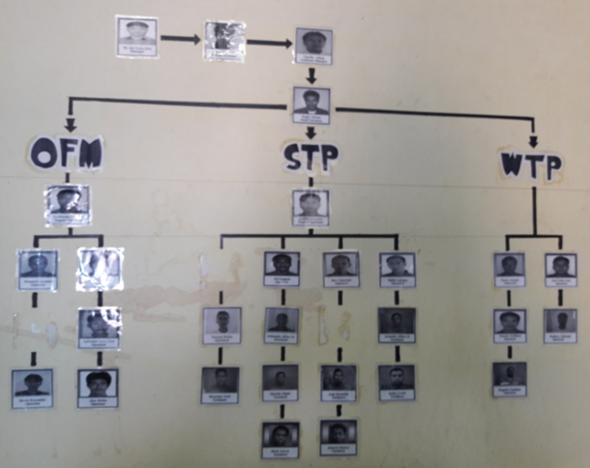

Figure 19: Past team chart for Operation Management

The Figure shows three branches, which are for WTP, STP, and OFM (Other Facility Machine). In total, there were about 30 people assumed to work for O&M activities for only the Nothern Yard area.

Per discussion with the managers and staff of the shipyard, it is understand that the operation of the shipyard has been separated into at least 2 shifts (day and night). Under the two shifts working scheme, the O&M team will be more or less allocated into 2 teams, with more people taking care for day shift and less people for the night shift since the production requirements during the night time was less than that of the day shift.

It was also reported that the organizational chart was the idea team setting up by Korean managers at the onset of the project. However, during operation phases, there was a reduction in the number of staff for O&M activities. An approximate good numbers of O&M personnel has not been revealed.

Regarding the O&M cost allocated for M&E and A&I assets of the shipyards, as discussed earlier, there is no magic numbers but rather an approximate values based on experience of experts working on the field. The O&M cost varies significantly from industry to industry and are different under different owership. If the owners cares more on O&M, owners will build a good asset management system and allocate higher budget in so as to avoid possible future idle times and downtime of the assets due to random or systematic failures.

Following bullet points illustrated the approximation of OPEX ballpark based on percentage of CAPEX.

* MEICA (Mechanical, Electrical, Instrumentation, Control and Automation) CAPEX

MEICA = 60% x CAPEX

* Civil and Structures

SC = 40% x CAPEX

This costs includes both materials and labors. Annual OPEX for civil and structure components is also often estimated based on percentage of CAPEX items, which varies depending on design parameters and sizes of the components. Thus, this is important to collect as-built drawings of the facilities.

* MEICA’s equipment CAPEX

MEICA_e = 70% x MEICA

* Annual OPEX for Equipment

OPEX_e = P x MEICA_e

Where P can range from 10% to 20%.

This formula is expert’s opinions that learnt from average cost of

* WTPs of similar sizes and process
* Water Network includes piping, booster pumps, and appurtenances
* STP of similar sizes and process
* Sewage network includes manholes, lift stations, and vacuum trucks

It is important to also note OPEX can varies significantly by manufactuers and by years. For example, pumps manufactured in China or Korean might have lower life expectancy than pumps produced in Japan or Germany. More frequent breakdown of assets will increase the OPEX for corrective intervention and budget for procuring necessary spare parts. In addition, year by year, after hours of operations, the efficiency of equipments become lower resulting in higher O&M cost. A fixed annual O&M cost might not be an idea but approximately good enough to give decision makers a medium and long-term view on the possible costs associated with routine maintenance and major interventions.

# Appendices

## Appendix 1: Schedule

## Appendix 2: CAPEX Tidy Dataset