Automation Task

The project created with node.js + nightwatch.js framework

In order to run this project:

* Download Java -

(Nightwatch.js runs its tests against the Selenium server. The Selenium server is a Java)

* Download Node.js
* Make sure that the Chromedriver is in the same version as the chrome browser

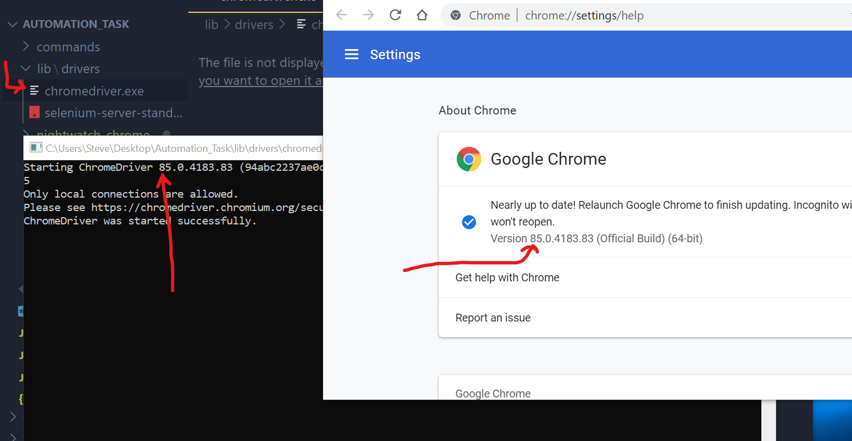

* Run in the terminal npm i in order to install the project

Project structure:

* commands file - Contains all the function that run on the DOM  
  and can reuse in different test-cases
* lib file - Contains the chromedriver + selenium-server
* reports file - Contains the reports for each test_case
* test_cases file - Contains all the test-cases that will run + the selectors for each test_case
* test_flow_classes file - Contains reused classes that can be consume in the test_cases
* tests_runner file - The main file which nightwatch run his tests
* exportsFunction file – Contain the export functions that exist in the commands file

How to run the automation:

* In order to run all the test-case run in the terminal npm start
* In order to run one test-case run in the terminal npm test <tag of test>  
  (the tags of each test appear in the “test_runner”) for example:  
  “npm test testPartOne”