Automation Task

The project created with Nightwatch + node.js, in order to run this project:

* Download Java -

(Nightwatch.js runs its tests against the Selenium server. The Selenium server is a Java)

* Download Node.js
* Make sure that the Chromedriver is in the same version as the chrome browser

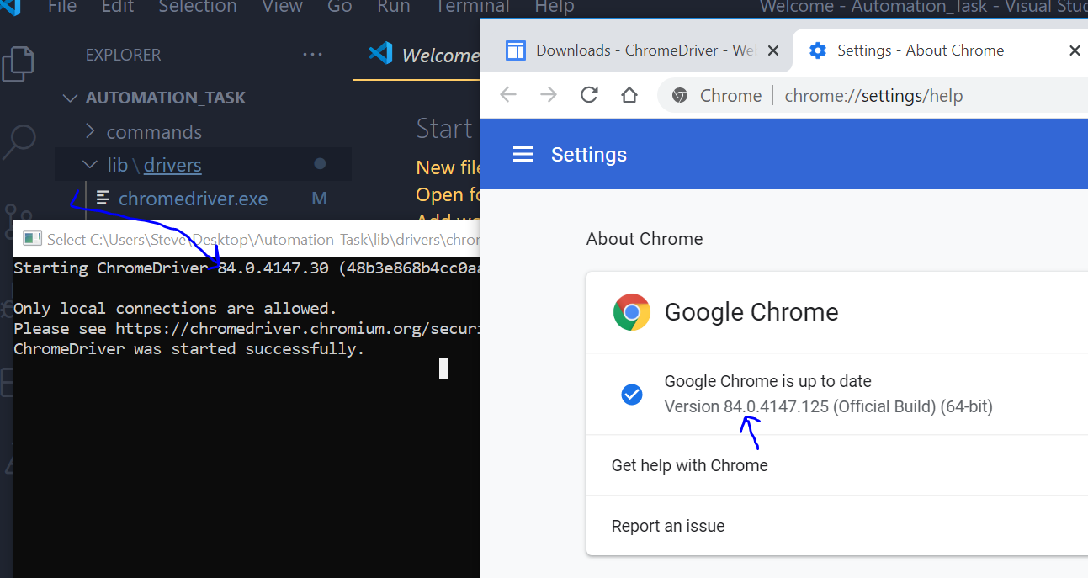

* Run in the terminal npm i in order to install the project

Project structure:

* commands file - contains all the function that run on the DOM  
  and can reuse in different test-cases
* lib file - contains the chromedriver + selenium-server
* reports - contains the reports for each cycle independently + summary   
  of all the cycles together
* testCases file - contains all the test-cases the can be run + the selectors
  + give the ability to change easily
    - url
    - runMoreThanOnce - to start more than one cycle
    - timeToWait right now is for 30 seconds
    - timeToReloadThePage

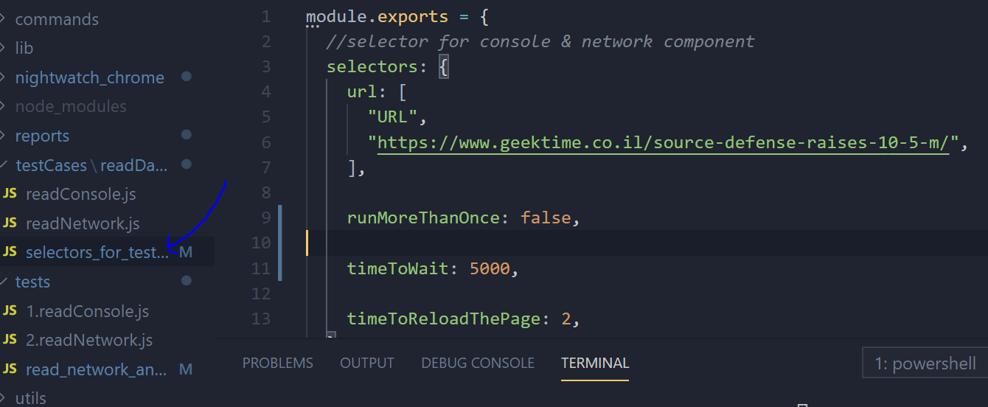

* tests file - contains the test-cases that can be run   
  (can choose to run one test-case by tag name)
* utils – contains all the reports functions
* exportsFunction file – contain the export functions that exist in the commands file

How to run the automation:

* In order to run all the test-case (network request + console logs):
  + Run in the terminal npm start
* In order to run only one test-case (network request or console logs):
  + Run in the terminal npm test <tag name>  
    