**MCD**

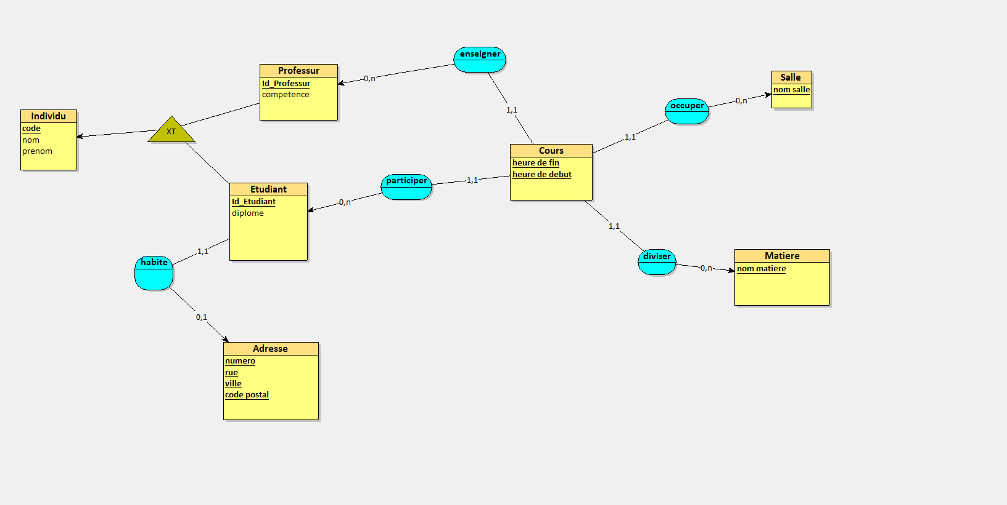

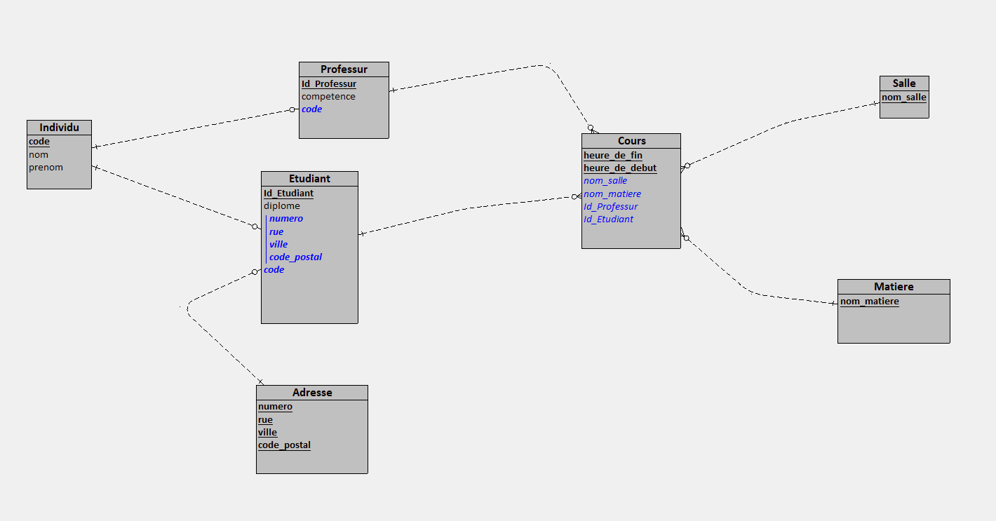**MLD**

**MPD / SQL**

CREATE TABLE Matiere(

nom_matiere VARCHAR(50),

PRIMARY KEY(nom_matiere)

);

CREATE TABLE Salle(

nom_salle VARCHAR(50),

PRIMARY KEY(nom_salle)

);

CREATE TABLE Individu(

code VARCHAR(50),

nom VARCHAR(50),

prenom VARCHAR(50),

PRIMARY KEY(code)

);

CREATE TABLE Adresse(

numero VARCHAR(50),

rue VARCHAR(50),

ville VARCHAR(50),

code_postal VARCHAR(50),

PRIMARY KEY(numero, rue, ville, code_postal)

);

CREATE TABLE Professur(

Id_Professur COUNTER,

competence VARCHAR(50),

code VARCHAR(50) NOT NULL,

PRIMARY KEY(Id_Professur),

UNIQUE(code),

FOREIGN KEY(code) REFERENCES Individu(code)

);

CREATE TABLE Etudiant(

Id_Etudiant COUNTER,

diplome VARCHAR(50),

numero VARCHAR(50) NOT NULL,

rue VARCHAR(50) NOT NULL,

ville VARCHAR(50) NOT NULL,

code_postal VARCHAR(50) NOT NULL,

code VARCHAR(50) NOT NULL,

PRIMARY KEY(Id_Etudiant),

UNIQUE(numero, rue, ville, code_postal),

UNIQUE(code),

FOREIGN KEY(numero, rue, ville, code_postal) REFERENCES Adresse(numero, rue, ville, code_postal),

FOREIGN KEY(code) REFERENCES Individu(code)

);

CREATE TABLE Cours(

heure_de_fin VARCHAR(50),

heure_de_debut VARCHAR(50),

nom_salle VARCHAR(50) NOT NULL,

nom_matiere VARCHAR(50) NOT NULL,

Id_Professur INT NOT NULL,

Id_Etudiant INT NOT NULL,

PRIMARY KEY(heure_de_fin, heure_de_debut),

FOREIGN KEY(nom_salle) REFERENCES Salle(nom_salle),

FOREIGN KEY(nom_matiere) REFERENCES Matiere(nom_matiere),

FOREIGN KEY(Id_Professur) REFERENCES Professur(Id_Professur),

FOREIGN KEY(Id_Etudiant) REFERENCES Etudiant(Id_Etudiant)

);

Bonus Netflix

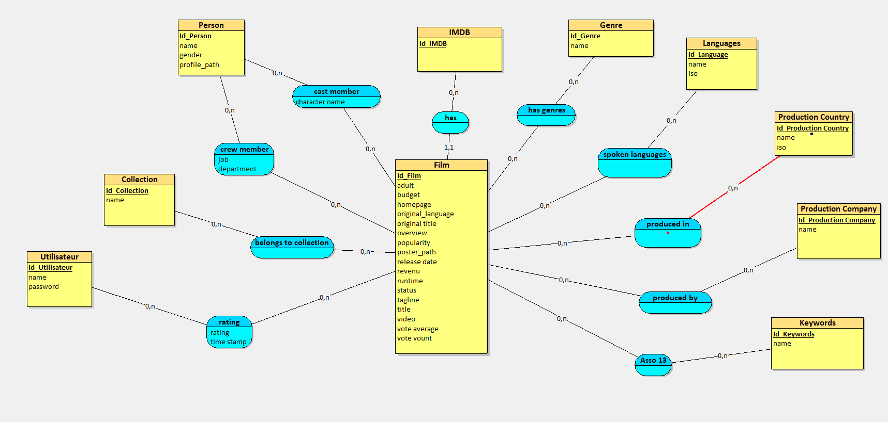

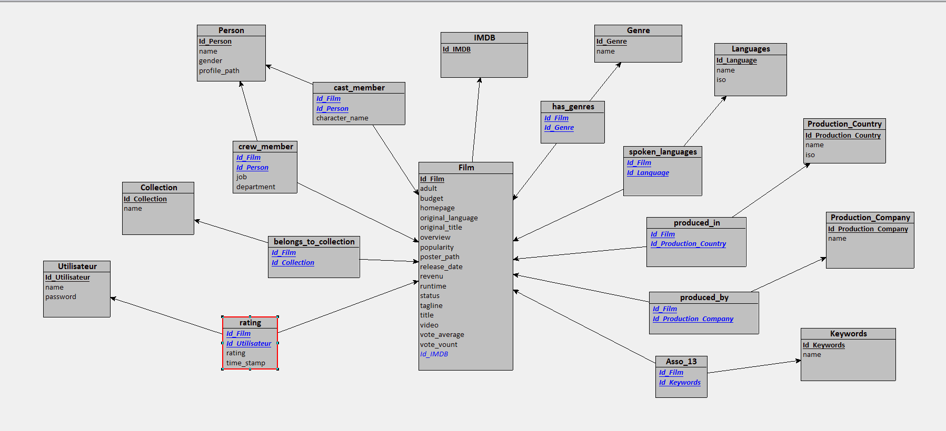

SQL

CREATE TABLE Genre(

Id_Genre COUNTER,

name VARCHAR(50),

PRIMARY KEY(Id_Genre)

);

CREATE TABLE Production_Country(

Id_Production_Country COUNTER,

name VARCHAR(50),

iso VARCHAR(50),

PRIMARY KEY(Id_Production_Country)

);

CREATE TABLE Languages(

Id_Language COUNTER,

name VARCHAR(50),

iso VARCHAR(50),

PRIMARY KEY(Id_Language)

);

CREATE TABLE Collection(

Id_Collection COUNTER,

name VARCHAR(50),

PRIMARY KEY(Id_Collection)

);

CREATE TABLE Production_Company(

Id_Production_Company COUNTER,

name VARCHAR(50),

PRIMARY KEY(Id_Production_Company)

);

CREATE TABLE IMDB(

Id_IMDB COUNTER,

PRIMARY KEY(Id_IMDB)

);

CREATE TABLE Person(

Id_Person COUNTER,

name VARCHAR(50),

gender VARCHAR(50),

profile_path TEXT,

PRIMARY KEY(Id_Person)

);

CREATE TABLE Keywords(

Id_Keywords COUNTER,

name VARCHAR(50),

PRIMARY KEY(Id_Keywords)

);

CREATE TABLE Utilisateur(

Id_Utilisateur COUNTER,

name VARCHAR(50),

password VARCHAR(50),

PRIMARY KEY(Id_Utilisateur)

);

CREATE TABLE Film(

Id_Film COUNTER,

adult LOGICAL,

budget INT,

homepage TEXT,

original_language VARCHAR(25),

original_title VARCHAR(50),

overview TEXT,

popularity DECIMAL(15,2),

poster_path TEXT,

release_date DATE,

revenu INT,

runtime DECIMAL(15,2),

status VARCHAR(50),

tagline TEXT,

title VARCHAR(50),

video LOGICAL,

vote_average DECIMAL(15,2),

vote_vount INT,

Id_IMDB INT NOT NULL,

PRIMARY KEY(Id_Film),

FOREIGN KEY(Id_IMDB) REFERENCES IMDB(Id_IMDB)

);

CREATE TABLE Rating(

Id_Rating COUNTER,

rating VARCHAR(50),

time_stamp DATETIME,

Id_Film INT NOT NULL,

Id_Utilisateur INT NOT NULL,

PRIMARY KEY(Id_Rating),

FOREIGN KEY(Id_Film) REFERENCES Film(Id_Film),

FOREIGN KEY(Id_Utilisateur) REFERENCES Utilisateur(Id_Utilisateur)

);

CREATE TABLE cast_member(

Id_Film INT,

Id_Person INT,

character_name VARCHAR(50),

PRIMARY KEY(Id_Film, Id_Person),

FOREIGN KEY(Id_Film) REFERENCES Film(Id_Film),

FOREIGN KEY(Id_Person) REFERENCES Person(Id_Person)

);

CREATE TABLE produced_in(

Id_Film INT,

Id_Production_Country INT,

PRIMARY KEY(Id_Film, Id_Production_Country),

FOREIGN KEY(Id_Film) REFERENCES Film(Id_Film),

FOREIGN KEY(Id_Production_Country) REFERENCES Production_Country(Id_Production_Country)

);

CREATE TABLE has_genres(

Id_Film INT,

Id_Genre INT,

PRIMARY KEY(Id_Film, Id_Genre),

FOREIGN KEY(Id_Film) REFERENCES Film(Id_Film),

FOREIGN KEY(Id_Genre) REFERENCES Genre(Id_Genre)

);

CREATE TABLE spoken_languages(

Id_Film INT,

Id_Language INT,

PRIMARY KEY(Id_Film, Id_Language),

FOREIGN KEY(Id_Film) REFERENCES Film(Id_Film),

FOREIGN KEY(Id_Language) REFERENCES Languages(Id_Language)

);

CREATE TABLE belongs_to_collection(

Id_Film INT,

Id_Collection INT,

PRIMARY KEY(Id_Film, Id_Collection),

FOREIGN KEY(Id_Film) REFERENCES Film(Id_Film),

FOREIGN KEY(Id_Collection) REFERENCES Collection(Id_Collection)

);

CREATE TABLE produced_by(

Id_Film INT,

Id_Production_Company INT,

PRIMARY KEY(Id_Film, Id_Production_Company),

FOREIGN KEY(Id_Film) REFERENCES Film(Id_Film),

FOREIGN KEY(Id_Production_Company) REFERENCES Production_Company(Id_Production_Company)

);

CREATE TABLE crew_member(

Id_Film INT,

Id_Person INT,

job VARCHAR(50),

department VARCHAR(50),

PRIMARY KEY(Id_Film, Id_Person),

FOREIGN KEY(Id_Film) REFERENCES Film(Id_Film),

FOREIGN KEY(Id_Person) REFERENCES Person(Id_Person)

);

CREATE TABLE Asso_13(

Id_Film INT,

Id_Keywords INT,

PRIMARY KEY(Id_Film, Id_Keywords),

FOREIGN KEY(Id_Film) REFERENCES Film(Id_Film),

FOREIGN KEY(Id_Keywords) REFERENCES Keywords(Id_Keywords)

);