Software Requirements Specification - Summary
OpsPilot
AI Restaurant Operations & Margin Management Platform
OPSPILOT-SRS-002 · Summary v2.0 · October 2026
Prepared by Gelila Tefera
Prepared for Brain3.ai - AI Automation Assignment (Full Stack AI Web Developer)
Full detail: OpsPilot Software Requirements Specification v2.0

1. Role & Industry
Operations and margin manager for independent and small multi-site restaurants (UK hospitality). Food and labour eat 55-65% of a restaurant's revenue, and margin leaks quietly: a supplier adds 18% to chicken and nobody reprices the dishes; a short delivery causes a Friday stock-out; stock is over-ordered and binned. The data to catch this exists - supplier invoices, POS sales, recipes, stock counts - but it lives in PDFs and spreadsheets and nobody joins it up daily. OpsPilot does that joining-up: it reads, reconciles, explains and proposes; managers approve.
It runs a closed loop: Ingest → Understand → Detect → Investigate → Predict → Recommend → Automate → Measure. Every number comes from deterministic, tested backend code; Gemini is used only where language is the problem - reading documents and explaining evidence - and is always checked.
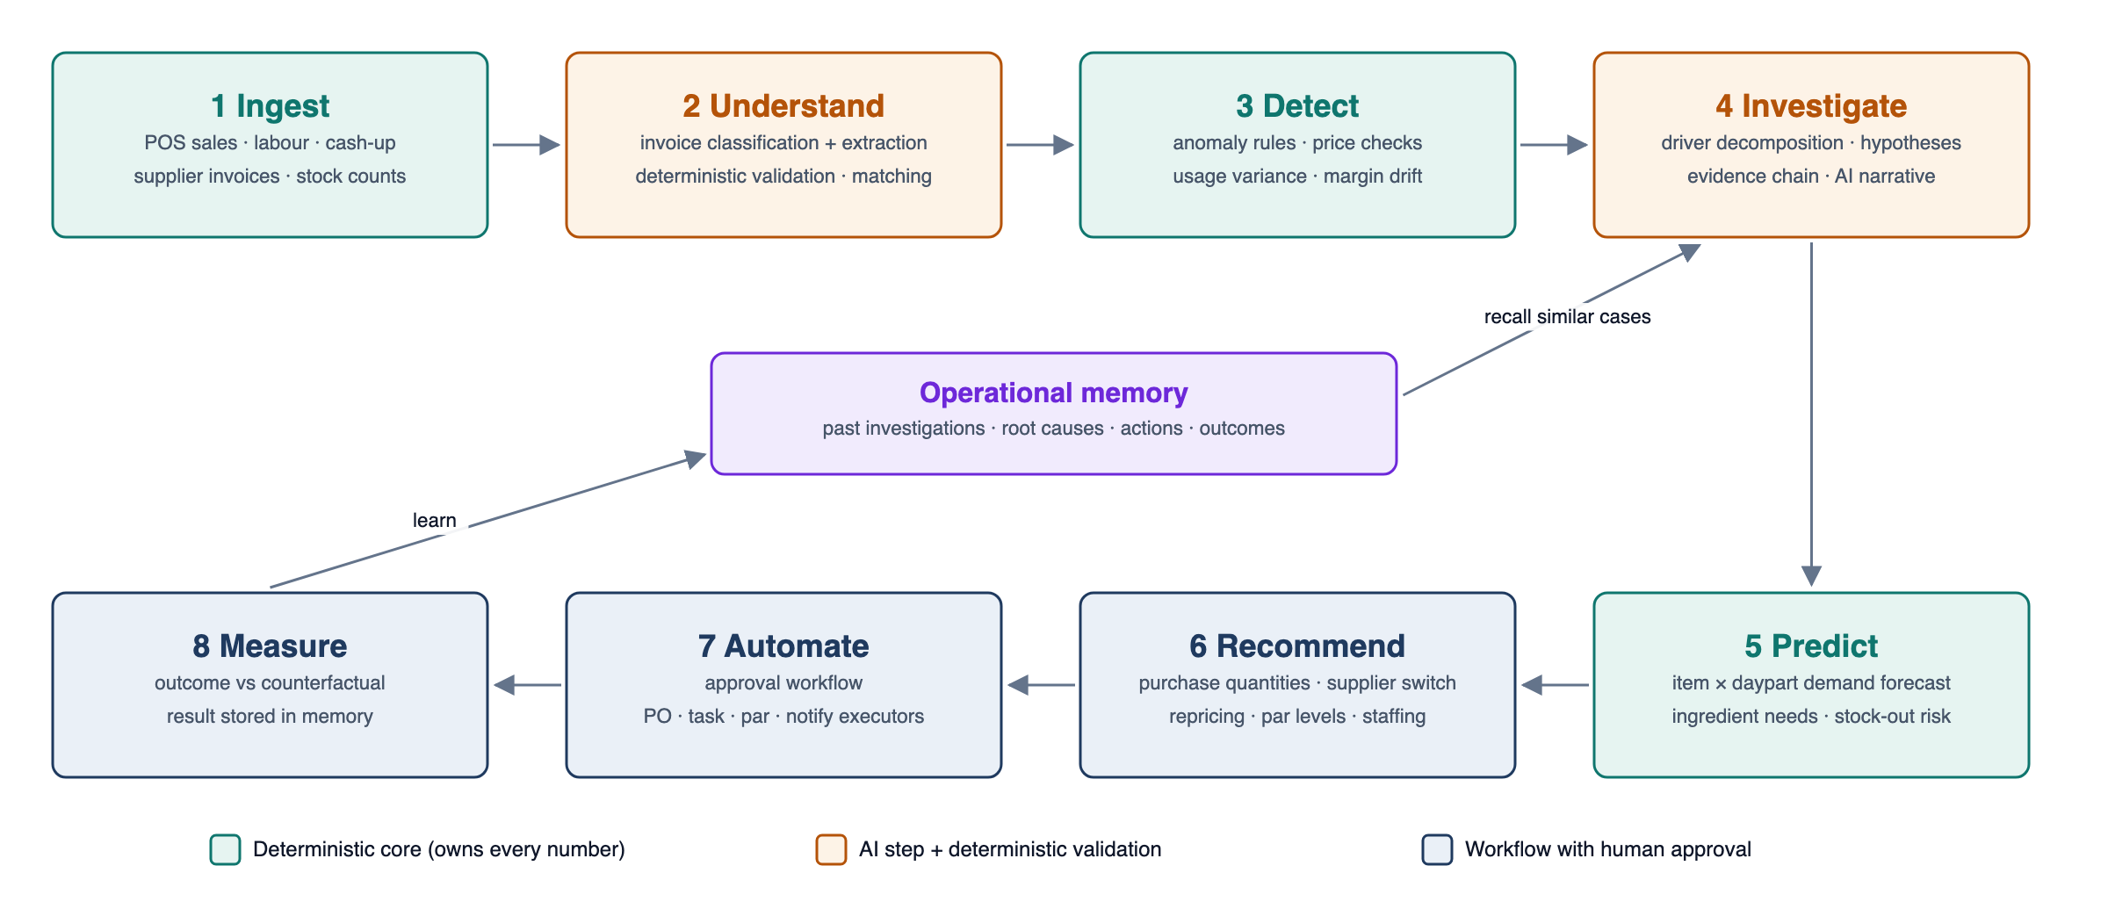
Figure 1: The OpsPilot operating loop

2. Tasks Automated
Capability | What OpsPilot does
AI invoice processing | Upload PDF/photo → byte-level checks and SHA-256 duplicate gate → Gemini classification (confidence gate 0.6) → structured extraction → Python validation (line maths, VAT, totals recomputed, unit/pack normalisation) → supplier and line matching with learned aliases → price check vs last price and 90-day median → PO quantity/price match → fuzzy duplicate check → exception-based review → role-limited approval → posts stock receipts and price history. Fully audited state machine.
Supplier & procurement | Normalised price history, supplier ranking (price, fill rate, lead time), cost-increase attribution by supplier, order-up-to purchase quantities with safety stock, pack/MOQ rounding, draft POs that are committed only after approval; recommendation accuracy tracked.
Inventory & waste | Append-only stock ledger (receipts, theoretical consumption from sales × recipes, counts, waste); usage variance actual vs theoretical; days of cover, stock-out and overstock risk.
Demand forecasting | Item × daypart forecast for 14 days: weighted weekday baseline × trend × weather, bank-holiday and event factors (ridge regression), p10/p50/p90, rolling backtests (WAPE targets 15% site / 30% item). Deterministic and testable.
Menu & margin | Recipe costing from live invoice prices, GP %, contribution margin, menu engineering (Star/Plowhorse/Puzzle/Dog), margin decline and cost inflation alerts, repricing what-if.
Root-cause investigation | Driver decomposition (revenue = orders × spend, LMDI mix/price split, day × daypart), 10 hypothesis tests joining stock, invoices, suppliers, labour, weather, leakage and memory; confidence-scored causes; evidence chain narrated by Gemini under a Number Guard.
Action Centre | Recommendations (PO, supplier switch, par level, price review, staffing, waste) with evidence, computed weekly impact, risk, approver, expiry → idempotent execution → follow-up → outcome measured against a counterfactual.
Operational memory | Investigations, notes, causes, actions and outcomes stored as structured records; retrieval by entity/cause + pgvector similarity + recency; recurring problems escalated.

3. Implementation
Layer | Technology
Frontend | Next.js 15 (App Router), TypeScript, Tailwind CSS, Recharts; typed client generated from the API's OpenAPI schema; Better Auth (sessions, roles, short-lived JWT).
Backend | Independent FastAPI service: Pydantic v2, SQLAlchemy 2 (async), Alembic; bounded contexts with hexagonal ports/adapters; RFC 7807 errors, idempotency keys, optimistic concurrency, append-only audit; JWT verified via JWKS with role + site scoping.
Workflows | Worker service running Procrastinate (PostgreSQL job queue): idempotent steps, retries, dead-letter list, transactional outbox; one Cloud Scheduler dispatcher (every 5 min) drives site-timezone schedules.
Data | Neon PostgreSQL + pgvector; invoice originals in private Cloud Storage (signed URLs); money in integer minor units, quantities as Decimal with units.
Quality | pytest, property-based tests for money/units, golden invoice fixtures, forecast backtests, testcontainers integration tests, e2e demo scenarios; ruff, pyright, import-linter, GitHub Actions.

Third-party APIs (all free, no credit card)
Service | Used for
Google Gemini API | Invoice classification and extraction (structured output), evidence narration, chat tool calling, embeddings for memory
Open-Meteo | Weather forecast and history for demand factors
gov.uk Bank Holidays | UK holiday calendar for forecasting
SendGrid (Resend fallback) | Daily brief, approval and risk alerts, approved POs to suppliers
Cloud Run + Cloud Scheduler | web, api and worker services; one dispatcher job

Trustworthy AI by design
- AI output is a proposal, not a fact: schema-validated, confidence-gated, then every invoice number is recomputed and checked in Python; documents are treated as data (prompt-injection defence).
- AI never calculates: forecasts, costs, impacts and confidence are deterministic; Gemini only explains facts the backend built, and the Number Guard rejects any unverified number.
- History only from records: "this happened before" is cited only from retrieved memory entries.

4. Automation & User Interaction
Worked example (seeded demo): Supplier A's invoice shows chicken thigh +18% and 12 kg delivered against a 20 kg PO → OpsPilot flags price_increase and qty_mismatch before approval → Friday revenue falls 18% → the investigation shows orders flat, spend -14%, chicken dishes -37%, 82% in Friday dinner, stock-out at 18:40, caused by the short delivery, and recalls a similar case on 19 Sep (confidence 0.86) → the Action Centre proposes switching to Supplier B (+£84/week), raising the par level and a Chicken Wrap price review (GP 68.1% → 64.3%) → the GM approves, a draft PO is created → after 7 days chicken cost per kg is measured -8.7% vs counterfactual: improved, stored in memory.
Schedule (site time) | Automated work
02:00 nightly | Metrics, theoretical consumption, forecast, procurement plan, margins, detection, investigations, recommendations
06:00 | Measure outcomes of executed recommendations
07:00 | Daily brief email: KPIs, margin moves, invoices to review, risks, pending approvals, outcomes
16:00 / Monday 08:00 | Approval and task follow-ups / weekly margin bridge
On upload | Invoice pipeline: classify → extract → validate → match → review

Screens: Morning Dashboard · Invoice inbox and side-by-side review · Suppliers & prices · Inventory (mobile counts, waste, variance) · Forecast & procurement · Menu & margins matrix · Investigation evidence chain · Action Centre · Ask OpsPilot (tool-restricted chat with confirmation) · Settings & audit. Roles: Owner, GM, Head Chef, Shift Manager, with approval limits.

5. Why It Works
- Measurable money outcomes: price increases caught on the invoice, true dish margins daily, fewer stock-outs and less waste, and every action measured against a counterfactual.
- A real workflow system, not a dashboard: state machines, approvals, idempotent execution, ledgers and audit - the parts that make automation trustworthy for money.
- AI where it adds value, maths where it must be right: document understanding and explanation from Gemini; every number from tested code.
- It learns: confirmed line mappings, outcomes and root causes feed memory and future investigations.
- Full-stack depth: independent FastAPI service, worker, PostgreSQL design and a responsive Next.js UI, all on free tiers.
Delivery: foundations → demo MVP slice (invoice-to-outcome for the chicken scenario across every loop stage) → breadth (forecasting, inventory variance, menu matrix, chat) → hardening. Full requirements (119 functional, traced), class design and 19 diagrams are in SRS v2.0.

