Software Requirements Specification - Summary
OpsPilot
AI Operations Manager for Independent Restaurants
OPSPILOT-SRS-001 · Summary v1.0 · October 2026
Prepared by Gelila Tefera
Prepared for Brain3.ai - AI Automation Assignment (Full Stack AI Web Developer)
Full detail: OpsPilot Software Requirements Specification v1.1

1. Role & Industry
Operations manager for independent and small multi-site restaurants (hospitality). OpsPilot does the daily analysis and follow-up work of an operations manager: it reviews yesterday's trading, finds what went wrong, explains why, assigns an investigation and chases it until it is resolved. It also plans tomorrow's staffing and prep.

Why this role
- Thin margins: independent restaurants typically run on 3-6% net margin, so labour creep, a manager over-discounting or a till that is regularly short can erase a month's profit.
- Problems are found too late: owners and GMs rarely have the time (or budget for an operations manager) to check the numbers daily, so leakage is discovered at month-end, if at all.
- Dashboards are not enough: POS reports show numbers but do not explain, prioritise or follow up. The valuable work is the judgement-and-follow-up loop, which is repetitive, data-heavy and time-critical - ideal for an AI agent.
- Grounded in real experience: the design draws on the author's work building finance and trading analytics for multi-site hospitality operators.

2. Tasks Automated
The role was broken down into sub-functions and prioritised by impact and feasibility with free APIs:
Role task | What OpsPilot does | Priority
Morning trading review | Computes revenue, covers, spend per cover, GP %, labour %, prime cost, discounts, voids and cash-up variance vs last week, the 4-week median and targets. Gemini writes a short Daily Operations Brief. | P0
Spot leakage and cost creep | 9 deterministic anomaly rules (discount and void spikes, labour over target, daypart and product drops, cash variance, COGS drift), each attributed to a manager, daypart, product or till. | P0
Report before service | Emails the verified brief to the owner at 07:00, without anyone opening the app. | P0
Assign and chase investigations | Every warning or critical anomaly becomes a task (Open → Acknowledged → Resolved / Dismissed). Critical tasks still open after 8 hours trigger a 16:00 nudge. | P1
Plan tomorrow | Weather forecast + same-weekday history → expected revenue and covers range, a labour-hours cap for the target labour %, and prep hints for weather-sensitive items. | P1
Answer ad-hoc questions | "Ask OpsPilot" chat using Gemini function calling over whitelisted analytics tools; it can propose a task, which runs only after the user confirms. | P1
Weekly recap | Monday 08:00 email: week vs previous week, anomalies opened and resolved, top and bottom products. | P2

Out of scope for v1: rota building, supplier ordering, payroll and live POS integrations (a POS simulator and CSV import stand in for the till).

3. Implementation
OpsPilot is a single Next.js application on Google Cloud Run. The key design decision is that the backend owns the numbers and Gemini owns the explanation: every figure is computed by code, and the AI only turns verified facts into plain English.
Layer | Technology
Frontend | Next.js 15 (App Router), React, TypeScript, Tailwind CSS, Recharts; responsive and mobile-first.
Backend | Next.js route handlers with Zod validation, Prisma ORM, Neon PostgreSQL; Better Auth (email/password, Owner and Manager roles).
AI | Gemini 2.5 Flash: structured JSON output for briefs, function calling for chat.
Automation | Cloud Scheduler (3 jobs) calling secured Cloud Run endpoints; GitHub Actions cron as a fallback trigger.
Data | Deterministic POS simulator (~120 days: 40-item menu, orders, staff shifts, discounts, voids, cash-ups) using real Open-Meteo weather history, with five planted scenarios so every rule can be demonstrated; CSV import for real POS exports.

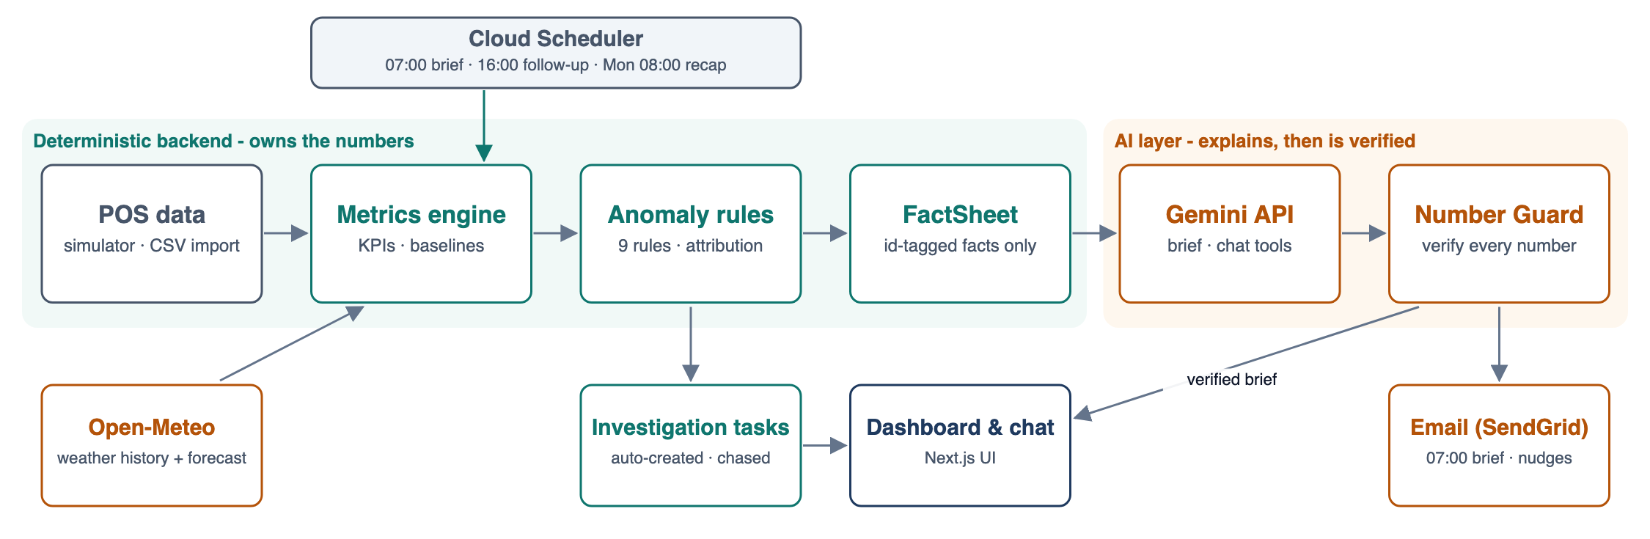
Figure 1: How OpsPilot works

Third-party APIs (all free, no credit card)
Service | Used for | Free-tier limit / expected use
Gemini API (Google AI Studio) | Brief narrative; chat with tool calling | Free tier; budgeted at ≤ 60 requests/day
Open-Meteo | Weather forecast and history for the outlook | No API key; < 10,000 calls/day (uses ~10)
SendGrid | Daily brief, follow-up nudges, weekly recap | Free allowance; ~40 emails/month (Resend is a drop-in alternative)
Cloud Run + Cloud Scheduler | Hosting and proactive jobs | 180,000 vCPU-seconds/month; 3 scheduler jobs (exactly what is used)
Neon PostgreSQL | Database | ~0.5 GB free (demo uses ~40 MB)

Trustworthy AI: no made-up numbers
- The backend computes every metric and anomaly, then builds a FactSheet of id-tagged facts with display strings (e.g. lab.pct = "31.2%"). Raw transactions and staff surnames are never sent to the AI.
- Gemini receives only the FactSheet and must return schema-valid JSON (headline, sections, actions) that cites fact ids.
- A Number Guard checks every number in the text against the FactSheet. On failure it retries once, then falls back to a deterministic template brief. Chat answers are checked against the tool results they used.

4. Automation & User Interaction
Scheduled job | When | What the agent does
daily-brief | Daily 07:00 | Recompute metrics → detect anomalies → open tasks → build outlook → write and verify brief → email the owner
task-follow-up | Daily 16:00 | Email a nudge for critical tasks still open after 8 hours
weekly-recap | Monday 08:00 | Email the weekly performance recap

Jobs are idempotent (one run per site and date), authenticated with an OIDC token and logged for audit, so a retry never sends a duplicate email.

User interface
- Morning Dashboard: KPI cards with deltas (arrow and sign, not colour alone), the AI brief clearly labelled with its cited facts, a "Needs attention" list and tomorrow's outlook.
- Anomaly Detail: observed vs expected, a 28-day chart with the baseline band, the contributor breakdown and the linked task.
- Investigations board: Kanban of tasks with notes; acknowledge, resolve or dismiss (dismissing as "expected" mutes that rule for 7 days).
- Ask OpsPilot: streaming chat on every screen that shows which tools it used; actions need confirmation.
- Settings & Data: targets, thresholds and recipients; "Simulate next day" and "Run job now" drive the live demo.

5. Why It Works
- Measurable outcomes: the daily numbers review drops from 30-60 minutes to under 5, and leakage or labour creep surfaces within 24 hours instead of at month-end.
- Acts, not just reports: each problem is attributed to a cause, turned into a task and chased until it is closed.
- Trustworthy by construction: figures come from code and are verified in the AI text, so a manager can act without re-checking a spreadsheet.
- Proactive: the owner has the brief before service without opening the app.
- Free to run and resilient: everything fits free tiers. If GCP requires billing, GitHub Actions triggers the same endpoints; if Gemini is unavailable, a template brief is sent; if SendGrid's trial ends, Resend replaces it in one class.
- Balanced full stack: a real backend (metrics engine, rule engine, AI guardrails, scheduled jobs) behind a responsive, mobile-first UI.

6. Delivery Plan
Step | Output
1. Data & metrics | Prisma schema on Neon, seeded POS simulator with planted scenarios, weather back-fill, KPI engine with unit tests
2. Anomalies & tasks | Rule registry (AR-01 to AR-09), attribution, automatic tasks and the task workflow
3. AI layer | FactSheet, Gemini brief with structured output, Number Guard and template fallback, Ask OpsPilot tools
4. Automation | Secured cron endpoints, SendGrid emails, Cloud Scheduler jobs on Cloud Run (GitHub Actions fallback)
5. Frontend & demo | Dashboard, anomaly detail, investigations, chat and settings; README, source code and a recorded walkthrough

The full requirements (73 traced requirements), class design and diagrams are in the OpsPilot Software Requirements Specification v1.1.

