Software Requirements Specification
OpsPilot
AI Operations Manager for Independent Restaurants

Project / identification no. | OpsPilot / OPSPILOT-SRS-001
Version | 1.0 — for review and approval
Date | September 2026
Prepared for | Brain3.ai — AI Automation Assignment (Full Stack AI Web Developer)
Document maturity | Draft for approval

Abstract
OpsPilot is an AI agent that performs the daily analytical and follow-up work of a restaurant operations manager for independent and small multi-site restaurants. Every morning it reconciles trading, labour, leakage and cash-up data, detects anomalies with deterministic statistics, explains them in plain English with Google Gemini, opens investigation tasks, chases them until they are resolved, and prepares tomorrow's staffing and prep outlook using weather forecasts. Its central design principle is that the backend owns the numbers and Gemini owns the explanation: every figure in AI-written text is verified against computed facts before a manager sees it.

Keywords
Restaurant operations; hospitality; AI agent; anomaly detection; labour cost; discounts and voids; cash-up variance; Gemini API; Open-Meteo; SendGrid; Cloud Scheduler; Cloud Run; Next.js; PostgreSQL.

Approved
Author | Reviewer / Approver | Product Owner
Gelila Tefera | Kidus — Brain3.ai | Brain3.ai
Signature / date: | Signature / date: | Signature / date:

Revision History
Version | Date | Author | Change description
1.0 | 29 September 2026 | Gelila Tefera | Initial version submitted to Brain3.ai for review and approval.

Table of Contents

(If page numbers are not shown, right-click the table and choose "Update Field".)

1. Introduction

1.1 Purpose
This Software Requirements Specification (SRS) defines what OpsPilot must do, the constraints it must respect and how its requirements will be verified. It serves as the implementation guide for the build phase and as the contract against which the delivered agent will be evaluated.
The document: (a) provides an overview of the product and the role it automates; (b) records the research and prioritisation behind the chosen scope; (c) specifies uniquely identified functional and non-functional requirements; and (d) provides a traceability matrix linking every requirement to a use case, screen, API and test.
Intended audience: the Brain3.ai reviewer (approval of scope and approach), the developer (implementation guide) and any future tester or contributor.

1.2 Scope
Product: OpsPilot — an AI Operations Manager web application for independent and small multi-site restaurants (initially UK, GBP, Europe/London).
OpsPilot will:
- Ingest daily trading data (orders, products, labour shifts, discounts, voids, cash-ups) from a simulated POS or a CSV export.
- Compute operational KPIs and comparisons deterministically in the backend.
- Detect operational anomalies (leakage, labour creep, daypart and product declines, cash variances, COGS drift) and attribute them to a manager, daypart, product or till.
- Write a concise Daily Operations Brief with Gemini, verified by a Number Guard so that no invented figures reach the user.
- Open investigation tasks automatically, and follow up on critical tasks that remain unresolved.
- Forecast tomorrow's demand using weather and weekday history, and recommend a labour-hours cap and prep hints.
- Answer ad-hoc operational questions through a tool-restricted chat assistant.
- Act proactively on a schedule: morning brief email, afternoon follow-up, Monday weekly recap.
OpsPilot will not (v1): connect to live commercial POS or rota APIs (Toast, Square, Lightspeed, etc.); change rotas or place supplier orders autonomously; process payroll; produce statutory or accounting reports (P&L, VAT); or provide multi-tenant billing. These are candidate extensions (Section 3.6).
Benefits and goals (measurable):
Goal | Measure of success
Remove the daily manual numbers review | Time for a GM to understand yesterday's trading falls from ~30–60 min to < 5 min (reading one brief).
Catch leakage and cost creep early | Discount, void, cash and labour anomalies surfaced within 24 hours (vs. month-end management accounts).
Trustworthy AI output | 100% of numbers in delivered AI text match computed facts (enforced by Number Guard, FR-BRF-05).
Close the loop, not just report | Every warning/critical anomaly becomes a tracked task; critical tasks are chased the same day.
Zero-cost operation for the demo | Runs entirely on free tiers (Appendix E) with no paid services.

1.3 Overview
Section 2 describes the product context, the research into the operations manager role and its prioritisation, product functions, users, constraints and assumptions. Section 3 specifies the requirements, organised by feature (IEEE 830 Annex template "organised by feature"), followed by external interfaces, performance, design constraints, attributes and other requirements. The appendices contain diagrams, the data model, AI contract samples, a free-tier budget, the delivery plan, the traceability matrix and risks. Appendices are informative, except Appendix C (AI contracts), which is normative where referenced by FR-BRF.

1.4 Definitions, Acronyms and Abbreviations
Term / Acronym | Definition
Anomaly | A metric value that breaches a rule in the anomaly rule registry (Table 3.1-3).
ATV / Spend per cover | Average transaction value; net revenue ÷ covers.
Baseline | Median of the same weekday over the trailing 4 weeks.
Cash-up | End-of-day reconciliation of expected vs counted cash and card takings.
COGS | Cost of goods sold — theoretical ingredient/drink cost of items sold.
Cover | One guest served.
Daypart | A trading period within the day (Lunch, Afternoon, Dinner, Late).
FactSheet | The JSON document of pre-computed, id-tagged facts that is the only data passed to Gemini.
GM | General Manager of a restaurant site.
GP % | Gross profit % = (net revenue − COGS) ÷ net revenue.
Labour % | Labour cost ÷ net revenue.
Leakage | Revenue lost to discounts, voids, comps and cash variances.
MAD | Median absolute deviation; robust spread measure (σ ≈ 1.4826 × MAD).
Number Guard | Validator that rejects AI text containing any number not present in the FactSheet.
POS | Point of sale (till) system.
Prime cost % | (COGS + labour cost) ÷ net revenue.
pt | Percentage point — the unit for differences between two percentages.
Void | An item removed from an order after being entered.
Wet / Dry | Drinks / Food revenue categories.
OIDC | OpenID Connect; token used by Cloud Scheduler to authenticate to Cloud Run.
SRS / IEEE | Software Requirements Specification / Institute of Electrical and Electronics Engineers.

1.5 References
Ref | Document | Source
[1] | AI Automation Assignment — Full Stack AI Web Developer (brief) | Brain3.ai, 2026
[2] | IEEE Std 830-1998, Recommended Practice for Software Requirements Specifications | IEEE
[3] | SRS Template V1.1 (Master SIGLIS, Industry 4.0 / yPBL) | Supplied template
[4] | Gemini API documentation — generateContent, structured output, function calling | ai.google.dev/gemini-api/docs
[5] | Open-Meteo Forecast API and Historical Weather API | open-meteo.com/en/docs
[6] | Twilio SendGrid v3 Mail Send API | docs.sendgrid.com/api-reference/mail-send
[7] | Google Cloud Run and Cloud Scheduler documentation; Google Cloud Free Tier | cloud.google.com
[8] | Neon serverless Postgres documentation and free plan | neon.tech/docs
[9] | Next.js 15, Prisma ORM, NextAuth.js documentation | nextjs.org, prisma.io, next-auth.js.org
[10] | UK GDPR / Data Protection Act 2018 guidance for employers | ico.org.uk

2. General Description

2.1 Product Perspective
OpsPilot is a new, self-contained product. In production it would sit downstream of a restaurant's POS, rota and cash-up tools; in this version those are represented by a simulated POS and a CSV importer that write into OpsPilot's own database. Figure 1 shows the system context.
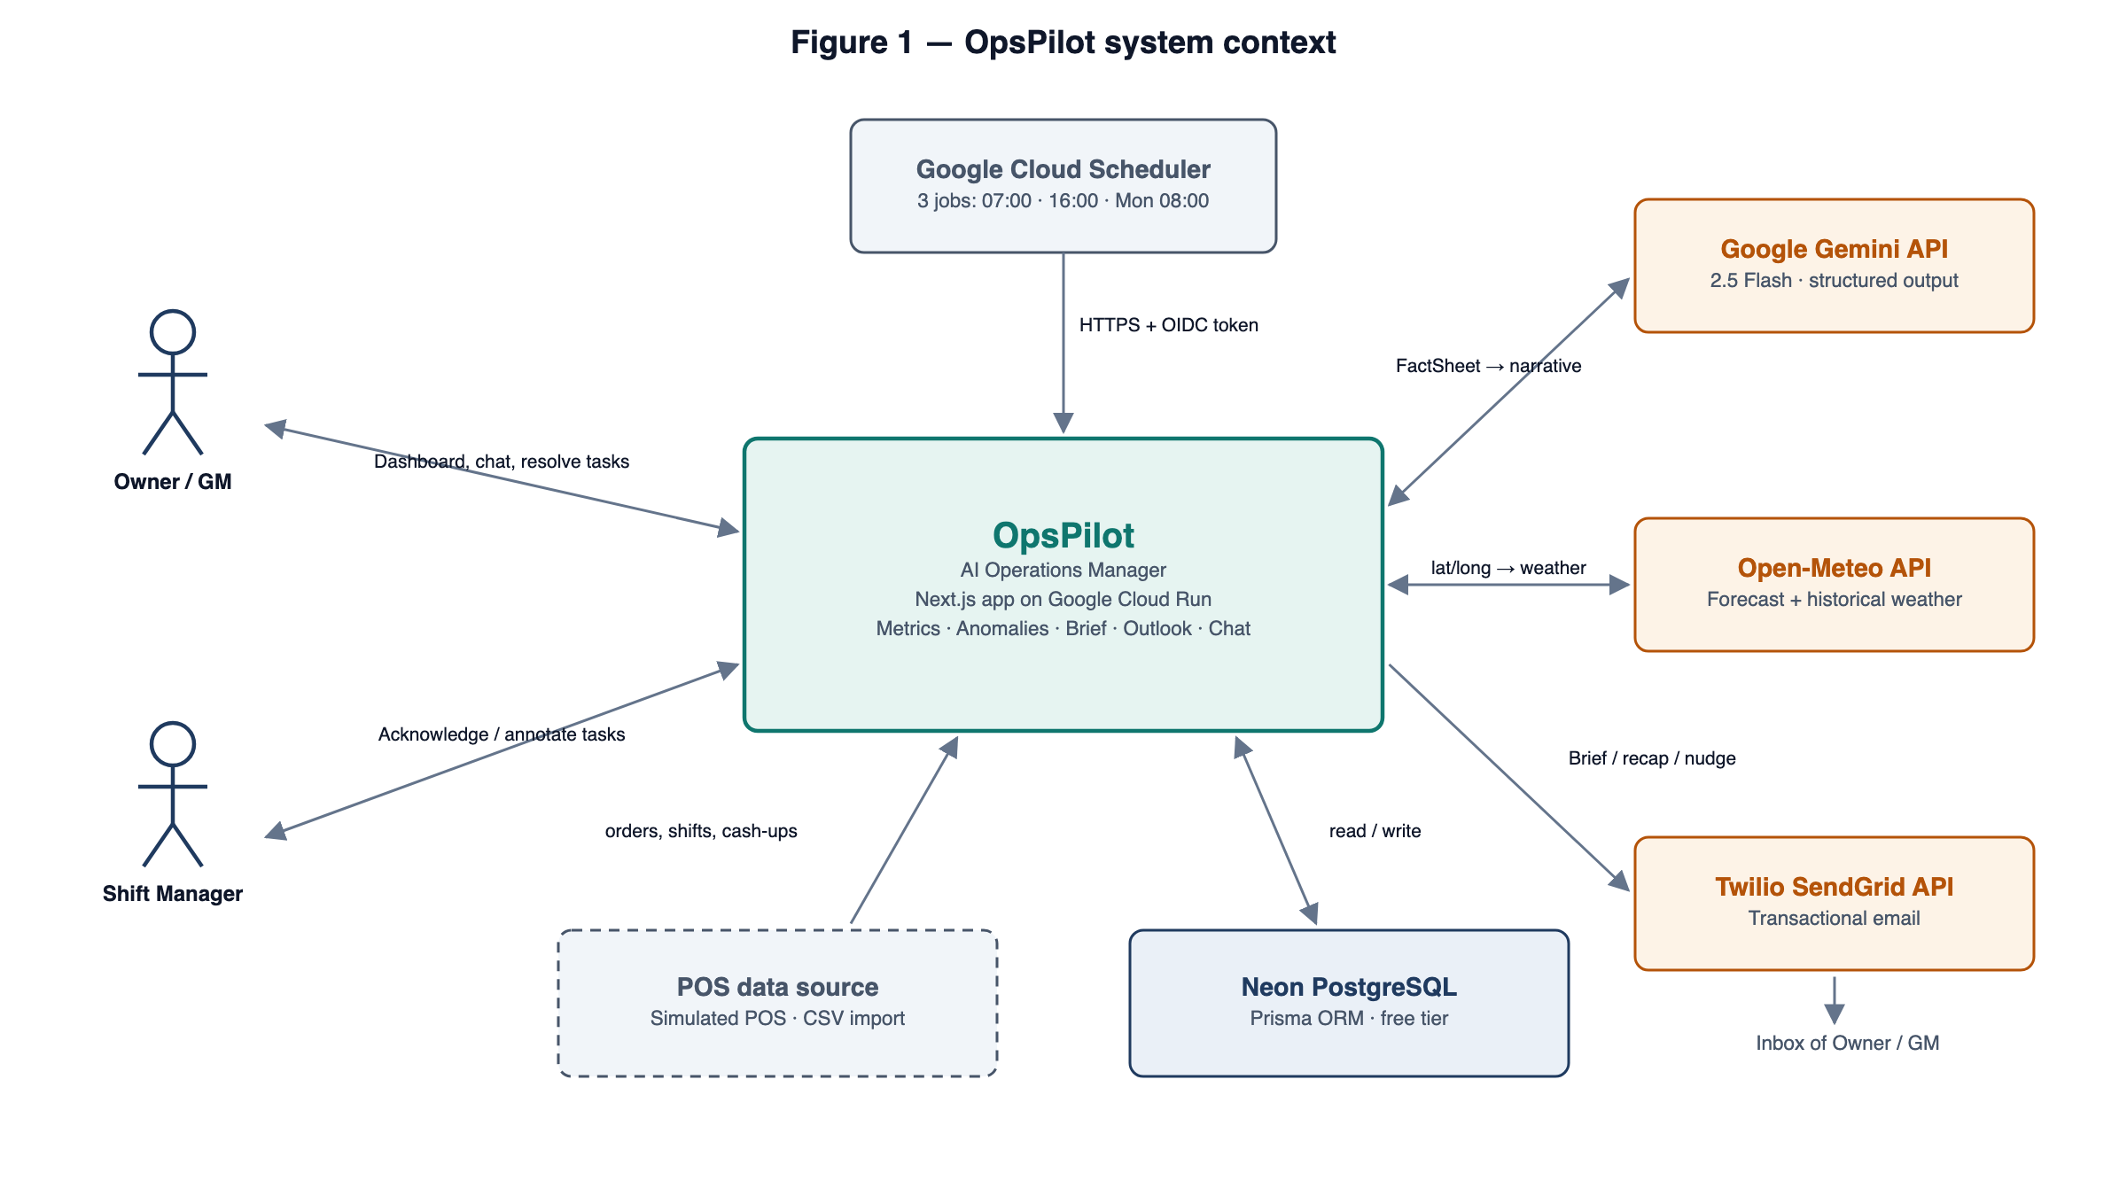
Figure 1 — System context

2.1.1 Why this role
Independent restaurants run on thin margins (typically 3–6% net), so a few points of labour creep, a manager over-discounting or a till that is regularly £40 short can erase a month's profit. Larger groups employ operations managers and finance teams to watch these numbers daily; an independent owner or GM usually cannot afford a £40–55k operations manager, and so the checking happens late (at month-end), partially, or not at all.
Existing POS dashboards show numbers but do not explain them, do not prioritise and do not follow up. The author's professional experience building finance and trading analytics for UK multi-site hospitality operators shows that the valuable part of the job is not the report — it is noticing what changed, working out why, telling the right person and making sure something is done. That judgement-and-follow-up loop is repetitive, data-heavy and time-critical, which makes it an excellent candidate for an AI agent.

2.1.2 Role research and breakdown
The operations manager role was decomposed into sub-functions and each was scored for impact (value to the owner), frequency and automation feasibility with free APIs. The top-priority functions form the v1 scope.
# | Sub-function | Human effort today | Impact | Feasibility | Priority | OpsPilot capability
1 | Review yesterday's trading (sales, labour, GP) | 30–60 min daily | High | High | P0 | Daily Operations Brief
2 | Spot leakage and cost creep (discounts, voids, cash, labour) | Often missed until month-end | Very high | High | P0 | Anomaly detection engine
3 | Report to the owner before service | 15 min daily | High | High | P0 | 07:00 proactive email
4 | Assign and chase investigations | Ad hoc, easily forgotten | High | High | P1 | Investigation queue + 16:00 follow-up
5 | Plan tomorrow (staffing, prep) | 20 min daily | High | Medium | P1 | Tomorrow Outlook (weather + history)
6 | Answer ad-hoc questions | Spreadsheet digging | Medium | High | P1 | Ask OpsPilot chat (tool-restricted)
7 | Weekly performance recap | 1–2 h weekly | Medium | High | P2 | Monday weekly recap email
8 | Maintain targets and thresholds | Occasional | Medium | High | P2 | Settings
– | Rota building, supplier ordering, payroll, hiring | High | High | Low (paid APIs / risk) | Out of scope | Future extensions

2.1.3 Value proposition
- Cheaper than a person, faster than month-end: a target price of ~£99 per site per month against a £40–55k salary, with anomalies surfaced within 24 hours.
- Explains and acts, not just displays: each insight names the cause (manager, daypart, product) and becomes a tracked task that is chased.
- Trustworthy by construction: figures are computed by code and verified in the AI text, so a GM can act on the brief without re-checking the spreadsheet.
- Proactive: the owner receives the brief before service starts, without opening the app.

2.1.4 Operating constraints
Area | Constraint
System interfaces | External APIs over HTTPS only: Gemini, Open-Meteo, SendGrid; database over TLS (Neon).
User interfaces | Responsive web UI; desktop and mobile browsers (Section 3.2.1).
Hardware interfaces | None — no POS hardware integration in v1.
Software interfaces | Node.js 20 LTS, Next.js 15, Prisma, PostgreSQL 16 (Section 3.2.3).
Communications | HTTPS/TLS 1.2+, JSON; email via the SendGrid HTTP API.
Memory | Cloud Run instance of 512 MiB – 1 GiB; datasets fit in the Neon free-plan storage.
Operations | Unattended scheduled jobs (3) plus interactive use (Section 3.6.1).
Site adaptation | Per-site timezone, coordinates, dayparts, targets and thresholds (Section 3.6.2).

2.2 Product Functions
The major functions are summarised below and shown in the use-case diagram (Figure 4).
ID | Function | Summary
F1 | Data ingestion | Seeded POS simulation with injected scenarios, next-day simulation, CSV import.
F2 | Metrics engine | Daily KPIs, daypart and manager breakdowns, baselines and comparisons.
F3 | Anomaly detection | Deterministic, statistical rules with severity, attribution and evidence.
F4 | Daily Operations Brief | Gemini narrative from a FactSheet, verified by the Number Guard, with a template fallback.
F5 | Investigation queue | Tasks from anomalies, a state workflow, notes, follow-up nudges and a suppression feedback loop.
F6 | Tomorrow Outlook | Weather-adjusted demand estimate, labour-hours cap and prep hints.
F7 | Ask OpsPilot | Chat with Gemini function calling over whitelisted analytics tools.
F8 | Proactive automation | 07:00 brief, 16:00 follow-up and Monday 08:00 recap via Cloud Scheduler + SendGrid.
F9 | Settings and administration | Targets, thresholds, recipients, job control, audit.

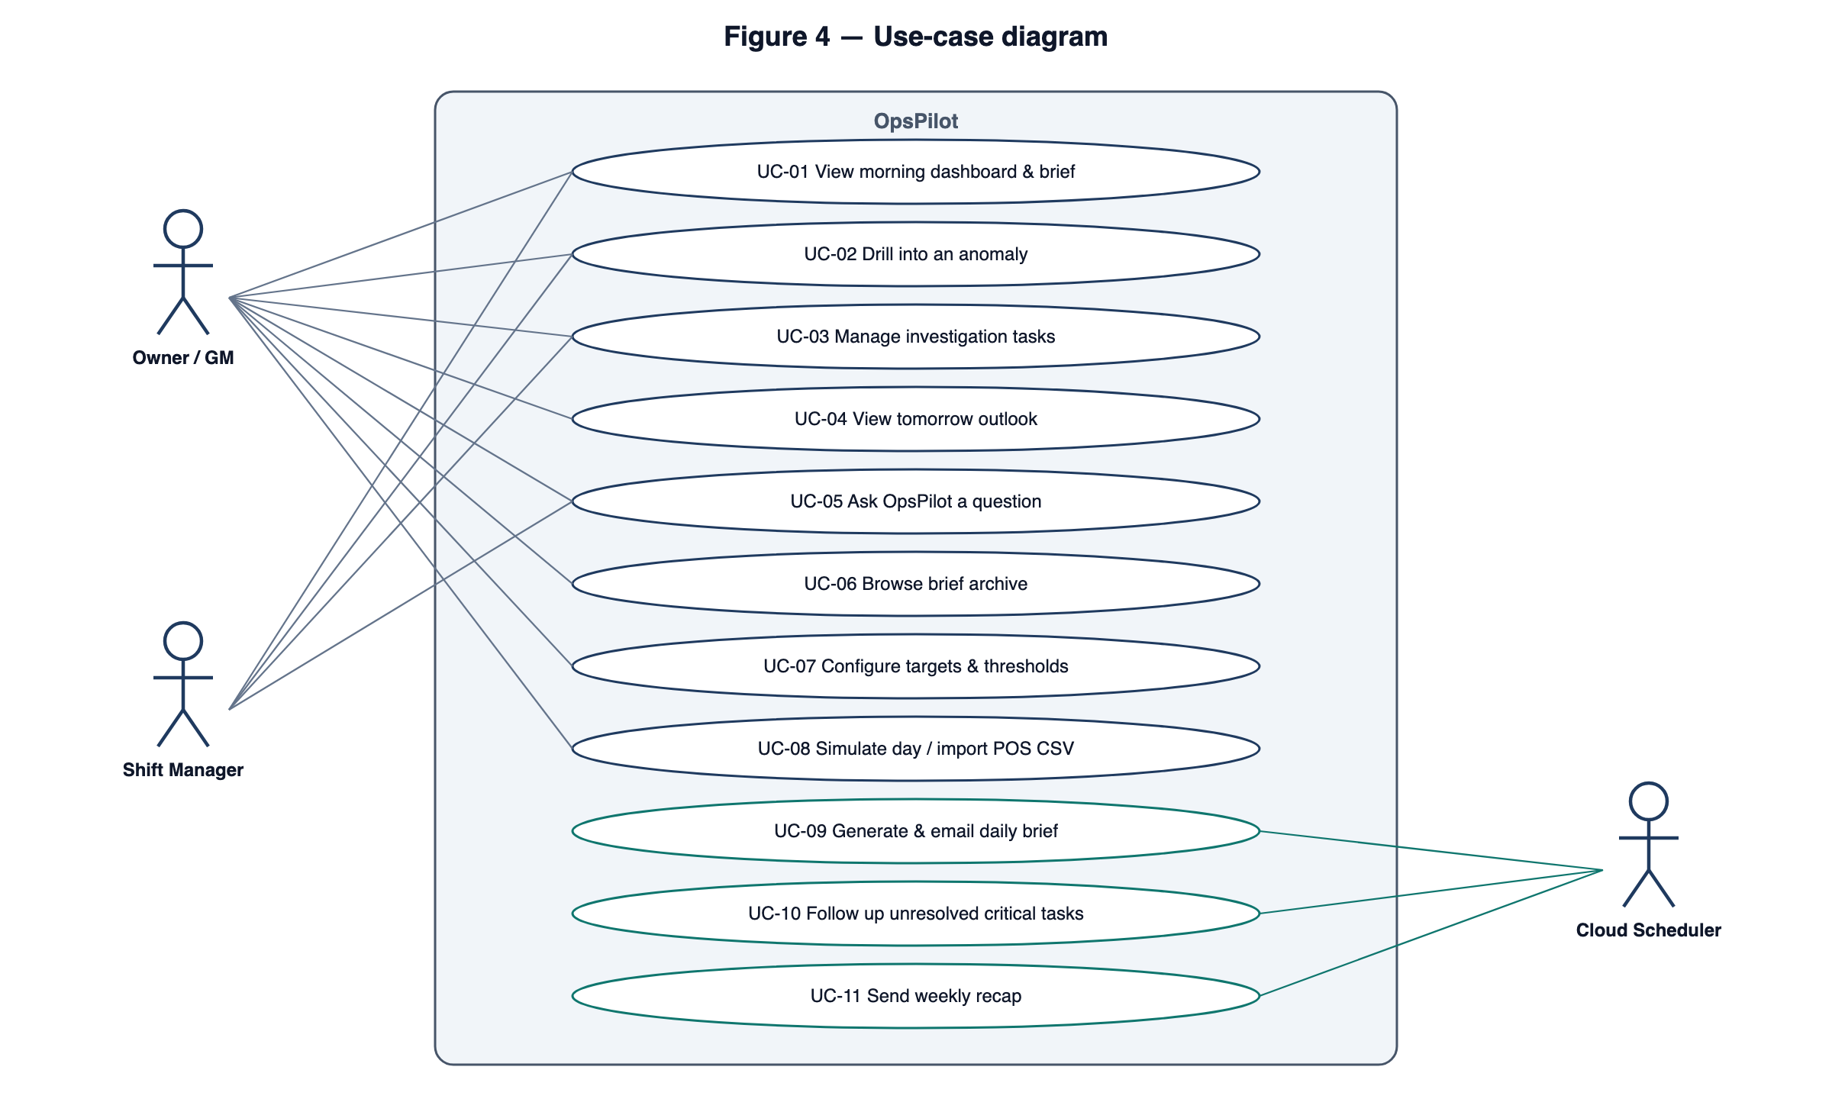
Figure 4 — Use-case diagram
Use case | Primary actor | Description
UC-01 View morning dashboard & brief | Owner / GM, Manager | See yesterday's KPIs with comparisons, the AI brief, items needing attention and tomorrow's outlook.
UC-02 Drill into an anomaly | Owner / GM, Manager | Open an anomaly to see its evidence chart, contributors, baseline and the linked task.
UC-03 Manage investigation tasks | Owner / GM, Manager | Acknowledge, annotate, resolve or dismiss tasks; filter the board.
UC-04 View tomorrow outlook | Owner / GM | See the expected revenue/covers range, labour-hours cap and prep hints.
UC-05 Ask OpsPilot a question | Owner / GM, Manager | Ask a natural-language question; receive a grounded answer; optionally confirm a proposed task.
UC-06 Browse brief archive | Owner / GM | Read past briefs and email delivery status.
UC-07 Configure targets & thresholds | Owner | Edit site settings, recipients and thresholds.
UC-08 Simulate day / import POS CSV | Owner | Generate the next trading day (optionally with a scenario) or upload a CSV.
UC-09 Generate & email daily brief | Cloud Scheduler | Unattended 07:00 job (Figure 3).
UC-10 Follow up unresolved critical tasks | Cloud Scheduler | Unattended 16:00 job that nudges assignees.
UC-11 Send weekly recap | Cloud Scheduler | Unattended Monday 08:00 job.

2.3 User Characteristics
User class | Characteristics | Implications for requirements
Owner / GM | Hospitality professional; commercially fluent (GP %, labour %) but not a data analyst; time-poor; often reads on a phone before service. | Plain-English brief; mobile-first dashboard; email delivery; conclusions first with drill-down.
Shift / Duty Manager | Runs the floor; limited admin time; accountable for their shift's discounts, voids and cash-up. | Restricted role; fast task acknowledgement; no access to settings.
Cloud Scheduler (system actor) | Unattended trigger; authenticates with an OIDC token. | Idempotent, secured endpoints; job audit log.

2.4 General Constraints
- Cost / free tiers: all services must run on free tiers without paid usage (Appendix E). Gemini usage is budgeted at ≤ 60 requests per day; Cloud Scheduler is limited to 3 jobs.
- Regulatory: staff names and performance attributions are personal data under UK GDPR. Only first name and last initial are displayed, only first names are sent to the AI service, and data is used solely for operational management.
- Criticality: OpsPilot is advisory; it never changes POS, payroll or rota data. Failures must degrade to less insight, never to wrong figures.
- Reliability: the AI service is treated as unreliable; every AI-dependent output has a deterministic fallback.
- Audit: all scheduled jobs, AI calls and settings changes are logged (Section 3.4.1).
- Security: secrets are held only in environment variables / Secret Manager; no secrets reach the browser.
- Time: delivery is within the assignment deadline, so v1 scope is limited to P0–P1 plus the low-cost P2 items.

2.5 Assumptions and Dependencies
- A Gemini API key is available from Google AI Studio free tier, and its limits are sufficient for ≤ 60 requests per day.
- Open-Meteo remains free for non-commercial use without an API key (< 10,000 calls per day).
- A SendGrid account with a verified single sender is available; the SendGrid free offering is currently a time-limited trial. The Mailer interface allows substituting Resend or Gmail API without changing requirements.
- Google Cloud Run and Cloud Scheduler may require a billing account to be attached even when usage is within the free tier. If so, the same secured endpoints will be triggered by GitHub Actions scheduled workflows and the app hosted on an alternative free host; functional requirements are unchanged.
- Neon's free plan provides sufficient storage (~0.5 GB) and compute for the demo dataset.
- Simulated data is statistically realistic (seasonality by weekday and daypart, weather effects, noise); real POS integration is out of scope.

3. Requirements
Requirements use "shall" for mandatory behaviour. Priority follows MoSCoW (Must, Should, Could). Each requirement has a unique ID of the form FR-<feature>-<nn> and is traced in Appendix G.

3.1 Functional Requirements

3.1.1 Data ingestion and POS simulation (F1)
Inputs: seed configuration (site, start date, days, random seed, scenario schedule), simulation request, CSV file. Outputs: persisted orders, shifts, discounts, voids, cash-ups and weather; an import report.
ID | Requirement | Priority
FR-ING-01 | The system shall provide a seed command that generates at least 120 consecutive trading days of deterministic data for a configured site from a fixed random seed, so that every run reproduces identical figures. | Must
FR-ING-02 | Seed data shall include: at least 40 products in categories flagged wet (drinks) or dry (food) with price and unit cost; orders with line items, timestamps, covers, table/channel; employees with role and hourly rate; shifts (clock-in/out); discounts (amount, reason, authorising manager); voids (value, reason, manager); and daily cash-ups (expected vs counted cash and card). | Must
FR-ING-03 | The seed shall inject the demonstration scenarios listed in Table 3.1-1 on configurable dates so each anomaly rule can be observed deterministically. | Must
FR-ING-04 | The system shall back-fill daily historical weather (max/min temperature, precipitation, weather code) for the seeded period from the Open-Meteo Historical API and store it in WeatherDaily; if the API is unavailable the seed shall continue with weather marked as missing. | Must
FR-ING-05 | An Owner shall be able to trigger "Simulate next trading day" from the UI, optionally choosing a scenario; the system shall generate the next un-traded date using the same generator and then recompute metrics and anomalies for that date (FR-MET-06, FR-ANO-01). | Must
FR-ING-06 | The system shall accept an orders CSV upload (max 5 MB / 50,000 rows) with columns external_order_id, timestamp (ISO 8601), sku, quantity, unit_price, discount_amount, discount_reason, manager_code, void_flag. | Should
FR-ING-07 | CSV validation shall reject the file and return a row-level error report when any row has missing required columns, an unparseable timestamp, a negative quantity or price, or an unknown SKU (unless "create unknown products" is selected); the user may choose "skip invalid rows" to import the valid remainder. | Should
FR-ING-08 | Imports shall be idempotent on (site, external_order_id): re-importing the same file shall not duplicate orders. | Should

Scenario | Injected behaviour | Expected detection
S1 Discount creep | Manager "Sam K." applies 2–3× normal discount value on Friday/Saturday dinner over two weeks. | AR-01, attributed to Sam K. and Dinner
S2 Over-staffed dinner | Two extra servers rostered on a quiet Tuesday dinner. | AR-03, attributed to the Dinner shift
S3 Product decline | "Chicken Shawarma Wrap" units fall ~35% from a given date (simulating a recipe change). | AR-05, product
S4 Cash shortfall | Till 2 cash counted £62 below expected on one night. | AR-07, critical, Till 2
S5 Heatwave | Real warm days in the weather history lift iced drinks and lower soup sales. | AR-06 plus weather-sensitive products in the Outlook

Table 3.1-1 — Demonstration scenarios injected by the seed

3.1.2 Metrics engine (F2)
ID | Requirement | Priority
FR-MET-01 | The system shall compute a DailyMetrics record per site per trading date, where a trading date runs from 05:00 to 04:59 local time (Europe/London by default). | Must
FR-MET-02 | The system shall compute the KPIs defined in Table 3.1-2 using the formulas given there; all monetary values shall be stored as integer pence and displayed in GBP (£) with thousands separators. | Must
FR-MET-03 | The system shall compute each KPI per daypart (Lunch 11:00–14:59, Afternoon 15:00–17:29, Dinner 17:30–21:59, Late 22:00–close; configurable per site) and per manager where the metric is attributable. | Must
FR-MET-04 | For every KPI the system shall compute comparisons vs the previous trading day, vs the same weekday last week, vs the 4-week same-weekday median, and vs target where a target exists. | Must
FR-MET-05 | Currency and count deltas shall be expressed as percentage change; ratio deltas (e.g. labour %) shall be expressed in percentage points (pt). | Must
FR-MET-06 | Metric computation shall be idempotent and shall be triggered automatically after any ingestion affecting a date; re-computing a date shall overwrite its previous DailyMetrics record. | Must
FR-MET-07 | Where a denominator is zero or data is missing, the metric shall be stored as null and displayed as "—"; it shall be excluded from baselines and AI FactSheets. | Must

KPI | Formula | Unit
Net revenue | Σ(line price × qty) − discounts − voids (ex-VAT) | £
Orders / Covers | count(orders) / Σ covers | count
Spend per cover | Net revenue ÷ covers | £
Wet / Dry mix | Revenue of wet (dry) categories ÷ net revenue | %
COGS % | Σ(unit cost × qty) ÷ net revenue | %
GP % | (Net revenue − COGS) ÷ net revenue | %
Labour cost | Σ(shift hours × hourly rate × (1 + on-cost 13.8%)) | £
Labour % | Labour cost ÷ net revenue | %
Prime cost % | (COGS + labour cost) ÷ net revenue | %
Covers per labour hour | Covers ÷ Σ shift hours | ratio
Discount rate | Σ discounts ÷ gross revenue | %
Void rate | Σ void value ÷ gross revenue | %
Cash-up variance | Counted − expected (cash, card, total) | £
Product units / revenue | Per product, per day and daypart | count / £

Table 3.1-2 — KPI definitions

3.1.3 Anomaly detection (F3)
ID | Requirement | Priority
FR-ANO-01 | The system shall evaluate every rule in the anomaly rule registry (Table 3.1-3) each time DailyMetrics are computed for a date. | Must
FR-ANO-02 | Each detected anomaly shall record: rule ID, severity (info, warning, critical), metric, observed value, expected value, deviation, attributed dimension (manager, daypart, product, category or till), an evidence payload (the breakdown used) and a drill-down link. | Must
FR-ANO-03 | Baselines shall be the median of the same weekday over the trailing 4 weeks; spread shall be the median absolute deviation scaled by 1.4826 (σ). A rule shall be skipped, and the skip logged, when fewer than 3 valid baseline observations exist. | Must
FR-ANO-04 | When a single dimension value accounts for at least 50% of the excess over baseline, the anomaly shall name it as the primary contributor (e.g. "Manager M. — 68% of excess discounts"). | Must
FR-ANO-05 | The system shall keep at most one open anomaly per (site, rule, dimension); a repeat on consecutive days shall increment a streak counter instead of creating a duplicate. | Must
FR-ANO-06 | Every anomaly of severity warning or critical shall automatically create an investigation Task (FR-TSK-01). | Must
FR-ANO-07 | Rule thresholds shall be configurable per site within the ranges in FR-SET-02. | Should
FR-ANO-08 | Anomaly detection shall be fully deterministic and shall not call any AI service. | Must

Rule | Name | Trigger (default thresholds) | Severity | Attribution
AR-01 | Discount spike | Discount rate > max(tolerance, baseline + 2σ) | Warning; Critical if > 2× baseline | Manager, daypart
AR-02 | Void spike | Void rate > baseline + 2σ and void value ≥ £25 | Warning | Manager
AR-03 | Labour over target | Labour % > target + 3 pt | Warning; Critical if ≥ +6 pt | Shift / daypart; covers per labour hour
AR-04 | Daypart revenue drop | Daypart revenue < 85% of baseline | Warning; Critical if < 70% | Daypart
AR-05 | Product decline | Units < 70% of baseline (baseline ≥ 10 units/day) | Info | Product
AR-06 | Product surge | Units > 150% of baseline (baseline ≥ 10 units/day) | Info (opportunity) | Product; weather correlation
AR-07 | Cash-up variance | |Total variance| > threshold (default £20) | Warning; Critical if > £50 | Till, closing manager
AR-08 | COGS drift | COGS % > baseline + 2 pt | Warning | Category
AR-09 | Revenue drop | Net revenue < 85% of baseline | Warning | Daypart with largest shortfall

Table 3.1-3 — Anomaly rule registry

3.1.4 Daily Operations Brief (F4)
The brief generator separates computation from language. Figure 3 (Appendix A) shows the sequence. The processing steps are:
- Load DailyMetrics, comparisons, anomalies and the outlook for the date.
- Build the FactSheet (Appendix C.1): each fact has a stable id (e.g. rev.net, lab.pct.delta_wk) and a pre-formatted display string (e.g. "£8,240", "31.2%", "+4.8 pt").
- Call Gemini with the system instruction ("Use only the facts provided; cite fact ids; do not calculate new numbers; lead with what needs attention") and the response schema (Appendix C.2).
- Validate against the schema, then run the Number Guard.
- On failure, retry once with feedback; otherwise fall back to the template brief.
- Persist the brief and AiCallLog, and return or send.
ID | Requirement | Priority
FR-BRF-01 | The system shall generate one Daily Operations Brief per site per trading date, triggered by the scheduled daily job (FR-NTF-01) or on demand by an Owner ("Regenerate"). | Must
FR-BRF-02 | The system shall build a FactSheet (Appendix C) containing only pre-computed facts, each with a unique id, label, value, unit and display string, plus anomalies, tomorrow's outlook and context (site, date, weekday, weather). Raw transactions and staff surnames shall never be sent to the AI service. | Must
FR-BRF-03 | The system shall call the Gemini API (model gemini-2.5-flash) with a fixed system instruction, the FactSheet and a JSON responseSchema; temperature shall be ≤ 0.3. | Must
FR-BRF-04 | The AI output shall conform to the schema: headline (≤ 140 characters), summary (≤ 3 sentences), sections[{title, body, factIds[]}], actions[{title, rationale, anomalyId?, priority}]. Non-conforming output shall be treated as a failure. | Must
FR-BRF-05 | The Number Guard shall extract every numeric token (including £, %, pt, × and plain numbers) from the AI text and verify that each matches a FactSheet display value, or a FactSheet value within half of the last displayed digit. Dates and times present in the FactSheet context are allowed. | Must
FR-BRF-06 | On a Number Guard or schema failure the system shall retry once, supplying the list of offending tokens; on a second failure, a Gemini error, or a timeout of 20 s, it shall produce a deterministic template brief from the same FactSheet and mark the brief source as "template". | Must
FR-BRF-07 | The system shall persist each Brief with status, source (ai | template), Number Guard result, FactSheet snapshot, model name and latency. | Must
FR-BRF-08 | In the UI, each brief section shall show its cited facts; selecting a cited fact shall reveal the underlying figure and its comparison. | Should
FR-BRF-09 | On-demand regeneration shall be limited to 5 per site per day to protect the AI free-tier quota. | Should

Condition | System response
Gemini returns HTTP 429 (quota) | No retry; template brief; AiCallLog status = quota; banner "AI narrative unavailable — showing standard brief".
Gemini timeout (> 20 s) or 5xx | One retry after 2 s; then template brief.
Schema-invalid JSON | Counts as a guard failure (retry once, then template).
Number Guard rejects a token | Retry with the offending tokens listed; then template.
No metrics for the date | No brief; JobRun status = skipped (no data); the owner is emailed a "no trading data received" notice.

Table 3.1-4 — Abnormal situations for brief generation

3.1.5 Investigation queue and follow-up (F5)
ID | Requirement | Priority
FR-TSK-01 | The system shall create a Task automatically from each warning/critical anomaly and shall allow users to create a Task manually from any anomaly or brief action. | Must
FR-TSK-02 | A Task shall have the states Open, Acknowledged, Resolved and Dismissed, with the transitions in Table 3.1-5; any other transition shall be rejected with an error message. | Must
FR-TSK-03 | Each Task shall have a title, linked anomaly, severity, assignee, due date (default: next trading day 12:00) and a timestamped note history. | Must
FR-TSK-04 | Resolving or dismissing a Task shall require a note of at least 10 characters; dismissing shall additionally require a reason (false positive, expected / known cause, duplicate). | Must
FR-TSK-05 | The follow-up job (16:00 daily) shall email the assignee and the Owner a nudge for every critical Task still Open more than 8 hours after creation, at most once per Task per day. | Must
FR-TSK-06 | When a Task is dismissed as "expected / known cause", the system shall suppress new anomalies for the same rule and dimension for 7 days. | Should
FR-TSK-07 | The Investigations board shall allow filtering by state, severity, assignee and date, and shall show counts per column. | Must

From | To | Allowed actor | Condition
Open | Acknowledged | Owner, Manager | —
Open / Acknowledged | Resolved | Owner, Manager | Note ≥ 10 characters
Open / Acknowledged | Dismissed | Owner | Reason + note
Resolved / Dismissed | Open | Owner | Reopen with note

Table 3.1-5 — Task state transitions

3.1.6 Tomorrow Outlook (F6)
ID | Requirement | Priority
FR-OUT-01 | The system shall fetch tomorrow's forecast (max temperature, precipitation sum, precipitation probability, weather code) for the site coordinates from the Open-Meteo Forecast API and cache it for 3 hours. | Must
FR-OUT-02 | The system shall estimate tomorrow's revenue and covers as the 4-week same-weekday median multiplied by a weather adjustment factor, derived from the site's history (mean revenue residual per temperature band and rain / no-rain) and bounded to 0.80–1.20; the estimate shall be shown as a range (±1σ). | Must
FR-OUT-03 | The system shall compute a recommended labour-hours cap = expected revenue × target labour % ÷ average blended hourly rate, and, where scheduled shifts exist for tomorrow, flag an over- or under-staffing gap of more than 10%. | Must
FR-OUT-04 | The system shall identify weather-sensitive products (unit sales on days ≥ 20 °C differing by ≥ 25% from other days, with at least 8 observations in each group) and show up to 3 prep hints when tomorrow's forecast falls in the relevant band. | Should
FR-OUT-05 | If the weather service is unavailable, the outlook shall fall back to the weekday-only estimate and state that weather was not considered. | Must

3.1.7 Ask OpsPilot (F7)
ID | Requirement | Priority
FR-CHT-01 | The system shall provide a chat panel, available from every screen, that accepts natural-language questions about the site's operations. | Must
FR-CHT-02 | The system shall answer using Gemini function calling restricted to the whitelisted tools in Table 3.1-6; the AI shall have no direct database or SQL access. | Must
FR-CHT-03 | Each tool shall validate its arguments (known site, date range ≤ 92 days and within available data, enumerated dimensions) and return a structured error for invalid input. | Must
FR-CHT-04 | The Number Guard (FR-BRF-05) shall be applied to chat answers using the numbers returned by the tools called in that turn; answers failing the guard shall be replaced by the tool results rendered as a table with a short fixed explanation. | Must
FR-CHT-05 | Actions with side effects (create_task) shall be proposed as a confirmation card and executed only after the user confirms. | Must
FR-CHT-06 | The assistant shall decline questions outside restaurant operations with a short explanation. | Should
FR-CHT-07 | A single turn shall make at most 5 tool calls; the conversation context shall include at most the last 10 messages of the session; responses shall be streamed to the UI. | Should

Tool | Arguments | Returns
get_kpis | date_from, date_to, daypart? | KPI values and comparisons
compare_periods | period_a, period_b, metrics[] | Side-by-side values and deltas
get_anomalies | date_from, date_to, severity?, rule? | Anomaly list with evidence
get_product_performance | date_from, date_to, sort, limit ≤ 20 | Units, revenue, GP and vs baseline per product
get_daypart_breakdown | date | Revenue, covers and labour per daypart
get_labour_breakdown | date_from, date_to | Hours and cost per role and shift; covers per labour hour
get_discounts_breakdown | date_from, date_to, group_by (manager | reason | daypart) | Discount value and rate by group
get_weather | date_from, date_to | Daily weather history or forecast
get_tasks | state?, severity? | Task list
create_task (confirmation required) | title, anomaly_id?, assignee, due | Proposed task card

Table 3.1-6 — Whitelisted chat tools

3.1.8 Proactive notifications and scheduled jobs (F8)
ID | Requirement | Priority
FR-NTF-01 | At 07:00 Europe/London each day the system shall generate the Daily Brief for the previous trading date and email it to the site's configured recipients; the email shall contain the headline, KPI table with comparisons, up to 3 top anomalies with deep links, tomorrow's outlook and a link to the dashboard. | Must
FR-NTF-02 | At 08:00 each Monday the system shall email a Weekly Recap: week vs previous week and vs 4-week average, anomalies opened / resolved / still open, and top and bottom 5 products. | Should
FR-NTF-03 | Cron endpoints shall accept requests only with a valid Google OIDC token for the configured service account and audience, or a matching X-Cron-Secret header (fallback schedulers); all other requests shall receive HTTP 401. | Must
FR-NTF-04 | Each job shall be idempotent per (job, site, date) using a unique JobRun record; a repeat call shall return the existing result unless force=true is supplied by an Owner. | Must
FR-NTF-05 | Email sending shall be retried up to 3 times with exponential back-off; final failures shall be recorded on the JobRun and shown in the UI delivery status. | Must
FR-NTF-06 | All emails shall include an HTML part and a plain-text alternative, and a link to manage recipients in Settings. | Must
FR-NTF-07 | Every emailed item shall also appear as an in-app notification. | Could

Job | Schedule (Europe/London) | Endpoint | Action
daily-brief | Every day 07:00 | POST /api/cron/daily | Metrics → anomalies → outlook → brief → email (Figure 3)
task-follow-up | Every day 16:00 | POST /api/cron/followup | Nudge for critical tasks open > 8 h
weekly-recap | Monday 08:00 | POST /api/cron/weekly | Weekly recap email

Table 3.1-7 — Cloud Scheduler jobs (3 = free-tier limit)

3.1.9 Settings and site configuration (F9)
ID | Requirement | Priority
FR-SET-01 | An Owner shall be able to configure per site: name, timezone, latitude/longitude, daypart boundaries, target labour %, target COGS %, discount tolerance %, cash variance threshold (£), brief recipients and brief send time. | Must
FR-SET-02 | The system shall validate settings: target labour % 10–60, target COGS % 15–50, discount tolerance 1–25%, cash variance threshold £5–£500, latitude −90..90, longitude −180..180, recipients as valid email addresses (max 10). | Must
FR-SET-03 | Every settings change shall be recorded with user, timestamp and before / after values. | Should
FR-SET-04 | An Owner shall be able to run each scheduled job on demand ("Run now") and view the last 30 JobRuns with status and duration. | Must

3.1.10 Authentication and authorisation
ID | Requirement | Priority
FR-AUTH-01 | Users shall sign in with email and password (NextAuth credentials provider; passwords hashed with bcrypt, cost ≥ 10). | Must
FR-AUTH-02 | The system shall support two roles: Owner (all functions) and Manager (dashboard, anomalies, tasks, chat; no settings, simulation, import or job control). | Must
FR-AUTH-03 | Sessions shall expire after 12 hours of inactivity. | Must
FR-AUTH-04 | Every API route except /api/auth/* and /api/cron/* shall require an authenticated session and shall enforce role permissions server-side. | Must

3.2 External Interface Requirements

3.2.1 User Interfaces
The UI is a responsive single-page experience (Next.js App Router, Tailwind CSS, Recharts), usable from 360 px (mobile) to 1440 px+ widths. Navigation is a left sidebar on desktop and a bottom bar on mobile; the Ask OpsPilot panel is available on every screen.
Screen | Purpose | Key content and interactions
SCR-01 Sign-in | Authenticate | Email/password; error on invalid credentials without revealing which field was wrong.
SCR-02 Morning Dashboard | Answer "how did we do and what needs attention?" in 30 s | Greeting and date selector; KPI cards (value, vs last week, vs 4-wk median, vs target, sparkline); AI brief card with source badge (AI verified / Standard) and cited facts; "Needs attention" list ranked by severity; Tomorrow Outlook card.
SCR-03 Anomaly Detail | Explain one anomaly | Observed vs expected; 28-day chart with baseline band; contributor breakdown (e.g. discounts by manager × daypart); linked task with quick actions; "Ask OpsPilot about this".
SCR-04 Investigations | Close the loop | Kanban (Open, Acknowledged, Resolved, Dismissed) with filters; task drawer with note history.
SCR-05 Trends | Explore | Metric picker, date range, daypart filter, comparison overlay, weather overlay.
SCR-06 Ask OpsPilot | Ad-hoc questions | Streaming chat, suggested questions, tool-call transparency ("Checked discounts by manager"), confirmation cards.
SCR-07 Briefs Archive | History | List of briefs with source and delivery status; email preview.
SCR-08 Settings | Configure | Targets, thresholds, dayparts, coordinates, recipients; validation messages inline.
SCR-09 Data & Jobs | Admin / demo | Simulate next day (with scenario picker), CSV import with error report, job runs with Run now.

UI rules: conclusions first, numbers second, raw data on demand; green/red deltas are always accompanied by an arrow and a sign (not colour alone); AI-generated text is visibly labelled; all loading states use skeletons; every error message states what happened and what the user can do; money is shown as £ with no decimals above £1,000; ratios are shown to one decimal place.

3.2.2 Hardware Interfaces
None. OpsPilot runs in a standard web browser and on managed cloud infrastructure; no POS terminals, printers or other devices are integrated in v1.

3.2.3 Software Interfaces
Name (mnemonic) | Version / endpoint | Purpose | Interface definition | Free-tier limits used
Google Gemini API (GEM) | v1beta generateContent; model gemini-2.5-flash | Brief narrative; chat with function calling | HTTPS JSON; x-goog-api-key header; responseSchema; tools.functionDeclarations [4] | AI Studio free tier (brief cites 15 RPM / 1,500 RPD); design budget ≤ 60 req/day
Open-Meteo Forecast (OMF) | api.open-meteo.com/v1/forecast | Tomorrow's weather | HTTPS GET; daily=temperature_2m_max, precipitation_sum, precipitation_probability_max, weather_code; timezone=Europe/London [5] | No key; < 10,000 calls/day (non-commercial)
Open-Meteo Historical (OMH) | archive-api.open-meteo.com/v1/archive | Weather back-fill | HTTPS GET; same daily variables; start_date / end_date [5] | As above
Twilio SendGrid (SGM) | v3 POST /v3/mail/send | Brief, recap and nudge emails | Bearer API key; JSON personalizations, from, subject, content[text/plain, text/html] [6] | Free trial allowance; ≤ 10 emails/day needed
Neon PostgreSQL (DB) | PostgreSQL 16 | System of record | TLS connection string; Prisma ORM 6.x [8] | ~0.5 GB storage free plan
Google Cloud Run (RUN) | Managed container | Hosts the Next.js app and API | HTTPS; container on port 8080; min-instances 0 [7] | 2M requests, 180k vCPU-s, 360k GiB-s / month
Google Cloud Scheduler (SCH) | v1 | Proactive triggers | HTTP target with OIDC token (service account) [7] | 3 jobs free
Runtime / frameworks | Node.js 20 LTS; Next.js 15; React 19; Prisma 6; NextAuth 4; Recharts 2 | Application platform | npm packages [9] | Open source

3.2.4 Communications Interfaces
- All client–server and server–third-party traffic uses HTTPS with TLS 1.2 or higher.
- The browser communicates with the API using JSON over fetch; chat responses stream over HTTP (chunked / server-sent events).
- Email is delivered through the SendGrid HTTP API (no direct SMTP from the application).
- Cloud Scheduler calls the API with an OIDC bearer token whose audience is the service URL.

3.3 Performance Requirements
ID | Requirement
PR-01 | Dashboard API responses (metrics, anomalies, outlook) shall complete within 1.5 s at the 95th percentile for a warm instance and a 120-day dataset.
PR-02 | The daily brief job shall complete end-to-end (metrics → email hand-off) within 60 s for one site, including at most two Gemini calls.
PR-03 | The chat shall stream its first token within 5 s at the 95th percentile (excluding cold start).
PR-04 | Metric re-computation for one trading day shall complete within 5 s; a full 120-day seed within 3 minutes.
PR-05 | The system shall support 5 concurrent interactive users and 3 sites in v1 without degradation beyond PR-01.
PR-06 | Gemini usage shall not exceed 60 requests per day in normal operation (1–3 per brief, ≤ 2 per chat turn, 1 per weekly recap).
PR-07 | Cold start of the Cloud Run instance shall not exceed 10 s; scheduled jobs shall tolerate it (Scheduler attempt deadline 180 s).

3.4 Design Constraints
Architecture: a single Next.js 15 (TypeScript) application containing the UI and a layered backend (API routes → domain services → Prisma), deployed as one container. Domain logic (metrics, anomalies, Number Guard) consists of pure, framework-independent functions. Figure 2 (Appendix A) shows the architecture.

3.4.1 Standards Compliance
- Report format: currency GBP (£); dates in dd MMM yyyy; times in 24-hour Europe/London; percentages to one decimal place; differences between ratios in percentage points.
- Data naming: Prisma models in PascalCase and columns in camelCase; money columns suffixed Pence (integer).
- Accounting conventions: revenue reported net of VAT, discounts and voids; labour cost includes employer on-cost (13.8% default).
- Audit tracing: JobRun (job, site, date, status, duration, error), AiCallLog (purpose, model, prompt hash, tokens, latency, guard result, source) and SettingsAudit (user, field, before, after, timestamp) shall be written for every relevant event and retained for 90 days.
- Code quality: ESLint + Prettier; unit tests (Vitest) for every metric formula, anomaly rule and the Number Guard.

3.4.2 Hardware Limitations
Cloud Run instances are limited to 1 vCPU and 512 MiB–1 GiB of memory and scale to zero; heavy computation must be done in SQL aggregations or streamed, and no in-memory state may be relied on between requests. The Neon free plan may suspend compute after inactivity (first query latency of up to ~1 s).

3.5 Attributes

3.5.1 Availability
- The target availability of the interactive UI is 99% during 06:00–23:00 Europe/London (best effort on free tiers).
- Scheduled jobs are checkpointed through JobRun: a failed or partial job can be re-run safely (idempotent), and Cloud Scheduler retries up to 3 times with back-off.
- Degradation order: AI unavailable → template brief; weather unavailable → weekday-only outlook; email unavailable → in-app brief with a delivery-failed status. Core metrics never depend on third-party APIs.

3.5.2 Security
- API keys and database credentials are stored in environment variables / Google Secret Manager, never committed or exposed to the client.
- Passwords are hashed with bcrypt; sessions use signed, HTTP-only, secure cookies.
- Role-based authorisation is enforced server-side on every route (FR-AUTH-04); cron endpoints require OIDC or a secret (FR-NTF-03).
- AI tool calls are restricted to whitelisted, argument-validated functions; the model cannot execute SQL or arbitrary code. User chat input is treated as untrusted and cannot alter the system instruction or tool list.
- Personal data is minimised: only staff first names reach Gemini; the data is not used for other purposes.
- Input validation (Zod schemas) is applied to every API request and to CSV rows; request bodies are limited to 5 MB.
- Integrity: metric recomputation is transactional, and financial totals are cross-checked (the sum of dayparts equals the day total) with any mismatch logged.

3.5.3 Maintainability
- Anomaly rules are registered through a common interface (evaluate(facts, baseline, settings) → Anomaly[]), so a new rule requires no change to the brief, task or UI code.
- Third-party services are accessed only through adapter modules (gemini.ts, weather.ts, mailer.ts), allowing a provider to be swapped (e.g. SendGrid → Resend) in one file.
- Prompts and response schemas are versioned constants; the prompt version is stored with each brief.
- Target unit test coverage of at least 80% for the metrics, anomalies and Number Guard modules.

3.5.4 Transferability / Conversion
- The application is written 100% in TypeScript on Node.js 20 LTS and packaged as a standard OCI container (Dockerfile, Next.js standalone output); host-dependent code is limited to configuration.
- It can run on Cloud Run, any container host, or Vercel with no code changes; the database is standard PostgreSQL.
- Scheduling is endpoint-based, so Cloud Scheduler, GitHub Actions cron or Vercel Cron are interchangeable.

3.6 Other Requirements

3.6.1 Operations
Mode | Description
Unattended | Three scheduled jobs (Table 3.1-7). No user action is required for the owner to receive the daily brief, follow-ups and weekly recap.
Interactive | Dashboard, investigation, chat and settings during the day; manual Run now and Regenerate for Owners.
Data processing support | Metric recomputation on ingestion; daily weather cache refresh; nightly clean-up of logs older than 90 days (executed within the daily job).
Backup and recovery | Neon point-in-time restore (free-plan retention); the seed is deterministic, so demo data can be rebuilt with one command; migrations are managed with Prisma Migrate.

3.6.2 Site Adaptation
- Per-site settings: timezone, coordinates (for weather), trading-day start hour, daypart boundaries, targets (labour %, COGS %), thresholds (discount tolerance, cash variance), employer on-cost %, recipients and brief time.
- Initial demo site: "The Copper Pot", an independent 80-cover restaurant, Manchester (53.4808, −2.2426), Europe/London, GBP.
- Future adaptation points: POS connectors (Square, Toast) implementing the same ingestion interface; rota connectors; additional currencies and locales.

Appendixes
The appendices are informative and are not part of the requirements, except Appendix C, which is normative where referenced by FR-BRF-02 to FR-BRF-05.

Appendix A — Architecture and Sequence Diagrams
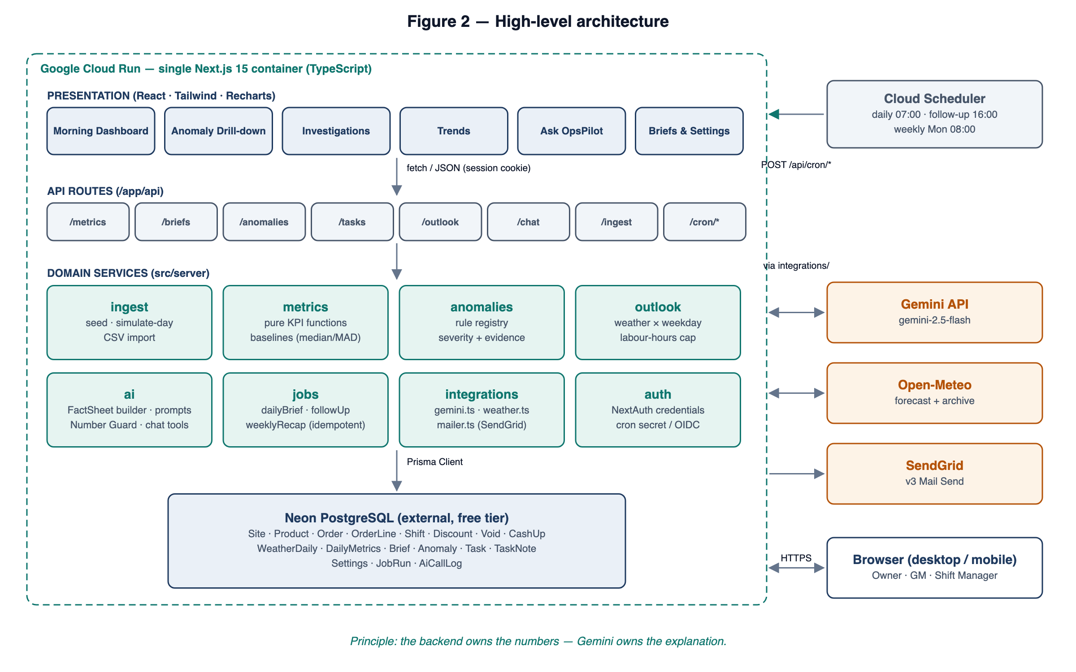
Figure 2 — High-level architecture
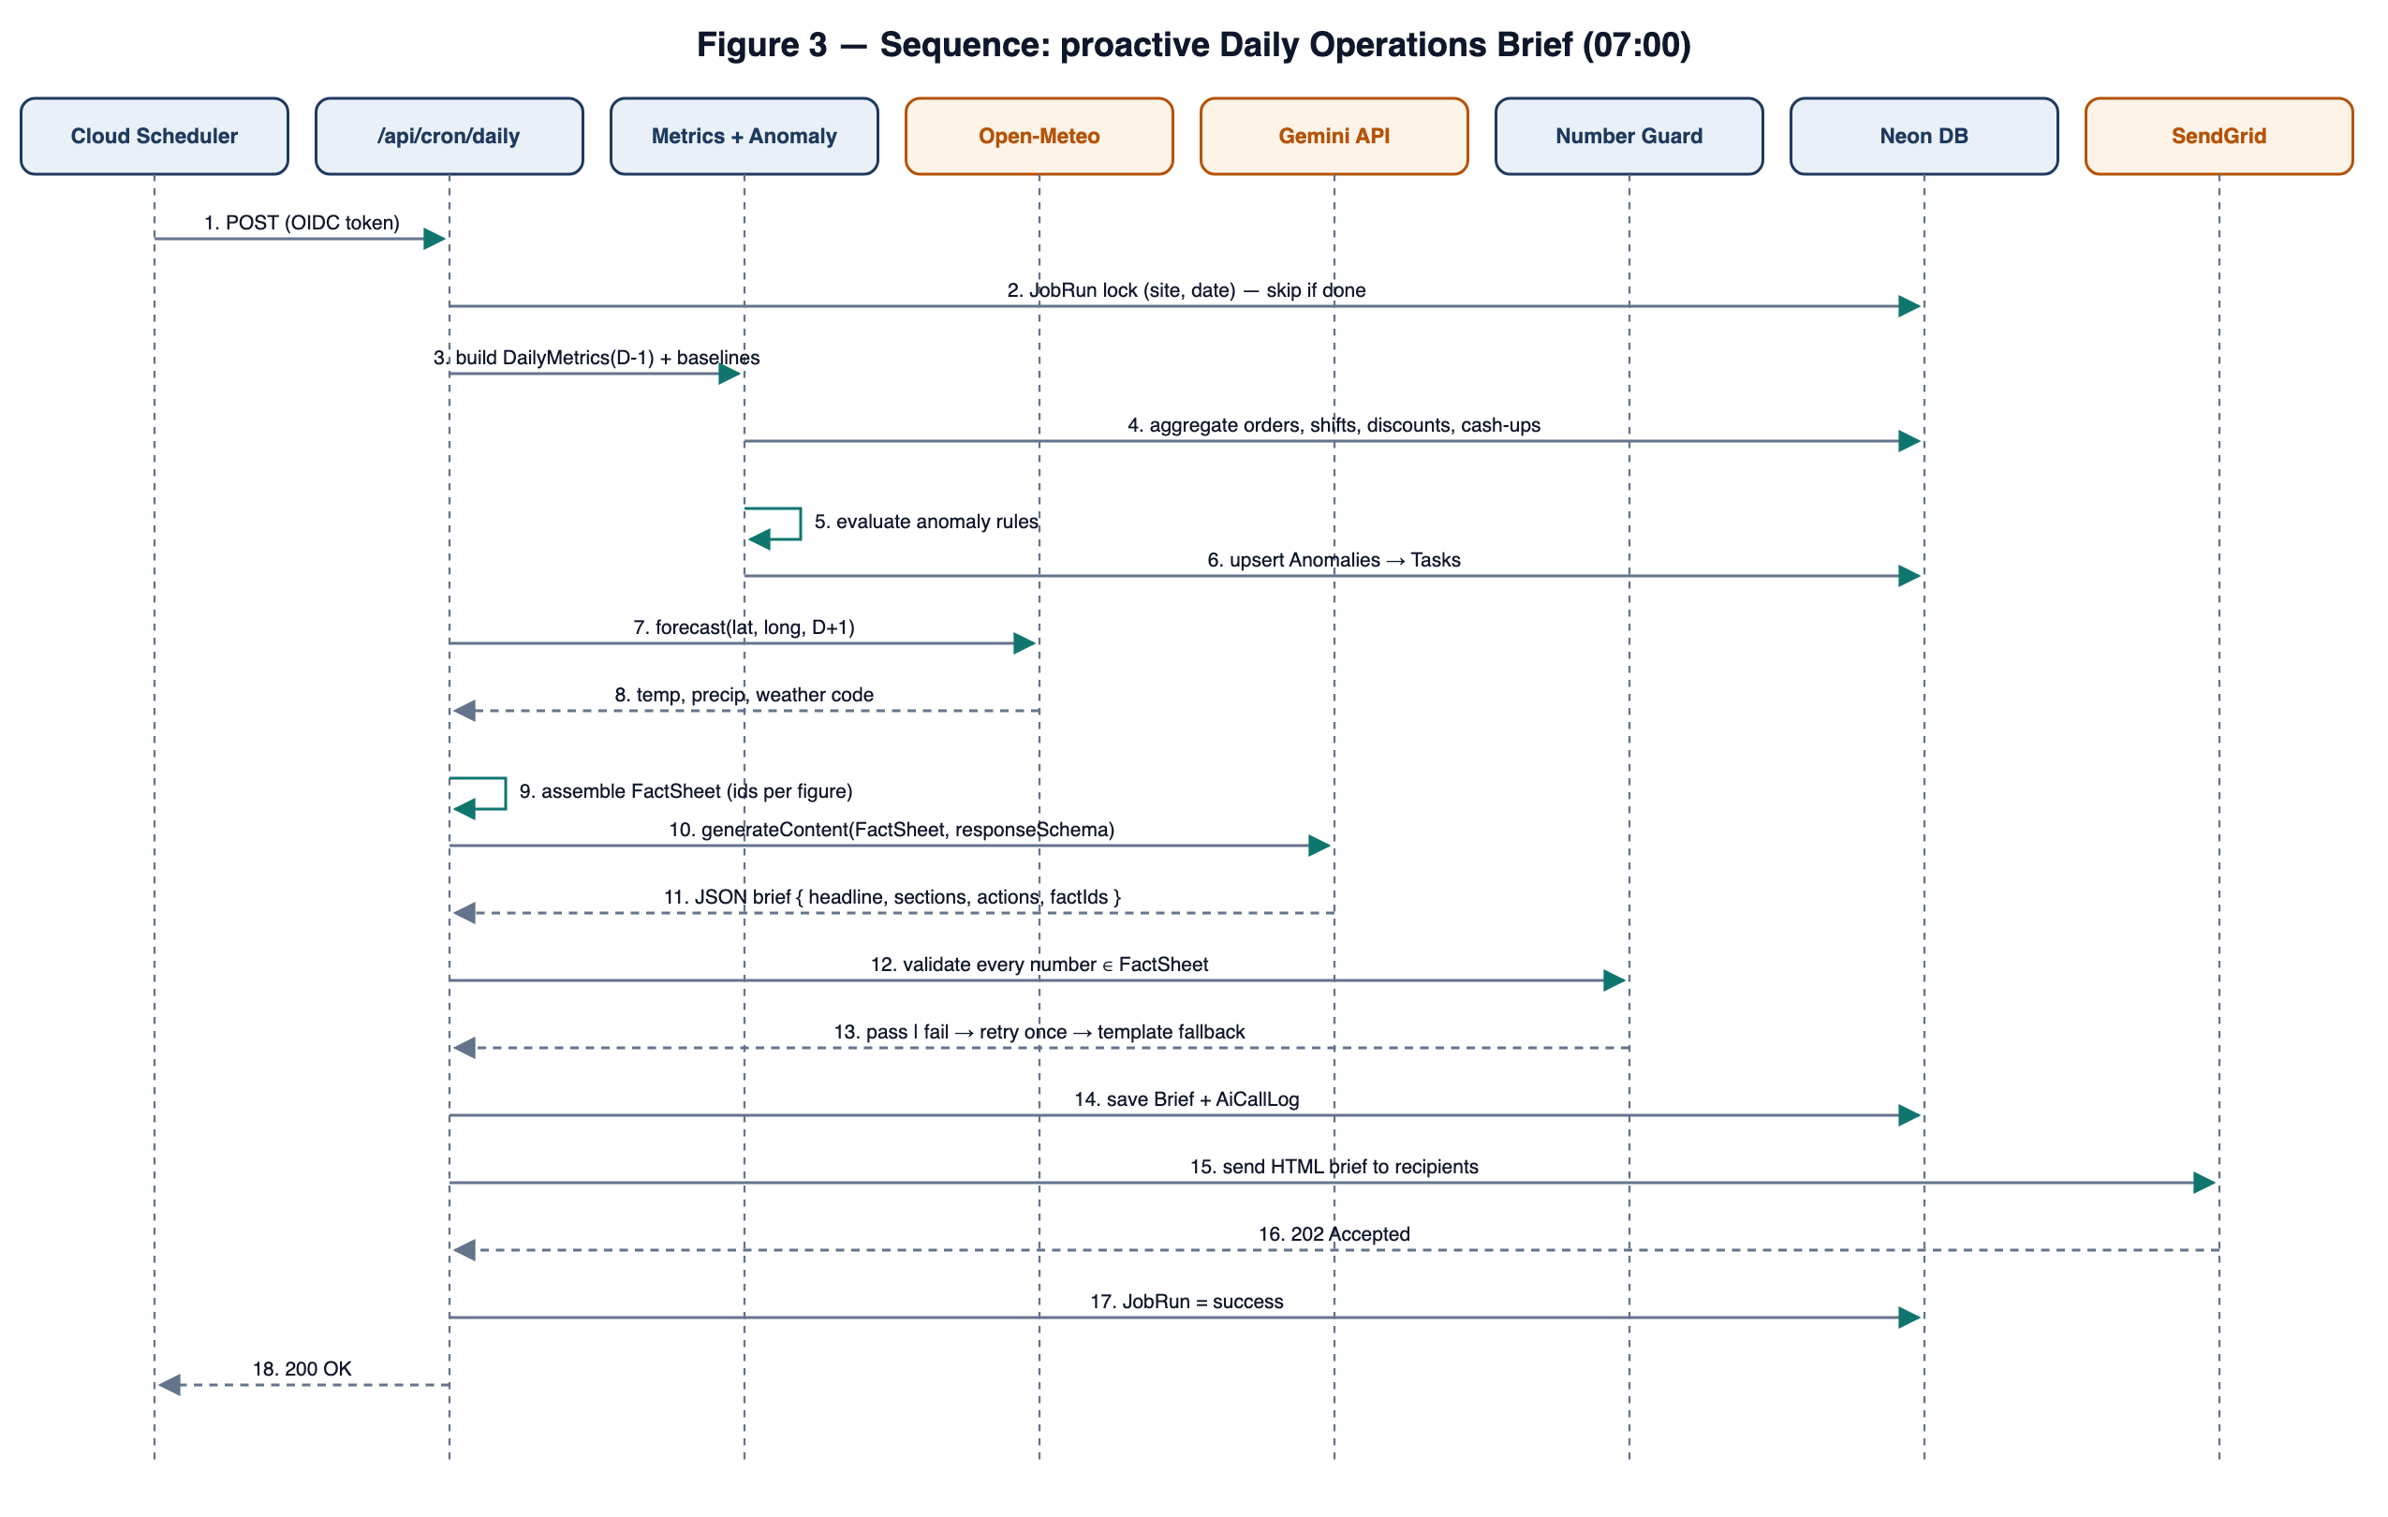
Figure 3 — Sequence: proactive Daily Operations Brief
Technology choices. Frontend: Next.js 15 App Router, React 19, TypeScript, Tailwind CSS, Recharts, lucide-react. Backend: Next.js route handlers, Zod validation, Prisma ORM, Neon PostgreSQL, NextAuth. AI: @google/genai SDK (Gemini 2.5 Flash) with structured output and function calling. Integrations: Open-Meteo (weather), SendGrid (email). Automation: Cloud Scheduler → Cloud Run. Testing: Vitest; Playwright smoke test.

Appendix B — Data Model
Entity | Key fields | Notes
Site | id, name, timezone, lat, lng, settings (JSON) | One row per restaurant
User | id, email, passwordHash, role, siteIds | Owner | Manager
Category / Product | id, name, isWet; sku, priceP, unitCostP, categoryId | Menu
Employee | id, siteId, firstName, lastInitial, role, hourlyRateP, managerCode | Minimal personal data
Order / OrderLine | id, siteId, externalId, openedAt, covers, channel, tillId; productId, qty, pricePence | Unique (siteId, externalId)
Discount / Void | id, orderId, amountPence, reason, managerId, at | Leakage sources
Shift | id, employeeId, siteId, start, end, role, scheduled (bool) | Actual and scheduled
CashUp | id, siteId, date, tillId, expectedCashP, countedCashP, expectedCardP, countedCardP, closedById
WeatherDaily | siteId, date, tMax, tMin, precipMm, code, source (archive | forecast) | Unique (siteId, date, source)
DailyMetrics | siteId, date, kpis (JSON), dayparts (JSON), byManager (JSON), computedAt | Unique (siteId, date)
Anomaly | id, siteId, date, ruleId, severity, dimension, observed, expected, evidence (JSON), streak, status
Task / TaskNote | id, anomalyId?, title, severity, state, assigneeId, dueAt; noteId, taskId, authorId, body, at
Brief | id, siteId, date, kind (daily | weekly), source, content (JSON), factSheet (JSON), guard (JSON), promptVersion
JobRun / AiCallLog / SettingsAudit | See Section 3.4.1 | Audit trail

Appendix C — AI Contracts (normative)

C.1 FactSheet (excerpt)
{
"site": "The Copper Pot", "date": "2026-09-27", "weekday": "Saturday",
"facts": [
{ "id": "rev.net", "value": 824000, "unit": "pence", "display": "£8,240" },
{ "id": "rev.net.vs_4wk", "value": -0.081, "unit": "ratio", "display": "-8.1%" },
{ "id": "lab.pct", "value": 0.312, "unit": "ratio", "display": "31.2%" },
{ "id": "lab.pct.vs_target", "value": 0.052, "unit": "pt", "display": "+5.2 pt" },
{ "id": "disc.rate.x_base", "value": 2.3, "unit": "x", "display": "2.3×" }
],
"anomalies": [ { "id": "an_812", "rule": "AR-01", "severity": "critical",
"contributor": "Sam K.", "share_display": "68%", "daypart": "Dinner" } ],
"outlook": { "tMax_display": "24°C", "rev_range_display": "£8,900–£9,700",
"labour_cap_display": "118 h" }
}

C.2 Brief response schema
{ type: OBJECT, required: [headline, summary, sections, actions], properties: {
headline: { type: STRING }, // <= 140 chars
summary: { type: STRING }, // <= 3 sentences
sections: { type: ARRAY, items: { type: OBJECT, properties: {
title: STRING, body: STRING, factIds: { type: ARRAY, items: STRING } } } },
actions: { type: ARRAY, items: { type: OBJECT, properties: {
title: STRING, rationale: STRING, anomalyId: STRING,
priority: { type: STRING, enum: [high, medium, low] } } } } } }

C.3 Number Guard algorithm
- Tokenise all AI text fields; extract numeric tokens with the pattern [£]?[-+]?\d[\d,]*(\.\d+)?\s?(%|pt|×|x|h|°C)?
- Normalise each token (remove separators and currency; convert % to a ratio).
- Accept a token if it equals a FactSheet display string, or a FactSheet value within half of the last displayed digit, or a date/time in the context.
- Otherwise record it as a violation. Any violation causes the output to fail (FR-BRF-06).

Appendix D — Sample Daily Brief Email
Subject: The Copper Pot · Sat 27 Sep — Revenue −8.1%, discounts 2.3× normal
Today's Operations Brief
Revenue was £8,240, 8.1% below the 4-week Saturday median, driven by a weaker Dinner.
Labour ran at 31.2% of revenue, +5.2 pt over target, concentrated in the Dinner shift.
Discounts were 2.3× the normal Saturday level; Sam K. accounts for 68% of the excess.
Needs attention: ● Critical — discount spike (Sam K., Dinner) · ● Warning — labour over target (Dinner).
Tomorrow: 24°C and dry; expect £8,900–£9,700; keep labour under 118 h; prep extra iced drinks.
[Open dashboard] [View investigations]

Appendix E — Free-Tier Budget
Service | Free allowance | Expected monthly use (1 site) | Headroom
Gemini 2.5 Flash | Per AI Studio free tier (daily cap) | ≤ 60 requests/day | Budgeted well below the daily cap
Open-Meteo | < 10,000 calls/day | ~10 calls/day (cached) | > 99%
SendGrid | Free trial allowance | ~40 emails/month | Ample
Neon Postgres | ~0.5 GB storage | ~40 MB (120 days, ~30k orders, ~90k lines) | > 90%
Cloud Run | 2M requests; 180k vCPU-s | < 20k requests; < 20k vCPU-s | > 85%
Cloud Scheduler | 3 jobs | 3 jobs | At limit by design

Appendix F — Delivery Plan
# | Milestone | Output | Est.
0 | SRS approval | This document approved by Brain3.ai | —
1 | Scaffold | Next.js + TS + Tailwind + Prisma/Neon + NextAuth; CI lint/test | 1 h
2 | Data | Schema, seed with scenarios S1–S5, weather back-fill, simulate-day, CSV import | 3 h
3 | Metrics & anomalies | KPI functions, baselines, rule registry, unit tests | 3 h
4 | AI | FactSheet, Gemini brief, Number Guard, template fallback, chat tools | 3 h
5 | Outlook | Forecast, weather factor, labour cap, prep hints | 1.5 h
6 | Jobs & email | Cron endpoints, JobRun, SendGrid templates, follow-up | 2 h
7 | Frontend | SCR-01 to SCR-09, responsive layout | 5 h
8 | Deploy | Dockerfile, Cloud Run, 3 Scheduler jobs (or GitHub Actions fallback), README | 2 h
9 | Submission | Demo video (problem → design → live demo → code walkthrough), repository link | 2 h

Appendix G — Requirements Traceability Matrix
Each requirement maps to at least one use case, screen or API and to a verification test. Tests prefixed T- are automated (Vitest/Playwright) where the requirement is deterministic, and manual demo checks where it involves an external service. The status column is completed during the build.
Req. ID | Feature | Use case | Screen | API | Test | Status
FR-ING-01 | Data ingestion and POS simulation | UC-08 | SCR-09 | /api/ingest/* | T-ING-01
FR-ING-02 | Data ingestion and POS simulation | UC-08 | SCR-09 | /api/ingest/* | T-ING-02
FR-ING-03 | Data ingestion and POS simulation | UC-08 | SCR-09 | /api/ingest/* | T-ING-03
FR-ING-04 | Data ingestion and POS simulation | UC-08 | SCR-09 | /api/ingest/* | T-ING-04
FR-ING-05 | Data ingestion and POS simulation | UC-08 | SCR-09 | /api/ingest/* | T-ING-05
FR-ING-06 | Data ingestion and POS simulation | UC-08 | SCR-09 | /api/ingest/* | T-ING-06
FR-ING-07 | Data ingestion and POS simulation | UC-08 | SCR-09 | /api/ingest/* | T-ING-07
FR-ING-08 | Data ingestion and POS simulation | UC-08 | SCR-09 | /api/ingest/* | T-ING-08
FR-MET-01 | Metrics engine | UC-01, UC-05 | SCR-02, SCR-05 | /api/metrics | T-MET-01
FR-MET-02 | Metrics engine | UC-01, UC-05 | SCR-02, SCR-05 | /api/metrics | T-MET-02
FR-MET-03 | Metrics engine | UC-01, UC-05 | SCR-02, SCR-05 | /api/metrics | T-MET-03
FR-MET-04 | Metrics engine | UC-01, UC-05 | SCR-02, SCR-05 | /api/metrics | T-MET-04
FR-MET-05 | Metrics engine | UC-01, UC-05 | SCR-02, SCR-05 | /api/metrics | T-MET-05
FR-MET-06 | Metrics engine | UC-01, UC-05 | SCR-02, SCR-05 | /api/metrics | T-MET-06
FR-MET-07 | Metrics engine | UC-01, UC-05 | SCR-02, SCR-05 | /api/metrics | T-MET-07
FR-ANO-01 | Anomaly detection | UC-02 | SCR-02, SCR-03 | /api/anomalies | T-ANO-01
FR-ANO-02 | Anomaly detection | UC-02 | SCR-02, SCR-03 | /api/anomalies | T-ANO-02
FR-ANO-03 | Anomaly detection | UC-02 | SCR-02, SCR-03 | /api/anomalies | T-ANO-03
FR-ANO-04 | Anomaly detection | UC-02 | SCR-02, SCR-03 | /api/anomalies | T-ANO-04
FR-ANO-05 | Anomaly detection | UC-02 | SCR-02, SCR-03 | /api/anomalies | T-ANO-05
FR-ANO-06 | Anomaly detection | UC-02 | SCR-02, SCR-03 | /api/anomalies | T-ANO-06
FR-ANO-07 | Anomaly detection | UC-02 | SCR-02, SCR-03 | /api/anomalies | T-ANO-07
FR-ANO-08 | Anomaly detection | UC-02 | SCR-02, SCR-03 | /api/anomalies | T-ANO-08
FR-BRF-01 | Daily Operations Brief (AI narrative with Number Guard) | UC-01, UC-06, UC-09 | SCR-02, SCR-07 | /api/briefs, /api/cron/daily | T-BRF-01
FR-BRF-02 | Daily Operations Brief (AI narrative with Number Guard) | UC-01, UC-06, UC-09 | SCR-02, SCR-07 | /api/briefs, /api/cron/daily | T-BRF-02
FR-BRF-03 | Daily Operations Brief (AI narrative with Number Guard) | UC-01, UC-06, UC-09 | SCR-02, SCR-07 | /api/briefs, /api/cron/daily | T-BRF-03
FR-BRF-04 | Daily Operations Brief (AI narrative with Number Guard) | UC-01, UC-06, UC-09 | SCR-02, SCR-07 | /api/briefs, /api/cron/daily | T-BRF-04
FR-BRF-05 | Daily Operations Brief (AI narrative with Number Guard) | UC-01, UC-06, UC-09 | SCR-02, SCR-07 | /api/briefs, /api/cron/daily | T-BRF-05
FR-BRF-06 | Daily Operations Brief (AI narrative with Number Guard) | UC-01, UC-06, UC-09 | SCR-02, SCR-07 | /api/briefs, /api/cron/daily | T-BRF-06
FR-BRF-07 | Daily Operations Brief (AI narrative with Number Guard) | UC-01, UC-06, UC-09 | SCR-02, SCR-07 | /api/briefs, /api/cron/daily | T-BRF-07
FR-BRF-08 | Daily Operations Brief (AI narrative with Number Guard) | UC-01, UC-06, UC-09 | SCR-02, SCR-07 | /api/briefs, /api/cron/daily | T-BRF-08
FR-BRF-09 | Daily Operations Brief (AI narrative with Number Guard) | UC-01, UC-06, UC-09 | SCR-02, SCR-07 | /api/briefs, /api/cron/daily | T-BRF-09
FR-TSK-01 | Investigation queue and follow-up | UC-03, UC-10 | SCR-03, SCR-04 | /api/tasks, /api/cron/followup | T-TSK-01
FR-TSK-02 | Investigation queue and follow-up | UC-03, UC-10 | SCR-03, SCR-04 | /api/tasks, /api/cron/followup | T-TSK-02
FR-TSK-03 | Investigation queue and follow-up | UC-03, UC-10 | SCR-03, SCR-04 | /api/tasks, /api/cron/followup | T-TSK-03
FR-TSK-04 | Investigation queue and follow-up | UC-03, UC-10 | SCR-03, SCR-04 | /api/tasks, /api/cron/followup | T-TSK-04
FR-TSK-05 | Investigation queue and follow-up | UC-03, UC-10 | SCR-03, SCR-04 | /api/tasks, /api/cron/followup | T-TSK-05
FR-TSK-06 | Investigation queue and follow-up | UC-03, UC-10 | SCR-03, SCR-04 | /api/tasks, /api/cron/followup | T-TSK-06
FR-TSK-07 | Investigation queue and follow-up | UC-03, UC-10 | SCR-03, SCR-04 | /api/tasks, /api/cron/followup | T-TSK-07
FR-OUT-01 | Tomorrow Outlook | UC-04 | SCR-02 | /api/outlook | T-OUT-01
FR-OUT-02 | Tomorrow Outlook | UC-04 | SCR-02 | /api/outlook | T-OUT-02
FR-OUT-03 | Tomorrow Outlook | UC-04 | SCR-02 | /api/outlook | T-OUT-03
FR-OUT-04 | Tomorrow Outlook | UC-04 | SCR-02 | /api/outlook | T-OUT-04
FR-OUT-05 | Tomorrow Outlook | UC-04 | SCR-02 | /api/outlook | T-OUT-05
FR-CHT-01 | Ask OpsPilot (conversational analysis) | UC-05 | SCR-06 | /api/chat | T-CHT-01
FR-CHT-02 | Ask OpsPilot (conversational analysis) | UC-05 | SCR-06 | /api/chat | T-CHT-02
FR-CHT-03 | Ask OpsPilot (conversational analysis) | UC-05 | SCR-06 | /api/chat | T-CHT-03
FR-CHT-04 | Ask OpsPilot (conversational analysis) | UC-05 | SCR-06 | /api/chat | T-CHT-04
FR-CHT-05 | Ask OpsPilot (conversational analysis) | UC-05 | SCR-06 | /api/chat | T-CHT-05
FR-CHT-06 | Ask OpsPilot (conversational analysis) | UC-05 | SCR-06 | /api/chat | T-CHT-06
FR-CHT-07 | Ask OpsPilot (conversational analysis) | UC-05 | SCR-06 | /api/chat | T-CHT-07
FR-NTF-01 | Proactive notifications and scheduled jobs | UC-09, UC-10, UC-11 | SCR-07, SCR-09 | /api/cron/* | T-NTF-01
FR-NTF-02 | Proactive notifications and scheduled jobs | UC-09, UC-10, UC-11 | SCR-07, SCR-09 | /api/cron/* | T-NTF-02
FR-NTF-03 | Proactive notifications and scheduled jobs | UC-09, UC-10, UC-11 | SCR-07, SCR-09 | /api/cron/* | T-NTF-03
FR-NTF-04 | Proactive notifications and scheduled jobs | UC-09, UC-10, UC-11 | SCR-07, SCR-09 | /api/cron/* | T-NTF-04
FR-NTF-05 | Proactive notifications and scheduled jobs | UC-09, UC-10, UC-11 | SCR-07, SCR-09 | /api/cron/* | T-NTF-05
FR-NTF-06 | Proactive notifications and scheduled jobs | UC-09, UC-10, UC-11 | SCR-07, SCR-09 | /api/cron/* | T-NTF-06
FR-NTF-07 | Proactive notifications and scheduled jobs | UC-09, UC-10, UC-11 | SCR-07, SCR-09 | /api/cron/* | T-NTF-07
FR-SET-01 | Settings and site configuration | UC-07 | SCR-08 | /api/settings | T-SET-01
FR-SET-02 | Settings and site configuration | UC-07 | SCR-08 | /api/settings | T-SET-02
FR-SET-03 | Settings and site configuration | UC-07 | SCR-08 | /api/settings | T-SET-03
FR-SET-04 | Settings and site configuration | UC-07 | SCR-08 | /api/settings | T-SET-04
FR-AUTH-01 | Authentication and authorisation | all | SCR-01 | /api/auth/* | T-AUTH-01
FR-AUTH-02 | Authentication and authorisation | all | SCR-01 | /api/auth/* | T-AUTH-02
FR-AUTH-03 | Authentication and authorisation | all | SCR-01 | /api/auth/* | T-AUTH-03
FR-AUTH-04 | Authentication and authorisation | all | SCR-01 | /api/auth/* | T-AUTH-04
PR-01 | Performance | — | — | — | T-PR-01
PR-02 | Performance | — | — | — | T-PR-02
PR-03 | Performance | — | — | — | T-PR-03
PR-04 | Performance | — | — | — | T-PR-04
PR-05 | Performance | — | — | — | T-PR-05
PR-06 | Performance | — | — | — | T-PR-06
PR-07 | Performance | — | — | — | T-PR-07

Appendix H — Risks and Mitigations
Risk | Likelihood / Impact | Mitigation
GCP requires a billing account for Cloud Run / Scheduler | Medium / Medium | Endpoints are scheduler-agnostic; fall back to GitHub Actions cron and an alternative free host (FR-NTF-03, 3.5.4).
SendGrid free offering is time-limited or sender verification is delayed | Medium / Low | Mailer adapter; swap to Resend or the Gmail API; the in-app brief remains available.
Gemini free-tier quota or regional restriction | Low / Medium | ≤ 60 req/day budget; template fallback; retry limits (FR-BRF-06, FR-BRF-09).
AI hallucinated figures | Medium / High | FactSheet-only input, structured output, Number Guard, template fallback.
Synthetic data looks unrealistic | Medium / Medium | Weekday/daypart seasonality, real historical weather, noise, injected scenarios.
Scope creep within the deadline | High / High | MoSCoW priorities; P2 items built only after P0–P1 pass tests.

