Study of the relationship between Tooth Growth and Vitamin C in Guinea Pigs

# Data Summary

## len supp dose   
## Min. : 4.20 OJ:30 Min. :0.500   
## 1st Qu.:13.07 VC:30 1st Qu.:0.500   
## Median :19.25 Median :1.000   
## Mean :18.81 Mean :1.167   
## 3rd Qu.:25.27 3rd Qu.:2.000   
## Max. :33.90 Max. :2.000

The ToothGrowth dataset contains three variables; *len*, *supp* and *dose*.

* The *len* variable corresponds to the measured length, in microns, of the guinea pigs' odontoblast, ranging from 4.20 to 33.90 microns, with a mean of 18.81.
* The *supp* variable corresponds to the supplement type used. It can take two nominal values, *OJ* or *VC*, for *Orange Juice* and *Ascorbic Acid* respectively.
* The *dose* variable corresponds to the dose of Vitamin C, in milligram, of either supplement. Three set doses have been used, 0.5 mg, 1.0 mg and 2 mg.

It contains 60 observations, 10 for each combination of *dose* and *supp*.

# Exploratory Data Analysis

The following graphs aim at observing certain patterns between variables to propose relevant hypothesis testing.

## Exploratory Graphs

From Graph 1, the overall positive aspect of the relationship between the dose and the length of the odontoblast can be fully appreciated. By its overall look, the ascorbic acid (*VC*) data displays a stronger linearity than the orange juice (*OJ*).

Graph 2 is meant to compare both delivery method and showcase any significant difference between both.

Finally, Graph 3 intends to portray the relationship between the growth of odontoblast in guinea pigs, with no distinction between delivery method.

# Hypothesis Testing

In the light of the previous exploratory graphs, two questions will be examined in this experiment, both pertaining to the link between the growth of odontoblasts in guinea pigs and ascorbic acid.

1. Does the ascorbic acid delivery method impact the growth of odontoblasts?
2. Does the growth of odontoblasts in respect of ascorbic acid is dose dependent?

The α value selected for this experiment is 0.05, for a 95% confidence level.

### Supply Method

#### Hypothesis Formulation and Presentation

Orange juice ($OJ$) delivery generates more odontoblast growth than ascorbic acid ($VC$) delivery.

$H_{0}:µ_{OJ}=µ_{VC}$

$H_{a}:µ_{OJ}>µ_{VC}$

The data provided does not allow to reject the null hypothesis, as the confidence interval (-0.171, 7.571) includes 0, suggesting that no change from the mean is possible. Furthermore, the p-value (0.0606) suggests that there is weak evidence that $H_{a}$ is true, rendering the test result not statistically significant. Finally, the test statistic (1.92) is not part of the rejection region (-2, 2).

### Dose of Ascorbic Acid

#### Hypothesis Formulation and Presentation

The length of odontoblasts in guinea pigs is positively linked to the dose of ascorbic acid provided.

$H_{0}:µ_{0.5mg}=µ_{1.0mg}=µ_{2.0mg}$

$H_{a}:µ_{0.5mg}<µ_{1.0mg}<µ_{2.0mg}$

The data provided does allow to reject the null hypothesis in all three cases (Doses 1.0 vs 0.5, 2.0 vs 1.0 and 2.0 vs 0.5), as their respective confidence interval (6.28, 3.73 and 6.28) do not include 0, suggesting that a difference from the mean is likely. Furthermore, the p-values ($1.3×{10}^{−7}$, $1.9×{10}^{−5}$ and $4.4×{10}^{−14}$) suggest that there is overwhelming evidence that $H_{a}$ is true, rendering the test result to be highly significant. Finally, all three test statistics (6.48,4.9 and 11.8) are part of the rejection regions of all three tests (~[-2.025;2.025] < test statistic).

# Assumptions and Conclusions

## Assumptions

In order be valid, the following assumptions with regards to the data, the population and the experiment must be fulfilled. The population must be independent and unpaired, it must be normally distributed. Concerning the samples, its variances must be unequal as the test for unequal variances has been used (Welch Two Sample t-test) and finally, the sampling from the population must be random.

According to the original experiment, one guinea pig was sacrificed for each observation provided, meeting assumption regarding independence. Despite the small size of the data set, some normality can be observed surrounding the length of odontoblasts (see Annex B). It is also assumed that the guinea pigs were randomly selected from their population and the variances have been automatically calculated by R using *t.test* function.

## Conclusions

Assuming that the preceding assumptions are true, it may be infered that there is a highly significant difference between tooth length and the dose levels across delivery methods. The data used in this analysis provides overwhelming evidence that higher dosage of Vitamin C led to longer odontoblasts no matter the delivery method.

The same conclusion cannot be drawn concerning the two delivery methods studied. Although the first two graphs hint for a difference in tooth length between the delivery methods, the present data does not provide sufficient evidence to support this, when analyzed as a whole. Larger samples of data, following the same research protocols and methodology, could probably narrow the confidence interval and potentially allow to reject the null hypothesis.

# Annex A - The Code

#fetching the data  
data("ToothGrowth")  
#loading ggplot2 to make some neat graphs  
require(ggplot2)

summary(ToothGrowth)

#Some more summaries of the data  
head(ToothGrowth)

## len supp dose  
## 1 4.2 VC 0.5  
## 2 11.5 VC 0.5  
## 3 7.3 VC 0.5  
## 4 5.8 VC 0.5  
## 5 6.4 VC 0.5  
## 6 10.0 VC 0.5

str(ToothGrowth)

## 'data.frame': 60 obs. of 3 variables:  
## $ len : num 4.2 11.5 7.3 5.8 6.4 10 11.2 11.2 5.2 7 ...  
## $ supp: Factor w/ 2 levels "OJ","VC": 2 2 2 2 2 2 2 2 2 2 ...  
## $ dose: num 0.5 0.5 0.5 0.5 0.5 0.5 0.5 0.5 0.5 0.5 ...

#Overall portrait of the data  
qplot(ToothGrowth$dose,ToothGrowth$len, colour=ToothGrowth$supp, ylab = "Length (µm)", xlab="Dose (mg)") + geom_smooth() + scale_colour_discrete("Delivery Method")

#Supply methods compared  
qplot(ToothGrowth$supp,ToothGrowth$len,geom="boxplot", fill=ToothGrowth$supp,ylab = "Length (µm)", xlab="Delivery Method")+ scale_fill_discrete("Delivery Method")

#Dose provided compared  
qplot(ToothGrowth$dose,ToothGrowth$len,geom="boxplot", fill=factor(ToothGrowth$dose), ylab = "Length (µm)", xlab="Dose (mg)") + scale_fill_discrete("Dose (mg)")

#Setting the α in order to establish the confidence level  
α <- 0.05

#Subsetting the data by delivery method  
OJ <- subset(ToothGrowth,ToothGrowth$supp =="OJ")  
VC <- subset(ToothGrowth,ToothGrowth$supp =="VC")  
  
#Testing for any statistical difference between them  
Hypo1 <- t.test(OJ$len,VC$len,paired=FALSE,conf.level=1-α)  
  
#Establishing the rejection regions for the t-tests  
RejRegionHypo1 <- qt(1-α/2,df=Hypo1$parameter)*c(-1,1)

#Subseting the different dosage of Vitamin C given to guinea pigs  
Dose0.5 <- subset(ToothGrowth,ToothGrowth$dose == 0.5)  
Dose1 <- subset(ToothGrowth,ToothGrowth$dose == 1)  
Dose2 <- subset(ToothGrowth,ToothGrowth$dose == 2)  
  
#Testing for any statistical difference between them  
Hypo2.1 <- t.test(Dose1$len,Dose0.5$len,paired=FALSE,conf.level=1-α)  
Hypo2.2 <- t.test(Dose2$len,Dose1$len,paired=FALSE,conf.level=1-α)  
Hypo2.3 <- t.test(Dose2$len,Dose0.5$len,paired=FALSE,conf.level=1-α)  
  
#Establishing the rejection regions for the t-tests  
RejRegionHypo2.1 <- qt(1-α/2,df=Hypo2.1$parameter)*c(-1,1)  
RejRegionHypo2.2 <- qt(1-α/2,df=Hypo2.2$parameter)*c(-1,1)  
RejRegionHypo2.3 <- qt(1-α/2,df=Hypo2.3$parameter)*c(-1,1)

## Graph codes

#Overall portrait of the data  
qplot(ToothGrowth$dose,ToothGrowth$len, colour=ToothGrowth$supp, ylab = "Length (µm)", xlab="Dose (mg)") + geom_smooth() + scale_colour_discrete("Delivery Method")

#Supply methods compared  
qplot(ToothGrowth$supp,ToothGrowth$len,geom="boxplot", fill=ToothGrowth$supp,ylab = "Length (µm)", xlab="Delivery Method")+ scale_fill_discrete("Delivery Method")

#Dose provided compared  
qplot(ToothGrowth$dose,ToothGrowth$len,geom="boxplot", fill=factor(ToothGrowth$dose), ylab = "Length (µm)", xlab="Dose (mg)") + scale_fill_discrete("Dose (mg)")

# Annex B - Graphs

## Graph 1

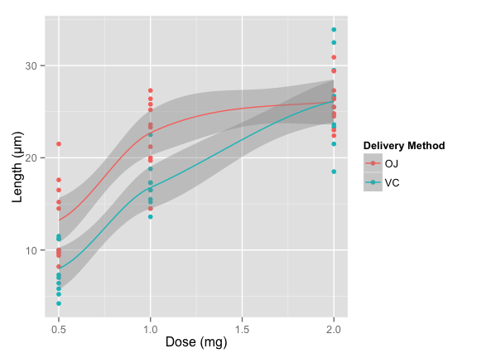

## Graph 2

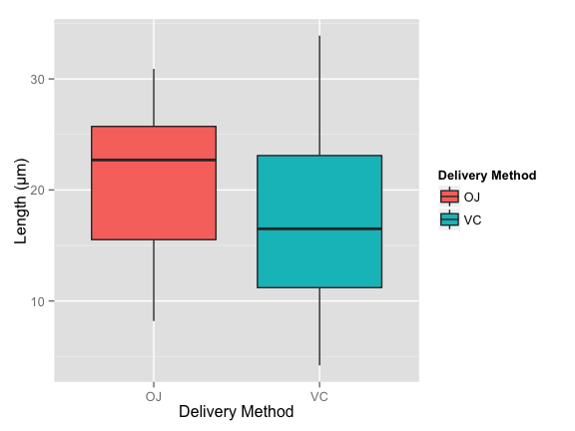

## Graph 3

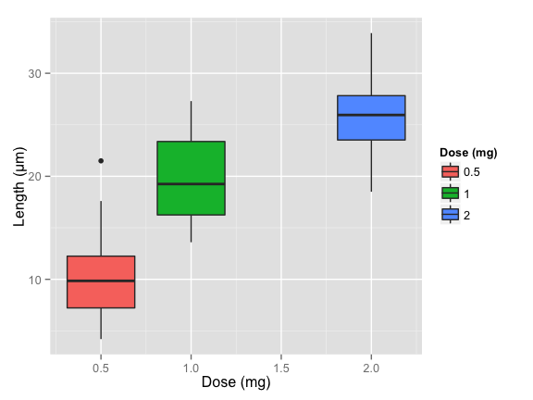

## Graph 4 - Distribution of Odontoblasts

## Graph 4 - Distribution of Odontoblast Length  
ggplot(ToothGrowth, aes(x=ToothGrowth$len))+geom_histogram(aes(y = ..density.., fill=..count..),binwidth=3.5) + stat_function(fun = dnorm, colour="blue", arg = list(mean = mean(ToothGrowth$len),sd=sd(ToothGrowth$len)), geom="line", size=2) + geom_vline(aes(xintercept = mean(ToothGrowth$len),colour="red"),size=1)+ ylab("Density") + xlab("Odontoblast Length (µm)") + labs(title="Odontoblast Length Distribution")

