**Report on Dialogs**

Gelmis Bartulis

GE20070469

[Gelmis.bartulis@wipro.com](mailto:Gelmis.bartulis@wipro.com)

**Assignment**

This assignment is for an Android developer at L1 level to get an understanding on how to use the dialog boxes support in Android. Android comes with a set of dialog boxes which the programmer can use at appropriate times for an application.

**Initial Screen**

Within the initial screen the date and time are set to current time. That is done by calling **Calender.getInstance().getTime();** and then using **SimpleDateFormat** class to format the date into a wished format in order to fit that into the string.

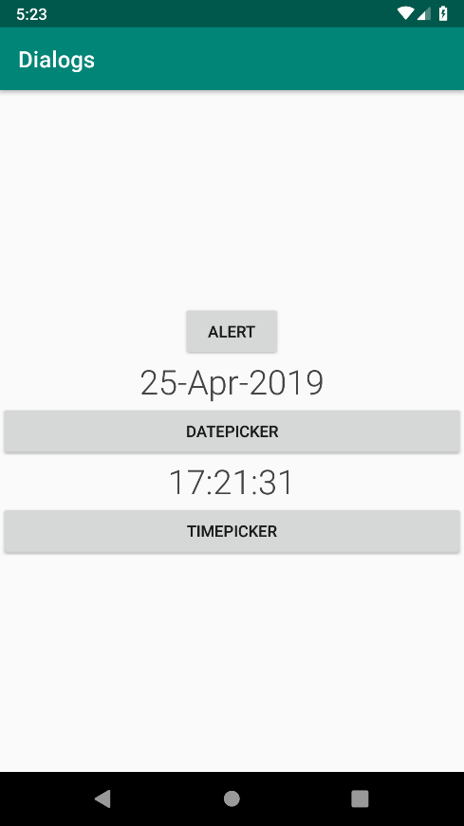

Figure 1: Shows initial application screen (onResume())

**Alert** **dialog**

The alert dialog is called when the button “Alert” is pressed. Within that, an **onClickListener** is attached to see when the button has been pressed. When the dialog opens up, it shows all the details that have been specified while creating the **AlertDialog**. The title and the message of the dialog have to be specified in order to warn the user about a certain action, i.e. Deleting a record.

The actions are then specified that decide on the positive or the negative answers from the user. In these cases both actions are not set to anything. Lastly, the icon is set to give a more accurate representation of the warning.

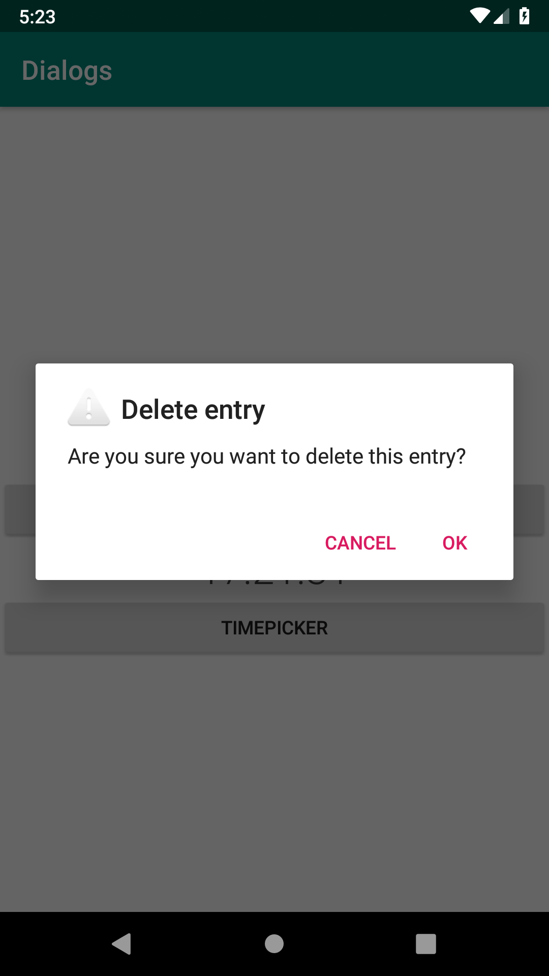

Figure 2: An alert dialog is displayed to the user with information and images

**DateDialog**

The **datePicker** is initiated when the user selects the button “DatePicker”. The date picker has to have the current calendar instance in order to show the current date when the dialog comes up, therefore **DatePickerDialog**.**OnDateSetListener** is called and then **onDateSet**. Within the **onDateSet** when the dialog is shown to the user, the data is set to the current date. This reduces the possible confusion the user may have. After these parameters have been set, the **updateDate**() method is called to update the TextView to the date that the user has selected. This is done by passing the calendar reference to the method, then within the method – creating a date format and calling the **SimpleDateFormat** in order to get the right locale. And only then the date is set within the TextView as seen below within the image.

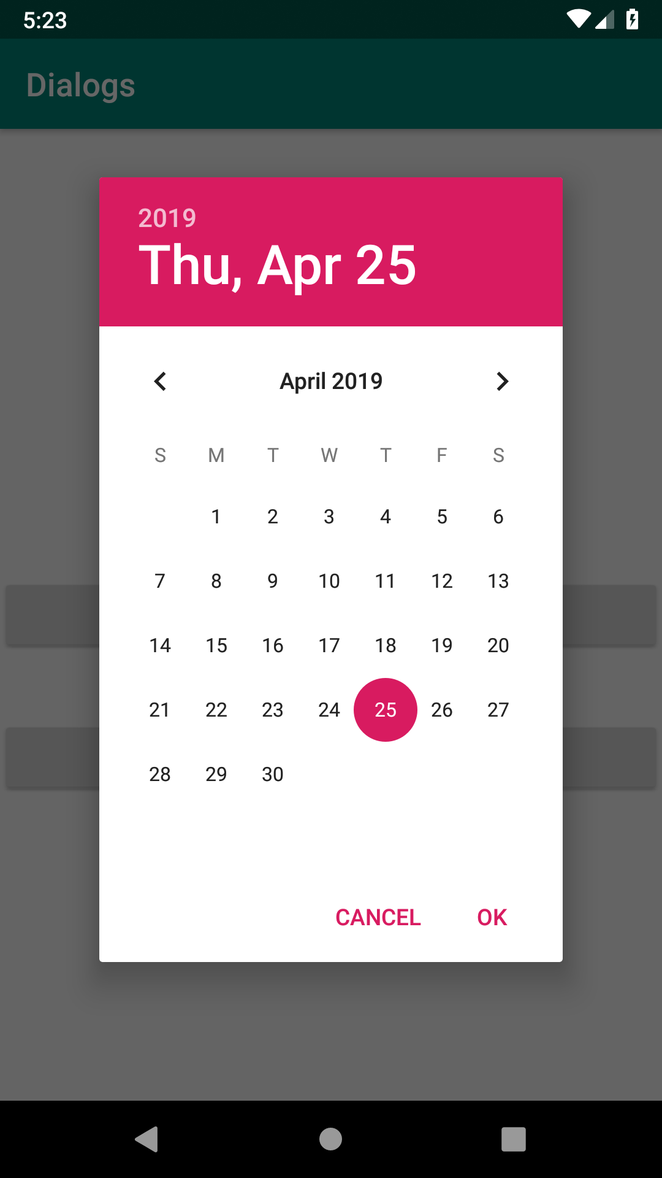

Figure 3: The calendar (datePicker) dialog is displayed to the user to pick the date

**TimePicker**

This class allows the user to pick the current time (hours and minutes) by either entering the digits by pressing on numbers or by rotating the clock arrow to the desired hour and minute position and then clicking “ok” to accept the changes. The **TimePicker** is also called using the **Calendar**.**getInstance**() because that method get the most current time (now). The user can then selected the time and accept or decline. Just like the **DatePicker**, the title has to be specified in order to show the user what they are being asked for as seen in the image below.

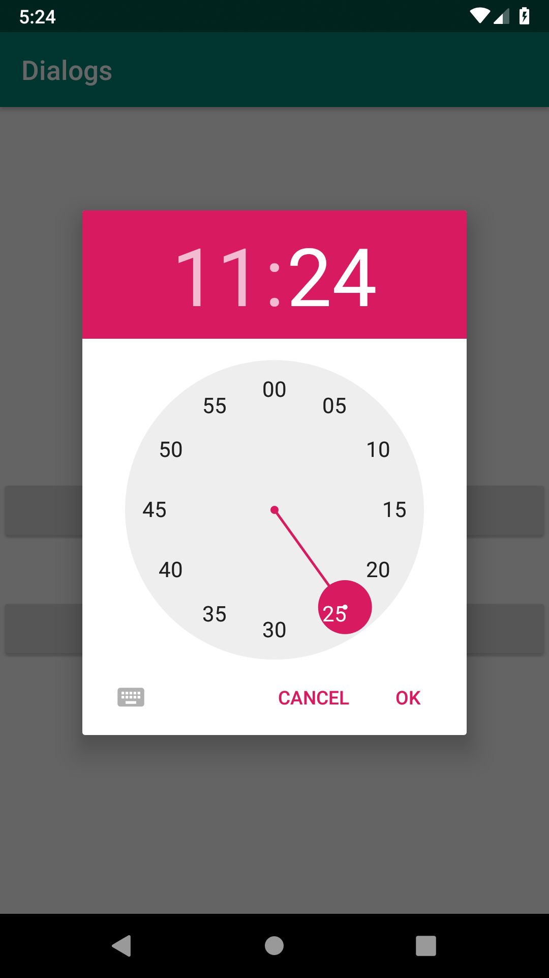

Figure 4: Shows the TimePicker dialog that is being called and shown

**Assignment summary**

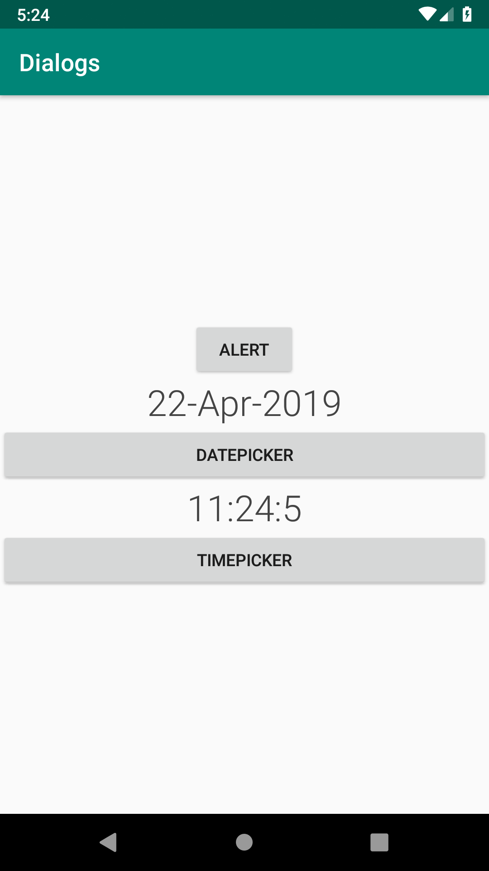After all the methods have been called and executed the activity screen is show as seen in the image below (Fig. 5). The date and time TextView’s have been altered using the aforementioned methods and classes. I have learned how to use these dialogs efficiently and practically. Now I understand how they work and how to build them. Great exercise.

Figure 5: Shows the end screen when all the methods have been exectued