**ASSIGNMENT 1**

**JAVASCRIPT CODE : table.js file**

(function () {

//heading of the assignment

var headtag = document.createElement("h3");

headtag.innerText = "ASSIGNMENT 1";

headtag.style.textAlign = "center";

headtag.style.color = "#FF7F50";

headtag.style.fontSize = "40px";

document.body.appendChild(headtag);

//Build an array containing Customer records.

var people = Array(

Array ("Harry",23,"29th jan", "[harry@gmail.com","Gemini](mailto:harry@gmail.com","Gemini) solutons"),

Array("Manny",24,"26th Jul", "[manny@gmail.com","Gemini](mailto:manny@gmail.com","Gemini) solutons"),

Array ("Sandy",33,"12th Aug", "[sandy@gmail.com","Gemini](mailto:sandy@gmail.com","Gemini) solutons"),

Array ("Nora", 29,"21th Sep", "[nora@gmail.com","Gemini](mailto:nora@gmail.com","Gemini) solutons"),

Array ("Monty",29,"11th Oct", "[monty@gmail.com","Gemini](mailto:monty@gmail.com","Gemini) solutons"),

);

//creating the headings of each column

var heading = Array("NAME","AGE", "DOB", "EMAIL", "COMPANY");

const tbl = document.createElement("table");

const tblBody = document.createElement("tbody");

var headRow = tbl.insertRow(-1);

headRow.style.color = "turquoise";

for(var i = 0; i<5; i++){

var headcell = document.createElement("Td");

//styling

headcell.style.border = 'solid 2px'

headcell.style.padding = "20px";

headcell.style.textAlign = "center";

headcell.style.fontWeight = "bold";

headcell.innerHTML = heading[i];

headRow.appendChild(headcell);

}

//adding the celles int the table

var cell,row;

// creating all cells

for (let i = 0; i < 5; i++) {

// creates a table row

row = document.createElement("tr");

for (let j = 0; j < 5; j++) {

// Create a <td> element and a text node, make the text

// node the contents of the <td>, and put the <td> at

// the end of the table row

cell = document.createElement("td");

//styling

cell.style.border = 'solid 1px';

cell.style.padding = "20px";

const cellText = document.createTextNode(people[i][j]);

cell.appendChild(cellText);

row.appendChild(cell);

}

// add the row to the end of the table body

tblBody.appendChild(row);

}

// put the <tbody> in the <table>

tbl.appendChild(tblBody);

//adding styles to table

tbl.style.border = 'solid 2px black';

tbl.style.marginLeft = "350px";

tbl.style.marginTop = "100px";

// appends <table> into <body>

document.body.appendChild(tbl);

})();

**HTML CODE: index.html file**

<!DOCTYPE html>

<html lang="en">

<head>

<meta charset="UTF-8">

<meta http-equiv="X-UA-Compatible" content="IE=edge">

<meta name="viewport" content="width=device-width, initial-scale=1.0">

<title>Document</title>

</head>

<body>

<script src="table.js"></script>

</body>

</html>

**OUTPUT**

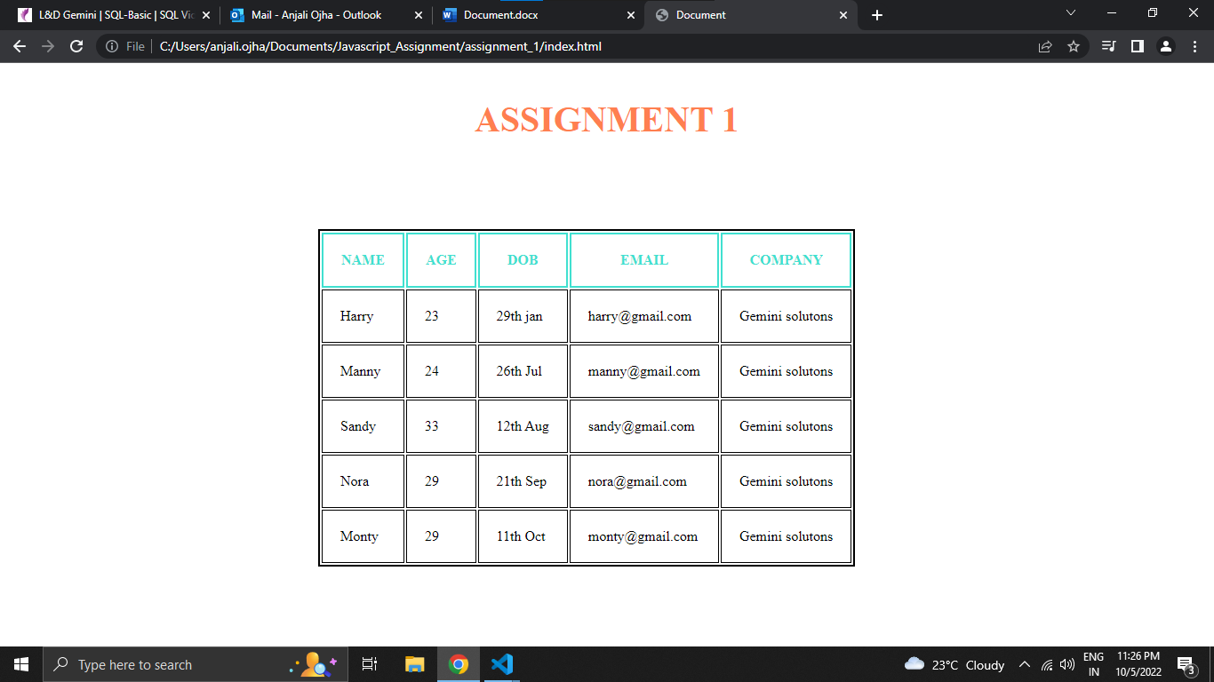

**ASSIGNMENT 2**

**JAVASCRIPT CODE : validate.js**

function validateForm(){

var name = document.getElementById("name").value;

var nameResult = validateName(name);

// window.alert(nameResult);

var email = document.getElementById("email").value;

var emailResult = validateEmail(email);

// window.alert(emailResult);

var mobile = document.getElementById("mobile").value;

var mobileResult = true;

if(mobile != null || mobile != ""){

mobileResult = validateMobile(mobile);

}

// window.alert(name+" "+email+" "+mobile);

// window.alert(mobileResult);

if(nameResult == true && emailResult == true && mobileResult == true){

storeData(name,email,mobile);

}

}

//user name validation

function validateName(name){

var result = false;

if (name == "" || name == null){

alert ("name is required");

}

else{

var regex = /[a-zA-Z ]/;

result = regex.test(name);

if(result == false)

alert("Name should contain only letters and space");

}

return result;

}

//user email validation

function validateEmail(email){

var result = false;

if(email == "" || name == null){

alert("email is required");

}

else{

var regex = /^\w+([-+.']\w+)*@\w+([-.]\w+)*\.\w+([-.]\w+)*$/;

result = regex.test(email);

if(result == false)

alert("Enter a valid email");

}

return result;

}

//user mobile number validation

function validateMobile(mobile){

var regex =/^[0-9]{10}/;

var result = regex.test(mobile);

if(result == false)

alert("Invalid mobile number");

return result;

}

//method to store the data into local storage

function storeData(name,email,mobile){

let user_records=new Array();

user_records.push({

"name":name,

"email":email,

"mobile":mobile

})

localStorage.setItem("users",JSON.stringify(user_records))

displayData();

}

//method to display the data in a table

function displayData(){

document.getElementById("showUsers").innerHTML = "";

let user_records = new Array();

user_records = JSON.parse(localStorage.getItem("users"));

if(user_records)

{

var heading = new Array("NAME", "EMAIL","MOBILE");

const tbl = document.createElement("table");

const tblBody = document.createElement("tbody");

var headRow = tbl.insertRow(-1);

headRow.style.color = "turquoise";

for(var i = 0;i<3;i++){

var headcell = document.createElement("td");

headcell.style.border = 'solid 2px';

headcell.style.padding = "20px";

headcell.style.textAlign = "center";

headcell.style.fontWeight = "bold";

headcell.innerHTML = heading[i];

headRow.appendChild(headcell);

}

for(let i=0;i<user_records.length;i++)

{

let addRow = document.createElement('tr');

addRow.style.border = "2px solid black";

addRow.style.color = "turquoise";

for(let j = 0; j < user_records.length; j++){

let td1 = document.createElement('td');

let td2 = document.createElement('td');

let td3 = document.createElement('td');

var text1 = document.createTextNode(user_records[i].name);

var text2 = document.createTextNode(user_records[i].email);

var text3 = document.createTextNode(user_records[i].mobile);

// td1==============

td1.appendChild(text1);

td1.style.border = 'solid 2px';

td1.style.padding = "20px";

td1.style.textAlign = "center";

td1.style.fontWeight = "bold";

// td2===========

td2.appendChild(text2);

td2.style.border = 'solid 2px';

td2.style.padding = "20px";

td2.style.textAlign = "center";

td2.style.fontWeight = "bold";

// td3================

td3.appendChild(text3);

td3.style.border = 'solid 2px';

td3.style.padding = "20px";

td3.style.textAlign = "center";

td3.style.fontWeight = "bold";

3

addRow.appendChild(td1);

addRow.appendChild(td2);

addRow.appendChild(td3);

}

tblBody.appendChild(addRow);

}

tbl.appendChild(tblBody);

document.getElementById("showUsers").appendChild(tbl);

}

}

**CSS CODE : style.css**

* {

box-sizing: border-box;

}

/* Create two equal columns that floats next to each other */

.column {

float: left;

width: 50%;

padding: 10px;

height: 500px;

}

/* Clear floats after the columns */

.row:after {

content: "";

display: table;

clear: both;

}

.mbsc-ios .mbsc-form-grid .mbsc-textfield-wrapper {

margin: 0.75em 1em;

}

/* Responsive layout - makes the two columns stack on top of each other instead of next to each other */

@media screen and (max-width: 600px) {

.column {

width: 100%;

}

}

**HTML CODE: index.html file**

<!DOCTYPE html>

<html lang="en">

<head>

<meta charset="UTF-8">

<meta http-equiv="X-UA-Compatible" content="IE=edge">

<meta name="viewport" content="width=device-width, initial-scale=1.0">

<link [href="https://cdn.jsdelivr.net/npm/bootstrap@5.1.1/dist/css/bootstrap.min.css](mailto:href="https://cdn.jsdelivr.net/npm/bootstrap@5.1.1/dist/css/bootstrap.min.css)" rel="stylesheet">

<script [src="https://cdn.jsdelivr.net/npm/bootstrap@5.1.1/dist/js/bootstrap.bundle.min.js"></script](mailto:src="https://cdn.jsdelivr.net/npm/bootstrap@5.1.1/dist/js/bootstrap.bundle.min.js"></script)>

<link rel="stylesheet" href="style.css">

<title>Document</title>

</head>

<body >

<h2 style="text-align:center;color:#FF7F50;">ASSIGNMENT 2</h2>

<div class="row">

<div class="column" style="background-color:rgb(182, 106, 106);">

<h2>FORM</h2>

<div mbsc-page>

<div class="mbsc-grid mbsc-grid-fixed">

<div class="mbsc-form-group">

<div class="mbsc-row mbsc-justify-content-center">

<div class="mbsc-col-md-10 mbsc-col-xl-8 mbsc-form-grid">

<div class="mbsc-row">

<div class="mbsc-col-md-6 mbsc-col-12">

<label for="name">Name</label>

<input id="name" mbsc-input data-label="Name" data-input-style="box" style="height:40px;width:290px; border-radius: 6px; border: 2px solid white" data-label-style="floating" type="text" placeholder="Name" />

</div>

<div class="mbsc-col-md-6 mbsc-col-12">

<label for="email"> EMAIL</label>

<input id="email" mbsc-input data-label="Email" data-input-style="box" style="margin-top:5px;height:40px;width:290px; border-radius: 6px; border: 2px solid white" data-label-style="floating" type="text" placeholder="Email" />

</div>

</div>

<div class="mbsc-row">

<div class="mbsc-col-12">

<label for="mobile">MOBILE</label>

<input id="mobile" mbsc-input data-label="Phone number" data-input-style="box" style="height:40px;margin-top:5px;width:290px; border-radius: 6px; border: 2px solid white" data-label-style="floating" type="text" placeholder="Phone number" />

</div>

</div>

<!--<input type="submit" value="Submit" onclick="return store()" style="margin-top:10px;font-weight:bold">-->

<input type="submit" value="Submit" onclick="validateForm()" style="margin-top:5px;font-weight:bold;">

</div>

</div>

</div>

</div>

</div>

</div>

<div class="column" style="background-color:rgb(113, 95, 165);">

<h2>USER DATA</h2>

<div id="showUsers">

</div>

</div>

</div>

<script src = validate.js></script>

</body>

</html>

**OUTPUT**

