**Ring Builder 2.0 Installation Guide**

Once the application is approved by the Shopify Team, it will become available on the Shopify Marketplace to install directly to a Shopify store. For the time being, we need to install the application via Partners Account 🡪 App section.

After installation of the application is completed, the following are the steps to configure it on the Shopify store –

Step 1: Once the application gets installed on the store, you will see the My Plan section to choose an appropriate plan according to your need.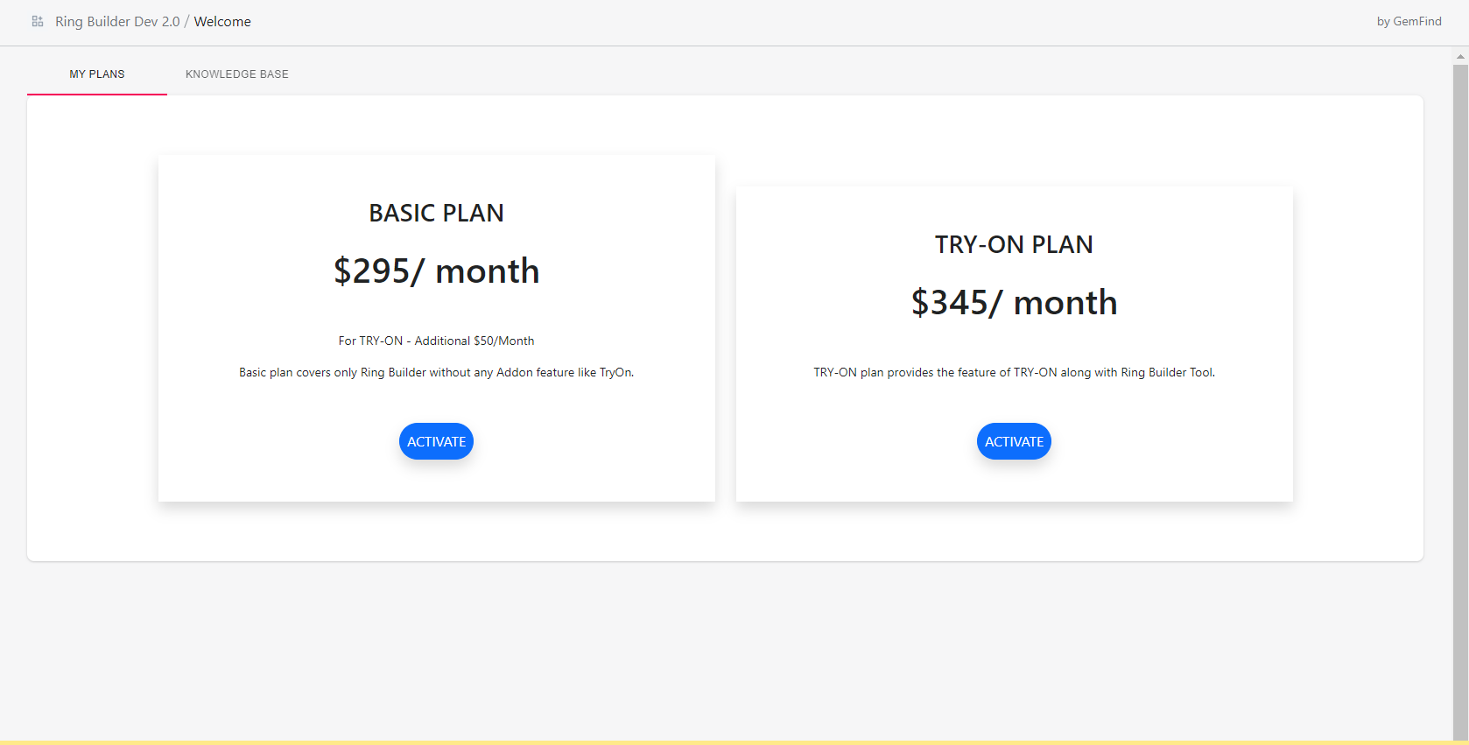

Step 2: Select your plan from the available options.

**Basic Plan:** This is the basic plan of the application where you will get all the standard features excluding Try-On.

**TRY-ON Plan:** In this plan you will get the basic plan features of the application including the Try-On feature. This feature allows the end-consumer to review the respective jewelry product on their own using Augmented Reality with any desktop/mobile device that has a front-facing camera.

Step 3: Registration Form Submission

After selection of a suitable plan and activation, you will see the customer registration form. Filling out this form will help us to collect the required information to create an account for you within our JewelCloud Platform. Once you have filled out the form with your information and saved, you will receive an email notification confirmation. Once your account has been setup, a member of our Support Team will reach out to you to provide you with your JewelCloud account credentials, and Account# or DealerID.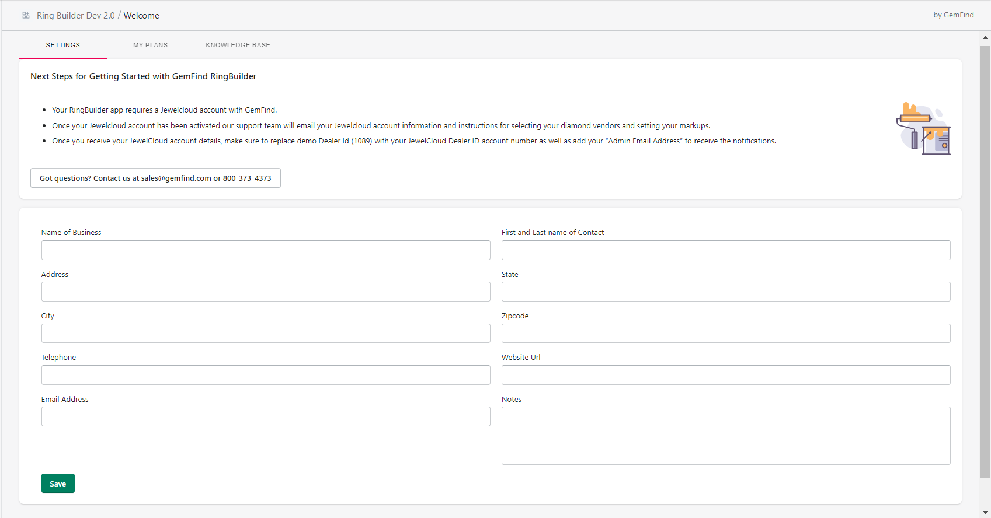

Step 4: Settings Tab – The Settings section allows you to choose from the available options -

1.JewelCloud API (JC Api) – This option will provide you with Engagement Ring Settings inventory from our JewelCloud Platform via our API.

2.Import – This option will provide the facility to import the engagement ring settings in bulk with the help of a CSV file format. In addition, you can also add your products manually.

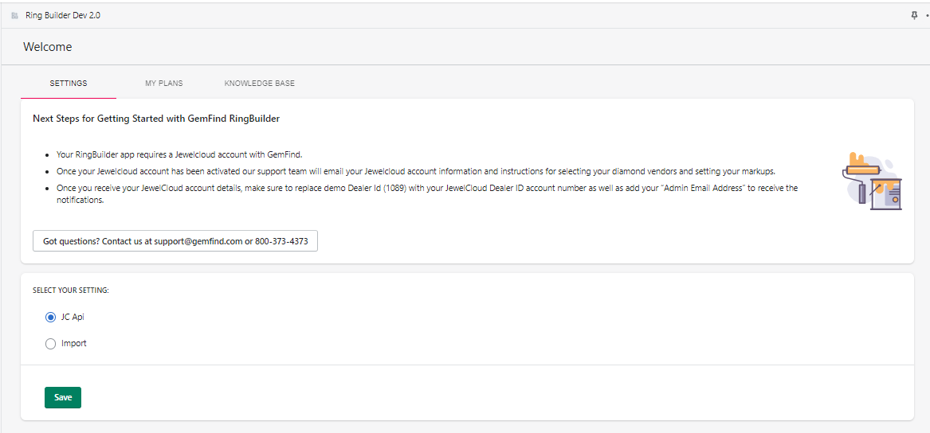

When you select Import option and save, an automatic collection is created inside the store with the name “RingBuilder” to collect and display all your ring settings products at the front-end as follows.

Collection:

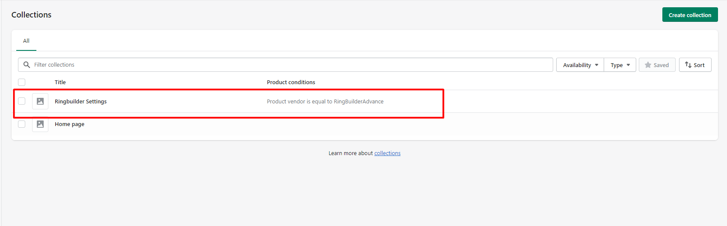

Step 5: CSV Import

Option, Bulk CSV Or Manual Product Upload will provide bulk settings upload as well as manual product addition feature along with the necessary instructions as follows -

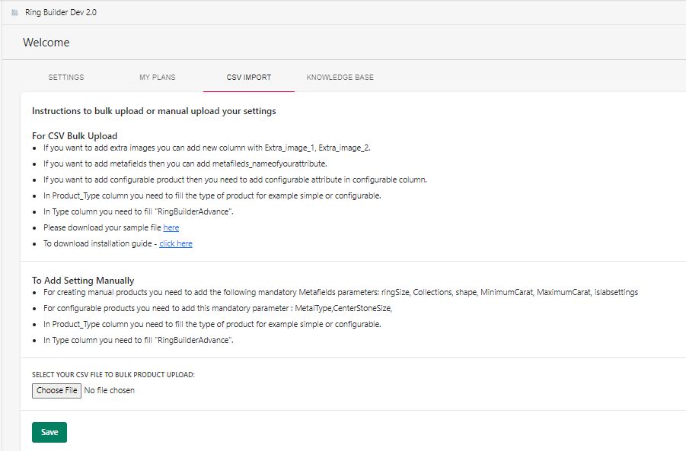

To get help further on bulk csv upload, attached is the sample file to provide all possible guidelines required during this process.

Also, another link will provide the download option for installation guide.

For creating manual product, you need to add the following mandatory Metafields parameters:

ringSize, Collections, shape, MinimumCarat, MaximumCarat, islabsettings

For configurable products you need to add these mandatory configurable product attributes:

MetalType, CenterStoneSize

Step 6: Settings and Configuration

Once you have successfully submitted the form from Step 3, you will get redirected to the general settings page. This is where you can configure the application with multiple options at the front end. By default the application is automatically configured with Demo Dealer ID Account (1089), so that you are able to see the default demo data display. Once you receive your JewelCloud account information from the GemFind Support Team, you will need to replace the Demo Dealer ID (1089) with your Account # or Dealer ID as well as configure your Admin Email Address in order to receive email notifications from the application.

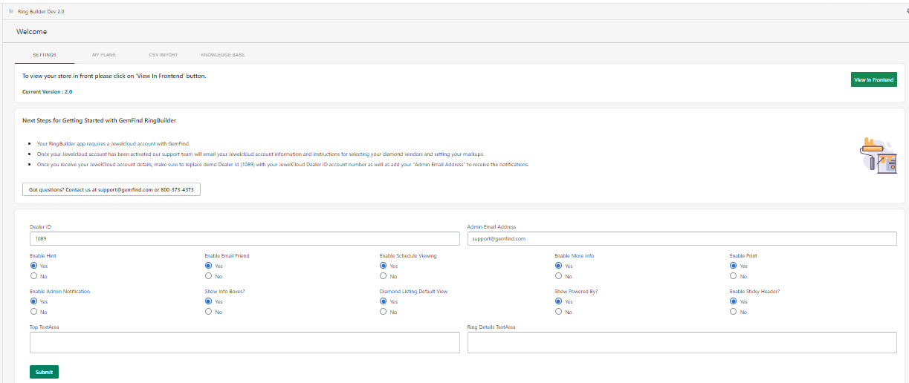

Step 7: Inside the configuration settings, there are two text area sections, Top TextArea & Ring Details TextArea respectively. Following are the screenshots describing the exact location of the contents when you are utilizing them.

Top TextArea -

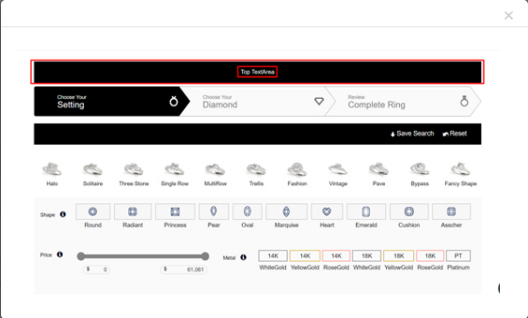

Ring Details TextArea -