User manual help

1. Login to the System

First open site and click on login link

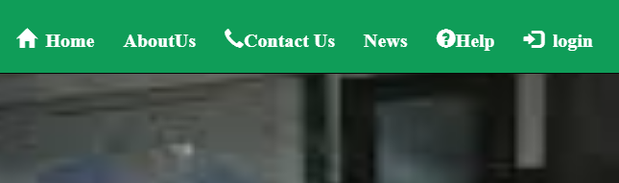

After login form pop up fill the form correctly if you have already created password and username you need sign up link

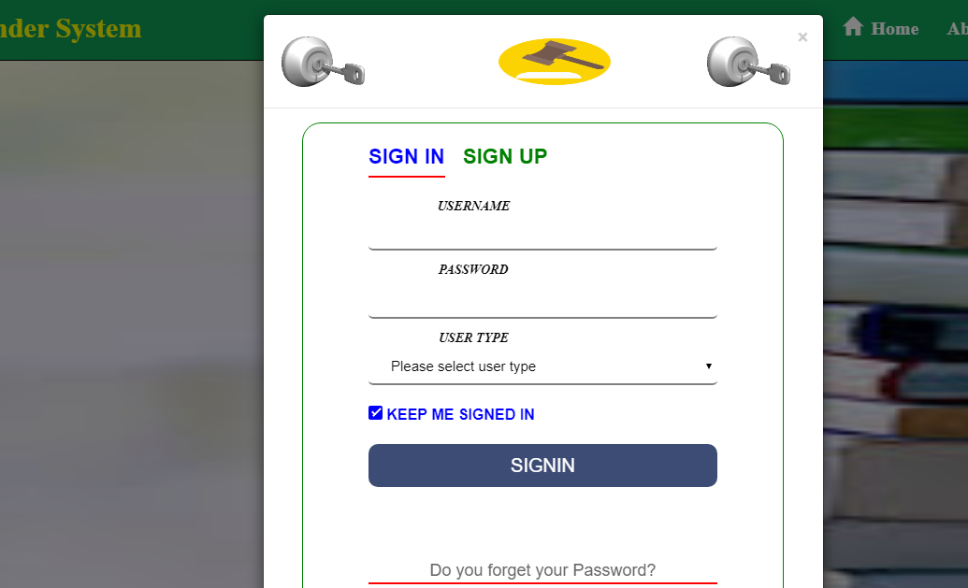

Then click signin button

Enter the password here

Select user type here

Enter username here

* **create account**

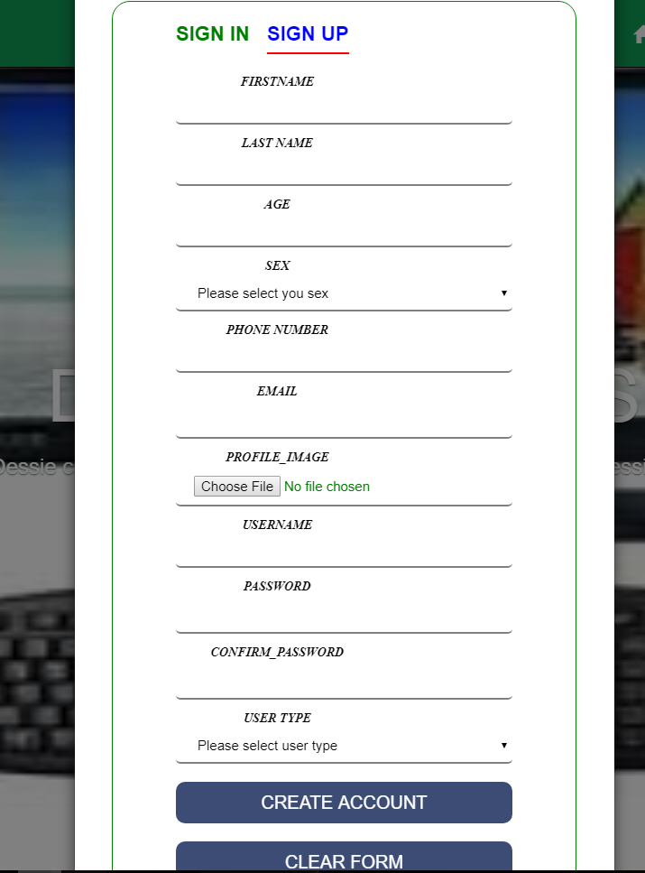

Input profile image

Enter mobile number

Enter last name

Select sex

Enter ageirst name

Enter first name

Enter email

Enter username

Enter password

Confirm password

Select user type

Then click ‘create account‘ button

* **send request**

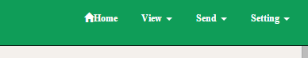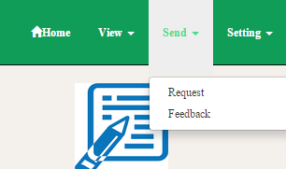

Click send button

Click request

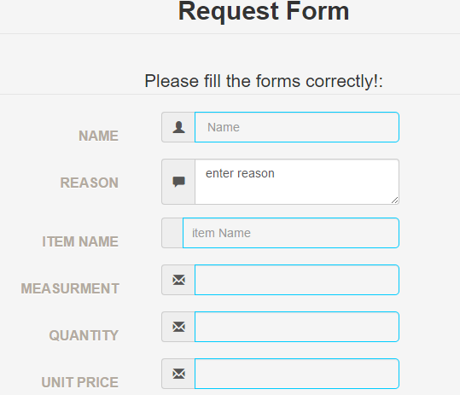

Enter unit price

Enter quantity

Enter item name

Enter measurement

Enter full reason

Enter full name

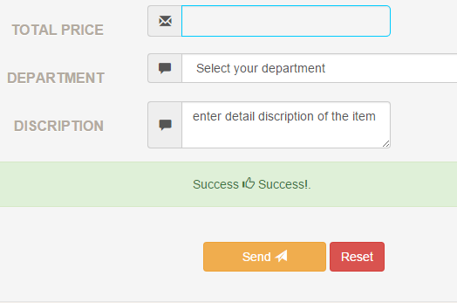

Enter department

Enter total price

Enter full description of the item

Then click send button

* Register suppliers

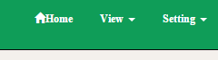 then 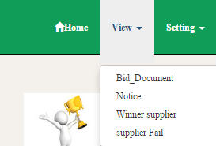

Click view button

Click bid document

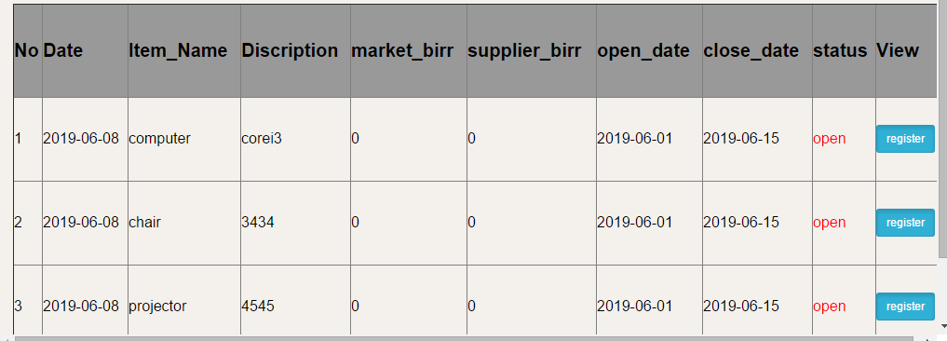

Click register button

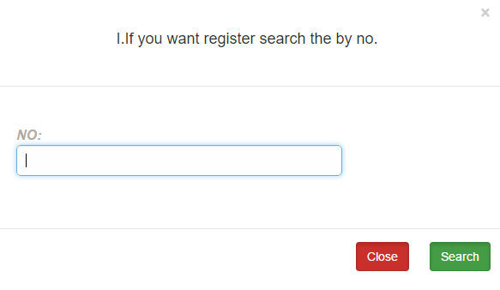

Click search button

Enter number

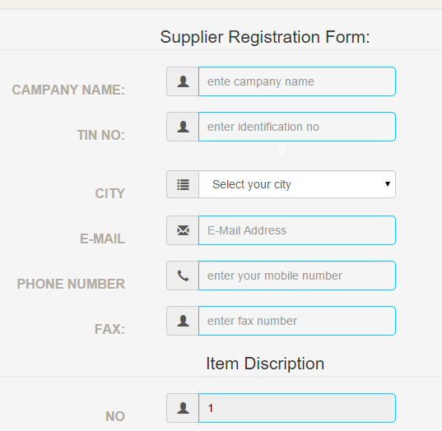

Enter fax number

Enter email

Enter identification number

Enter company name

Enter mobile number

Select city

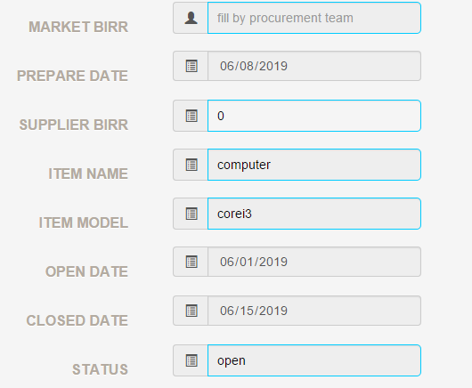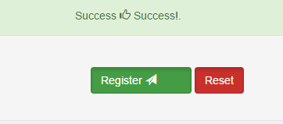

Click register button

Input price