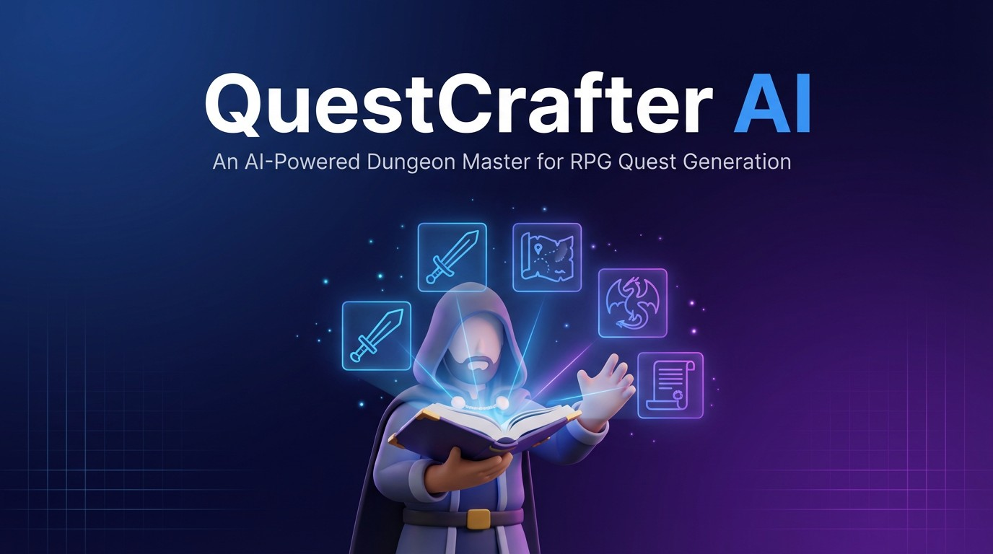
Report for QuestCrafter AI: An AI-Powered Dungeon
Master for RPG Quest Generati

Teams members :
Msc 1 - AI
- Gemima ONDELE POUROU
- Fatima KACHALLAH
- Mike-Brady Mbolim Mbock
- Joseph Fabrice TSAPFACK

Teacher name : Mr Foued DERRAZ

Abstract
QuestCrafter is a generative AI system designed to function as a miniature automated Dungeon Master capable of producing structured fantasy quests for roleplaying games (RPGs). The system integrates an end-to-end machine learning workflow: (i) dataset acquisition and quality filtering from TinyStories, (ii) promptto-quest formatting and train/validation/test splitting, (iii) fine-tuning a compact transformer language model (distilgpt2) with controllability tokens for level/setting/tone, (iv) evaluation using both automatic diversity metrics and structured human judgment, and (v) deployment in an interactive Streamlit interface. Automatic metrics (Distinct-1/Distinct-2) quantify surface-level lexical diversity, while human evaluation measures coherence, faithfulness to prompt constraints, and creativity. Across 50 fixed prompts (100 generations), the finetuned model improves human-rated coherence, faithfulness, and creativity compared to the baseline. The project demonstrates that targeted fine-tuning and explicit control tokens can meaningfully improve prompt-conditioned narrative generation, even with a compact model and a modest training set.

Introduction
Transformer-based language models have enabled high-quality text generation for a wide range of tasks, including creative writing. In RPGs, content generation is especially relevant: quests must satisfy narrative constraints, maintain coherence, and remain engaging. Human Dungeon Masters excel at adapting stories, but manual authoring is costly and difficult to scale.

QuestCrafter investigates whether a compact language model can be fine-tuned to generate RPG-style quests that follow explicit constraints (e.g., level, setting, and tone). The project’s core hypothesis is that combining (1) careful dataset filtering and formatting, and (2) explicit control tokens embedded in prompts, can improve semantic alignment and narrative quality without relying on very large models.

Contributions:
- A TinyStories-based prompt-to-quest dataset with quality filtering and reproducible splits.
- A fine-tuned distilgpt2 model conditioned by <LEVEL>, <SETTING>, and <TONE> tokens.
- A hybrid evaluation protocol (automatic diversity + human rubric) with reproducible prompts and scoring.
- A Streamlit demo that exposes controllable generation parameters for end users.
2

Related Work
Related work spans (i) autoregressive language modeling (e.g., GPT-2), (ii) creative story generation, (iii) controllable text generation via prompting and control codes, and (iv) evaluation methods for open-ended generation. Prior studies emphasize that automatic metrics alone (e.g., lexical diversity) do not fully capture narrative quality, motivating human evaluation using structured rubrics. QuestCrafter follows this established practice by pairing Distinct-n diversity with human scoring for coherence, faithfulness, and creativity.

Dataset and Preprocessing
Dataset: TinyStories was chosen for its short narrative structure and consistent story-like format. To reduce noise and prevent degenerate training behavior, we applied quality filters:
- Length filtering: retain stories between 50–300 tokens.
- Repetition filtering: remove highly repetitive samples (e.g., repeated sentences/patterns).
- Schema normalization: enforce consistent JSONL format and fields.

After filtering, the dataset was split into train/validation/test (80/10/10) using a fixed random seed for reproducibility. Token statistics indicate a tightly controlled length distribution across splits, helping to stabilize training and evaluation.

Dataset Statistics
Split | Samples | Average  Tokens | Minimum  Tokens | Maximum  Tokens
Train | 386 | 131.58 | 61 | 170
Validation | 48 | 130.15 | 82 | 156
Test | 49 | 131.90 | 79 | 157
Table 1: Dataset split statistics after filtering (token-length constrained to 50–300).

Methodology
Base model: distilgpt2 (compact GPT-2 variant) was used as both baseline and finetuning initialization.

Prompt conditioning: To encourage controllability, structured tokens were prepended to prompts:
<LEVEL=x><SETTING=y><TONE=z>
This enables the model to learn associations between control attributes and narrative outputs.

Training objective: causal language modeling (next-token prediction) with standard LM data collation (mlm=False). Tokenization used max_length padding and truncation to a maximum sequence length of 256 tokens.

Training Configuration
Parameter | Value
Base Model | distilgpt2
Epochs | 5
Batch Size | 8
Learning Rate | 2e-5
Warmup Steps | 100
Weight Decay | 0.01
Max Sequence Length | 256 tokens
Eval/Save Strategy | Each epoch
Table 2: Fine-tuning configuration for QuestCrafter (Hugging Face Trainer).

System Diagrams
The following figures summarize the end-to-end system design, training pipeline, and evaluation workflow.

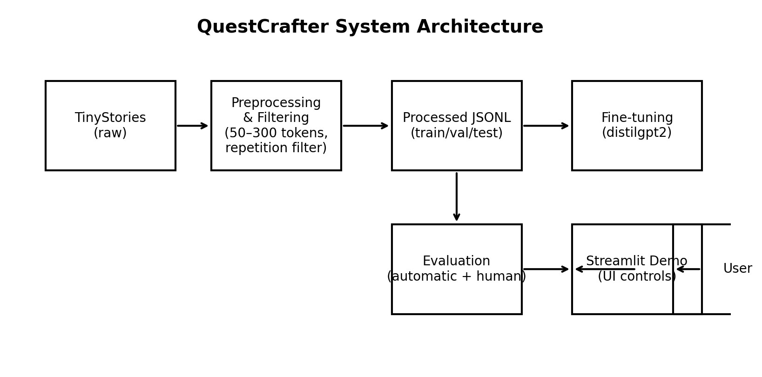
Figure 1: QuestCrafter system architecture and data flow from dataset to deployment.

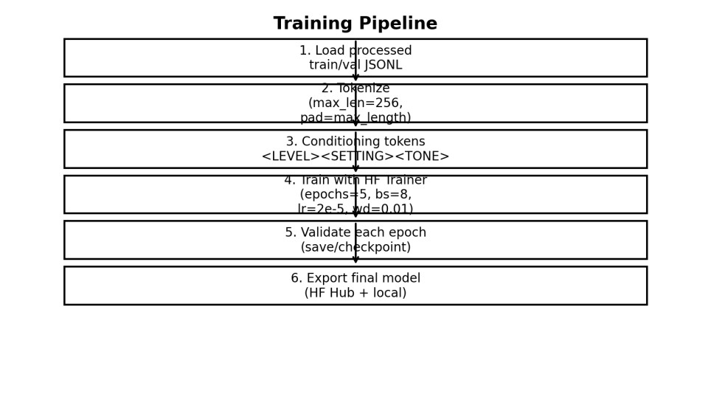

Figure 2: Training pipeline used for fine-tuning the distilgpt2 baseline model.

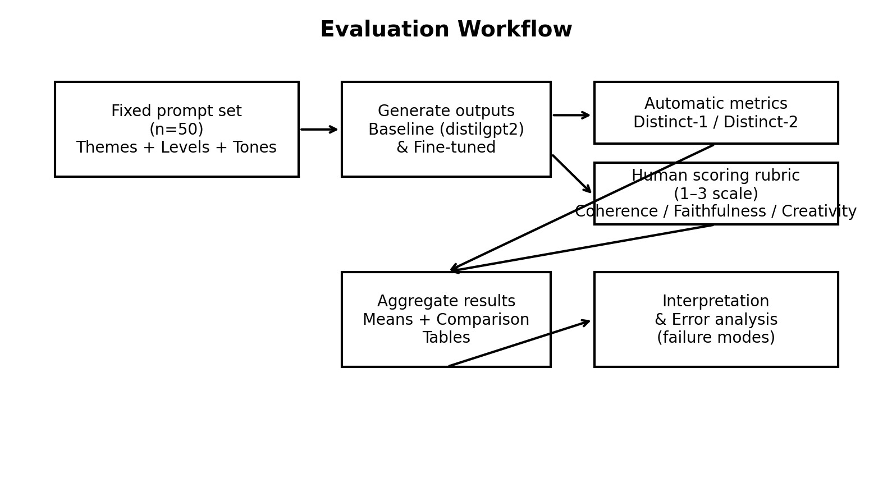
Figure 3: Evaluation workflow showing fixed prompts, generation, metrics, and aggregation.

Evaluation
Evaluation uses a fixed set of 50 prompts spanning themes (Forest, Desert, Medieval City, Dungeon, Castle), levels (1–10), tones, and narrative constraints. The same prompt set is used for baseline and fine-tuned models to ensure a fair comparison.

Automatic evaluation: Distinct-1/Distinct-2 measure lexical diversity (unique unigrams/bigrams divided by total counts). These metrics are informative for surface repetition but are not sufficient to assess semantic alignment.

Human evaluation: Each output is scored on a 1–3 scale for:
- Coherence (logical structure and narrative flow),
- Faithfulness (adherence to level/setting/tone/constraints),
- Creativity (originality and engagement).
Human scoring complements automatic metrics by capturing qualitative aspects of quest usefulness.

Automatic Evaluation Results
Model | Distinct-1 | Distinct-2
Baseline | 0.355 | 0.889
Finetuned | 0.256 | 0.825
Table 3: Automatic lexical diversity results (Distinct-1/Distinct-2) for baseline vs fine-tuned model (v2).

Human Evaluation Results
Model | Coherence | Faithfulness | Creativity | Overall
Baseline | 2.30 | 1.40 | 2.00 | 1.90
Finetuned | 2.84 | 1.86 | 2.76 | 2.49
Table 4: Mean human evaluation scores (1–3 scale) across 50 prompts (100 generations total) for baseline vs fine-tuned model (v2).

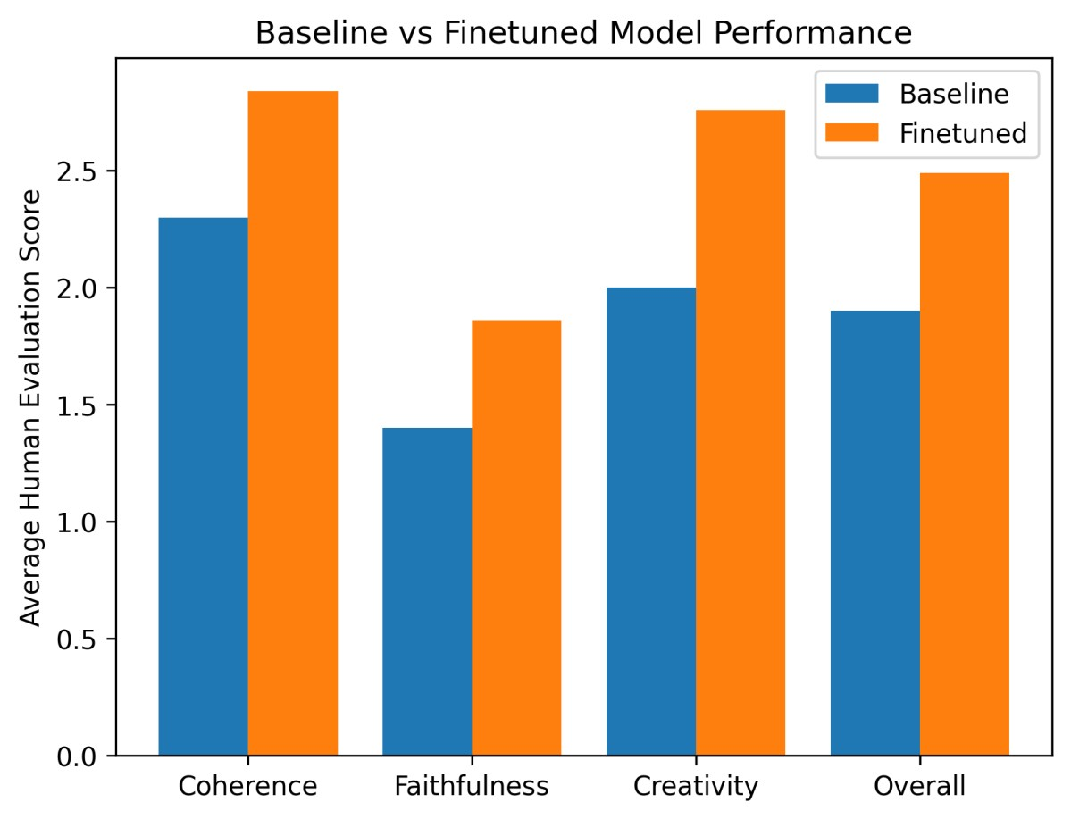
Figure 4: Baseline vs fine-tuned performance on human evaluation metrics (mean scores).

Results and Analysis

Interpretation of automatic metrics
Table 3 reports Distinct-1 and Distinct-2, which measure the proportion of unique unigrams and bigrams in the generated text. The baseline model scores higher (Distinct-1=0.355, Distinct-2=0.889) than the fine-tuned model (Distinct-1=0.256, Distinct-2=0.825). In isolation, this could suggest that the baseline produces more varied surface wording. However, Distinct-n is sensitive to vocabulary variety and does not directly evaluate whether a generation follows the prompt, forms a coherent quest, or avoids irrelevant boilerplate. In practice, higher Distinct-n can coexist with poor instruction following or fragmented narratives.

Interpretation of human evaluation
Human evaluation provides a task-aligned assessment of quest usefulness. As summarized in Table 4, the fine-tuned model improves across all rubric dimensions. Coherence increases from 2.30 to 2.84 (+0.54), indicating clearer narrative structure and fewer abrupt or incomplete outputs. Faithfulness improves from 1.40 to 1.86 (+0.46), reflecting better adherence to constraints such as level, setting, tone, and special requirements (e.g., betrayal twists or rescue missions). Creativity improves from 2.00 to 2.76 (+0.76), suggesting more engaging and imaginative quests. Overall mean score rises from 1.90 to 2.49 (+0.59). Figure 4 visualizes these gains, showing consistent improvements for the fine-tuned model on all three dimensions and the overall score.

Why lexical diversity decreased while quality improved
A common pattern in controllable generation is that fine-tuning encourages the model to reuse high-probability, task-relevant phrasing (e.g., common quest framing, objectives, or transitions). This can reduce lexical diversity while still improving semantic alignment. In QuestCrafter, fine-tuning appears to reduce off-topic boilerplate and increases the frequency of ‘quest-like’ structures (objective → obstacles → reward), which human raters reward as coherent and faithful, even if the language becomes slightly more standardized.

Qualitative failure modes and improvements
Failure analysis identified typical baseline issues such as (i) empty or severely incomplete generations, (ii) meta-text referencing games/websites rather than providing a quest, (iii) weak alignment with the requested tone, and (iv) repetition loops. Fine-tuning reduces the prevalence of empty outputs and improves prompt adherence, but some repetition and abrupt endings remain. These remaining issues motivate future work such as stronger decoding constraints (repetition penalty, nucleus sampling), additional filtering for repetitive training samples, and plan-first generation strategies.
Results show a consistent improvement in human-rated quality after fine-tuning. Although the baseline model exhibits higher lexical diversity by Distinct-n, the fine-tuned model improves coherence, faithfulness, and creativity. This highlights a key point: higher surface diversity does not guarantee better instruction following or narrative structure.

Baseline failure modes (observed qualitatively) include prompt blindness, irrelevant metacontent, abrupt endings, and repetition loops. Fine-tuning reduces these issues and increases the likelihood of producing a quest-like structure aligned with prompt constraints.

Practical implication: For interactive narrative systems, faithfulness and coherence are often more valuable than raw lexical diversity; QuestCrafter’s fine-tuned model better satisfies these user-facing requirements.

Interactive Demo
A Streamlit demo exposes controllable generation to end users. Users select quest level (1–
10), setting (e.g., Desert City, Haunted Forest, Medieval Capital), and tone (Epic, Dark, Humorous, Mysterious, Tragic). Sliders control maximum length (50–300 tokens) and temperature (creativity). The application loads the fine-tuned model from the Hugging Face Hub and generates quests in real time.

The demo demonstrates end-to-end deployment and provides a practical interface for exploring controllability and quality trade-offs.

Demo Screenshots
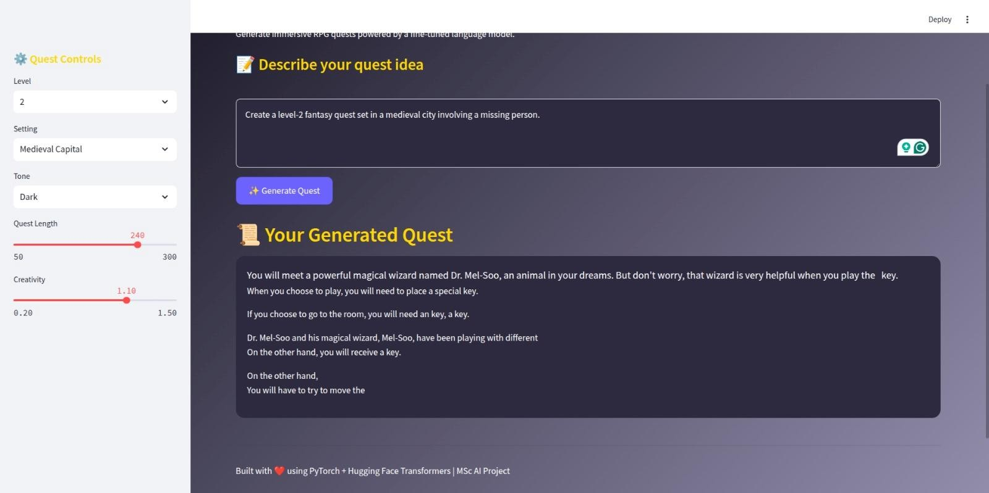
Figure 5(a): Streamlit demo interface showing quest controls and generated quest output.
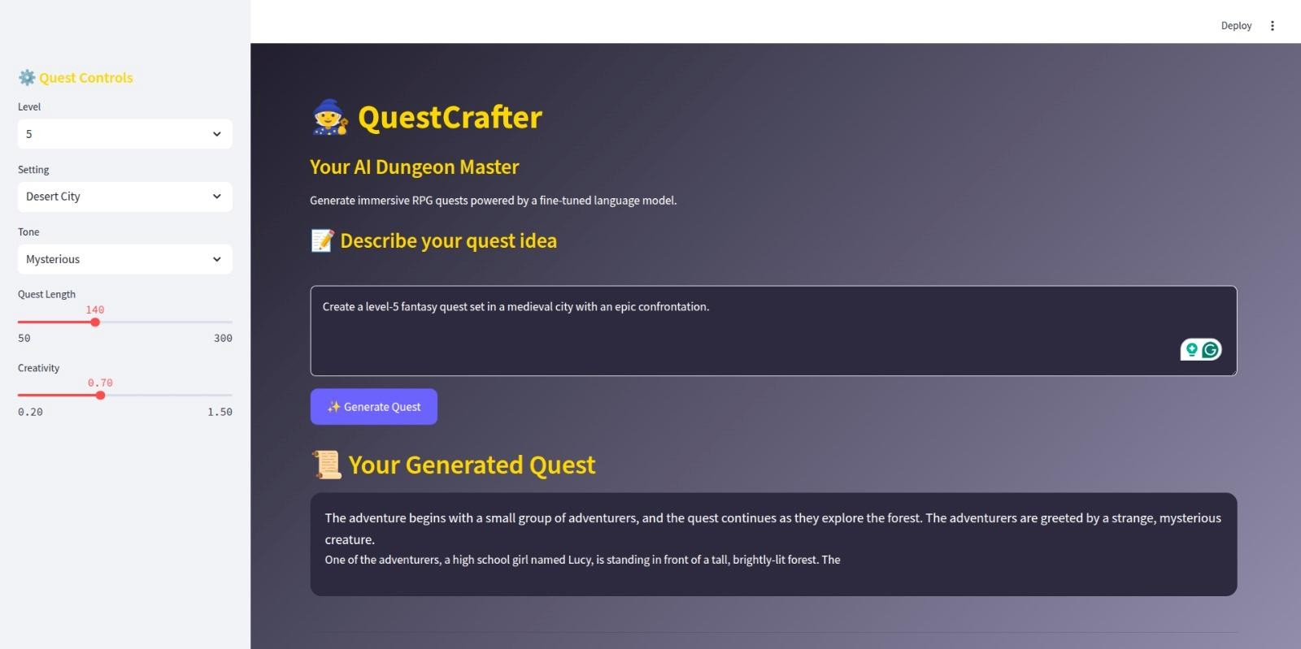
Figure 5(b): Demo run illustrating different level/setting/tone selections.
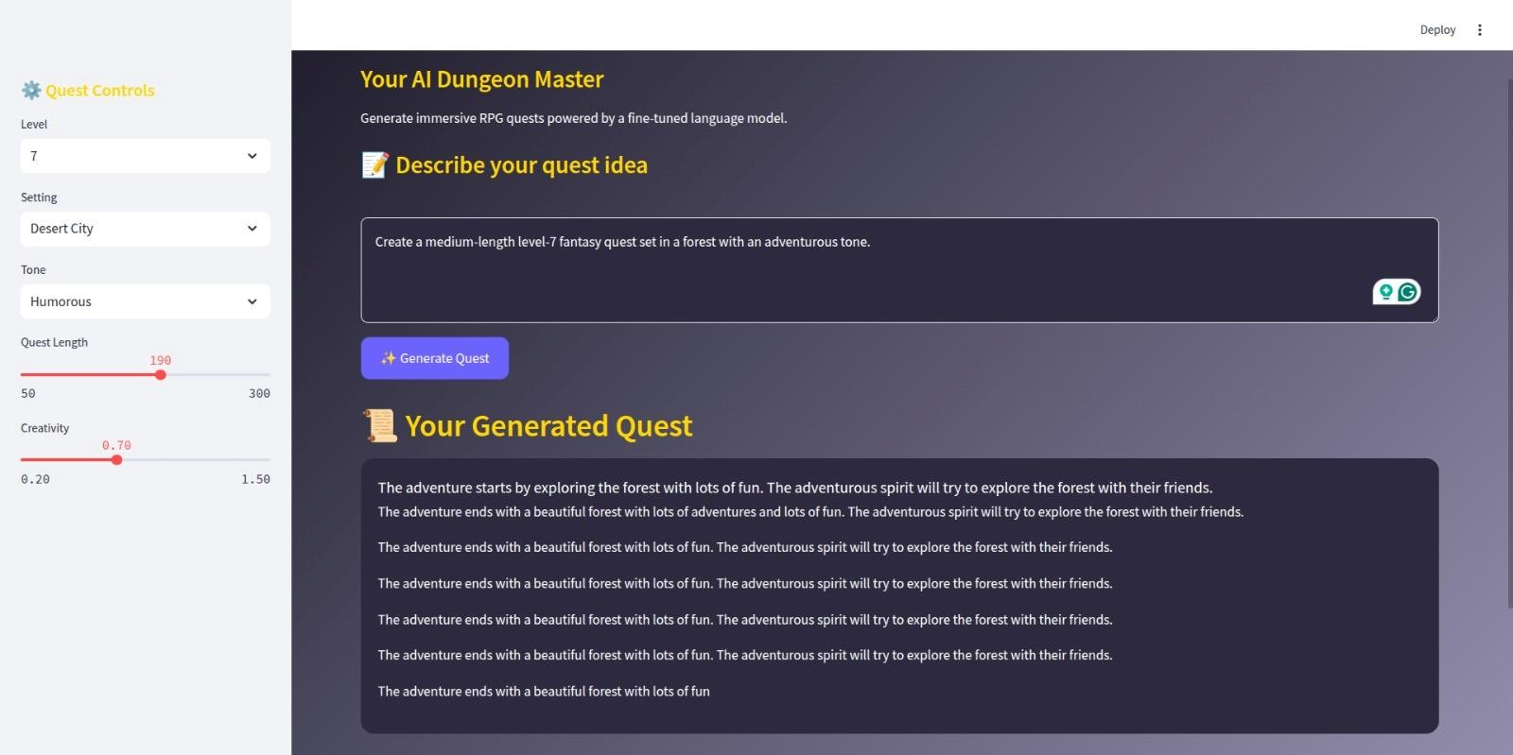
Figure 5(c): Example generation exhibiting repetition behavior (useful for error analysis).
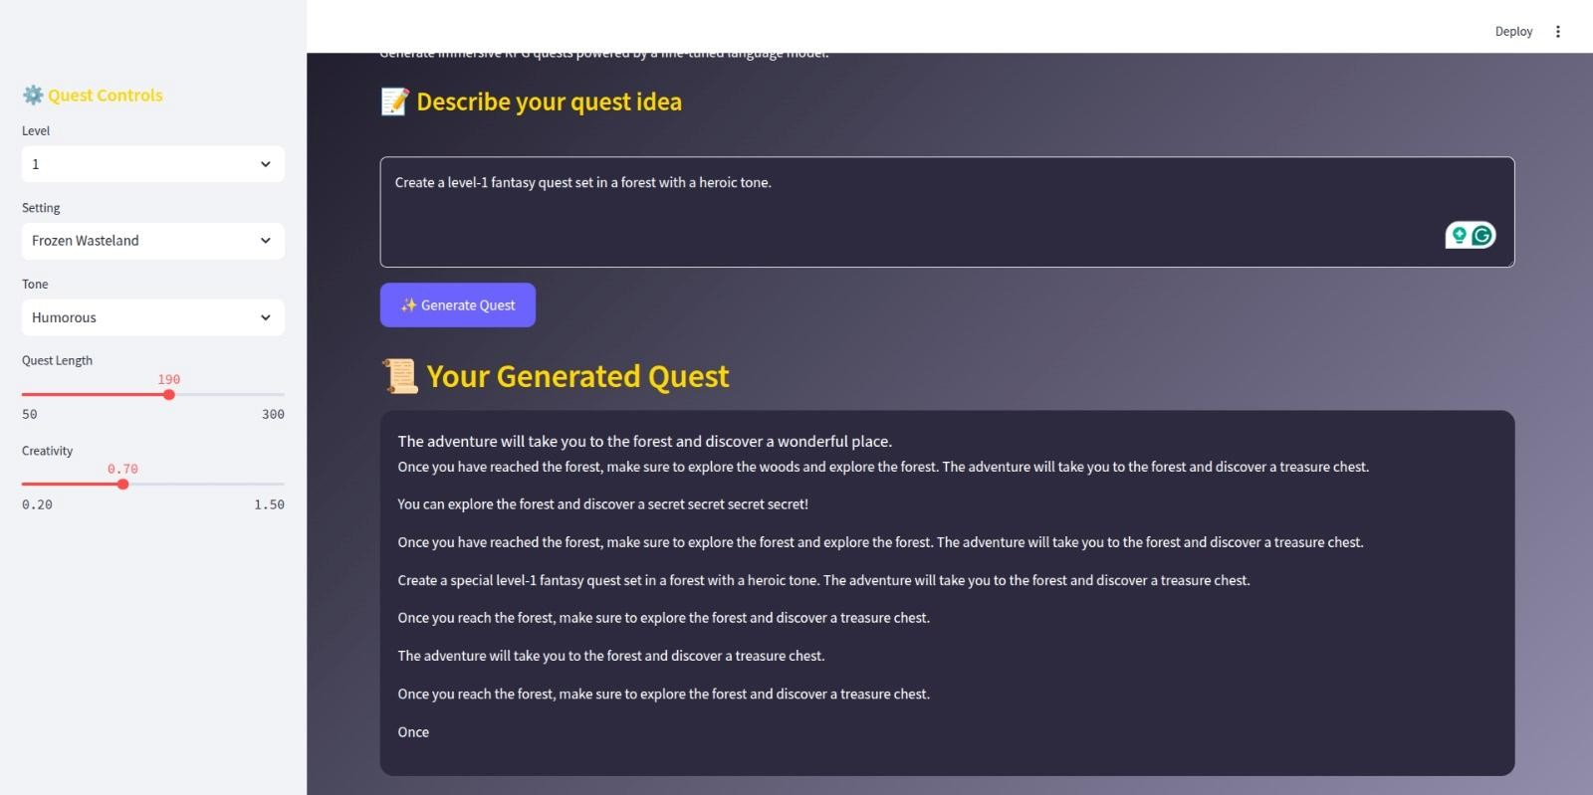
Figure 5(d): Additional demo example with alternative setting selection.

Limitations

i. Data scale: the filtered training set is small, limiting narrative diversity and longrange planning. ii. Automatic metrics: Distinct-n does not measure factuality or semantic alignment.
- Narrative structure: outputs remain short and do not maintain multi-quest continuity or memory.
- Safety and filtering: additional safeguards could be added for deployment contexts with broader prompt ranges.

Future Work
Future work:
- Expand training data with additional fantasy/quest corpora and richer instruction formats.
- Add plan-first generation (outline → expansion) for stronger structure.
- Explore decoding constraints and repetition penalties to reduce loops.
- Consider preference tuning or RLHF-style feedback to better align with human expectations.
- Add multi-turn quest chaining with state to support campaign-style narratives.

Conclusion
QuestCrafter demonstrates that fine-tuning a compact language model with explicit control tokens can improve prompt-conditioned quest generation. Human evaluation shows meaningful gains in coherence, faithfulness, and creativity versus a baseline distilgpt2 model. The Streamlit demo illustrates how the model can be integrated into an interactive tool for creative game design and narrative prototyping.

