

Bank Direct Marketing Campaign Analytics

**Bank Marketing Analytics**

|  |  |
| --- | --- |
| **Written By** | Akhilesh Buxi Pattnaik,  Abhijeet Sethy |
| **Document Version** | 1.0 |
| **Last Revised Date** | **12-01-2023** |



**DOCUMENT CONTROL**

**Change Record:**

|  |  |  |
| --- | --- | --- |
| **VERSION** | **DATE** | **COMMENTS** |
| 0.1 | 23- Dec - 2022 | Introduction and architecture defined |
| 0.2 | 24 - Dec - 2022 | Architecture & Architecture description appended and updated. |
| 0.3 | 02 - Jan - 2022 | Data cleaning & Categorization : Using Microsoft SQL server and MS Excel 2016 |
| 0.4 | 11 – Jan - 2023 | Data visualization using Power BI |



**Contents**

Introduction 3

1. Architecture 5

2. Data Description 7

4. Data Visualization 10



# Introduction

The information relates to telephone-based direct marketing activities of a Portuguese banking institution. The classification's objective is to foretell the client's intent to sign up for a term deposit. Data from a Portuguese banking institution's direct marketing efforts is being used. On phone conversations, the marketing campaigns were based.

## Scope

To evaluate whether or not the product (a bank term deposit) will be subscribed by having many interactions with the same consumer.



## Architecture

The following is a picture of the project's whole architecture.

X

**Excel**

Microsoft SQL Server



**Power BI Desktop**

* The full dataset was initially converted from csv to excel format using Pandas library in Python with the help of Jupyter notebook. The data was then cleaned in Excel based on univariate analysis for each numeric column.
* For a better understanding of the dataset, several outliers were eliminated.
* Once a SQL server was set up, a bank database was created. The dataset was then uploaded as a csv file.
* After that, the dataset was connected to Power BI in Direct query mode so that any changes made to the data in SQL Server would be immediately and effortlessly visible in POWER BI.



## Data Description

* Two data files in csv format were provided; one included fewer data than the other while the other contained the entire dataset.
* At first the data set was converted to readable csv format as shown below with the help of Jupyter notebook and pandas library.

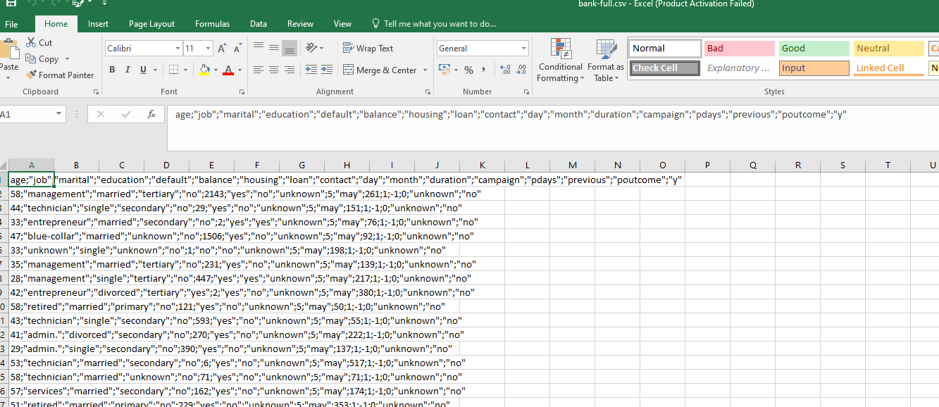

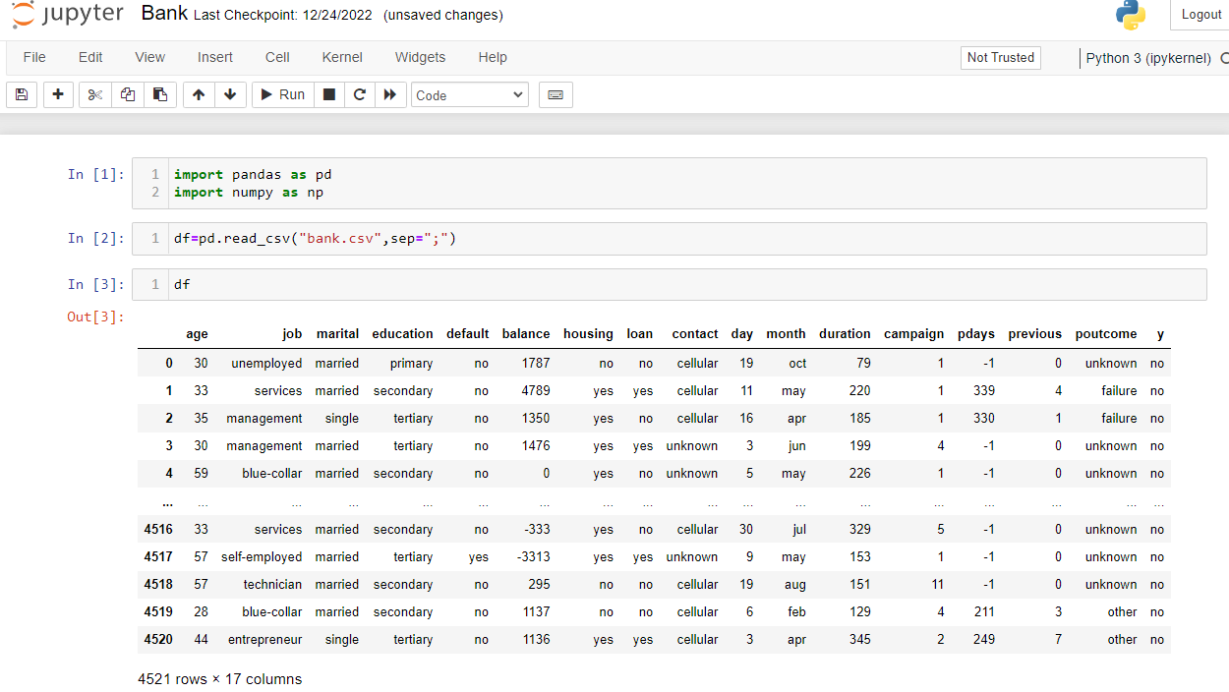

* There were initially 17 columns in the dataset. The columns include basic information like age, occupation, marital status, education, etc.The outliers are then eliminated using a Box plot analysis on several columns with the assistance of Seaborn and Matplotlib.



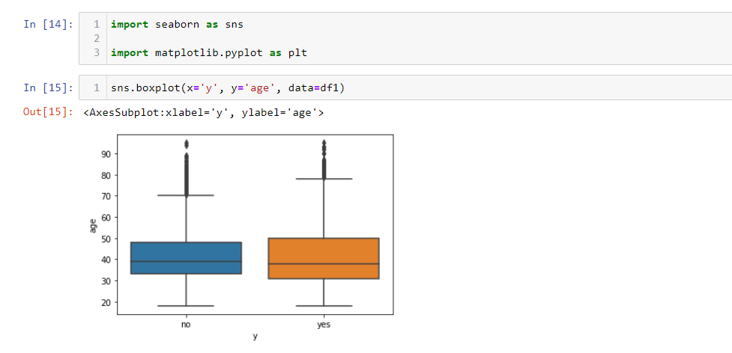

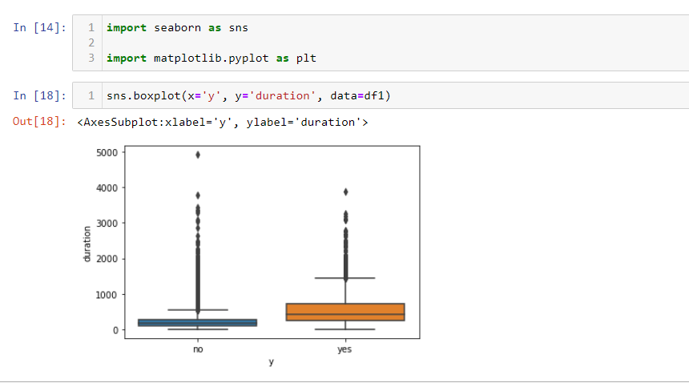

* The dataset was imported to Microsoft SQL server which was created as shown below.

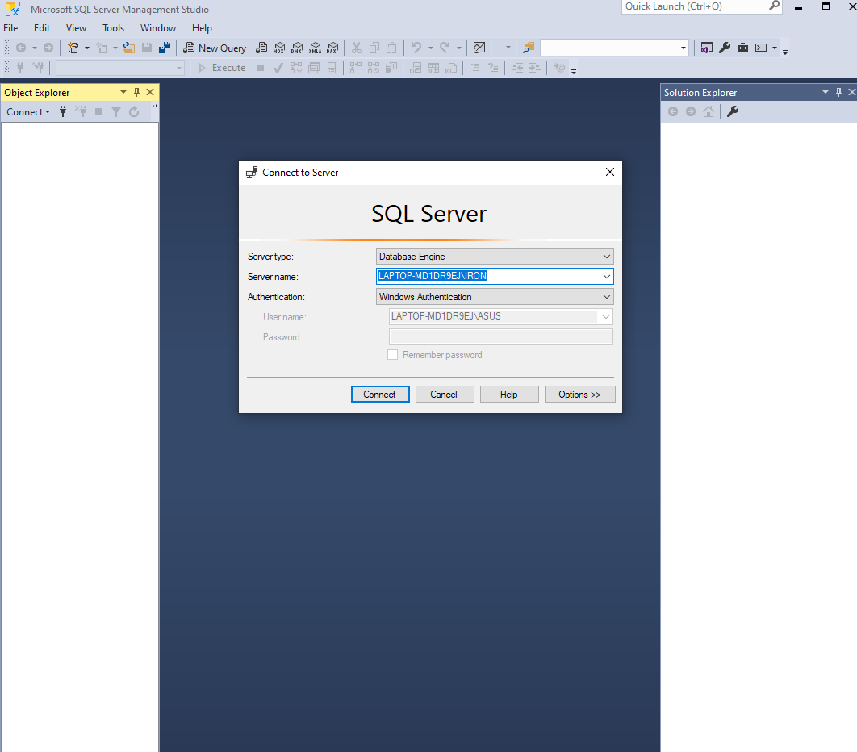

* After that the dataset was imported to the server and saved inside a database named as Bank_Marketing_Database.



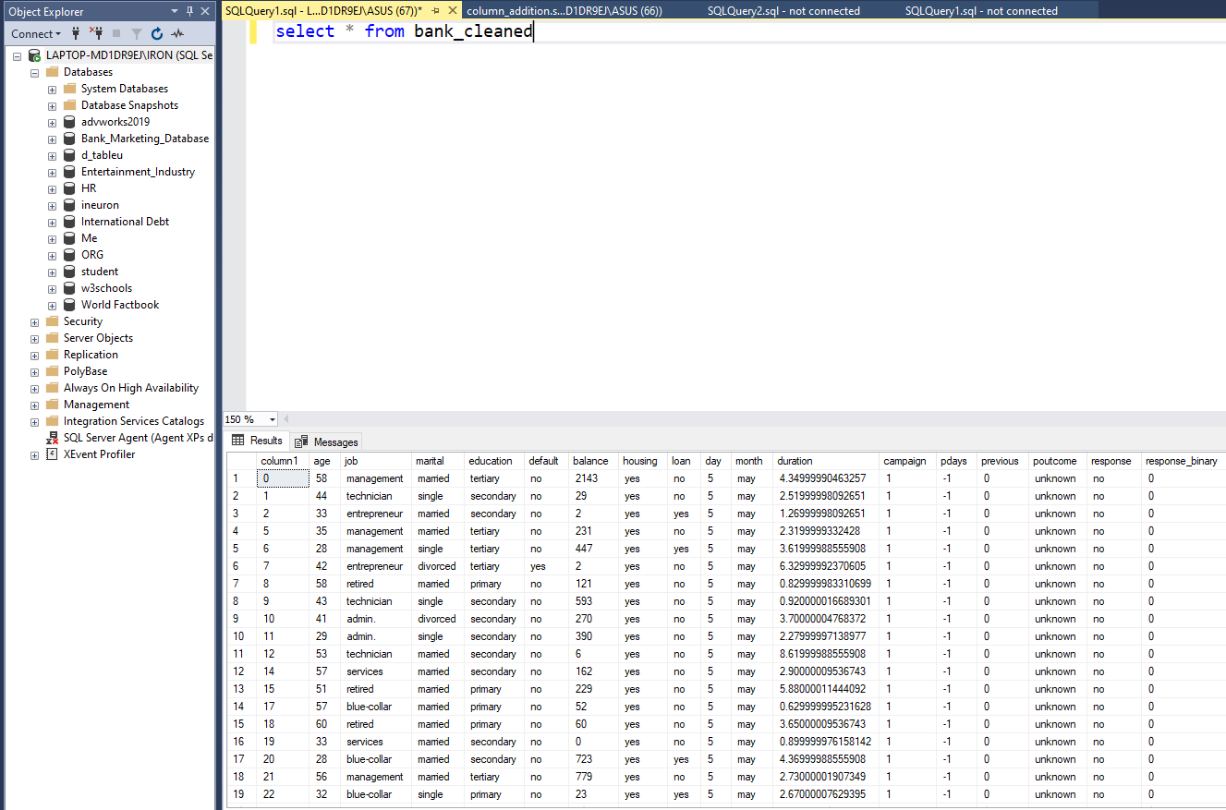

* Three more columns were added in this dataset using SQL commands for the ease of categorization i.e.

1. **Financial Category**

Here, the dataset was divided into groups based on the amount of money in each person's account.

1. --0-70 (Very poor)
2. --71-450 (poor)
3. --451-1335 (middle standard)
4. --1336-4860 (upper middle standard)
5. --4861-10000 (Rich)
6. **Age Category**

People of various age groups are separated here for easier assessment of the data.

* + - 1. 0-30 (Young)
      2. 31-50 (Middle-aged)
      3. 51 onwards (Senior Citizen)



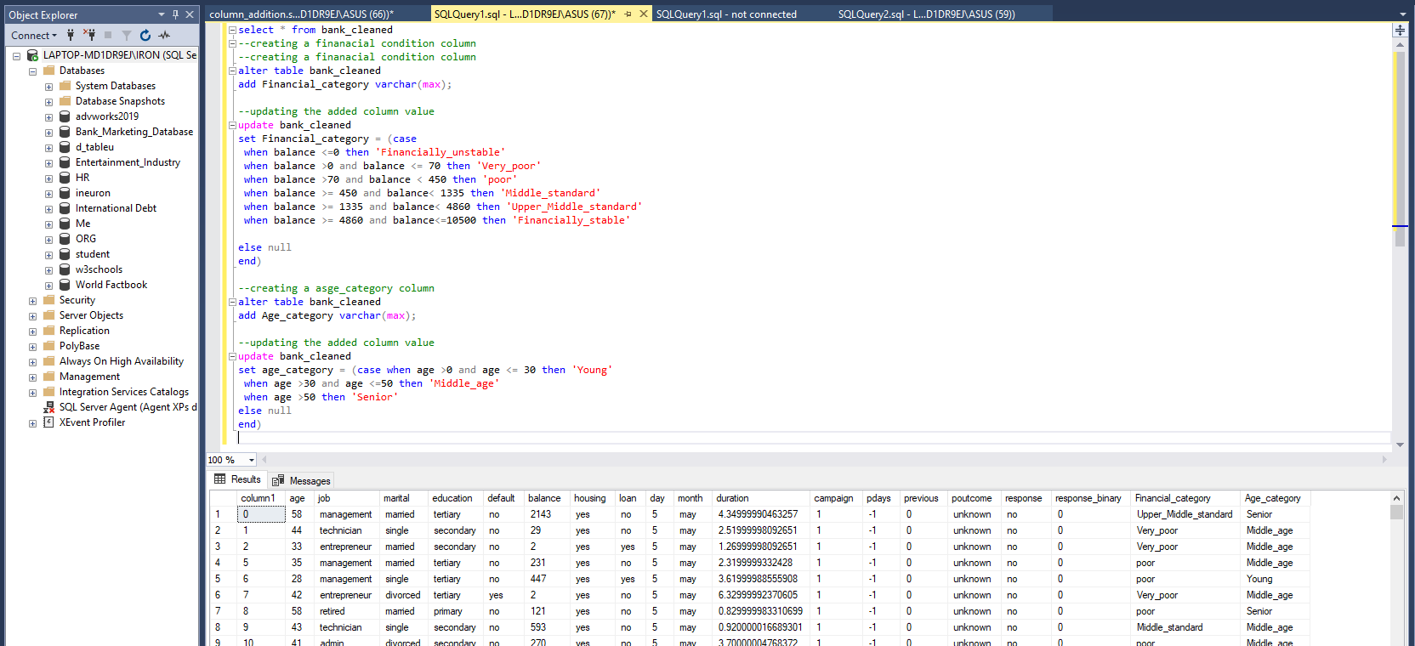

* Also, the duration column was given to us in seconds' format, therefore we divided it by 60 to convert it to minutes' format for convenience. Then the **call duration** column is further categorized as mentioned below:
  1. Call duration > 1 as ‘<=1 min’
  2. 1 < Call duration < =3 as ‘1-3 mins’
  3. 3 < Call duration < =10 as ‘3-10 mins’
  4. 10 < Call duration as ‘>10 mins’
* After some processing, the dataset looks like this:

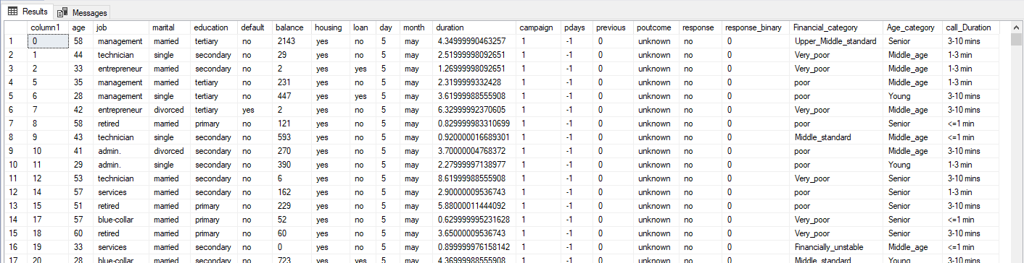



* **Age:** This column shows us the age of individual customer.
* **Job:** Here, the customer's work type is specified.
* **Martial:** Here, it is shown if the person is married or not.
* **Education:** This column contains the customer's highest level of education.
* **Default:** If the consumer has credit in default or not, this field lets us know.
* **Balance:** This column indicates the available balance on the customer's bank account.
* **Housing:** This states if the individual has a mortgage or not.
* **Loan:** Here it is stated whether the person has a personal loan or not.
* **Day and Month:** The last contact day of the week and the last contact month of the year are listed in these two columns.
* **Duration:** The latest contact's overall duration is displayed in this column in minutes.
* **Campaign:** The amount of contacts made for this customer and throughout this campaign.
* **Pdays:** The total number of days that passed by after the client was last contacted from a previous campaign.
* **Previous:** The total amount of contacts made for this client and before this campaign
* **Poutcome:** This column shows results of the preceding marketing effort
* **Response:** Whether or not the client has subscribed to the term deposit is shown by the final result in this column**.**
* **Response binary:** Here, the customer's response is transformed into binary data, where Yes denotes 1 and No denotes 0.
* **Financial category:** As stated up front, this column indicates the customer's financial situation.
* **Age category:** For convenience in categorising the consumer in the visualisation step, the age category to which they belong is indicated here.
* **Call duration:** Call duration has been categorized in 4 categories as mentioned above.

## Data Visualization

* First, a direct query approach was used to connect the SQL server dataset to PowerBI, ensuring that any future data additions would also be reflected in PowerBI.
* PowerBI's home page: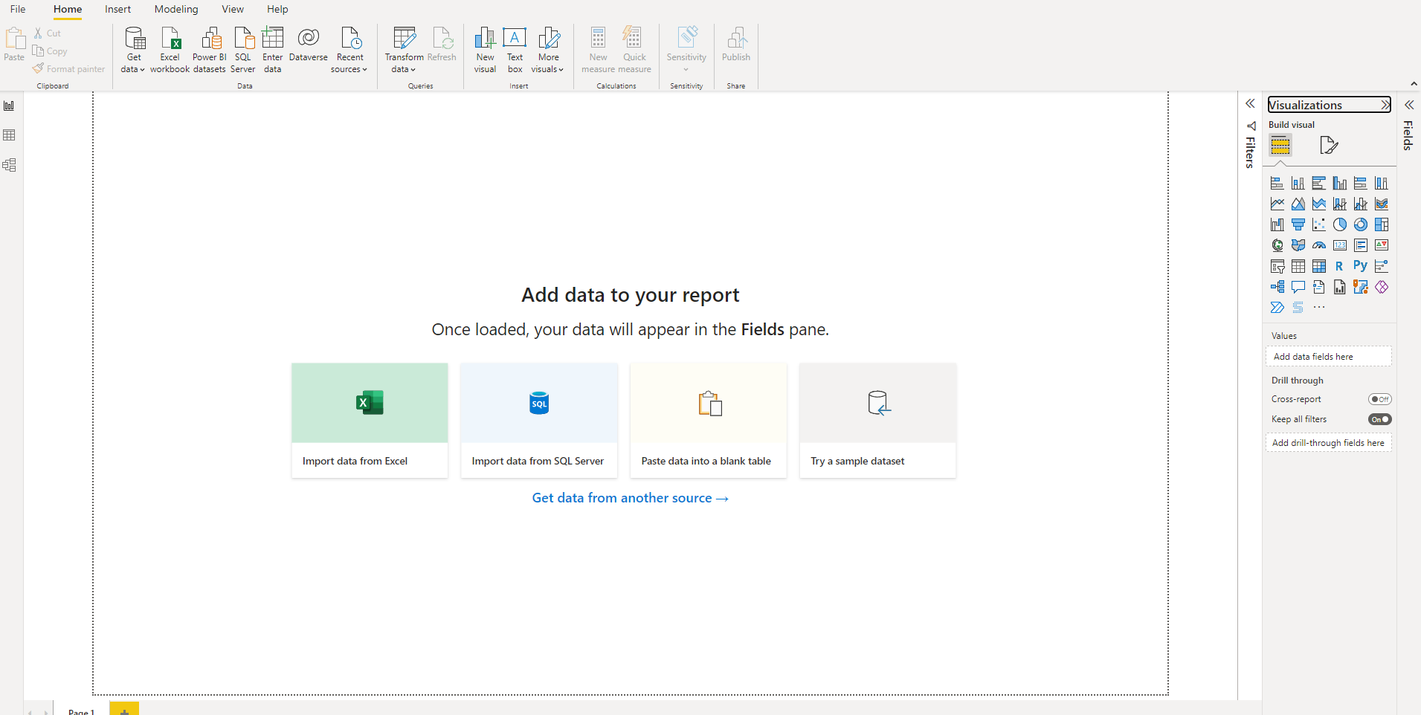
* The final report is published in Power BI service. Then the link is shared to client. Below is the document link to access the report.
* **Link:** <https://app.powerbi.com/view?r=eyJrIjoiMjJlOWVmNmEtMmU3Zi00NWM1LWE5ZmYtZTNiOGZkMTE1Mzc0IiwidCI6ImRmODY3OWNkLWE4MGUtNDVkOC05OWFjLWM4M2VkN2ZmOTVhMCJ9&pageName=ReportSection>
* Also the entire project is uploaded in Novypro.com for public use.
* Link: <https://www.novypro.com/project/abpattanaik96novyprocom>
* The report must be published in the power service following the creation of the graphs.