|  |
| --- |
| Temperature Report |
| Gemju Sherpa2810ICT Software TechnologiesJanuary 12, 2018 |

# Abstract

This document include introduction, database structure, Chinese state temperature and Australian state data and national data. This documents also presents the brief overview data analysis on world temperature.

# Introduction

This project is mainly focused on the data analysis using Python libraries and SQLite3 database. In this project there are several tasks to perform data analysis on the basis of provided sample data of temperature for different country, state and city for specific date.

For the first task, database with the tables has been created using SQLite3 to import the sample data from excel file. Second task is to query the table data using the database and export to the excel file. Third task is to use excel via python to analyze data and save it to the new sheet.

The final task for this project is to plot the analyzed data into excel file using python packages numpy and matplotlib.

## Database Structure

For this project simple database named globaltemperature.db has been created with the three table Bycity, Bycountry and Bystate.

The structure of table are as follows:

**Bycity:**

|  |  |
| --- | --- |
| Id | Primary key, Autoincrement |
| Date | date |
| Average_Temp | real |
| Avg_Temp_Uncertainty | real |
| City | varchar |
| Country | varchar |
| Latitude | varchar |
| Longitude | varchar |

**ByCountry:**

|  |  |
| --- | --- |
| Id | Primary key, Autoincrement |
| Date | date |
| Average_Temp | real |
| Avg_Temp_Uncertainty | real |
| Country | varchar |

**Bystate**:

|  |  |
| --- | --- |
| Id | Primary key, Autoincrement |
| Date | date |
| Average_Temp | real |
| Avg_Temp_Uncertainty | real |
| State | varchar |
| Country | varchar |

# **Chinese City Temperature Data**

# **Australian State and National Temperature Data**

The figure showed below is the plot of national data vs state data for Australia for each year. The figure has plotted year vs mean data for both national and state data.

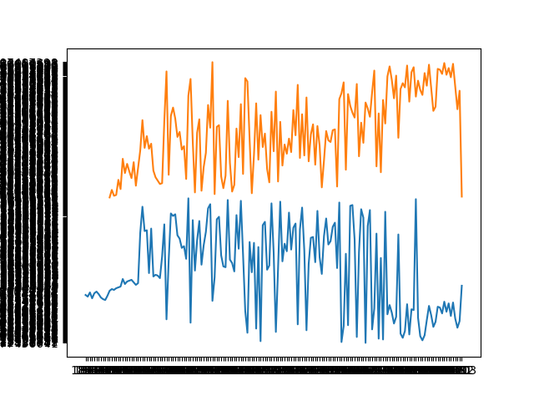

# Appendix: Unit Test Report (7810ICT Students)

Include your unit test report here.