**Mobile Platform Development – MHI326841-21-B**

**Coursework 1 for Session 2021-2022**

**Department of Computing**

**Name: Gemma Grant**

**Student Number: S2030516**

“I declare that all work submitted for this coursework is the work of alone unless stated otherwise.”

**Signed by Student: Gemma Grant Date: 24/08/2022**

Contents

GitHub Link 3

APK Link 4

Screencast-o-matic Link 4

Test Documentation 4

Documentation of Functionality and Test Reports 4

Test Cases 4

Appendices 31

Appendix 1 31

Appendix 2 31

Appendix 3 31

Appendix 4 31

Appendix 5 31

Appendix 6 31

Figures

Figure 1 – Homepage of the application displaying as expected . All cities are displayed in a list view with some details displayed. 6

Figure 2 - Homepage displaying parsed data from RSS feed. The highlighted section shows basic details for Glasgow. 10

Figure 3 - RSS feed for Glasgow. The highlighted areas in the screenshot prove that the application parses the RSS feed and uses this data in the application. 10

Figure 4 - Homepage displaying parsed data from RSS feed. The highlighted section shows basic details for London. 11

Figure 5 - RSS feed for London. The highlighted areas in the screenshot prove that the application parses the RSS feed and uses this data in the application. 11

Figure 6 - Homepage displaying parsed data from RSS feed. The highlighted section shows basic details for New York. 12

Figure 7 - RSS feed for New York. The highlighted areas in the screenshot prove that the application parses the RSS feed and uses this data in the application. 12

Figure 8 - Homepage displaying parsed data from RSS feed. The highlighted section shows basic details for Oman. 13

Figure 9 - RSS feed for Oman. The highlighted areas in the screenshot prove that the application parses the RSS feed and uses this data in the application. 13

Figure 10 - Homepage displaying parsed data from RSS feed. The highlighted section shows basic details for Mauritius. 14

Figure 11- RSS feed for Mauritius. The highlighted areas in the screenshot prove that the application parses the RSS feed and uses this data in the application. 15

Figure 12 - Homepage displaying parsed data from RSS feed. The highlighted section shows basic details for Bangladesh. 15

Figure 13 - RSS feed for Bangladesh. The highlighted areas in the screenshot prove that the application parses the RSS feed and uses this data in the application. 16

Figure 14 - Error: the application shows the default image instead of the one that matches the condition 16

Figure 15 - The code snippet that was implemented to fix imaging issue 17

Figure 16 - The new homepage loaded with the correct images 17

Figure 17 – Detailed 3-day forecast for the Glasgow GCU Campus location. 20

Figure 18 – Homepage displaying after the back arrow is clicked by user 21

Figure 19 - Detailed 3-day forecast for the London GCU Campus location 21

Figure 20 - Detailed 3-day forecast for the New York GCU Campus location 22

Figure 21- Detailed 3-day forecast for the Oman GCU Campus location 23

Figure 22- Detailed 3-day forecast for the Mauritius GCU Campus location 24

Figure 23 - Detailed 3-day forecast for the Bangladesh GCU Campus location 25

# GitHub Link

Link to repo: <https://github.com/Gemmag7/GrantGemmaMPDSecondDiet>

# APK Link

Link to apk file: <https://github.com/Gemmag7/GrantGemmaMPDSecondDiet/blob/master/Documentation/app-debug.apk>

# Screencast-o-matic Link

Link to the screencast-o-matic video: <https://github.com/Gemmag7/GrantGemmaMPDSecondDiet/blob/master/Documentation/Grant_Gemma_s2030516_Video.mp4>

# Test Documentation

## Documentation of Functionality and Test Reports

|  |  |
| --- | --- |
| **Traffic Scotland App Testing Schedule:** | |
| **LIST OF TEST CASES** | |
| **TEST NO** | **PURPOSE OF TEST** |
| 1 | Testing to ensure the application runs |
| 2 | Testing that the data in the link is the data that is displayed in the various views provided by the app |
| 3 | Testing that the user can navigate around the app and select the required functionality as identified in the specification |
| 4 | Testing that the functionality required of the features asked for in the specification have been tested. |

## Test Cases

|  |  |  |  |  |  |  |
| --- | --- | --- | --- | --- | --- | --- |
| **ID** | **Name of Test** | **ACTION** | **EXPECTED OUTCOME** | **ACTUAL OUTCOME** | **PASS/FAIL** | **EVIDENCE** |
| 1.0 | Testing to ensure that the application starts as expected without any issues | Click on the ‘Run app’ button in Android Studio to start the application | The application should load up and app should display in the emulator as expected | The application executes and displays the homepage as expected | PASS | See Figure 1 for evidence. |
| **Summary Test Results for Running the Application:**  The application displays in the emulator as expected see *Figure 1* for provided evidence. | | | | | | |

Figure – Homepage of the application displaying as expected . All cities are displayed in a list view with some details displayed.

|  |  |  |  |  |  |  |
| --- | --- | --- | --- | --- | --- | --- |
| **ID** | **Name of Test** | **ACTION** | **EXPECTED OUTCOME** | **ACTUAL OUTCOME** | **PASS/FAIL** | **EVIDENCE** |
| 2 | Testing that the data in the link is the data that is displayed in the various views provided by the app | The user loads up the application for the homepage to display the multiple weather forecasts. | Once user loads up the application, a listView should be populated with the parsed xl data and be displayed to the user . | The application shows the parsed xml data in a list view for all locations. The data used for testing is supported with screenshots from the api. | PASS* | Review Figures 2-15. |
| 2.1 | Testing that the data in the link is the data that is displayed in the various views provided by the app | Run the app to view the homepage that will display a list of basic forecasts on several locations | The application should display the basic information for a forecast on the Glasgow GCU Campus | The application displays the parsed rss feed for Glasgow, showing basic information such as a description, maximum temperature and minimum temperature  as expected | PASS | See Figures 2 and 3 for evidence. |
| 2.2 | Testing that the data in the link is the data that is displayed in the various views provided by the app | Run the app to view the homepage that will display a list of basic forecasts on several locations | The application should display the basic information for a forecast on the London GCU Campus | The application displays the parsed rss feed for London, showing basic information such as a description, maximum temperature and minimum temperature  as expected | PASS | See Figure 4 and 5 for evidence. |
| 2.3 | Testing that the data in the link is the data that is displayed in the various views provided by the app | Run the app to view the homepage that will display a list of basic forecasts on several locations | The application should display the basic information for a forecast on the New York GCU Campus | The application displays the parsed rss feed for New York, showing basic information such as a description, maximum temperature and minimum temperature  as expected | PASS | See Figure 6 and 7 for more details. |
| 2.4 | Testing that the data in the link is the data that is displayed in the various views provided by the app | Run the app to view the homepage that will display a list of basic forecasts on several locations | The application should display the basic information for a forecast on the Oman GCU Campus | The application displays the parsed rss feed for Oman, showing basic information such as a description, maximum temperature and minimum temperature  as expected | PASS | See Figure 8 and 9 for evidence. |
| 2.5 | Testing that the data in the link is the data that is displayed in the various views provided by the app | Run the app to view the homepage that will display a list of basic forecasts on several locations | The application should display the basic information for a forecast on the Mauritius GCU Campus | The application displays the parsed rss feed for Mauritius, showing basic information such as a description, maximum temperature and minimum temperature  as expected | PASS | See Figures 10 and 11 for evidence. |
| 2.6 | Testing that the data in the link is the data that is displayed in the various views provided by the app | Run the app to view the homepage that will display a list of basic forecasts on several locations | The application should display the basic information for a forecast on the Bangladesh GCU Campus | The application displays the parsed rss feed for Bangladesh, showing basic information such as a description, maximum temperature and minimum temperature  as expected | PASS | See Figure 12 and 13 for evidence. |
| **Summary Test Results for Testing that the data in the application is the data from the rss feed:**  The application displays the data from the rss feed into the application correctly and displays the parsed data in a list view. Each row in the list view has been tested against the locations corresponding rss feed which has been supplied via the use of screenshots as well as in the appendices of the testing documentation. | | | | | | |

Figure - Homepage displaying parsed data from RSS feed. The highlighted section shows basic details for Glasgow.

Figure - RSS feed for Glasgow. The highlighted areas in the screenshot prove that the application parses the RSS feed and uses this data in the application.

Figure - Homepage displaying parsed data from RSS feed. The highlighted section shows basic details for London.

Figure - RSS feed for London. The highlighted areas in the screenshot prove that the application parses the RSS feed and uses this data in the application.

Figure - Homepage displaying parsed data from RSS feed. The highlighted section shows basic details for New York.

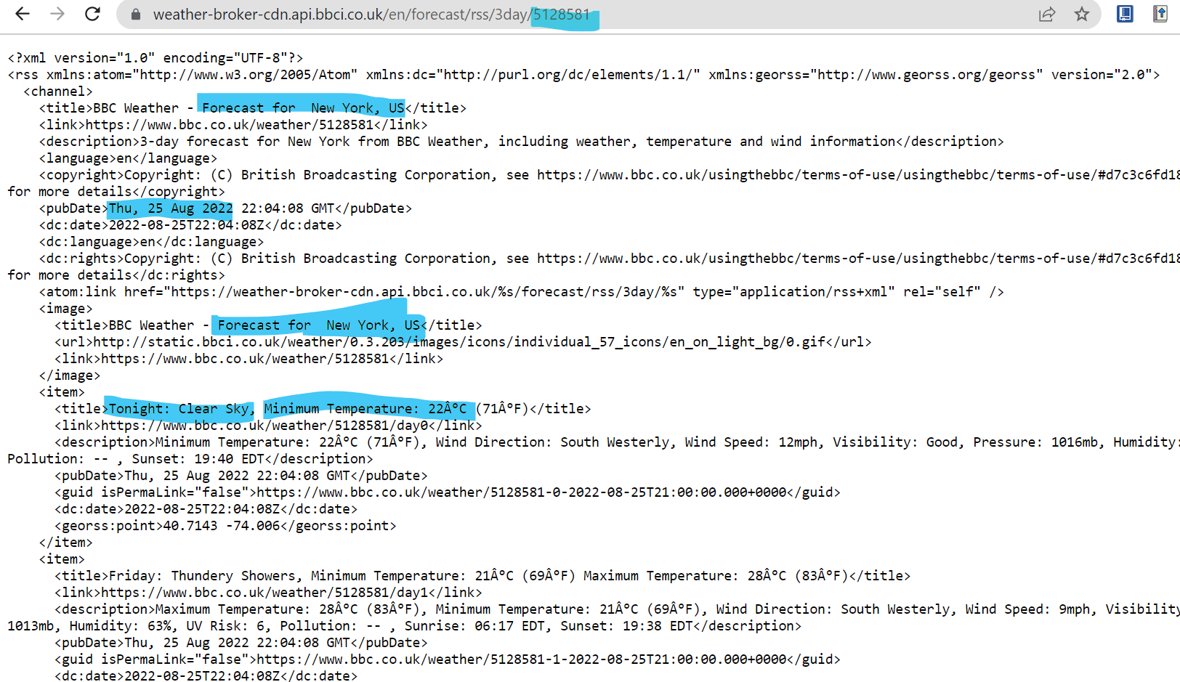

Figure - RSS feed for New York. The highlighted areas in the screenshot prove that the application parses the RSS feed and uses this data in the application.

Figure - Homepage displaying parsed data from RSS feed. The highlighted section shows basic details for Oman.

Figure - RSS feed for Oman. The highlighted areas in the screenshot prove that the application parses the RSS feed and uses this data in the application.

Figure - Homepage displaying parsed data from RSS feed. The highlighted section shows basic details for Mauritius.

Figure - RSS feed for Mauritius. The highlighted areas in the screenshot prove that the application parses the RSS feed and uses this data in the application.

Figure - Homepage displaying parsed data from RSS feed. The highlighted section shows basic details for Bangladesh.

Figure - RSS feed for Bangladesh. The highlighted areas in the screenshot prove that the application parses the RSS feed and uses this data in the application.

* Although not a major error, during the time of testing, the application does not display the correct image for the weather when the weather condition is ‘Partly Cloudy’ and instead shows the default image that the image view is assigned to.

Figure - Error: the application shows the default image instead of the one that matches the condition

When checking the LocationAdapter, it was clear that there was no statement in place to set an image to the view that would match the condition of the forecast. Therefore, the following code was implemented:

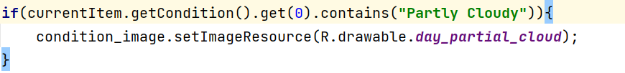

Figure - The code snippet that was implemented to fix imaging issue

Which resulted in the following:

Figure - The new homepage loaded with the correct images

|  |  |  |  |  |  |  |
| --- | --- | --- | --- | --- | --- | --- |
| **ID** | **Name of Test** | **ACTION** | **EXPECTED OUTCOME** | **ACTUAL OUTCOME** | **PASS/FAIL** | **EVIDENCE** |
| 3 | Testing that the user can navigate around the app and select the required functionality as identified in the specification | User selects which location they wish to view by clicking on an item in the list view | Once user selects the location they wish to see via list view item, the app should load the page the user wishes to see | The user is able to select locations in the homepage list view and the application displays a more detailed 3 day weather forecast view as highlighted in the specification | PASS | Review *Figures 17 –23* for evidence. |
| 3.1 | Testing to ensure that the user can navigate through the app and select functionality | User selects to view the weather forecast for Glasgow whilst app is running | The application should display the basic information for the forecast of the Glasgow GCU Campus | The application displays the detailed 3 day forecast for Glasgow, showing the details that were not shown previously | PASS | See Figure 17 for evidence. |
| 3.2 | Testing to ensure that the user can navigate through the app and select functionality | User selects the arrow to go back to the homepage | The application should display the homepage once the arrow back button is clicked | The application displays the homepage after the back arrow is clicked. | PASS | See *Figure 18* for evidence. |
| 3.3 | Testing to ensure that the user can navigate through the app and select functionality | User selects to view the weather forecast for London whilst app is running | The application should display the detailed view for the forecast of the London GCU Campus | The application displays the detailed 3 day forecast for London, showing the details that were not shown previously | PASS | See *Figure 19* for evidence. |
| 3.4 | Testing to ensure that the user can navigate through the app and select functionality | User selects to view the weather forecast for New York whilst app is running | The application should display the detailed view for the forecast of the New York GCU Campus | The application displays the detailed 3 day forecast for New York, showing the details that were not shown previously. | PASS | See *Figure 20* for evidence. |
| 3.5 | Testing to ensure that the user can navigate through the app and select functionality | User selects to view the weather forecast for Oman whilst app is running | The application should display the detailed view for the forecast of the Oman GCU Campus | The application displays the detailed 3 day forecast for Oman, showing the details that were not shown previously. | PASS | See *Figure 21* for evidence |
| 3.6 | Testing to ensure that the user can navigate through the app and select functionality | User selects to view the weather forecast for Mauritius whilst app is running | The application should display the detailed view for the forecast of the Mauritius GCU Campus | The application displays the detailed 3 day forecast for Mauritius, showing the details that were not shown previously | PASS | See *Figure 22* for evidence |
| 3.7 | Testing to ensure that the user can navigate through the app and select functionality | User selects to view the weather forecast for Bangladesh whilst app is running | The application should display the detailed view for the forecast of the Bangladesh GCU Campus | The application displays the detailed 3 day forecast for Bangladesh, showing the details that were not shown previously | PASS | See *Figure 23* for evidence |
| **Summary Test Results for Running the Application:**  The application allows for the user to move between views via the use of the onClickItemListener that is set to the listview. Once an item in the listview is selected, a new activity appears with the more detailed forecast for the location that shows all 3 days. | | | | | | |

Figure 17 – Detailed 3-day forecast for the Glasgow GCU Campus location.

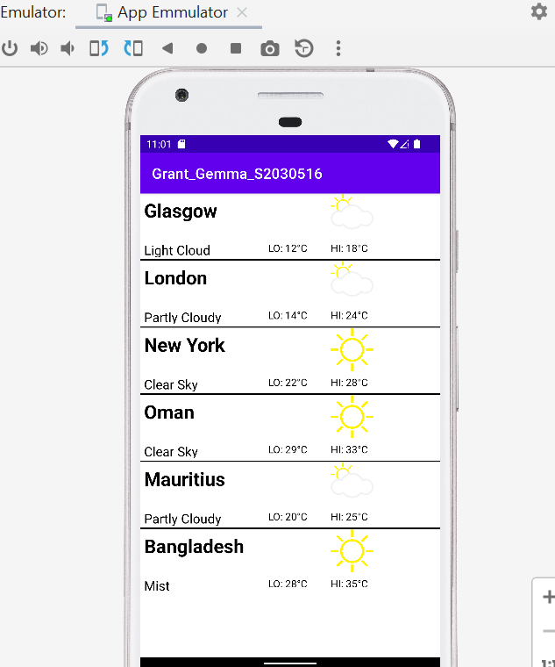

Figure 18 – Homepage displaying after the back arrow is clicked by user

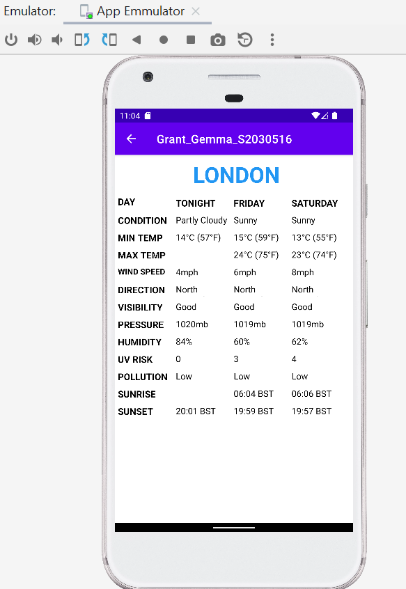

Figure 19 - Detailed 3-day forecast for the London GCU Campus location

Figure 20 - Detailed 3-day forecast for the New York GCU Campus location

Figure - Detailed 3-day forecast for the Oman GCU Campus location

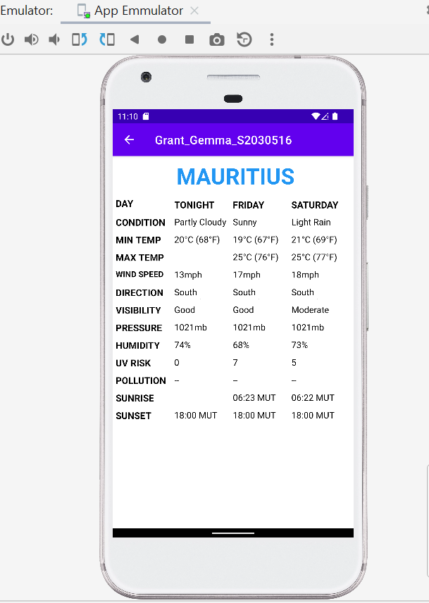

Figure - Detailed 3-day forecast for the Mauritius GCU Campus location

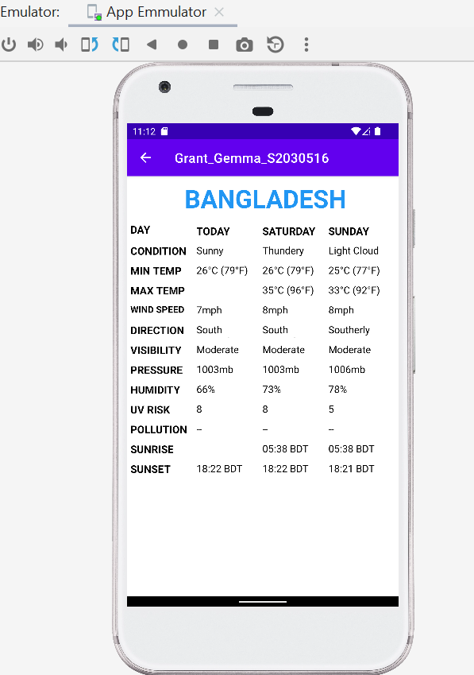

Figure - Detailed 3-day forecast for the Bangladesh GCU Campus location

|  |  |  |  |  |  |  |
| --- | --- | --- | --- | --- | --- | --- |
| **ID** | **Name of Test** | **ACTION** | **EXPECTED OUTCOME** | **ACTUAL OUTCOME** | **PASS/FAIL** | **EVIDENCE** |
| 4.1 | Testing that the functionality required of the features asked for in the specification have been tested.  (Application displaying 3 day weather forecast –basic view) | User loads application to view basic weather forecast for a specific weather location | Application should display a basic weather forecast that should contain min and max temperature as well as a short description | The application runs and loads the homepage as expected. It is in the homepage that a weather forecast for the current day displays showing only the location, a short description, minimum and maximum temperature as well as an image view that corresponds with the short description | PASS | See test case 2 for evidence. The data and the views are both compared in this test case. |
| 4.2 | Testing that the functionality required of the features asked for in the specification have been tested.  (Application displaying 3 day weather forecast –basic view) | User clicks on an item in the list view the detailed weather forecast. | The application should display the detailed weather forecast for the location and day selected. | The application runs loads the detailed 3-day weather forecast view. This view displays extra information that was not displayed in the basic forecast view. The view is not specific to the day only the location | FAIL | The view is designed to show the detailed view for a specific location instead of a specific day. See Test Case 3 for details. |
| 4.3 | Testing that the functionality required of the features asked for in the specification have been tested.  (Application should update at regular intervals) | The application should automatically update once the end of the sequence has been reached to ensure that data | The application should have a method that will automatically update the application at regular times so that the application does not have missing data such as maximum temperature once it is passed 8pm | The application does not contain any implementation of updating the data at regular intervals and so, fails the test | FAIL |  |
| **Summary Test Results for Running the Application:**  The application displays the basic weather forecast and makes use of graphics and texts to display the information. The detailed weather forecast does not display by day, instead it displays by location – which does not meet the specification. The updating of the application has also not been implemented and so, fails the testing stage. By the next iteration of the application, hopefully the application will include the missing criteria. | | | | | | |

# Appendices

## Appendix 1

The data used at the time of testing for Mauritius:

<?xml version="1.0" encoding="UTF-8"?>

<rss xmlns:atom="http://www.w3.org/2005/Atom" xmlns:dc="http://purl.org/dc/elements/1.1/" xmlns:georss="http://www.georss.org/georss" version="2.0">

<channel>

<title>BBC Weather - Forecast for Port Louis, MU</title>

<link>https://www.bbc.co.uk/weather/934154</link>

<description>3-day forecast for Port Louis from BBC Weather, including weather, temperature and wind information</description>

<language>en</language>

<copyright>Copyright: (C) British Broadcasting Corporation, see https://www.bbc.co.uk/usingthebbc/terms-of-use/usingthebbc/terms-of-use/#d7c3c6fd18ea551b9f3f26ecbd4612be for more details</copyright>

<pubDate>Thu, 25 Aug 2022 22:19:46 GMT</pubDate>

<dc:date>2022-08-25T22:19:46Z</dc:date>

<dc:language>en</dc:language>

<dc:rights>Copyright: (C) British Broadcasting Corporation, see https://www.bbc.co.uk/usingthebbc/terms-of-use/usingthebbc/terms-of-use/#d7c3c6fd18ea551b9f3f26ecbd4612be for more details</dc:rights>

<atom:link href="https://weather-broker-cdn.api.bbci.co.uk/%s/forecast/rss/3day/%s" type="application/rss+xml" rel="self" />

<image>

<title>BBC Weather - Forecast for Port Louis, MU</title>

<url>http://static.bbci.co.uk/weather/0.3.203/images/icons/individual_57_icons/en_on_light_bg/2.gif</url>

<link>https://www.bbc.co.uk/weather/934154</link>

</image>

<item>

<title>Tonight: Partly Cloudy, Minimum Temperature: 20Â°C (68Â°F)</title>

<link>https://www.bbc.co.uk/weather/934154/day0</link>

<description>Minimum Temperature: 20Â°C (68Â°F), Wind Direction: South Easterly, Wind Speed: 13mph, Visibility: Good, Pressure: 1021mb, Humidity: 74%, UV Risk: 0, Pollution: -- , Sunset: 18:00 MUT</description>

<pubDate>Thu, 25 Aug 2022 22:19:46 GMT</pubDate>

<guid isPermaLink="false">https://www.bbc.co.uk/weather/934154-0-2022-08-25T21:00:00.000+0000</guid>

<dc:date>2022-08-25T22:19:46Z</dc:date>

<georss:point>-20.1619 57.4989</georss:point>

</item>

<item>

<title>Friday: Sunny Intervals, Minimum Temperature: 19Â°C (67Â°F) Maximum Temperature: 25Â°C (76Â°F)</title>

<link>https://www.bbc.co.uk/weather/934154/day1</link>

<description>Maximum Temperature: 25Â°C (76Â°F), Minimum Temperature: 19Â°C (67Â°F), Wind Direction: South Easterly, Wind Speed: 17mph, Visibility: Good, Pressure: 1021mb, Humidity: 68%, UV Risk: 7, Pollution: -- , Sunrise: 06:23 MUT, Sunset: 18:00 MUT</description>

<pubDate>Thu, 25 Aug 2022 22:19:46 GMT</pubDate>

<guid isPermaLink="false">https://www.bbc.co.uk/weather/934154-1-2022-08-25T21:00:00.000+0000</guid>

<dc:date>2022-08-25T22:19:46Z</dc:date>

<georss:point>-20.1619 57.4989</georss:point>

</item>

<item>

<title>Saturday: Light Rain, Minimum Temperature: 21Â°C (69Â°F) Maximum Temperature: 25Â°C (77Â°F)</title>

<link>https://www.bbc.co.uk/weather/934154/day2</link>

<description>Maximum Temperature: 25Â°C (77Â°F), Minimum Temperature: 21Â°C (69Â°F), Wind Direction: South Easterly, Wind Speed: 18mph, Visibility: Moderate, Pressure: 1021mb, Humidity: 73%, UV Risk: 5, Pollution: -- , Sunrise: 06:22 MUT, Sunset: 18:00 MUT</description>

<pubDate>Thu, 25 Aug 2022 22:19:46 GMT</pubDate>

<guid isPermaLink="false">https://www.bbc.co.uk/weather/934154-2-2022-08-25T21:00:00.000+0000</guid>

<dc:date>2022-08-25T22:19:46Z</dc:date>

<georss:point>-20.1619 57.4989</georss:point>

</item>

</channel>

</rss>

## Appendix 2

The data used at the time of testing for Glasgow:

<?xml version="1.0" encoding="UTF-8"?>

<rss xmlns:atom="http://www.w3.org/2005/Atom" xmlns:dc="http://purl.org/dc/elements/1.1/" xmlns:georss="http://www.georss.org/georss" version="2.0">

<channel>

<title>BBC Weather - Forecast for Glasgow, GB</title>

<link>https://www.bbc.co.uk/weather/2648579</link>

<description>3-day forecast for Glasgow from BBC Weather, including weather, temperature and wind information</description>

<language>en</language>

<copyright>Copyright: (C) British Broadcasting Corporation, see https://www.bbc.co.uk/usingthebbc/terms-of-use/usingthebbc/terms-of-use/#d7c3c6fd18ea551b9f3f26ecbd4612be for more details</copyright>

<pubDate>Thu, 25 Aug 2022 22:15:28 GMT</pubDate>

<dc:date>2022-08-25T22:15:28Z</dc:date>

<dc:language>en</dc:language>

<dc:rights>Copyright: (C) British Broadcasting Corporation, see https://www.bbc.co.uk/usingthebbc/terms-of-use/usingthebbc/terms-of-use/#d7c3c6fd18ea551b9f3f26ecbd4612be for more details</dc:rights>

<atom:link href="https://weather-broker-cdn.api.bbci.co.uk/%s/forecast/rss/3day/%s" type="application/rss+xml" rel="self" />

<image>

<title>BBC Weather - Forecast for Glasgow, GB</title>

<url>http://static.bbci.co.uk/weather/0.3.203/images/icons/individual_57_icons/en_on_light_bg/7.gif</url>

<link>https://www.bbc.co.uk/weather/2648579</link>

</image>

<item>

<title>Tonight: Light Cloud, Minimum Temperature: 12Â°C (53Â°F)</title>

<link>https://www.bbc.co.uk/weather/2648579/day0</link>

<description>Minimum Temperature: 12Â°C (53Â°F), Wind Direction: South Westerly, Wind Speed: 5mph, Visibility: Good, Pressure: 1019mb, Humidity: 92%, UV Risk: 0, Pollution: Low, Sunset: 20:28 BST</description>

<pubDate>Thu, 25 Aug 2022 22:15:28 GMT</pubDate>

<guid isPermaLink="false">https://www.bbc.co.uk/weather/2648579-0-2022-08-25T19:38:00.000+0000</guid>

<dc:date>2022-08-25T22:15:28Z</dc:date>

<georss:point>55.8652 -4.2576</georss:point>

</item>

<item>

<title>Friday: Drizzle, Minimum Temperature: 8Â°C (46Â°F) Maximum Temperature: 18Â°C (64Â°F)</title>

<link>https://www.bbc.co.uk/weather/2648579/day1</link>

<description>Maximum Temperature: 18Â°C (64Â°F), Minimum Temperature: 8Â°C (46Â°F), Wind Direction: Westerly, Wind Speed: 8mph, Visibility: Good, Pressure: 1019mb, Humidity: 80%, UV Risk: 2, Pollution: Low, Sunrise: 06:11 BST, Sunset: 20:25 BST</description>

<pubDate>Thu, 25 Aug 2022 22:15:28 GMT</pubDate>

<guid isPermaLink="false">https://www.bbc.co.uk/weather/2648579-1-2022-08-25T19:38:00.000+0000</guid>

<dc:date>2022-08-25T22:15:28Z</dc:date>

<georss:point>55.8652 -4.2576</georss:point>

</item>

<item>

<title>Saturday: Sunny Intervals, Minimum Temperature: 10Â°C (51Â°F) Maximum Temperature: 20Â°C (68Â°F)</title>

<link>https://www.bbc.co.uk/weather/2648579/day2</link>

<description>Maximum Temperature: 20Â°C (68Â°F), Minimum Temperature: 10Â°C (51Â°F), Wind Direction: Westerly, Wind Speed: 6mph, Visibility: Moderate, Pressure: 1021mb, Humidity: 74%, UV Risk: 4, Pollution: Low, Sunrise: 06:13 BST, Sunset: 20:23 BST</description>

<pubDate>Thu, 25 Aug 2022 22:15:28 GMT</pubDate>

<guid isPermaLink="false">https://www.bbc.co.uk/weather/2648579-2-2022-08-25T19:38:00.000+0000</guid>

<dc:date>2022-08-25T22:15:28Z</dc:date>

<georss:point>55.8652 -4.2576</georss:point>

</item>

</channel>

</rss>

## Appendix 3

The data used at the time of testing for London:

<?xml version="1.0" encoding="UTF-8"?>

<rss xmlns:atom="http://www.w3.org/2005/Atom" xmlns:dc="http://purl.org/dc/elements/1.1/" xmlns:georss="http://www.georss.org/georss" version="2.0">

<channel>

<title>BBC Weather - Forecast for London, GB</title>

<link>https://www.bbc.co.uk/weather/2643743</link>

<description>3-day forecast for London from BBC Weather, including weather, temperature and wind information</description>

<language>en</language>

<copyright>Copyright: (C) British Broadcasting Corporation, see https://www.bbc.co.uk/usingthebbc/terms-of-use/usingthebbc/terms-of-use/#d7c3c6fd18ea551b9f3f26ecbd4612be for more details</copyright>

<pubDate>Thu, 25 Aug 2022 22:43:31 GMT</pubDate>

<dc:date>2022-08-25T22:43:31Z</dc:date>

<dc:language>en</dc:language>

<dc:rights>Copyright: (C) British Broadcasting Corporation, see https://www.bbc.co.uk/usingthebbc/terms-of-use/usingthebbc/terms-of-use/#d7c3c6fd18ea551b9f3f26ecbd4612be for more details</dc:rights>

<atom:link href="https://weather-broker-cdn.api.bbci.co.uk/%s/forecast/rss/3day/%s" type="application/rss+xml" rel="self" />

<image>

<title>BBC Weather - Forecast for London, GB</title>

<url>http://static.bbci.co.uk/weather/0.3.203/images/icons/individual_57_icons/en_on_light_bg/2.gif</url>

<link>https://www.bbc.co.uk/weather/2643743</link>

</image>

<item>

<title>Tonight: Partly Cloudy, Minimum Temperature: 14Â°C (57Â°F)</title>

<link>https://www.bbc.co.uk/weather/2643743/day0</link>

<description>Minimum Temperature: 14Â°C (57Â°F), Wind Direction: North Westerly, Wind Speed: 4mph, Visibility: Good, Pressure: 1020mb, Humidity: 84%, UV Risk: 0, Pollution: Low, Sunset: 20:01 BST</description>

<pubDate>Thu, 25 Aug 2022 22:43:31 GMT</pubDate>

<guid isPermaLink="false">https://www.bbc.co.uk/weather/2643743-0-2022-08-25T21:04:00.000+0000</guid>

<dc:date>2022-08-25T22:43:31Z</dc:date>

<georss:point>51.5085 -0.1257</georss:point>

</item>

<item>

<title>Friday: Sunny Intervals, Minimum Temperature: 15Â°C (59Â°F) Maximum Temperature: 24Â°C (75Â°F)</title>

<link>https://www.bbc.co.uk/weather/2643743/day1</link>

<description>Maximum Temperature: 24Â°C (75Â°F), Minimum Temperature: 15Â°C (59Â°F), Wind Direction: North Westerly, Wind Speed: 6mph, Visibility: Good, Pressure: 1019mb, Humidity: 60%, UV Risk: 3, Pollution: Low, Sunrise: 06:04 BST, Sunset: 19:59 BST</description>

<pubDate>Thu, 25 Aug 2022 22:43:31 GMT</pubDate>

<guid isPermaLink="false">https://www.bbc.co.uk/weather/2643743-1-2022-08-25T21:04:00.000+0000</guid>

<dc:date>2022-08-25T22:43:31Z</dc:date>

<georss:point>51.5085 -0.1257</georss:point>

</item>

<item>

<title>Saturday: Sunny Intervals, Minimum Temperature: 13Â°C (55Â°F) Maximum Temperature: 23Â°C (74Â°F)</title>

<link>https://www.bbc.co.uk/weather/2643743/day2</link>

<description>Maximum Temperature: 23Â°C (74Â°F), Minimum Temperature: 13Â°C (55Â°F), Wind Direction: North Easterly, Wind Speed: 8mph, Visibility: Good, Pressure: 1019mb, Humidity: 62%, UV Risk: 4, Pollution: Low, Sunrise: 06:06 BST, Sunset: 19:57 BST</description>

<pubDate>Thu, 25 Aug 2022 22:43:31 GMT</pubDate>

<guid isPermaLink="false">https://www.bbc.co.uk/weather/2643743-2-2022-08-25T21:04:00.000+0000</guid>

<dc:date>2022-08-25T22:43:31Z</dc:date>

<georss:point>51.5085 -0.1257</georss:point>

</item>

</channel>

</rss>

## Appendix 4

The data used at the time of testing for New York:

<?xml version="1.0" encoding="UTF-8"?>

<rss xmlns:atom="http://www.w3.org/2005/Atom" xmlns:dc="http://purl.org/dc/elements/1.1/" xmlns:georss="http://www.georss.org/georss" version="2.0">

<channel>

<title>BBC Weather - Forecast for New York, US</title>

<link>https://www.bbc.co.uk/weather/5128581</link>

<description>3-day forecast for New York from BBC Weather, including weather, temperature and wind information</description>

<language>en</language>

<copyright>Copyright: (C) British Broadcasting Corporation, see https://www.bbc.co.uk/usingthebbc/terms-of-use/usingthebbc/terms-of-use/#d7c3c6fd18ea551b9f3f26ecbd4612be for more details</copyright>

<pubDate>Thu, 25 Aug 2022 22:04:08 GMT</pubDate>

<dc:date>2022-08-25T22:04:08Z</dc:date>

<dc:language>en</dc:language>

<dc:rights>Copyright: (C) British Broadcasting Corporation, see https://www.bbc.co.uk/usingthebbc/terms-of-use/usingthebbc/terms-of-use/#d7c3c6fd18ea551b9f3f26ecbd4612be for more details</dc:rights>

<atom:link href="https://weather-broker-cdn.api.bbci.co.uk/%s/forecast/rss/3day/%s" type="application/rss+xml" rel="self" />

<image>

<title>BBC Weather - Forecast for New York, US</title>

<url>http://static.bbci.co.uk/weather/0.3.203/images/icons/individual_57_icons/en_on_light_bg/0.gif</url>

<link>https://www.bbc.co.uk/weather/5128581</link>

</image>

<item>

<title>Tonight: Clear Sky, Minimum Temperature: 22Â°C (71Â°F)</title>

<link>https://www.bbc.co.uk/weather/5128581/day0</link>

<description>Minimum Temperature: 22Â°C (71Â°F), Wind Direction: South Westerly, Wind Speed: 12mph, Visibility: Good, Pressure: 1016mb, Humidity: 54%, UV Risk: 1, Pollution: -- , Sunset: 19:40 EDT</description>

<pubDate>Thu, 25 Aug 2022 22:04:08 GMT</pubDate>

<guid isPermaLink="false">https://www.bbc.co.uk/weather/5128581-0-2022-08-25T21:00:00.000+0000</guid>

<dc:date>2022-08-25T22:04:08Z</dc:date>

<georss:point>40.7143 -74.006</georss:point>

</item>

<item>

<title>Friday: Thundery Showers, Minimum Temperature: 21Â°C (69Â°F) Maximum Temperature: 28Â°C (83Â°F)</title>

<link>https://www.bbc.co.uk/weather/5128581/day1</link>

<description>Maximum Temperature: 28Â°C (83Â°F), Minimum Temperature: 21Â°C (69Â°F), Wind Direction: South Westerly, Wind Speed: 9mph, Visibility: Good, Pressure: 1013mb, Humidity: 63%, UV Risk: 6, Pollution: -- , Sunrise: 06:17 EDT, Sunset: 19:38 EDT</description>

<pubDate>Thu, 25 Aug 2022 22:04:08 GMT</pubDate>

<guid isPermaLink="false">https://www.bbc.co.uk/weather/5128581-1-2022-08-25T21:00:00.000+0000</guid>

<dc:date>2022-08-25T22:04:08Z</dc:date>

<georss:point>40.7143 -74.006</georss:point>

</item>

<item>

<title>Saturday: Sunny Intervals, Minimum Temperature: 20Â°C (68Â°F) Maximum Temperature: 29Â°C (85Â°F)</title>

<link>https://www.bbc.co.uk/weather/5128581/day2</link>

<description>Maximum Temperature: 29Â°C (85Â°F), Minimum Temperature: 20Â°C (68Â°F), Wind Direction: Northerly, Wind Speed: 8mph, Visibility: Good, Pressure: 1016mb, Humidity: 59%, UV Risk: 5, Pollution: -- , Sunrise: 06:18 EDT, Sunset: 19:37 EDT</description>

<pubDate>Thu, 25 Aug 2022 22:04:08 GMT</pubDate>

<guid isPermaLink="false">https://www.bbc.co.uk/weather/5128581-2-2022-08-25T21:00:00.000+0000</guid>

<dc:date>2022-08-25T22:04:08Z</dc:date>

<georss:point>40.7143 -74.006</georss:point>

</item>

</channel>

</rss>

## Appendix 5

The data used at the time of testing for Bangladesh:

<?xml version="1.0" encoding="UTF-8"?>

<rss xmlns:atom="http://www.w3.org/2005/Atom" xmlns:dc="http://purl.org/dc/elements/1.1/" xmlns:georss="http://www.georss.org/georss" version="2.0">

<channel>

<title>BBC Weather - Forecast for Dhaka, BD</title>

<link>https://www.bbc.co.uk/weather/1185241</link>

<description>3-day forecast for Dhaka from BBC Weather, including weather, temperature and wind information</description>

<language>en</language>

<copyright>Copyright: (C) British Broadcasting Corporation, see https://www.bbc.co.uk/usingthebbc/terms-of-use/usingthebbc/terms-of-use/#d7c3c6fd18ea551b9f3f26ecbd4612be for more details</copyright>

<pubDate>Thu, 25 Aug 2022 22:24:07 GMT</pubDate>

<dc:date>2022-08-25T22:24:07Z</dc:date>

<dc:language>en</dc:language>

<dc:rights>Copyright: (C) British Broadcasting Corporation, see https://www.bbc.co.uk/usingthebbc/terms-of-use/usingthebbc/terms-of-use/#d7c3c6fd18ea551b9f3f26ecbd4612be for more details</dc:rights>

<atom:link href="https://weather-broker-cdn.api.bbci.co.uk/%s/forecast/rss/3day/%s" type="application/rss+xml" rel="self" />

<image>

<title>BBC Weather - Forecast for Dhaka, BD</title>

<url>http://static.bbci.co.uk/weather/0.3.203/images/icons/individual_57_icons/en_on_light_bg/5.gif</url>

<link>https://www.bbc.co.uk/weather/1185241</link>

</image>

<item>

<title>Tonight: Mist, Minimum Temperature: 28Â°C (82Â°F)</title>

<link>https://www.bbc.co.uk/weather/1185241/day0</link>

<description>Minimum Temperature: 28Â°C (82Â°F), Wind Direction: South Westerly, Wind Speed: 6mph, Visibility: Moderate, Pressure: 1004mb, Humidity: 89%, UV Risk: 0, Pollution: -- , Sunset: 18:22 BDT</description>

<pubDate>Thu, 25 Aug 2022 22:24:07 GMT</pubDate>

<guid isPermaLink="false">https://www.bbc.co.uk/weather/1185241-0-2022-08-25T21:00:00.000+0000</guid>

<dc:date>2022-08-25T22:24:07Z</dc:date>

<georss:point>23.7104 90.4074</georss:point>

</item>

<item>

<title>Friday: Sunny Intervals, Minimum Temperature: 27Â°C (80Â°F) Maximum Temperature: 35Â°C (96Â°F)</title>

<link>https://www.bbc.co.uk/weather/1185241/day1</link>

<description>Maximum Temperature: 35Â°C (96Â°F), Minimum Temperature: 27Â°C (80Â°F), Wind Direction: South Westerly, Wind Speed: 7mph, Visibility: Moderate, Pressure: 1003mb, Humidity: 66%, UV Risk: 8, Pollution: -- , Sunrise: 05:38 BDT, Sunset: 18:22 BDT</description>

<pubDate>Thu, 25 Aug 2022 22:24:07 GMT</pubDate>

<guid isPermaLink="false">https://www.bbc.co.uk/weather/1185241-1-2022-08-25T21:00:00.000+0000</guid>

<dc:date>2022-08-25T22:24:07Z</dc:date>

<georss:point>23.7104 90.4074</georss:point>

</item>

<item>

<title>Saturday: Thundery Showers, Minimum Temperature: 26Â°C (79Â°F) Maximum Temperature: 33Â°C (92Â°F)</title>

<link>https://www.bbc.co.uk/weather/1185241/day2</link>

<description>Maximum Temperature: 33Â°C (92Â°F), Minimum Temperature: 26Â°C (79Â°F), Wind Direction: South Westerly, Wind Speed: 8mph, Visibility: Moderate, Pressure: 1003mb, Humidity: 73%, UV Risk: 8, Pollution: -- , Sunrise: 05:39 BDT, Sunset: 18:21 BDT</description>

<pubDate>Thu, 25 Aug 2022 22:24:07 GMT</pubDate>

<guid isPermaLink="false">https://www.bbc.co.uk/weather/1185241-2-2022-08-25T21:00:00.000+0000</guid>

<dc:date>2022-08-25T22:24:07Z</dc:date>

<georss:point>23.7104 90.4074</georss:point>

</item>

</channel>

</rss>

## Appendix 6

The data used at the time of testing for Oman:

<?xml version="1.0" encoding="UTF-8"?>

<rss xmlns:atom="http://www.w3.org/2005/Atom" xmlns:dc="http://purl.org/dc/elements/1.1/" xmlns:georss="http://www.georss.org/georss" version="2.0">

<channel>

<title>BBC Weather - Forecast for Muscat, OM</title>

<link>https://www.bbc.co.uk/weather/287286</link>

<description>3-day forecast for Muscat from BBC Weather, including weather, temperature and wind information</description>

<language>en</language>

<copyright>Copyright: (C) British Broadcasting Corporation, see https://www.bbc.co.uk/usingthebbc/terms-of-use/usingthebbc/terms-of-use/#d7c3c6fd18ea551b9f3f26ecbd4612be for more details</copyright>

<pubDate>Thu, 25 Aug 2022 22:01:10 GMT</pubDate>

<dc:date>2022-08-25T22:01:10Z</dc:date>

<dc:language>en</dc:language>

<dc:rights>Copyright: (C) British Broadcasting Corporation, see https://www.bbc.co.uk/usingthebbc/terms-of-use/usingthebbc/terms-of-use/#d7c3c6fd18ea551b9f3f26ecbd4612be for more details</dc:rights>

<atom:link href="https://weather-broker-cdn.api.bbci.co.uk/%s/forecast/rss/3day/%s" type="application/rss+xml" rel="self" />

<image>

<title>BBC Weather - Forecast for Muscat, OM</title>

<url>http://static.bbci.co.uk/weather/0.3.203/images/icons/individual_57_icons/en_on_light_bg/0.gif</url>

<link>https://www.bbc.co.uk/weather/287286</link>

</image>

<item>

<title>Tonight: Clear Sky, Minimum Temperature: 29Â°C (84Â°F)</title>

<link>https://www.bbc.co.uk/weather/287286/day0</link>

<description>Minimum Temperature: 29Â°C (84Â°F), Wind Direction: Easterly, Wind Speed: 7mph, Visibility: Good, Pressure: 1001mb, Humidity: 81%, UV Risk: 0, Pollution: -- , Sunset: 18:30 GST</description>

<pubDate>Thu, 25 Aug 2022 22:01:10 GMT</pubDate>

<guid isPermaLink="false">https://www.bbc.co.uk/weather/287286-0-2022-08-25T21:00:00.000+0000</guid>

<dc:date>2022-08-25T22:01:10Z</dc:date>

<georss:point>23.6139 58.5922</georss:point>

</item>

<item>

<title>Friday: Sunny, Minimum Temperature: 24Â°C (75Â°F) Maximum Temperature: 33Â°C (91Â°F)</title>

<link>https://www.bbc.co.uk/weather/287286/day1</link>

<description>Maximum Temperature: 33Â°C (91Â°F), Minimum Temperature: 24Â°C (75Â°F), Wind Direction: Easterly, Wind Speed: 13mph, Visibility: Moderate, Pressure: 1003mb, Humidity: 71%, UV Risk: 11, Pollution: -- , Sunrise: 05:46 GST, Sunset: 18:29 GST</description>

<pubDate>Thu, 25 Aug 2022 22:01:10 GMT</pubDate>

<guid isPermaLink="false">https://www.bbc.co.uk/weather/287286-1-2022-08-25T21:00:00.000+0000</guid>

<dc:date>2022-08-25T22:01:10Z</dc:date>

<georss:point>23.6139 58.5922</georss:point>

</item>

<item>

<title>Saturday: Sunny, Minimum Temperature: 24Â°C (75Â°F) Maximum Temperature: 32Â°C (90Â°F)</title>

<link>https://www.bbc.co.uk/weather/287286/day2</link>

<description>Maximum Temperature: 32Â°C (90Â°F), Minimum Temperature: 24Â°C (75Â°F), Wind Direction: North Easterly, Wind Speed: 13mph, Visibility: Moderate, Pressure: 1004mb, Humidity: 73%, UV Risk: 12, Pollution: -- , Sunrise: 05:46 GST, Sunset: 18:28 GST</description>

<pubDate>Thu, 25 Aug 2022 22:01:10 GMT</pubDate>

<guid isPermaLink="false">https://www.bbc.co.uk/weather/287286-2-2022-08-25T21:00:00.000+0000</guid>

<dc:date>2022-08-25T22:01:10Z</dc:date>

<georss:point>23.6139 58.5922</georss:point>

</item>

</channel>

</rss>