1. Do you need these for deep learning?
   * Lots of math T / F (F)
   * Lots of data T / F (F)
   * Lots of expensive computers T / F (F)
   * A PhD T / F (F)
2. Name five areas where deep learning is now the best in the world.
   * 1. NLP
     2. Biology
     3. Medicine
     4. Robotics
     5. Playing Games
3. What was the name of the first device that was based on the principle of the artificial neuron? (The Mark 1 Perceptron)
4. Based on the book of the same name, what are the requirements for parallel distributed processing (PDP)?

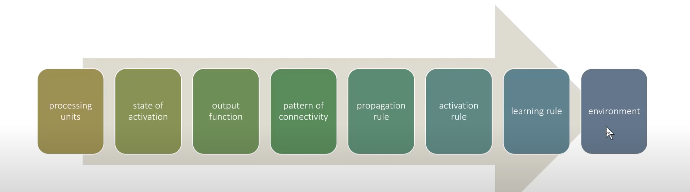

1. What were the two theoretical misunderstandings that held back the field of neural networks?
   * 1. The first misunderstanding was when people thought that AI was no good because it couldn’t do simple tasks, which was known as Minsky’s problem
     2. The second misunderstanding is that people thought that only one layer of neurons were enough.
2. What is a GPU? (Graphics Processing Unit)
3. Open a notebook and execute a cell containing: 1+1. What happens? (It prints out 2)
4. Follow through each cell of the stripped version of the notebook for this chapter. Before executing each cell, guess what will happen. ()
5. Complete the Jupyter Notebook online appendix. ()
6. Why is it hard to use a traditional computer program to recognize images in a photo? (Because we can’t write down the steps necessary)
7. What did Samuel mean by "weight assignment"? (Weight assignment is to teach the AI)
8. What term do we normally use in deep learning for what Samuel called "weights"? (Weights are parameters)
9. Draw a picture that summarizes Samuel's view of a machine learning model.

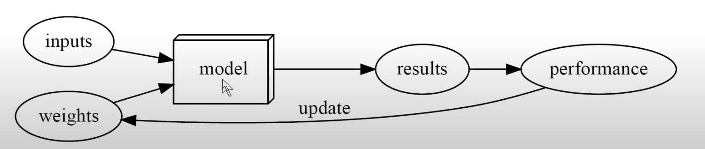

1. Why is it hard to understand why a deep learning model makes a particular prediction? (We can’t see what is going on in the model, which works like a neural network meaning it is complicated. We can only see the input and output.)
2. What is the name of the theorem that shows that a neural network can solve any mathematical problem to any level of accuracy? (The name of the theorem is “Universal Approximation Theorem”)
3. What do you need in order to train a model? (You need data in order to train a model)
4. How could a feedback loop impact the rollout of a predictive policing model? (The feedback loop impacts the model because depending on the feedback the model will know if it did good or bad. If it’s bad then the model will try to change until it’s good.)
5. Do we always have to use 224×224-pixel images with the cat recognition model? (Not always)
6. What is the difference between classification and regression? (The output of Classification is categorical while the output of regression is numerical)
7. What is a validation set? (A validation set is data that we are not allowed to touch but only to use to figure out if our model is working or not.) What is a test set? () Why do we need them? ()
8. What will fastai do if you don't provide a validation set? ()