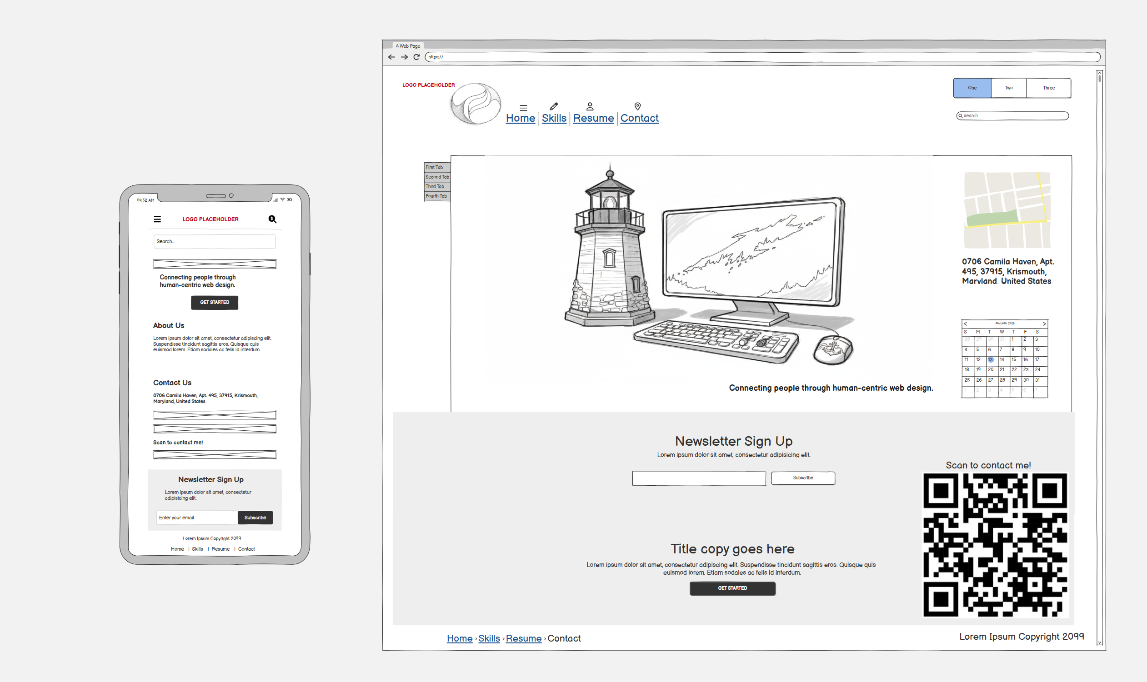

“The initial wireframe provided a basic structure for the portfolio. I changed the layout significantly during the build phase. The original plan featured a simple text list for the skills section. I updated this into a CSS grid. A grid organizes the information better and makes it easier for users to read. I also incorporated an aviation theme with specific colors and fonts to reflect my personal interests. I added custom animations to make the interface more engaging. These changes improve user experience and visual appeal. I learned that wireframes serve only as starting points. Building the site requires flexibility. You adapt the design as new technical possibilities emerge during development.”

