Project code | GEMS
Version | 1.1
Date | April 2011
Gems Survey Activation

Table of contents

1 Preparing the survey 2
1.1 Edit the survey 2
2 Activating the survey 4
2.1 Activate the survey 4
2.2 Creating the token table 5
2.3 Add additional attributes 5
3 Additional navigation tips 7
3.1 Returning to the survey 7
3.2 Changing the survey settings 7
3.3 Changing token usage 7

Preparing the survey
Gems can only link individual survey answers to respondents when the survey setup allows this.

Edit the survey

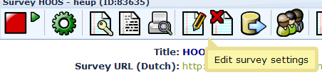

Click on the Presentation & Navigation tab.

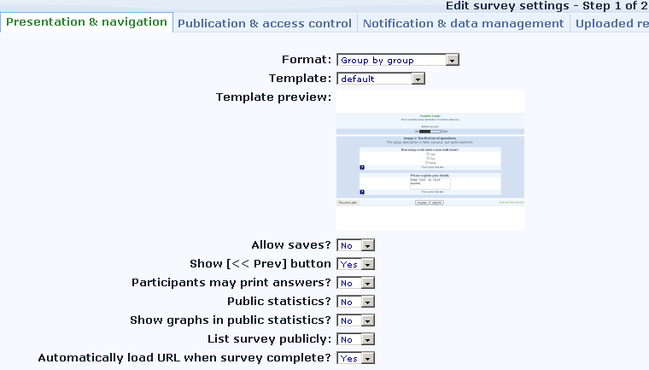
Allow saves is set to No
Automatically load URL when survey complete is set to Yes

Click on the Notification & data management tab.

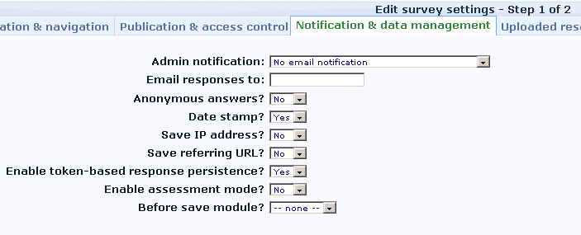

Make sure that:
- Anonymous answers is set to No.
- Date stamp is set to Yes.
- Enable token-based response persistence is set to Yes

Click on Save and continue.

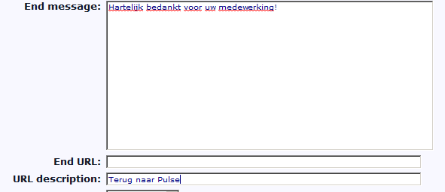

Type “Terug naar Pulse” or a similar statement in the URL description (the End URL is filled by Gems). Click on Save.

Activating the survey
You should activate a survey only when you are sure you will not need to change the number of questions on short notice.

Activate the survey
Click on the small Survey activation icon.

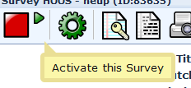

The next screen tells you what you can and cannot do after survey activation. Read this carefully if you do not yet know.

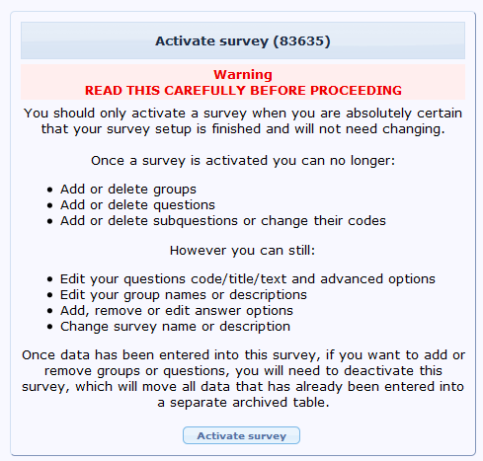

Click on the Activate survey button.

Creating the token table

The token table is created in the screen you see after you activated the survey. The next screen ask you if you want to switch to close access mode, this creates a token table.

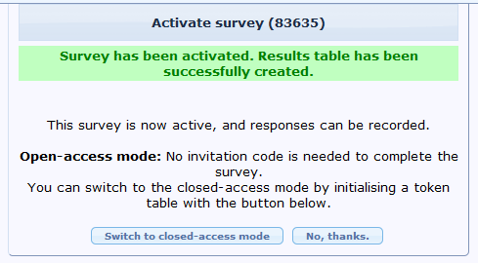

Gems works with closed-access mode so click on Switch to closed-access mode.

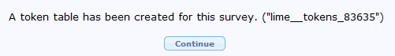

Token table has been created. Click on Continue.

Add additional attributes

Gems needs the token table to link a survey answer to a specific respondent, but as we want to perform statistical analysis on the results Gems also fills three attribute fields per token. These are:

- User identificatier
- Organisation identifier
- Informed consent identifier

The user & organisation identifiers are system generated unique identifiers that are not used in the interface. I.e. the application can link a user or organisation to an identifier on an individual basis, but the researcher using the Lime Survey database does not know who is who.

The informed consent identifiers tells the researcher which surveys should be ignored.

These fields are stored in additional attribute fields in the token table. These attributes fields must be added to the table.

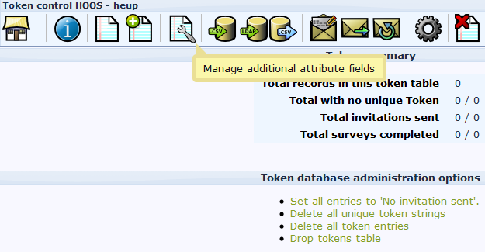

Click on the Manage additional attribute fields button.

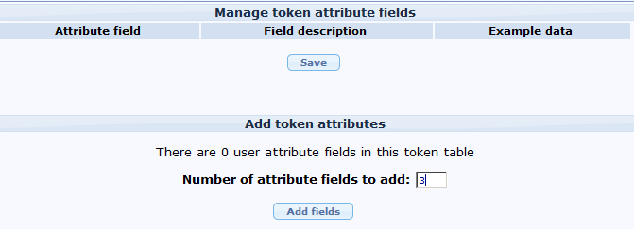

Make sure there are at least 3 user attribute fields and click on Add fields.

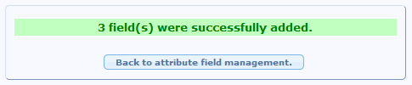

The atttribute fields have now been created. The survey can be used by Gems.

Additional navigation tips

Returning to the survey

You can always return to the main Lime Survey administration screen b y clicking the top-left “home” icon.

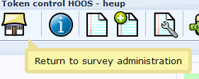

Changing the survey settings

Some survey settings can be changed after activiation, e.g. the URL Description. However, to change the Anonymity and Datestamp fields you will first need to deactivate the survey and then reactivate it.

Changing token usage

If you forgot to create the token table or the attributes for an activated survey, you can do so at a later stage by using the Token management button.

