–

GT-BASIC Theme manual

22 January 2022

Contents

Introduction 3

Acknowledgements 3

Installing the gt-basic theme 4

Using a preinstalled version 4

Downloading and importing 4

Customizing the theme 4

Using the theme 5

Using the extended functionality 6

Saving using GemsTracker 6

Autosave - Theme option 6

Yes No Questions–Theme option 6

Show groups as tabs – Theme option 7

Hide tip texts – Theme option 7

# Introduction

The gt-basic LimeSurvey 3 GemsTracker integration theme simplifies the use of LimeSurvey 3 and later in conjunction with GemsTracker projects.

It does this by adding theme options that you can configure either for the whole theme or separately for each single survey. These are the options most regularly requested by users.

# Acknowledgements

The gt-basic theme use functionality developed for these organizations:

* CP Register & Amsterdam UMC
* Erasmus MC
* Equipe zorgbedrijven
* Hersendata consortium
* Hogeschool Rotterdam
* Ipse de Brugge
* Rijndam Revalidatie

We thank these organizations for their contributions and for making the code freely available under new BSD license.

# Installing the gt-basic theme

There are two methods to install the gt-basic, either it comes pre-installed with GemsTracker, or you can download and install the theme yourself. In both cases all you need is the administrative right in LimeSurvey to access and use the Themes page through the configuration menu.

## Using a preinstalled version

Always check whether the theme has already been installed[1] – but not activated. Scroll to the bottom of the themes page and check for Available survey themes.

If you see can the theme as in the illustration, just click on the install button, otherwise you can just download and install the theme. However if the theme has been added, you can proceed to the next steps: customizing the theme and making it the default theme.

## Downloading and importing

If the theme is not yet available, download the .zip theme file from GitHub:  
 <https://github.com/GemsTracker/ls3-basic-themes/tree/main/downloads>

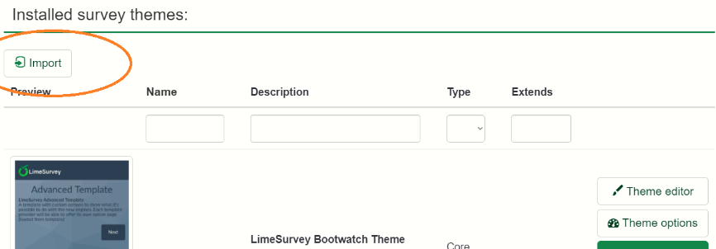Next install the template by uploading it on the LimeSurvey themes page. Click on the import button and upload the theme file.

If any error message appears: stay calm and read what it says, e.g. that the theme already exists.

## Customizing the theme

After the theme is installed it will appear in the list of installed survey themes, just like all the other themes. You can use the theme options buttons to customize the theme. At the top of this page you will see the **GT Theme options** which we will describe in extensive detail in the rest of this document.

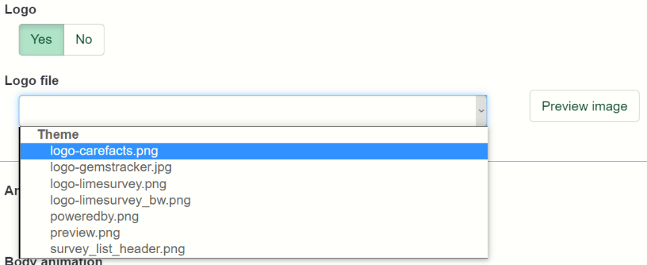In this section we describe the use of the standard LimeSurvey Fruity theme options to add logo’s and choose a colour scheme. Scroll down the options page until you see the **Logo** and **Logo file** options. As you can see we have provided some default logo’s.

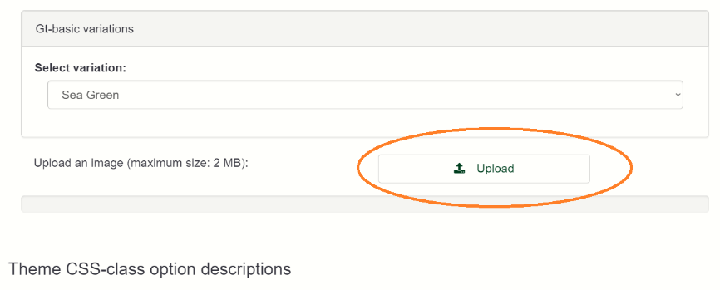You can add **your own logo** to this list using the upload button at the bottom of the screen You can add several logos here. Only one logo will be the standard logo for this theme, but you can choose to use a different logo by making an extended version of this theme or you can choose a different logo by changing the theme options for a specific survey.

Above the upload button you can also choose to use a default variation. This allows you to choose a **different colour scheme**. Instead of green you can go for red, blue, black, etc…

## Using the theme

To use the theme you have to set it for each survey. You can do this by opening the survey and choosing General Settings from the navigation menu.

On the right you see where you can choose the theme (here it is called template, because that was what it was called in a previous version of LimeSurvey).

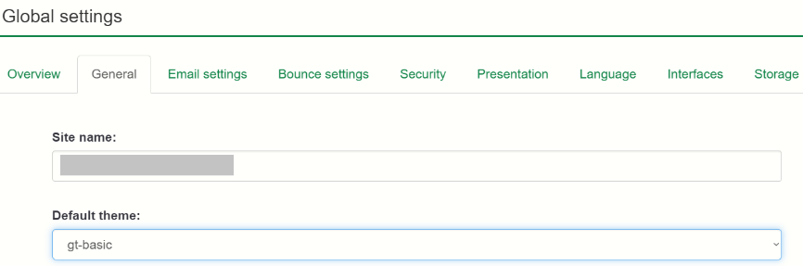You can also make this theme the default theme for new surveys by changing the Global Settings. (Choose the Configuration menu on top and then under Settings: Global settings.) You find the default theme in the General tab.

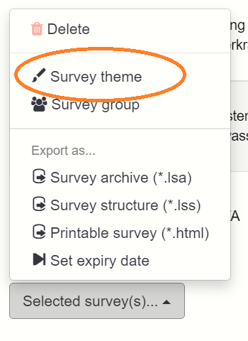This will work for new surveys. You can change the theme for existing surveys one by one, but there is also a bulk theme change option for selected surveys at the bottom of the survey list screen.

Another option is only available if you have access to the database of the installation and can send SQL queries to the database. There are some useful example queries available at [GitHub](https://github.com/GemsTracker/ls3-basic-themes/tree/main/sql).

# Using the extended functionality

The use of the extended features depends on each feature, but all the **Theme options** can be set either at the options of the installed theme itself or be overruled at the survey level by overruling the Theme options there.

## Saving using GemsTracker

LimeSurvey has its own save & resume function, but the gt-basic theme overrides it’s functionality. Instead of a 'Load unfinished survey' and a 'Save' link on the top of the page, the theme shows 'Save & Continue' and 'Save & Resume later' buttons at the bottom of the page. Both of these buttons save the current answers in the database, the Resume later button also returns to the GemsTracker page.

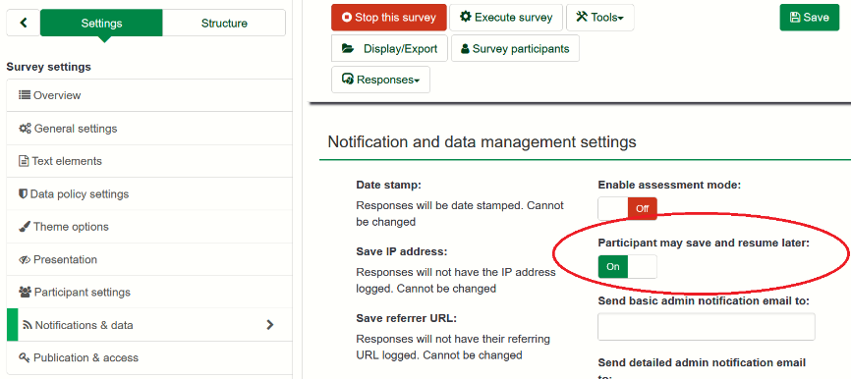You can turn this on and of by using the **Notification & data** setting: **Participant may save and resume later**. When on the buttons will appear, otherwise the will not be visible.

If a logged in staff member uses the ‘Resumes later’ button it will just return to the page the staff member was working on. The behaviour for anyone not logged in (i.e. respondents) is to return to the start page. The functionality then depends on the **Token ask** screen set for the organization, but the default behaviour should be that the respondent either gets a mail automatically on return or at least sees a button allowing the respondent to get that mail.

*Note:* it is not possible to use this theme and use the old LimeSurvey method.

## Autosave - Theme option

The theme options allow the setting of autosave. This can be set to every minute, to whenever the user switches a tab or to another application or when the tab is closed. This way the changes of loosing data are minimized.

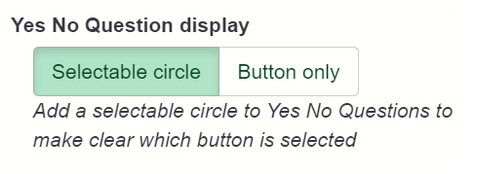Using the every minute setting should be restricted on very busy servers as it may increase the load.

## Yes No Questions–Theme option

In general LimeSurvey 3 displays a clearer survey than version two, but we disagree on the **Yes No Question** display so we added an option.

Yes No buttons with a selectable circle.

 Yes No buttons as a button only.

You can also enable this effect for a single question by setting the **CSS class** of that questions to ‘yesno-show-buttons’. (There is no option disable it for a single question.)

## Show groups as tabs – Theme option

Some organizations prefer to show all questions in a survey on one page, but then group the question groups in separate tabs.

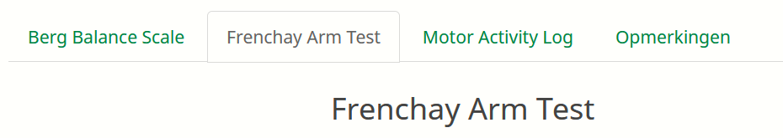On the right we see an example of how this will look in a survey. By clicking on a tab the questions of that group – and only that group – become visible. The survey always opens on the first tab, even when resuming later.

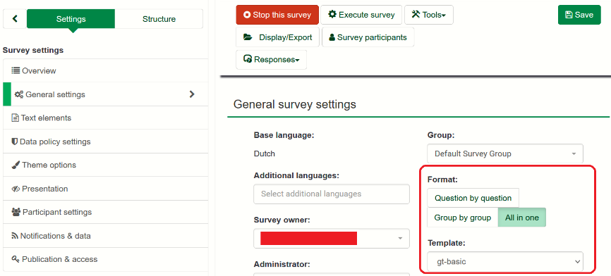This setting has effect only when under **General settings** of the survey settings the value **Format** is set to **All in one**.

Another requirement is that there actually has to be more than one questions group. If there is only one group, no tabs is displayed.

## Hide tip texts – Theme option

1. Instructions for pre-installing the theme and other technical adaptations can be found in the [README.md](https://github.com/GemsTracker/ls3-basic-themes) of this GitHub project.