NATIONAL INSTITUTE OF TRANSPORT

DEPARTMENT COMPUTING AND COMMUNICATION TECHNOLOGY

FINAL YEAR PROJECT PROPOSAL

ACADEMIC YEAR: 2024/2025

STUDENT NAME: JAMES MWITA MARWA REGISTRATION NO: NIT/BIT/2023/2263
COURSE: BACHELOR IN INFORMATION TECHNOLOGY SUPERVISOR NAME: Mr. EXAUD KITOMARY
TITLE: TRANSACTION FRAUD DETECTION AND ANALYSIS USING MACHINE LEARNING
PROJECT TYPE: WEB BASED PROJECT

DECLARATION
I hereby declare that this project proposal titled Transaction Fraud Detection and Analysis using Machine Learning is my original work and has not been submitted to any other institution for academic credit. All sources of information used in the preparation of this work have been duly acknowledged and referenced according to institute standards.

Signed:

Name: JAMES MWITA MARWA

Registration Number: NIT/BIT/2023/2263 Date:

ACKNOWLEDGEMENT

I wish to express my sincere gratitude to the Almighty God for granting me strength and perseverance throughout the preparation of this proposal. My deepest appreciation goes to my supervisor, Mr. EXAUD KITOMARY for their invaluable guidance, constructive feedback, and encouragement during the development of this work.

I am also grateful to the lecturers and staff of the National Institute of Transport for providing the academic foundation and resources that made this project possible. Special thanks go to my colleagues and classmates for their support, discussions, and motivation. Finally, I extend heartfelt appreciation to my family for their patience, moral support, and encouragement throughout my academic journey.

CHAPTER ONE INTRODUCTION

Background of the Study
The rapid growth of digital financial services has significantly increased the volume of electronic transactions conducted through online banking, mobile money platforms, and e-commerce systems. While these technologies have improved efficiency and convenience, they have also introduced new opportunities for fraudulent activities. Transaction fraud has become a major challenge for financial institutions, as fraudsters continuously develop sophisticated methods to exploit system vulnerabilities.

Many existing fraud detection systems rely heavily on manual monitoring or simple rule-based techniques, such as fixed thresholds and predefined conditions. Although these approaches can detect known fraud patterns, they are often ineffective against complex, evolving, and abnormal transaction behaviors. As transaction volumes continue to increase, rule-based systems struggle to scale and frequently generate false positives or fail to detect genuine fraudulent activities in real time.

Machine Learning techniques provide a promising solution to these challenges by enabling systems to learn patterns from historical transaction data and improve detection accuracy over time. By applying machine learning models to transaction analysis, it becomes possible to identify hidden patterns, detect anomalies, and enhance fraud detection efficiency. Therefore, this study proposes the development of a Transaction Fraud Detection and Analysis System Using Machine Learning to improve the accuracy, scalability, and effectiveness of fraud detection in modern digital financial systems.

Problem Statement

he rapid adoption of digital financial services in Tanzania, particularly mobile money and online banking, has led to a significant increase in electronic transactions. While these services offer convenience and efficiency, they have also contributed to a rise in transaction fraud, including unauthorized transfers and mobile payment scams.

Most existing fraud detection systems rely on rule-based approaches, which are limited in their ability to detect new, complex, and evolving fraud patterns. As transaction volumes continue to grow, these systems become less effective, resulting in delayed fraud detection, financial losses, and reduced trust in digital financial platforms. Therefore, there is a need for an intelligent fraud detection system that can accurately analyze transaction data and identify fraudulent activities using machine learning techniques.

Objective
    - Main Objective

To develop Transaction Fraud Detection and Analysis System Using Machine Learning techniques

Specific Objectives

      - To collect and preprocess transaction data for fraud detection analysis.
      - To develop a machine learning model capable of identifying fraudulent and legitimate transactions.
      - To analyze transaction patterns and detect anomalies that indicate potential fraud.
      - To implement a web-based system for monitoring and visualizing fraud detection results.
      - To evaluate the performance of the fraud detection model using appropriate evaluation metrics.

Significance of the Project

- The study will improve the accuracy of transaction fraud detection by applying machine learning techniques to analyze large volumes of transaction data and identify suspicious and abnormal transaction patterns.

- The proposed system will assist financial institutions and mobile money service providers in strengthening transaction security by providing an intelligent and automated fraud detection mechanism.
- The system will help reduce financial losses caused by fraudulent transactions by enabling early detection and timely response to fraudulent activities.
- The study will contribute to increased customer trust in digital financial services by enhancing the reliability and security of online and mobile financial transactions

Scope of the Project

- The study will focus on the development of a transaction fraud detection and analysis system using machine learning techniques to classify transactions as fraudulent or legitimate.
- The system will utilize the Logistic Regression algorithm to analyze historical transaction data and identify fraud patterns based on selected transaction features.
- The project will involve data preprocessing, including data cleaning, handling missing values, feature selection, and normalization to prepare the dataset for model training.
- The system will be implemented as a web-based application, allowing users to upload transaction data and view fraud detection results and basic analytical insights.
- The fraud detection process will be based on historical transaction datasets, and the system will perform offline analysis rather than real-time transaction monitoring.
- The study will focus on evaluating the model performance using standard machine learning evaluation metrics such as Accuracy, Precision, Recall, and F1-Score.
1.6 Limitations of the Study

- The study will use only the Logistic Regression algorithm for fraud detection, which may result in lower performance when compared to more advanced or hybrid machine learning models.
- The proposed system will not be integrated with live banking or mobile money platforms; therefore, fraud detection will be performed on historical transaction data rather than real-time transactions.
- The system will rely on a pre-existing dataset, which may not fully represent current fraud patterns or emerging fraud techniques used in real-world financial systems.
- The accuracy of the fraud detection model will depend on the quality and completeness of the dataset, including the presence of missing values or noisy data.

CHAPTER TWO

LITERATURE REVIEW

  - Introduction

Transaction fraud detection has become an important area of research due to the rapid growth of digital financial systems and the increasing complexity of fraudulent activities. Traditional rule-based fraud detection methods have shown limitations in identifying evolving and hidden fraud patterns within large transaction datasets. As a result, researchers have increasingly explored machine learning techniques to improve the accuracy and efficiency of fraud detection systems. This literature review examines existing studies related to transaction fraud detection using machine learning, focusing on the algorithms used, datasets applied, and challenges identified, in order to highlight research gaps that this study aims to address.

First Case Study of literature review

1. Almazroi, A. A., & Ayub, N. (2023). “Online Payment Fraud Detection Model Using Machine Learning Techniques.” IEEE Access

Overview

Almazroi and Ayub (2023) proposed a machine learning–based fraud detection model aimed at identifying fraudulent activities in online payment transactions. The motivation of the study was the increasing growth of digital payment systems and the corresponding rise in fraudulent activities, which traditional rule-based systems fail to detect effectively.

The authors used supervised machine learning techniques, where historical transaction data labeled as fraudulent or legitimate were used to train prediction models. The dataset consisted of transaction-level features such as transaction amount, transaction time, merchant-related attributes, and user behavior indicators.

Strengths of the Study

a) Use of Realistic Online Payment Context

The study is grounded in a real-world online payment environment, making the findings highly applicable to practical transaction fraud detection systems.

b) Proper Handling of Imbalanced Data

The authors explicitly addressed the class imbalance problem, which is a major challenge in fraud detection. This improves the reliability of their results and aligns with best practices in fraud analytics.

c) Comprehensive Model Evaluation

The use of multiple evaluation metrics (Precision, Recall, F1-Score, AUC-ROC) strengthens the validity of the conclusions, especially since accuracy alone is misleading in fraud detection tasks

Weaknesses and Gap of the Study

Gap 1: Lack of Simpler, Interpretable Models

The study emphasizes performance but does not explore lightweight and interpretable models such as Logistic Regression in depth, which are important for transparency and ease of deployment.

Gap 2: Absence of Web-Based System Integration

The paper does not present a web-based fraud detection system where transaction data can be analyzed and visualized for decision-making.

Gap 3: Limited Focus on Transaction Analysis

The study focuses mainly on detection accuracy but offers limited post-detection analysis, such as transaction trend analysis or fraud pattern visualization.

Second Case Study of literature review

1. Bhattacharyya, J., et al. (2011). “Comparative Analysis of Machine Learning Algorithms for Credit Card Fraud Detection.” International Journal of Computer Applications (IJCA).

Overview

Bhattacharyya et al. (2011) conducted a comparative experimental study to evaluate the performance of different machine learning algorithms in detecting credit card fraud. The primary objective was to determine which algorithms are more effective in classifying transactions as fraudulent or legitimate based on historical transaction data.

The authors implemented several supervised machine learning models, including Logistic Regression, Naive Bayes, and Decision Tree–based classifiers. These models were trained on a labeled transaction dataset and evaluated using performance metrics such as accuracy, detection rate, and false positive rate.

Strengths of the Study

a) Direct Algorithm Comparison

The study provides a clear comparison of multiple machine learning algorithms using the same dataset, which helps identify relative strengths and weaknesses of each model.

b) Inclusion of Logistic Regression

By including Logistic Regression, the study validates its continued relevance in fraud detection tasks, especially as a baseline model.

c) Experimental Orientation

The paper emphasizes implementation and experimentation, making it valuable for applied research and system development.

Weaknesses and Gap of the Study

Gap 1: Limited Fraud Analysis

The paper focuses on classification results without providing deeper transaction analysis or behavioral insights.

Gap 2: No Web-Based Implementation

There is no system-level or web-based framework for applying the models in practice.

Gap 3: Simplified Treatment of Imbalanced Data

The lack of robust imbalance handling presents an opportunity for improvement.

Third Case Study of literature review

3. Boubker, M. B., Benslimane, Y., & Boulmakoul, A. (2024). Fraud detection in financial transactions using machine learning with oversampling techniques: A case study of a Moroccan bank. Journal of Electrical Systems.

Overview

This study investigates the application of machine learning techniques for detecting fraudulent financial transactions in a real banking environment. The authors use transaction data obtained from a Moroccan bank, where fraudulent transactions represent a very small percentage of the total dataset, creating a highly imbalanced dataset, which is a common challenge in fraud detection.

To address this issue, the study applies oversampling techniques, particularly SMOTE (Synthetic Minority Over-sampling Technique), to balance the dataset before training the models. Several machine learning algorithms are evaluated, including Logistic Regression, Random Forest, Support Vector Machine (SVM), and Gradient Boosting.

Strengths of the Study

a) Real-world banking dataset

The use of actual bank transaction data increases the practical relevance and credibility of the study.

b) Proper handling of class imbalance

The study correctly identifies class imbalance as a key challenge and applies SMOTE, which is a well-established solution in fraud detection research.

c) Comparative analysis of multiple ML algorithms

Evaluating several algorithms allows for a fair comparison and helps identify which models perform better under imbalanced conditions.

Weaknesses and Gap of the Study

Gap1: Limited geographic scope

The dataset is specific to a Moroccan bank, which may limit the generalizability of the results to other regions or financial systems.

Gap2: Lack of real-time implementation

The study focuses on offline analysis and does not demonstrate how the model would perform in a real-time transaction environment.

CHAPTER THREE

SYSTEM DESIGN DIAGRAMS

1. System Architecture Diagram
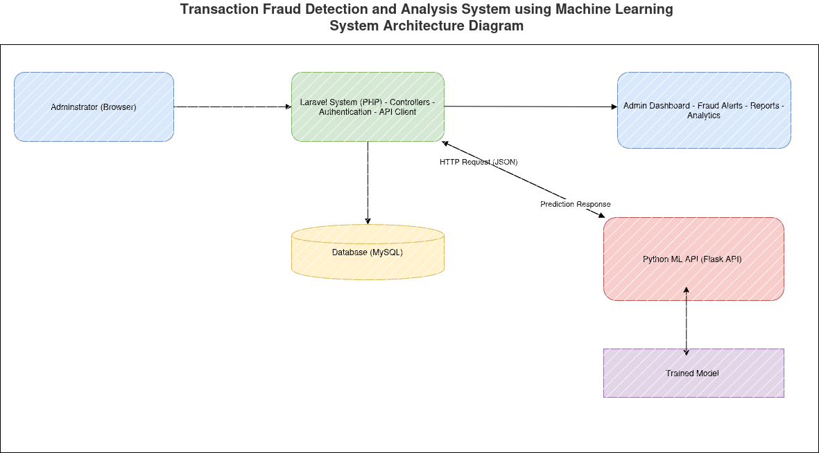Figure 1: System architecture diagram for Transaction Fraud Detection and Analysis System using Machine Learning

Explanation of the System Architecture Diagram Features

1.1️ Admin (Browser)
- This represents the user interface through which the system administrator interacts with the system.
- Admins can log in, upload transaction data, view fraud detection results, generate reports, and analyze transaction patterns via the dashboard.
- Interaction with the system is performed via standard web requests (HTTP).

1.2️ Laravel System (PHP)
- Serves as the main backend of the application.
- Handles core functionalities:
  - Controllers: Manage requests from the admin and route them to appropriate services.
  - Authentication: Ensures that only authorized users can access the system.
  - API Client: Communicates with the Python ML API by sending transaction data and receiving predictions.
- Acts as a bridge between the front-end (admin dashboard) and the machine learning engine.

1.3️ Database (MySQL)
- Stores all critical system data:
  - Transactions: Historical transaction data uploaded by the admin.
  - Users: Admin credentials and profile details.
  - Results: Prediction outcomes from the ML engine for later analysis and reporting.
- The database ensures persistence and allows the system to generate meaningful analytics.

1.4️ Python ML API (Flask API)
- Handles all machine learning-related tasks.
- Responsibilities include:
  - Data Preprocessing: Cleans and standardizes transaction data to prepare it for the ML model.
  - Logistic Regression Model: Applies the trained model to classify transactions as fraudulent or legitimate.
  - Prediction Engine: Returns prediction results to the Laravel backend.
- Communication with Laravel is done using HTTP requests in JSON format, ensuring modularity and language-agnostic integration.

1.5️ Trained Model
- Represents the saved Logistic Regression model stored using Joblib.
- The Python API loads this model to make predictions on incoming transaction data.
- Storing the model externally allows for retraining and updates without altering the rest of the system.

1.6️ Admin Dashboard
- Provides a visual interface for the admin to interact with system data.
- Features include:
  - Fraud Alerts: Notifications for potentially fraudulent transactions.
  - Reports: Summarized insights from historical transaction analysis.
  - Analytics: Visual graphs and statistics for trends and patterns.
- Receives processed data and predictions from the Laravel backend.

1.7️ Data Flow and Interactions
- Admin performs actions on the browser (uploads data in CSV).
- Laravel backend receives the request and stores/retrieves data from the database.
- For fraud detection:
  - Laravel sends transaction data as a JSON HTTP request to the Python ML API.
  - ML API preprocesses the data, runs it through the Logistic Regression model, and returns a prediction response.
- Predictions are saved back in the database and presented on the Admin Dashboard for visualization and reporting.

2. Use Case Diagram

7iyyyyyyyyyy
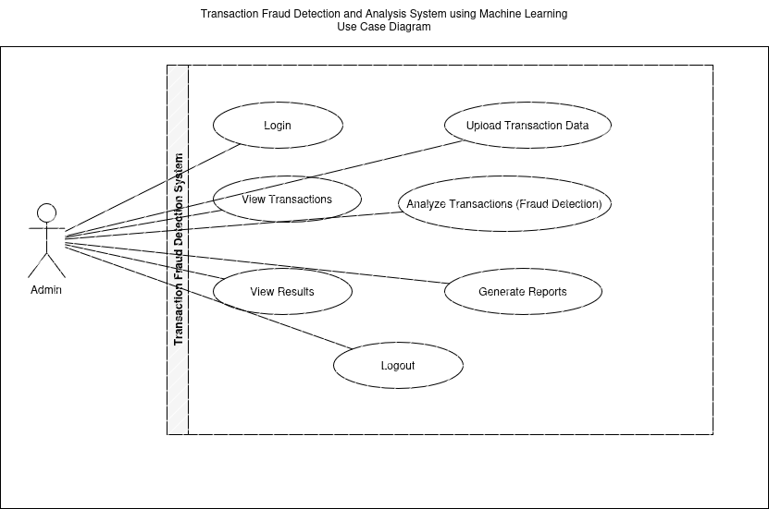Figure 2: Use Case Diagram for Fraud Detection and Analysis System using Machine Learning

Explanation of the Use Case Diagram Features

2.1️ Actor
- Admin
  - The primary actor of the system.
  - Responsible for performing all main operations, including logging in, uploading transaction data, initiating fraud analysis, viewing results, generating reports, and logging out.
  - Acts as the interface between the user and the system.

2.2️ System Boundary
- The “Transaction Fraud Detection System” box represents the boundary of the system.
- All functionality that the admin can perform resides within this boundary.
- It helps to clearly distinguish what is inside the system versus external entities (the actor).

2.3️ Use Cases
Each ellipse in the diagram represents a use case, which is a specific system function the admin can perform:
- Login
  - Allows the admin to securely access the system.
  - Ensures that only authorized personnel can perform transactions and analysis.
- Upload Transaction Data
  - Enables the admin to input historical transaction data into the system, either via CSV or direct upload.
  - Prepares the data for machine learning-based fraud analysis.
- View Transactions
  - Lets the admin browse and inspect uploaded transaction data.
  - Useful for data verification before running fraud detection.
- Analyze Transactions (Fraud Detection)
  - The core functionality where uploaded transactions are processed by the system’s machine learning engine to classify them as fraudulent or legitimate.
  - Provides actionable insights for potential fraud alerts.
- View Results
  - Displays the outcomes of the fraud analysis.
  - Admin can see flagged transactions, confidence scores, or summary statistics.
- Generate Reports
  - Produces analytical reports, charts, and summaries for management or auditing purposes.
  - Supports decision-making and regulatory compliance.
- Logout
  - Ends the admin session, ensuring security and preventing unauthorized access.

2.4️ Relationships
- Solid lines connect the Admin actor to each use case, showing direct interaction.
- This illustrates that the admin is the only entity interacting with the system in this scenario.
- No system-to-system dependencies are shown because the Use Case Diagram focuses purely on functional interactions from the user’s perspective.

REFERENCES

A. A. Almazroi and N. Ayub, “Online Payment Fraud Detection Model Using Machine Learning Techniques,” IEEE Access, vol. 11, pp. 137188–137203, 2023.
https://www.researchgate.net/publication/376223903_Online_Payment_Fraud_Detection_Model_Using_Machine_Learning_Techniques

Boubker, M. B., Benslimane, Y., & Boulmakoul, A. (2024). Fraud detection in financial transactions using machine learning with oversampling techniques: A case study of a Moroccan bank. Journal of Electrical Systems, 20(10s), 1351–1363
https://journal.esrgroups.org/jes/article/view/6664

Bhattacharyya, J., et al. (2011). “Comparative Analysis of Machine Learning Algorithms for Credit Card Fraud Detection.” International Journal of Computer Applications (IJCA).
https://www.ijisae.org/index.php/IJISAE/article/view/5232

