Queries

# NUMBER & TYPE OF INTERACTION PER FLIGHT

SELECT FACT.FLIGHT_KEY, INTERACTIONS_TYPE, count(*) as NUM_OF_INTERACTIONS

FROM customer_care FACT,

customer_interactions C,

date_dimension D,

flight F,

passenger P

WHERE FACT.DATE_KEY = d.DATE_KEY

AND FACT.INTERACTIONS_KEY = C.INTERACTIONS_KEY

AND FACT.P_KEY = P.P_KEY

AND FACT.FLIGHT_KEY = F.FLIGHT_KEY

group by FACT.FLIGHT_KEY, INTERACTIONS_TYPE;

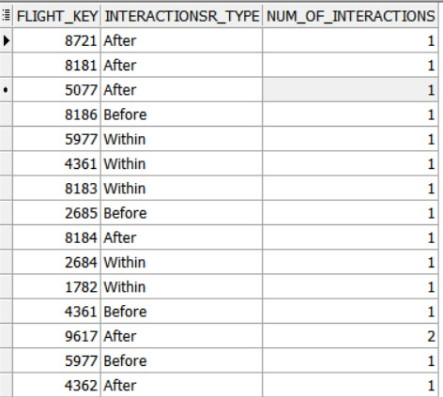

# AVERAGE PROBLEM SEVERITY PER FLIGHT

SELECT FACT.FLIGHT_KEY, AVG(PROBLEM_SEVERITY)

FROM customer_care FACT,

customer_interactions C,

date_dimension D,

flight F,

passenger P

WHERE FACT.DATE_KEY = D.DATE_KEY

AND FACT.INTERACTIONS_KEY = C.INTERACTIONS_KEY

AND FACT.P_KEY = P.P_KEY

AND FACT.FLIGHT_KEY = F. FLIGHT_KEY

group by FACT.FLIGHT_KEY;

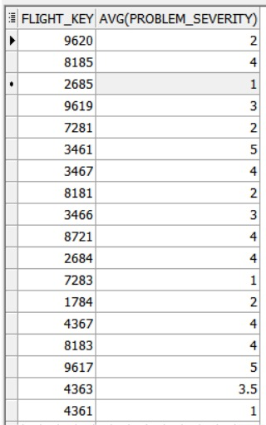

# NUMBER OF TRIPS FREQUENTLY TAKEN

SELECT F.DEP_AIRPORT , F.ARR_AIRPORT, count(*) as freq_taken

FROM flight F,

passenger P,

reservation R

WHERE F.FLIGHT_KEY= R.FLIGHT_KEY

AND P.P_KEY = R.P_KEY

AND P.STATUS = 'Gold'

GROUP BY F.DEP_AIRPORT, F.ARR_AIRPORT

ORDER BY 3 DESC;

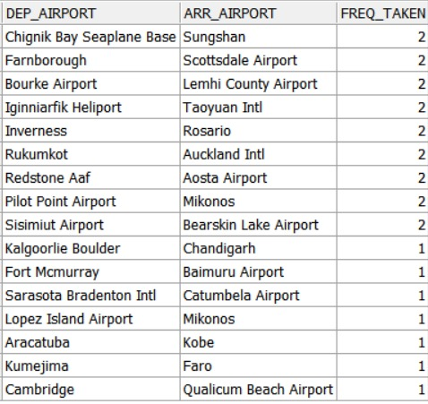

# AVG FARE BASE PER PASSENGER

SELECT P.P_ID, ROUND(AVG(fare_amount), 2) as avg_farebase

FROM fare_base FB,

passenger P,

reservation R

WHERE P.P_KEY = R.P_KEY

AND FB.FARE_KEY = R.FARE_KEY

GROUP BY P.P_ID;

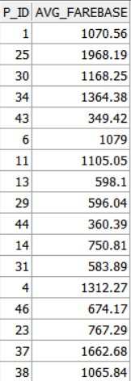

# HOW OFTEN THEY UPGRADE

SELECT change_indicator, COUNT(*)/(SELECT COUNT(change_indicator)

FROM class ) as PERC

FROM class

GROUP BY change_indicator;

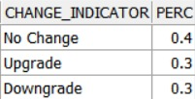

# HOW THEY EARN AND REDEEM MILES

SELECT P.P_ID , F.ARR_AIRPORT, COUNT(F.FLIGHT_NO) as flights_no,

SUM(R.redeemed_miles) as redemed_miles

from flight F,

passenger P,

reservation R

WHERE F.FLIGHT_KEY= R.FLIGHT_KEY

AND P.P_KEY = R.P_KEY

GROUP BY P.P_ID , F.ARR_AIRPORT

ORDER BY 4;

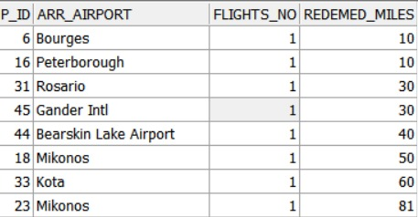

# PROFIT PER QUARTER IN EVERY YEAR

SELECT year, quarter , SUM(FB.FARE_AMOUNT) as revenue

FROM date_dimension DD,

Fare_base FB,

reservation R

WHERE DD.DATE_KEY=R.DATE_KEY

AND FB.FARE_KEY = R.FARE_KEY

GROUP BY year, quarter

ORDER BY year , quarter;

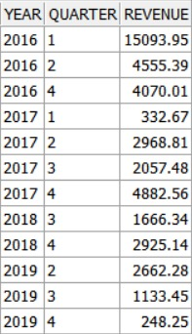

# PROFIT PER CHANNEL TYPE

SELECT RC.CHANNEL_TYPE , SUM(FB.FARE_AMOUNT) as revenue

FROM RESERVATION_CHANNELS RC,

Fare_base FB,

reservation R

WHERE RC.CHANNEL_KEY =R.CHANNEL_KEY

AND FB.FARE_KEY = R.FARE_KEY

GROUP BY RC.CHANNEL_TYPE;

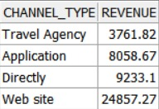

# HIGHEST PROFIT PER QUARTER EACH YEAR

SELECT *

FROM

( SELECT year, quarter , SUM(FB.FARE_AMOUNT) as revenue,

RANK() OVER(PARTITION BY year ORDER BY SUM(FB.FARE_AMOUNT)) as rak

FROM date_dimension DD,

Fare_base FB,

reservation R

WHERE DD.DATE_KEY=R.DATE_KEY

And FB.FARE_KEY = R.FARE_KEY

GROUP BY year, quarter) year_rnk

WHERE rak = 1;

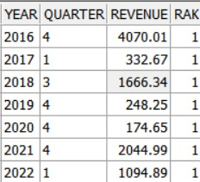

# AVERAGE NUMBER OF NIGHTS PER HOTEL

# 

SELECT F.FLIGHT_KEY, H.HOTEL_NAME , ROUND(AVG(OS.NUM_NIGHTS), 2) as avg_no

FROM flight F,

OVERNIGHT_STAY OS,

hotel H

WHERE F.FLIGHT_KEY = OS.FLIGHT_KEY

AND OS.HOTEL_KEY = H.HOTEL_KEY

GROUP BY F.FLIGHT_KEY, H.HOTEL_NAME;

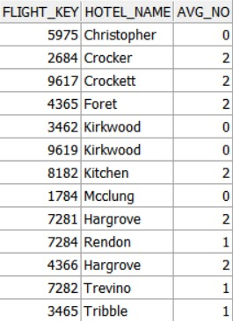

# NUMBER OF CUSTOMER IN EACH STATUS

SELECT P.STATUS, COUNT(P.STATUS)

FROM passenger P,

reservation R

where P.P_KEY = R.P_KEY

group by P.STATUS;

