**Final Week Report**

1. **Introduction: Describe the most salient features of the project:**
   1. *The Homepage*
      1. **The Navbar**
         1. The Visit Georgia webpage has a simple and user-friendly navigation bar conveniently located at the top of the page. It will remain at the top of the screen even as the user scrolls down the page.
      2. **The Carousel**
         1. The webpage contains a screen-width carousel with four beautiful images of four major tourist destinations of Georgia.
      3. **The Jumbotron with changing title feature**
         1. Under the Navbar, the user will find a jumbotron with the heading, “Welcome to Georgia: [title]”. As the user scrolls through the carousel images, the title will change with the photos reading, “Welcome to Georgia: Tbilisi”, “Welcome to Georgia: Alaverdi”, “Welcome to Georgia: Batumi”, “Welcome to Georgia: Korbuleti”.
      4. **Tabbed Information**
         1. Below the carousel, the user will find tabbed information regarding Georgia. The three tabbed sections are:
            1. About Georgia

Here the user can read a brief description of the country

* + - * 1. Map

By clicking on this tab, the user may view an interactive map of Georgia

* + - * 1. Currency

By navigating to this tab, the user may view the current exchange rate for the US Dollar to the Georgian Lari.

* + 1. **Weather Widget**
       1. Below the Tabbed Information, the user will find a weather widget that will tell them the current weather information for Georgia’s capital city, Tbilisi.
    2. **Embedded Videos**
       1. Under the weather widget, the user will be able to interact with two embedded videos:
          1. The Statue of Love: Batumi, Georgia
          2. The Most Beautiful Country, Georgia
    3. **Footer**
       1. The homepage will end with a footer containing:
          1. Links to other pages on the site:

Home

Activities

Tours

* + - * 1. Social Icons to follow Georgia on Social Media
        2. A signature crediting the authors of the project
  1. *The Activities Page:*
  2. *The Tours Page:*
     1. **The Navbar**
        1. The Visit Georgia webpage has a simple and user-friendly navigation bar conveniently located at the top of the page. It will remain at the top of the screen even as the user scrolls down the page.
     2. **Media Objects**
        1. The main section of the page includes the following media objects:
           1. Georgia Adventure
           2. Wine in Georgia
           3. Georgian Caucasus Mountain Ski Paradise
           4. Svaneti Highlands
     3. **Footer**
        1. The tours page will end with a footer containing:
           1. Links to other pages on the site:

Home

Activities

Tours

* + - * 1. Social Icons to follow Georgia on Social Media

1. **Design and Implementation**
   1. *How did we convert from the design to the actual reality of the project?*

We did not follow entirely the design layout due to some unforeseen issues and discoveries. As we have explored more content on the Bootstrap components, weather and map widgets, we decided to move the widget codes from the footer to tabs section. The time clock widget was never a part of the wire frame conceptual design, but was added later to the jumbotron. Due to lack of time, the development of the accommodation webpage (hotels/restaurants) was canceled.

* 1. *What choices, modifications, or substitutions did we make?*

The carousel being inserted into Home Page was customized drastically to match the home page color theme. The JQuery script was introduced to render the ‘Welcome Georgia’ title in the jumbotron with a respect of the image content. The dynamic and responsive modal with animation effects and descriptive caption was added to the Tours Page to each media object.

* 1. *What modules and libraries did we use?*

The npm node modules with the listed below dependencies, lite-server module, Boostrap and jQuery libraries were used.

*"bootstrap"*: "^4.0.0",

*"bootstrap-social"*: "^5.1.1",

*"font-awesome"*: "^4.7.0",

*"jquery"*: "^3.3.1",

*"popper.js"*: "^1.12.9",

*"requirejs"*: "^2.3.6"

}

* 1. *Screen Shots of web page:*
     1. **Home Page**
     2. **Tours Page**
     3. **Activities Page**

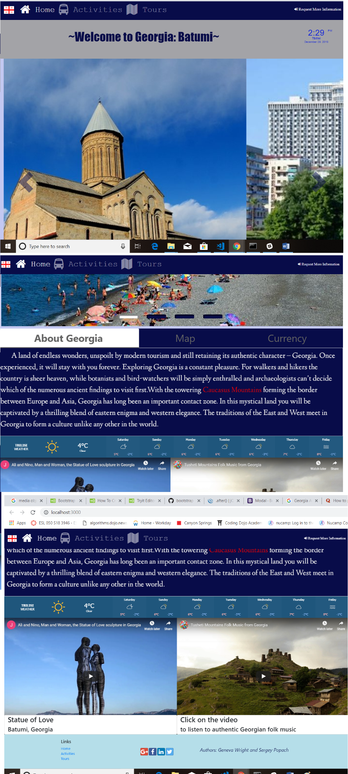

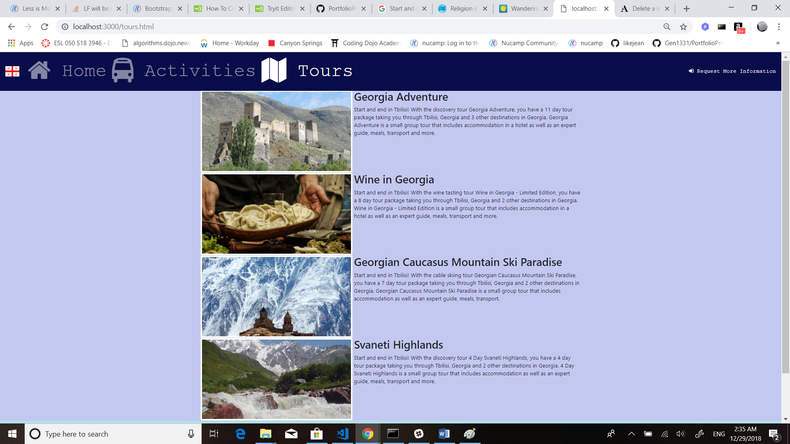

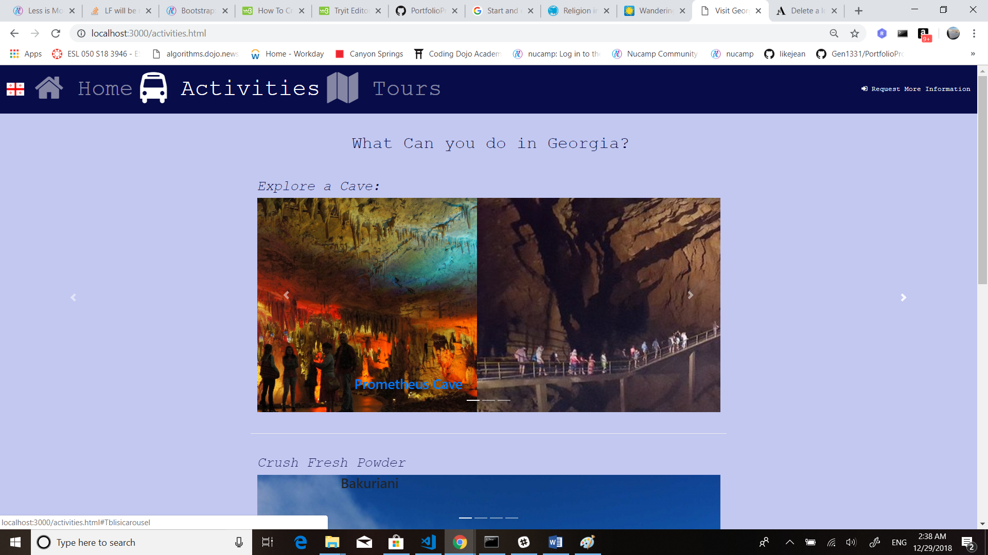

1. **Conclusions**
   1. Results:
   2. *Features and shortcomings:*
      1. **Features**
         1. The Home Page development is our greatest achievement despite its minor bugs and shortcomings. It is highly responsive and dynamic due to implementation of the Bootstrap components and Javascript coding.
      2. **Shortcomings**
         1. The Home Page carousel fails to render the title in the jumbotron after its manual controls are being used by a user. The automatic image cycling restarts only after a browser refresh.
         2. The modal can be displayed initial on the Tours Page only after second image click. Once it’s being clicked by a user, it requires only a single click after the initial double-click event.
         3. The font size and font typology consistency of the navigation bars, footers, widgets and carousels must be improved on all pages.
         4. The Tours Page is lack of detailed descriptive information on trails.
   3. *Anything we would have done differently, looking back?*
2. **References:**
   1. *Websites/books that we used* 
      1. <http://georgia.travel/>
      2. <https://www.facebook.com/georgiaandtravel/>
      3. <https://www.youtube.com/user/GeorgiaAndTravel>
      4. <https://www.youtube.com/watch?v=3vm6JZTN61Y>
      5. <https://www.pinterest.com/traveltogeorgia/>
      6. <https://twitter.com/georgiaandtrave>l

* + 1. <https://www.tripadvisor.com/Attractions-g294194-Activities-Georgia.html>
    2. <https://www.gotravelyourway.com/2013/11/12/8-reasons-to-travel-to-georgia-and-tbilisi/>