Here is a table of times that ff, bigmemory and filevector took to read/write 3000x3000 table row by row or column by column. DatABEL shows best result on sequencial read:

access type | DatABEL | bigmemory | Ff
Read, row by row | 10 sec | 18 sec | 16 sec
Read, col by col | 2740 sec | 64 sec | 8983 sec
Write, row by row | 12 sec | 10 sec | 16 sec
Write, col by col | 2657 sec | 1409 sec | 9936 sec

Random access is worse comparing to other packages since DatABEL always reloads fixed-size cache buffer when accessed address changes sufficiently:

access type | DatABEL | Bigmemory | ff
Read by rows | 600 sec | 64 sec | 44 sec
Read by cols | 4774 sec | 4509 sec | 6119 sec
Write by rows | 600 sec | 57.7 sec | 46 sec
Write by cols | 2763 sec | 6633.9 sec | 7381 sec

Accessing all table’s elements in random order:

library | time, seconds
DatABEL | 14811
bigmemory | 10747
Ff | 31200

In linear row-by-row access mode time, used by DatABEL depends only on file size. On the following graph point’s absciss is number of bytes in file, and ordinate is time, that takes C++ code to read this amount of data. Different symbols show different data types. There is no linear dependency when DatABEL is invoked from R, since inner R housekeeping takes up to 80% of time.

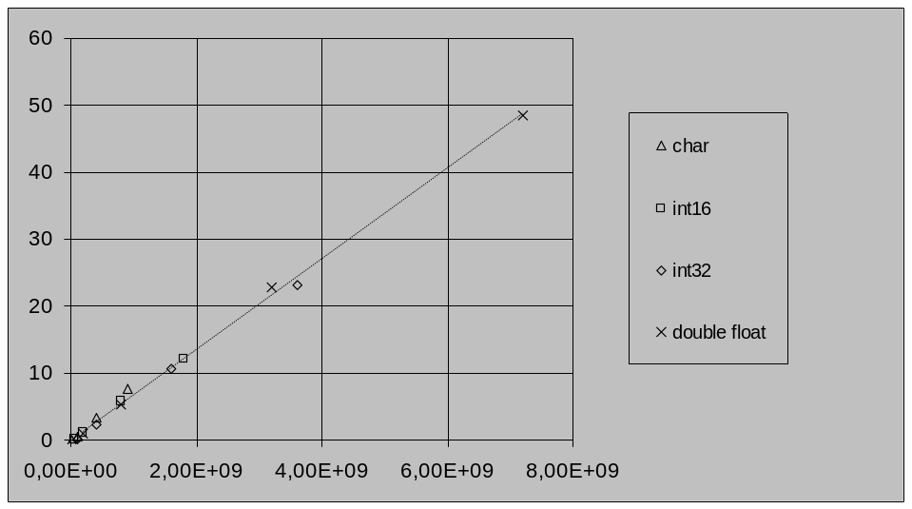

Package ff doesn’t have utilities for loading and parsing big text data. There is read.big.matrix() function in package bigmemory that shows same speed as text2databel() function from DatABEL. Average speed (that of course depends on data precision) was about 8MB/sec for our test configuration.

