Project Scope - Deep Research AutoGen/ Agentic Framework or LangGraph Agentic Network for AI Factory Growth Equity Identification

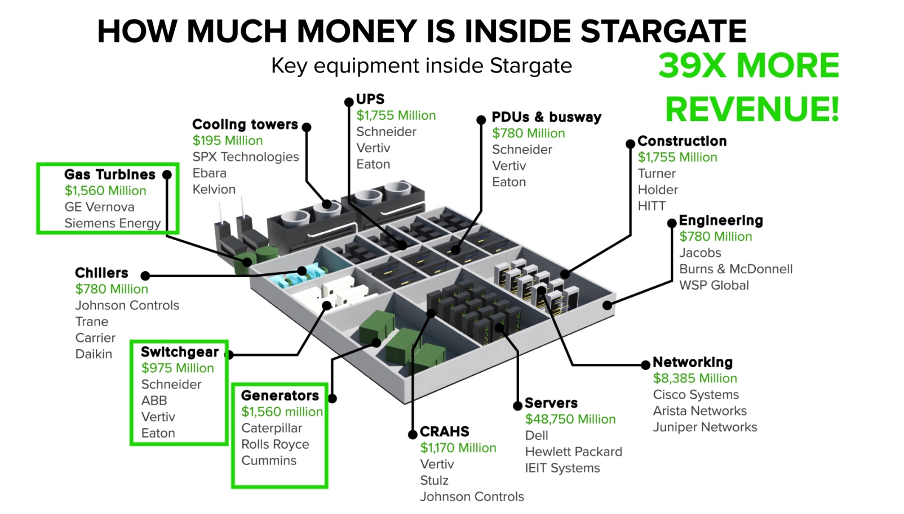

Deep Research AutoGen/N8N/Agentic Framework or Lang Graph Agentic Network for AIFactory Growth Equity Identification

1. Project Objective
To design and deploy a Deep Research AutoGen/Agentic Network/Lang Graph capable of systematically identifying, scoring, and ranking public companies best positioned to achieve superior equity growth over the next 3 years, driven by the global build-out of AI Factories and hyperscale data centers.
The system will:
- Map the AI Factory capital stack (compute, networking, power, cooling, construction).
- Identify public companies with direct revenue exposure to AIFactory builds.
- Quantify economic moat / differentiation by role in the AI Factory ecosystem.
- Evaluate operating leverage and margin quality.
- Forecast 3-year growth driven by AI Factory demand.
- Produce an ordered Top 20 Growth Ranking, based on a composite Growth Score.

2. Core Growth Evaluation Formula

Total AI Factory Growth Score (TAFGS)
TAFGS = (Moat Score × Operating Margin Score) × Forecast AI-Driven Growth

Where:

1. Moat Score (0–5)
Measures defensibility and uniqueness in AI Factory contribution:
- Architectural lock-in (e.g., CUDA, proprietary networking)
- Ecosystem dominance (design wins, reference architectures)
- Switching costs / standard-setting influence
- Scarcity or bottleneck position in the AI Factory supply chain

2. Operating Margin Score (0–5)
Normalized from actual operating margin:
Operating Margin | Score
>40% | 5
30–40% | 4
20–30% | 3
10–20% | 2
<10% | 1
High margins indicate pricing power + operating leverage, critical in capex supercycles.

3. Forecast AI-Driven Growth (3-Year CAGR %)
Derived from:
- AI Factory capex exposure
- Order backlog growth
- Hyperscaler / sovereign AI commitments
- Product cycle timing (e.g., 800G networking, liquid cooling, AIservers)

3. Key Deliverables

3.1 AI Factory Value-Chain Mapping
Classify companies by where they monetise AI Factory spend:
- Compute / Servers (GPUs, AI servers)
- Networking (Ethernet, InfiniBand, optical)
- Power Infrastructure (generators, turbines, UPS, switchgear)
- Cooling Systems (liquid cooling, chillers, CRAHs)
- Engineering & Construction (design, build, commissioning)
Each segment weighted by share of AI Factory dollar spend, reflecting the capital distribution shown in the reference material
Ranking Data Center Infrastruct…
.

3.2 Company Scoring Engine
For each company:
- Revenue exposure to AI Factory builds (% of total revenue).
- Moat analysis (qualitative → quantified).
- Operating margin normalization.
- 3-year AI-driven growth forecast.
- Risk adjustments (cyclicality, customer concentration, execution).

3.3 Top 20 AI Factory Growth Ranking
Ordered by Total AI Factory Growth Score, not market cap.
Each company profile includes:
- Primary AI Factory role.
- Moat & differentiation narrative.
- Operating margin profile.
- AI-driven growth catalysts (2026–2029).
- Key risks.
- Final Growth Score and rank.

4. Agentic AutoGen Architecture

Modular Agents
Agent | Function
Market Mapping Agent | Maps AI Factory spend across infrastructure layers
Company Ingestion Agent | Identifies eligible public companies globally
Moat Analysis Agent | Scores differentiation and ecosystem lock-in
Margin Analysis Agent | Normalizes operating margin strength
Growth Forecast Agent | Projects AI-driven 3-year CAGR
Risk Adjustment Agent | Applies execution, cyclicality, and concentration discounts
Ranking Agent | Computes Total AI Factory Growth Score
Report Agent | Produces investor-ready Top 20 output
Agents cross-validate assumptions to prevent single-factor bias.

5. In-Scope Functional Domains
- Equity Research Automation
- AI Factory Capex Attribution
- Margin & Operating Leverage Analysis
- Moat & Ecosystem Power Modeling
- Multi-agent ranking & scoring
- Repeatable quarterly refresh capability

6. Out-of-Scope (Phase 1)
- Valuation timing (P/E, DCF entry points).
- Short-term trading signals.
- Private companies.
- Venture-stage AI infrastructure startups.
- Macroeconomic or rate-cycle forecasting.

